Day-2
In this document we will see the
- User creations
- Policy creation
- AWS managed policies
- Customer Inline policies
ALL the work will be done through the IAM user account which is a best practice
- User creation
Step1:
a.Search IAM in AWS console in the IAM user account
- Here MFA(Multifactor Authentication) in Root and IAM account is activated which is nothing but the more security during signin to account or can be said as two factor authentication.
- Click on user section then create.
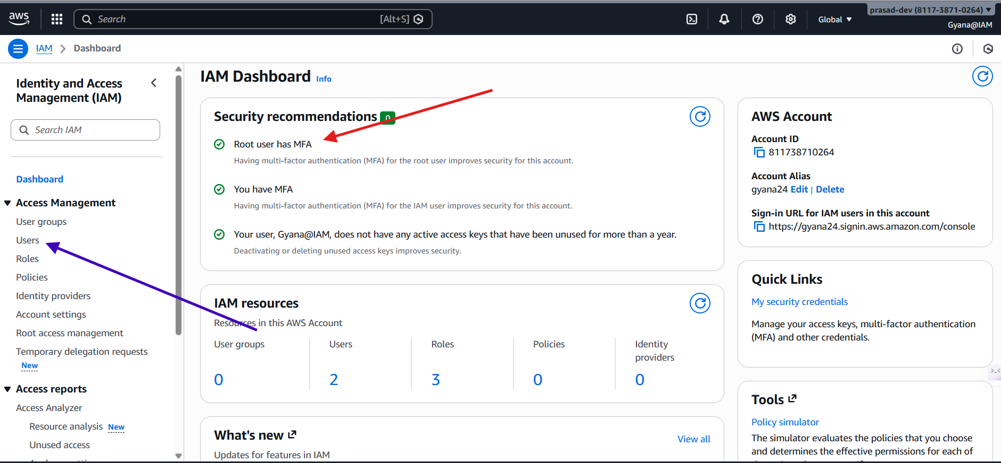

Step-2
b)Click on create user and then create.
-Here I have two users are there in the account and this IAM user account can access these services in AWS because I have given AWSAdministrator permissions in the AWS managed policie.
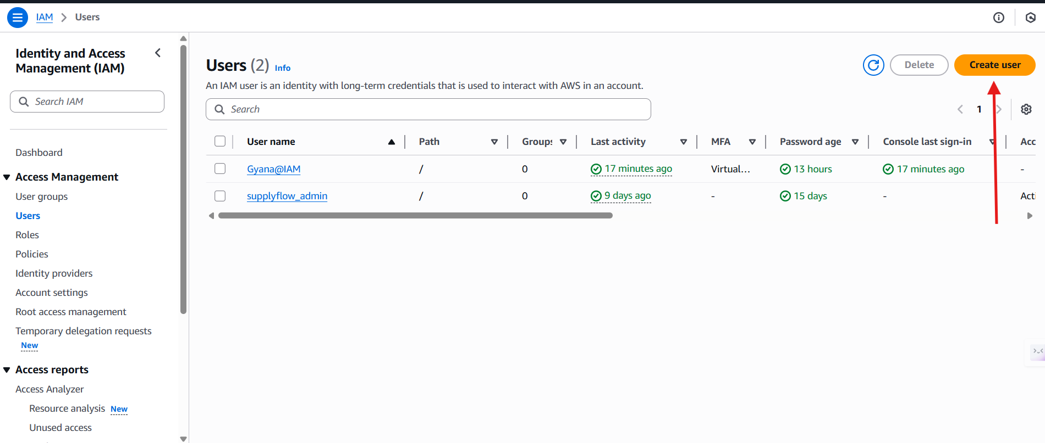
c) Here I am creating an user giving password and security click on that checkbox and it will appear console password section where you can give your customized permissions and also can give the autogenerated password.
d) Click next.
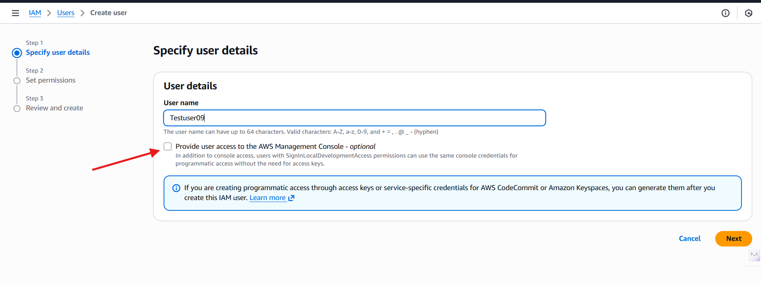
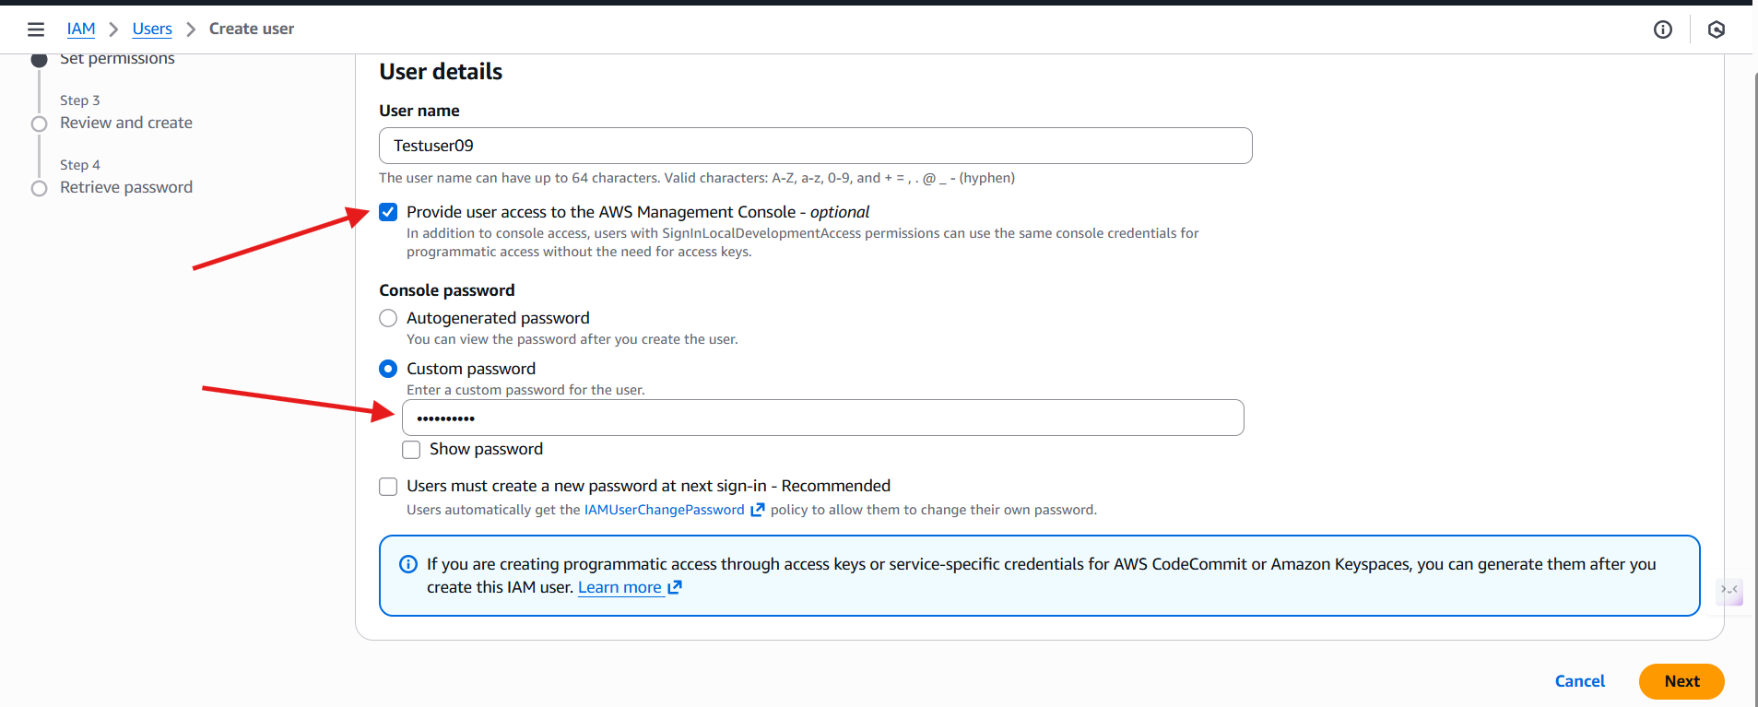
e) Here in the set permissions section we will attach policies from aws and remove it create inline polices and can also attach to the user.
-For now I am not giving any permission and will check the user first then will give permissions.
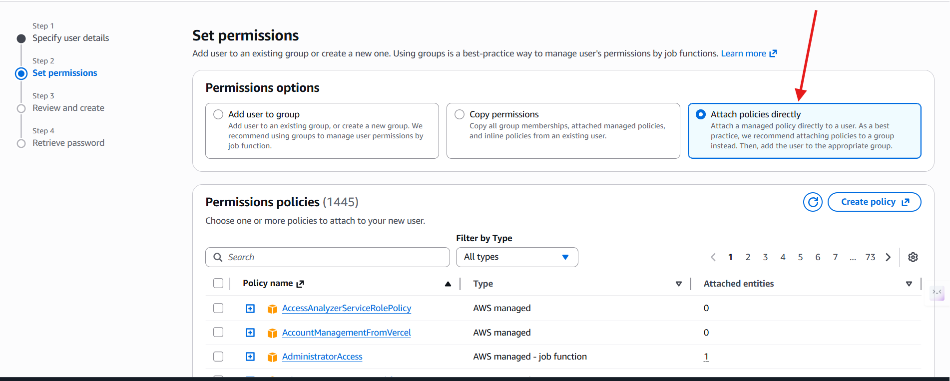
-Review and create the user.
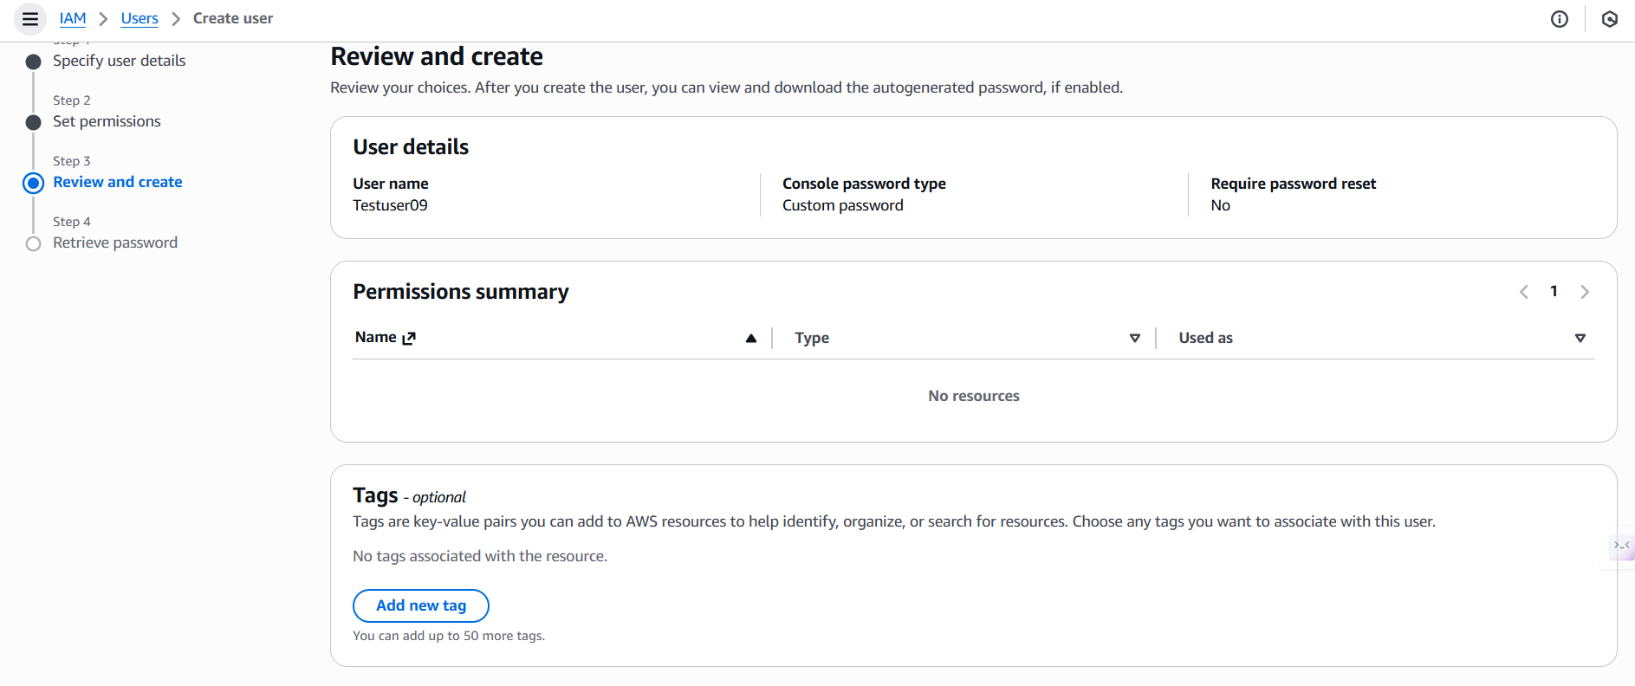
User Created successfully.
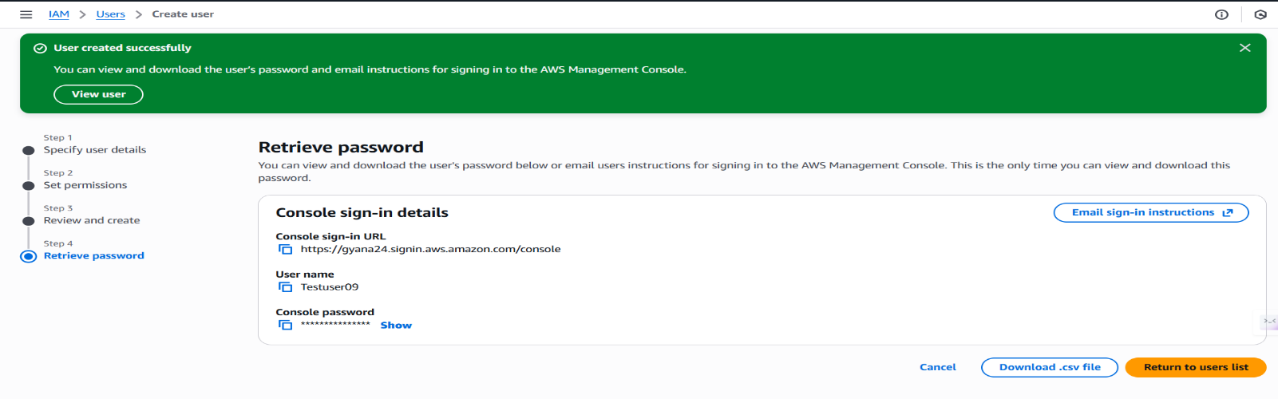
Step-3
Signin to the created user by login into the user using the username and password.
And whether it can access any services to the AWS or not as we have not given any permissions.
-Here in the below image you can see we have logged in as Testuser09.
-Also can see this showing Access denied because we have not given any permissions to the user while creation.
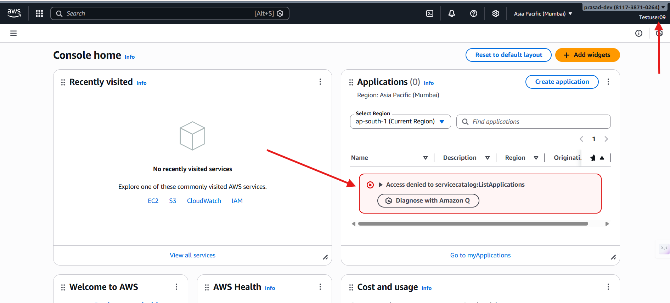

- I have searched IAM in the search and can see its showing access denied.
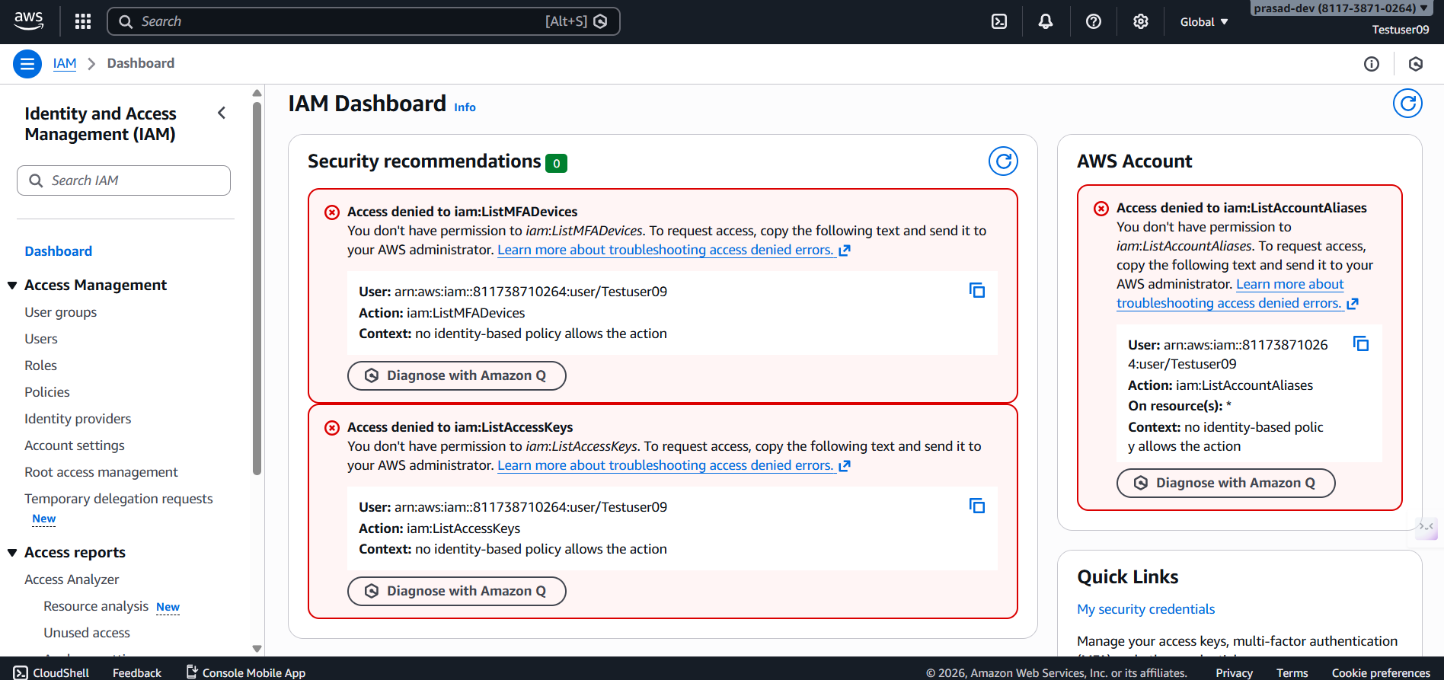

- Searching other services line EC2.
- Its also showing error because we don’t have the permission to access it.
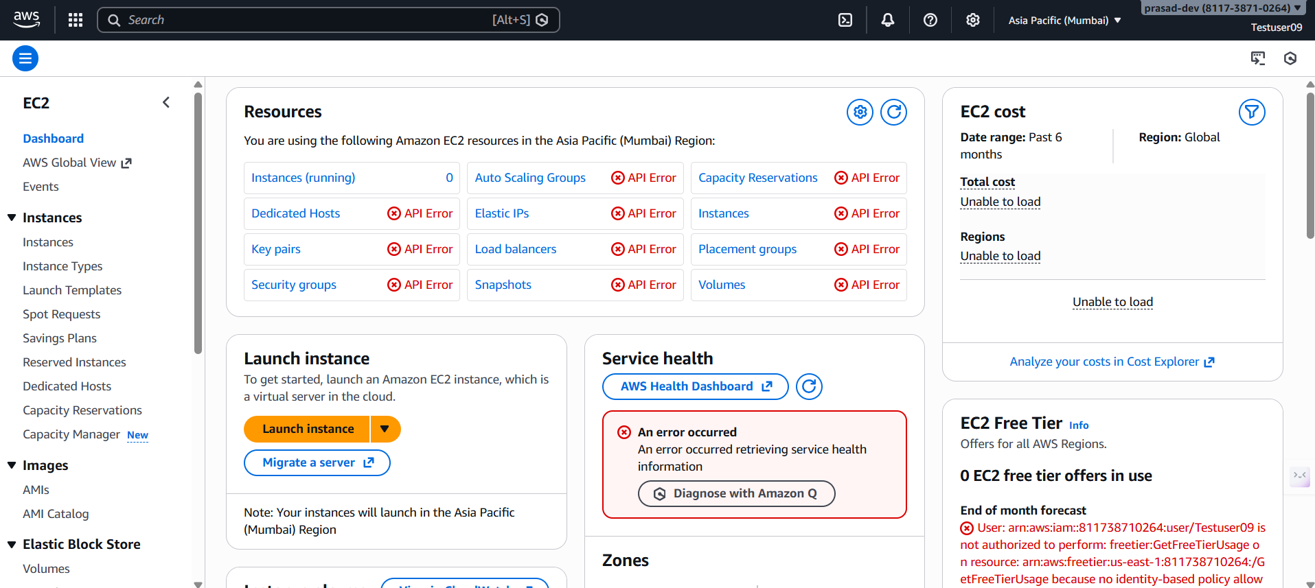

Step-4
Now I will give the permissions from our Gyana@IAM user account where we have created the user.
Permisisons are noting but attaching the policies to the user then will see what will be different.
-Entering into the Testuser09 account and giving the permissions.
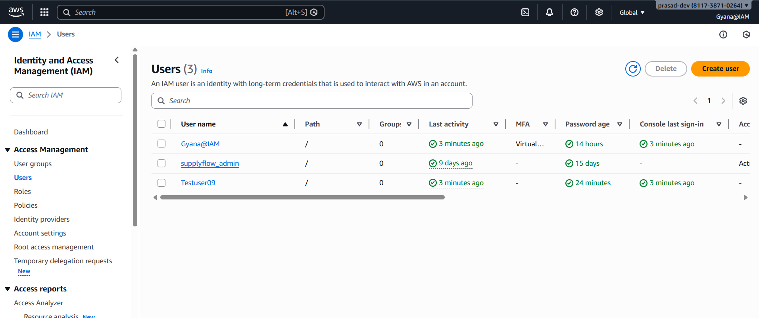

-Adding permissions.
-Here you can see in the add permission section we have two options one is Add permissions which is nothing but the AWS managed permissions.
-Another one its create inline policy which is nothing but the user based policies or can say user customized policies.
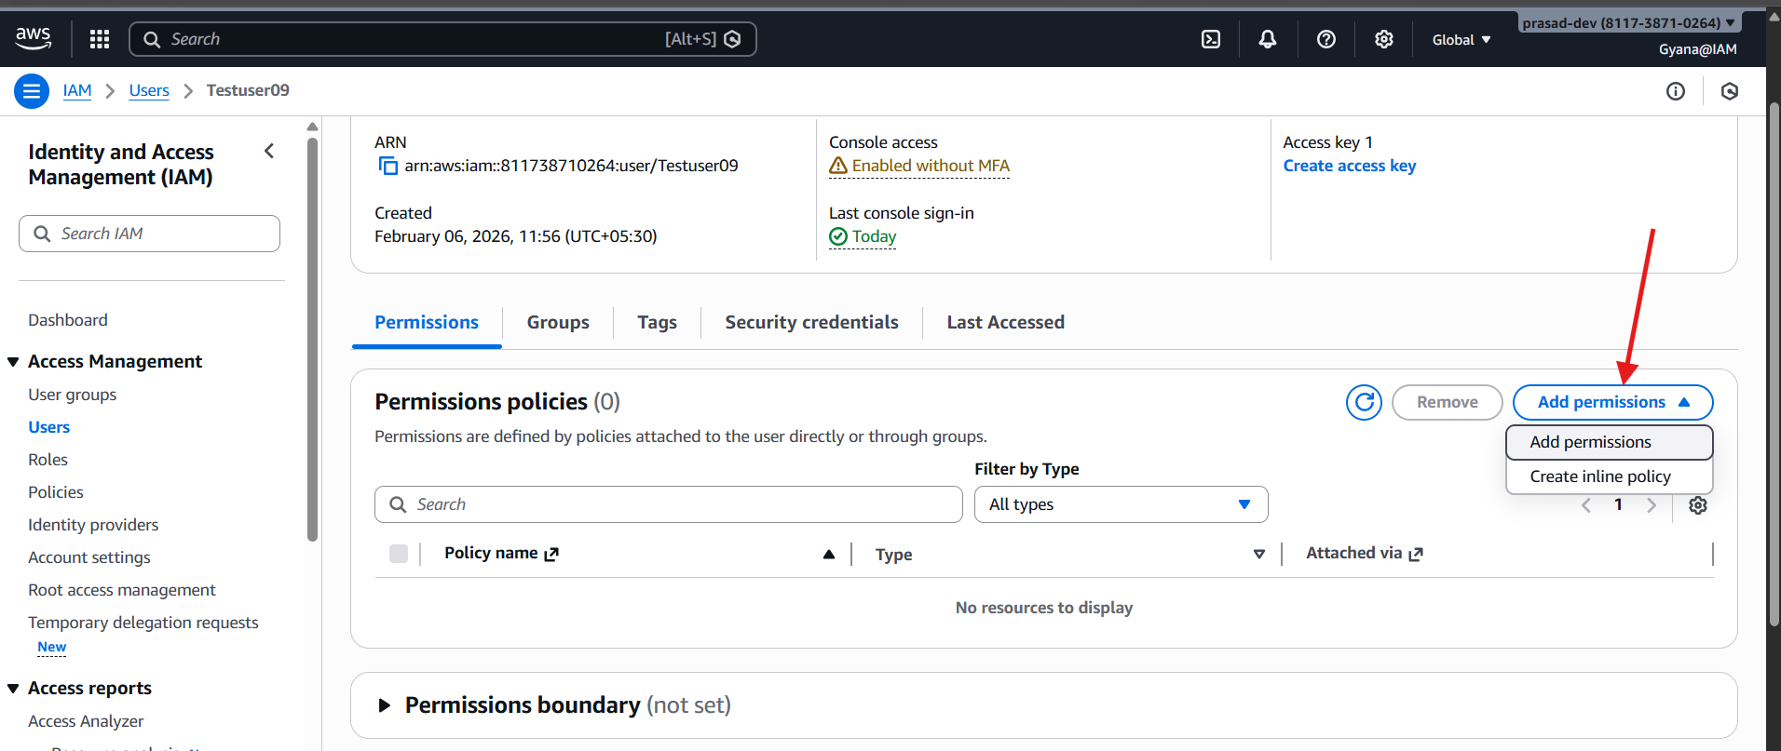

-We will first set the AWS managed policies.
- User attached policies directly we can attach or remove the policies or permissions provide by AWS.
- Here I am only giving the ec2 full access and IAMreadonly access to check.
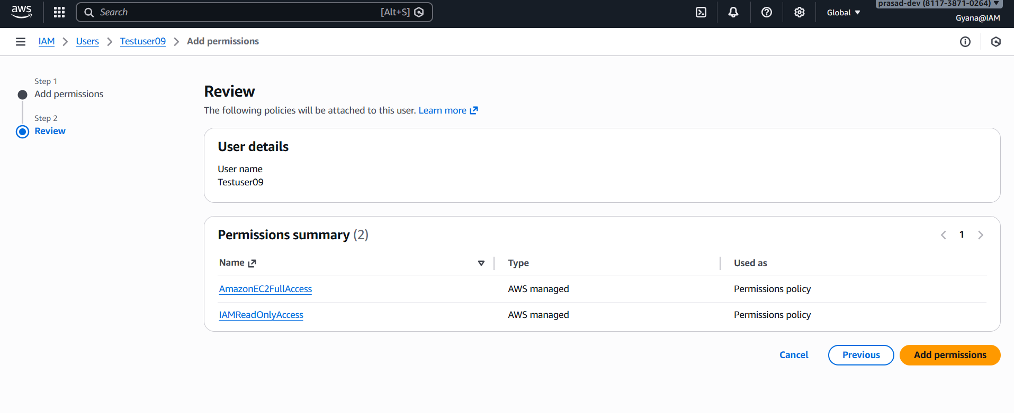

-Now you can see the policies are attached to the Testuser09 account.
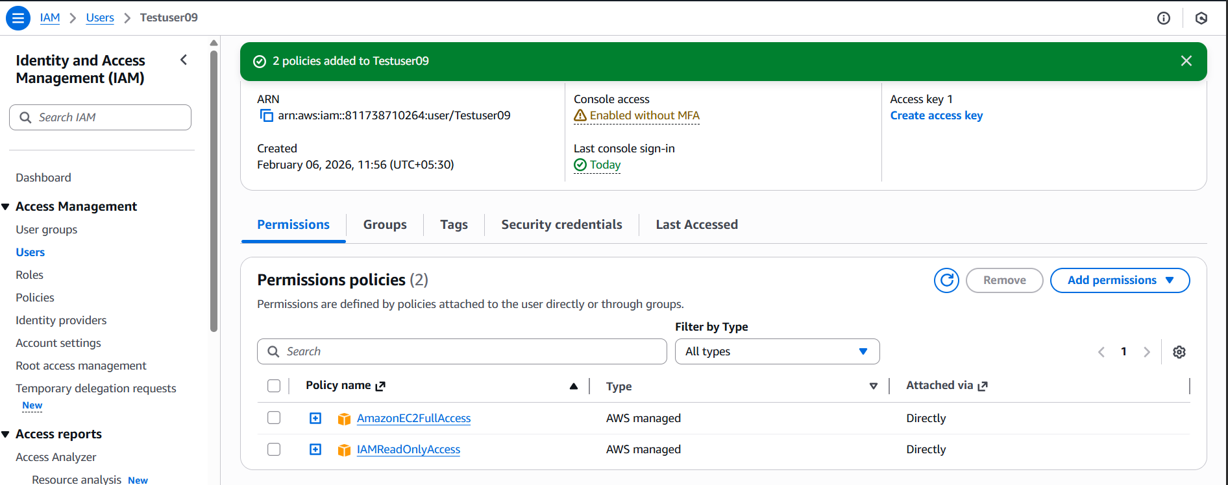

Step-5
-Now go to the Testuser09 account check the access EC2.
-You can see the EC2 interface has changed and no error is showing now.
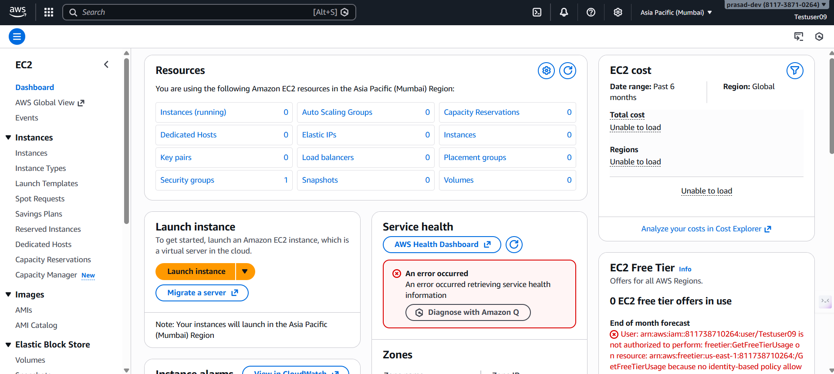

-IAM Service check
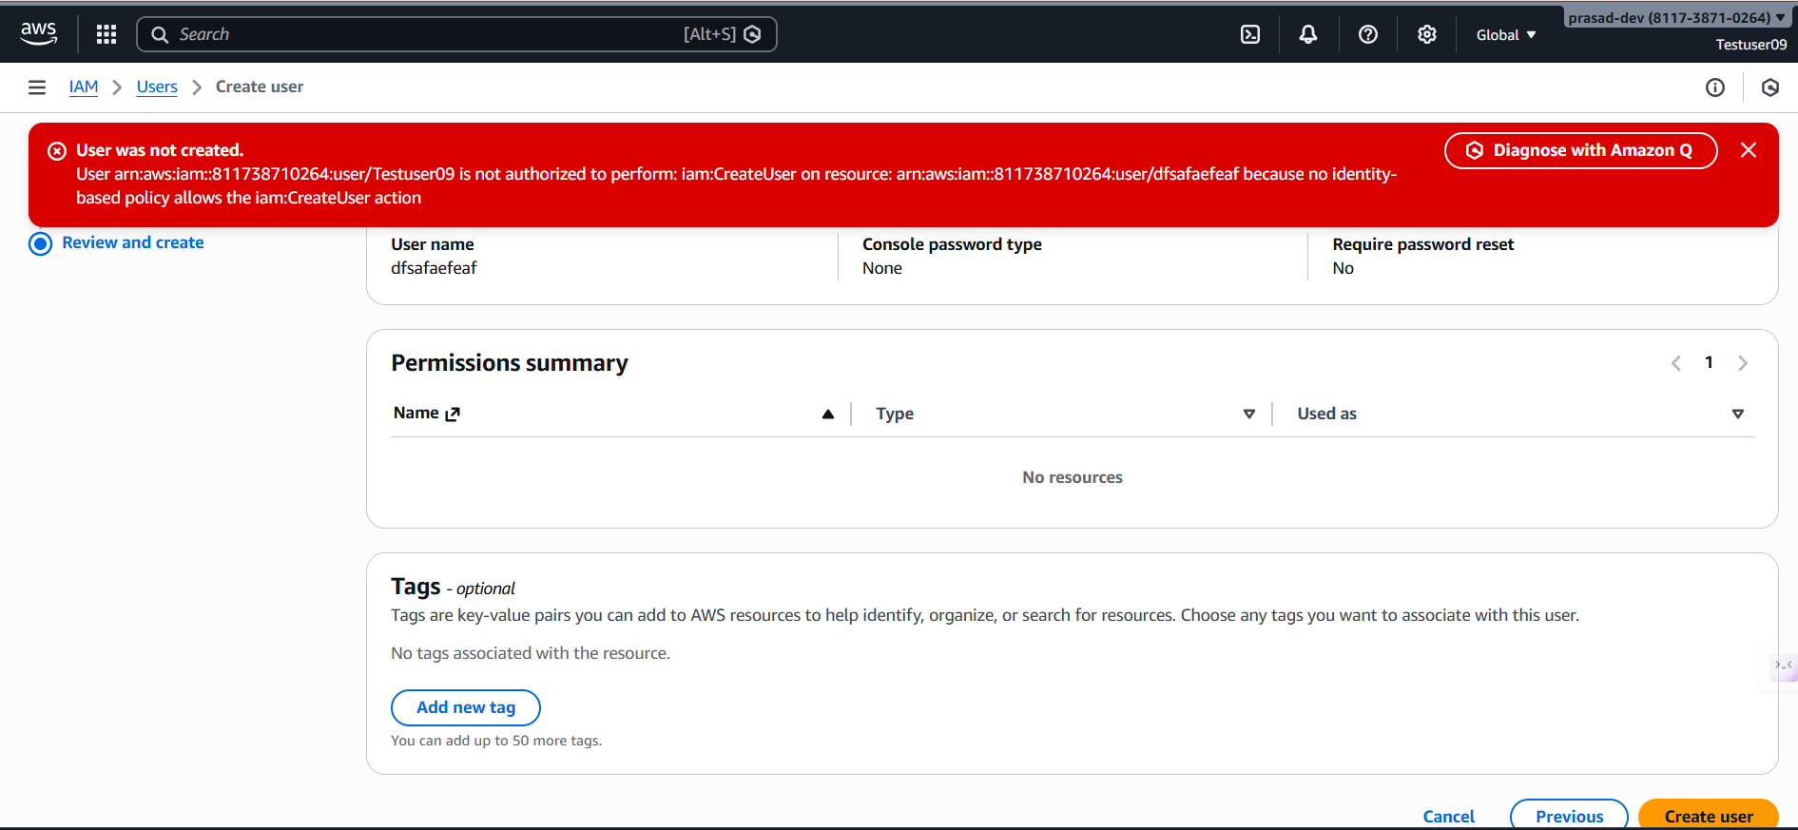

- Here it is showing the error because we have only given the IAMReadonly permissions so that this user can’t create or modify any user account.
- If will given full permissions the it can do the tasks.

Inline Policies Attaching to the user.
Under the IAM user account we can create and customized the policies in the create policies section.
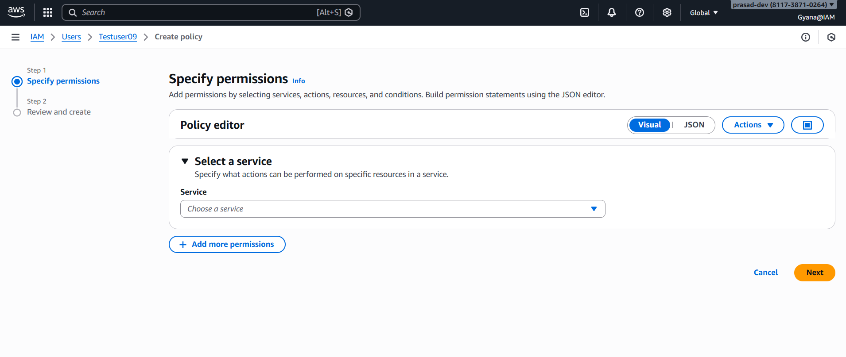

Select the permissions which you want to give to the user.
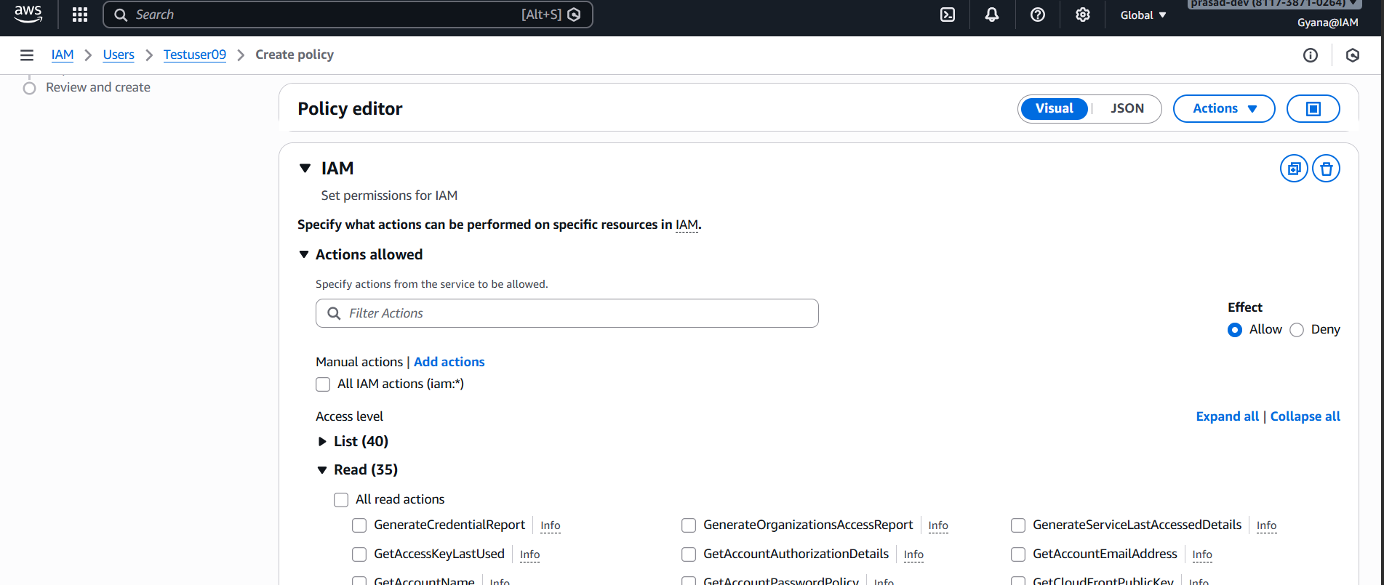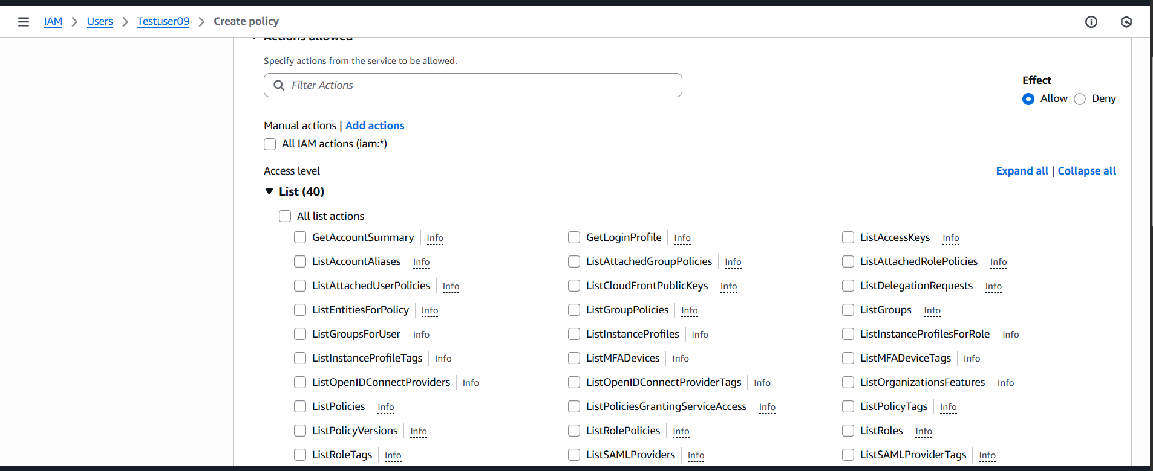Select the policies and move to next clicking the next button.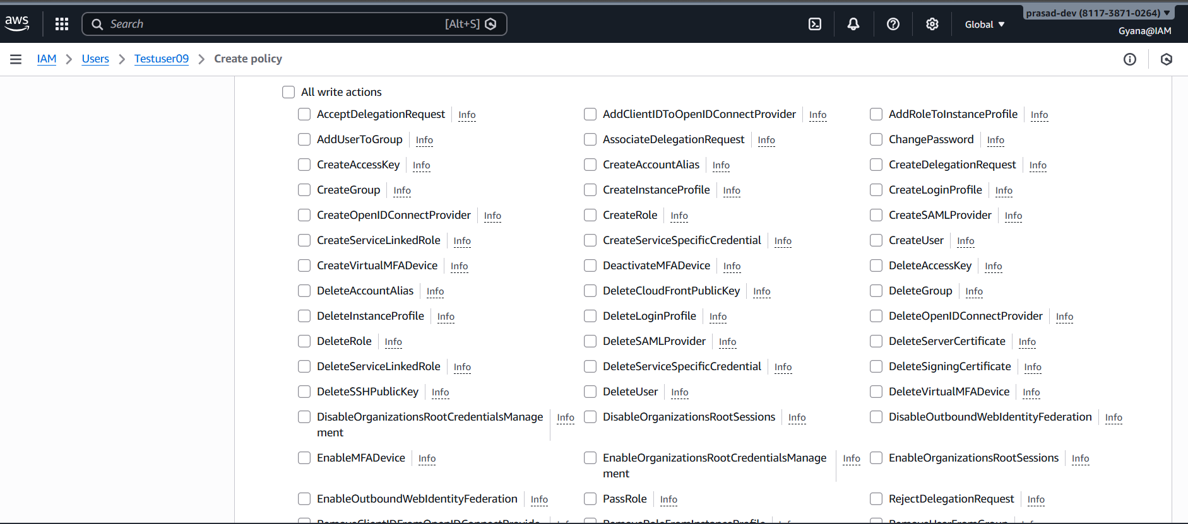
After Selecting the policies give the policies name and create a policy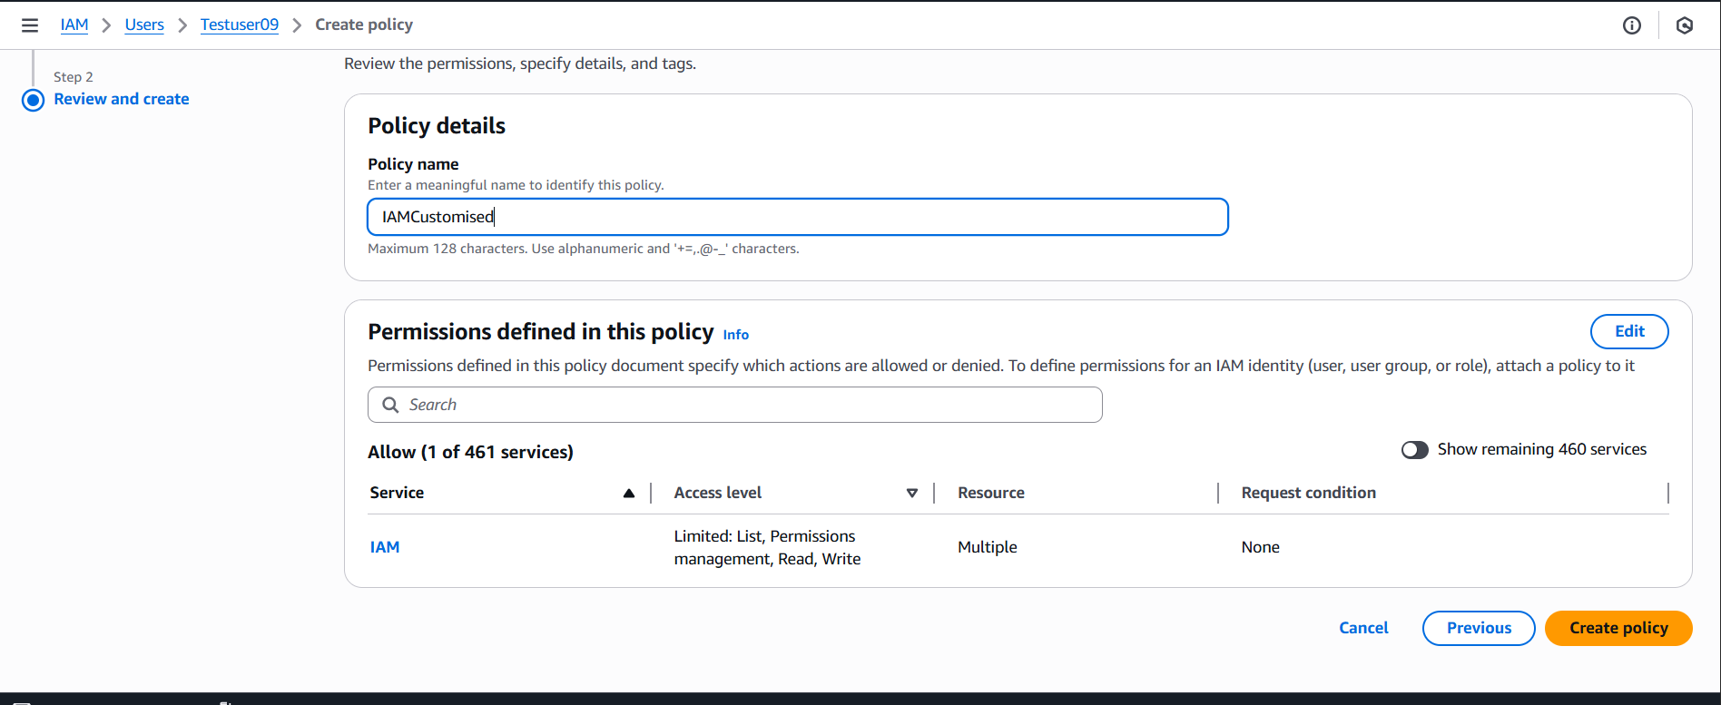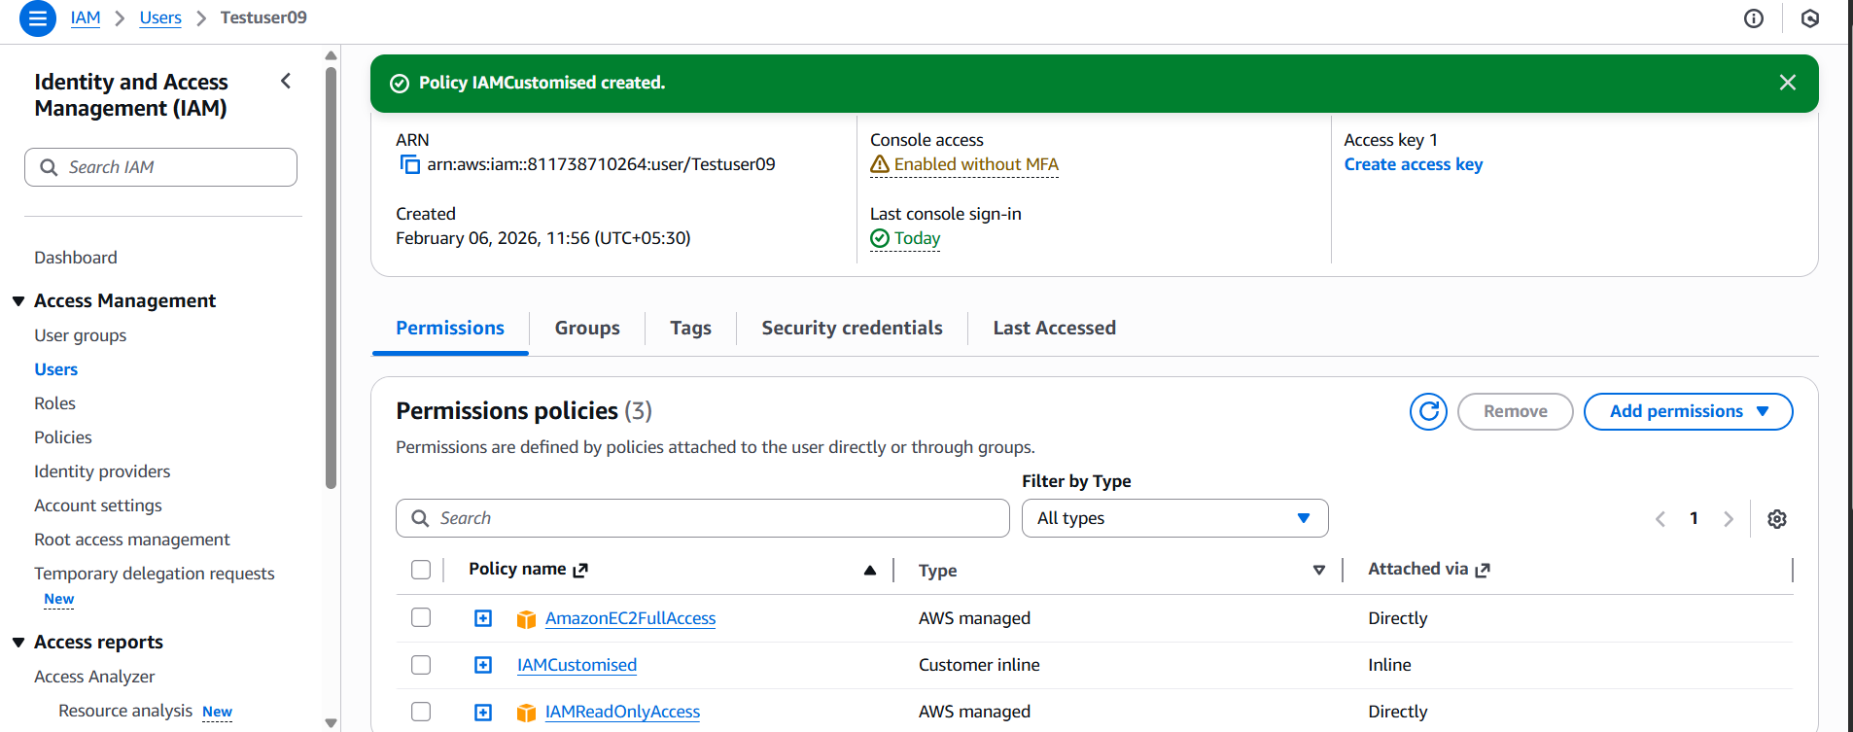
Policy created and attached to the Testuser09.
-Now that user can create the new IAM users.
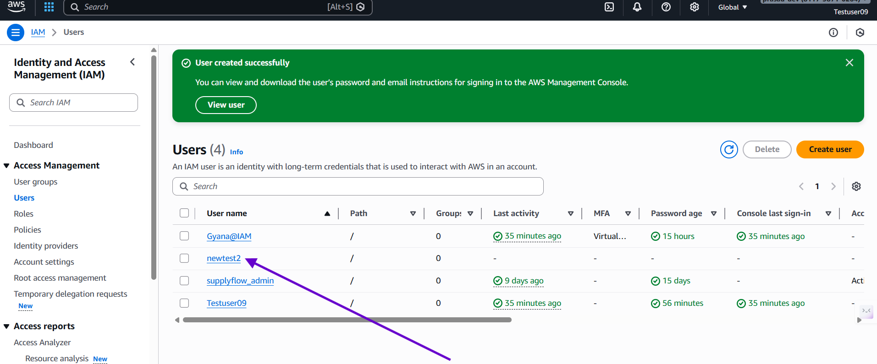
User get created under the Testuser09 account after giving the inline policy.

