**Step 1:** Clone git repository

git clone <https://github.com/gprashant2/prometheus.git>

**Step 2:** Navigate to Prometheus directory

cd prometheus/

**Step 3:** create the monitoring namespace:

kubectl apply -f namespace.yaml

**Step 4:** Create the service account and cluster role with the permission of getting cluster info for prometheus.

kubectl apply -f prometheus-rbac.yaml

**Step5:** Create the config for prometheus to collect data from Kubernetes

kubectl apply -f prometheus-config.yaml

**Step 6:** Create the deployment of Prometheus

kubectl apply -f prometheus-deploy.yaml

**Step 7:** Create the prometheus service

kubectl apply -f prometheus-svc.yaml

**Step 8:** Create the grafana deployment

kubectl apply -f grafana.yaml

**Step 9:** Expose grafana deployment with kubectl expose

kubectl expose deployment grafana --type=LoadBalancer --namespace=monitoring

**Step 10:** create node-exporter daemon set to export node information

kubectl apply -f node-exporter.yaml

**Step 11:** Create kube-state-metrics deployment to collect metrics about the cluster

kubectl apply -f state-metrics-deploy.yaml

**Step 12:** Create the service account and cluster role with the permission of getting cluster info for state-metrics.

kubectl apply -f state-metrics-rbac.yaml

**Step 12:** Access grafana using LB IP and port

http://<YOUR-PUBLIC-IP>:3000

Login name:admin

Password: helloworld

**Step 13:** Enable kubernates app

<http://35.193.99.86:3000/plugins/grafana-kubernetes-app/> and click on Enable.

**Step 14:** Add a data source

<http://35.193.99.86:3000/datasources>

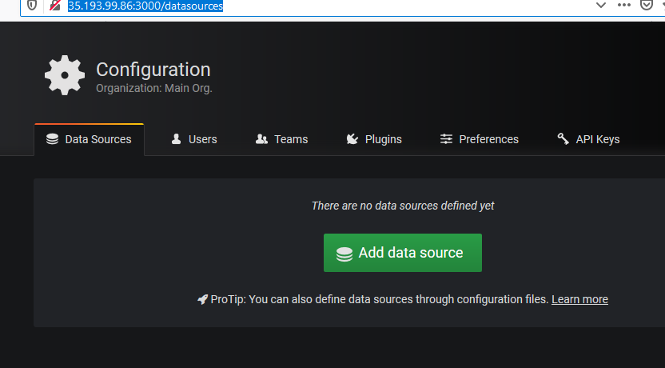

Choose “Prometheus” and put the following values.

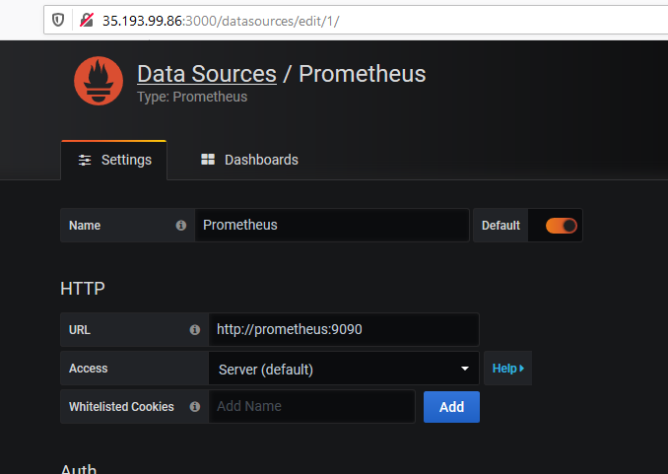

Click on “Save & Test”

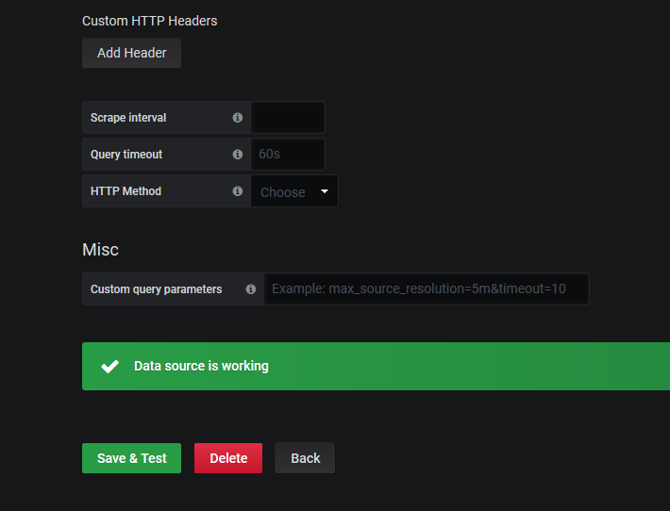

**Creating Grafana Dashboards:**

1. **Browse the grafana public website and search for POD overview keyword**

**Browse one of the results -** <https://grafana.com/grafana/dashboards/6781>

1. **Copy the dashboard id: 6781 in this case.**
2. **Open our grafana URL (http://<Public-ip>:3000 ) and on the left click the + button and choose “Import”**

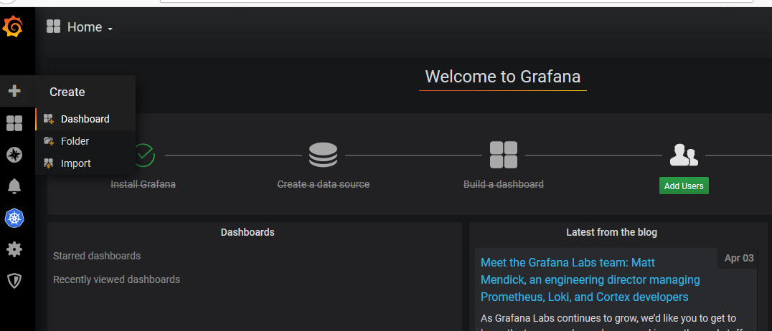

1. **The following screen will appear.**

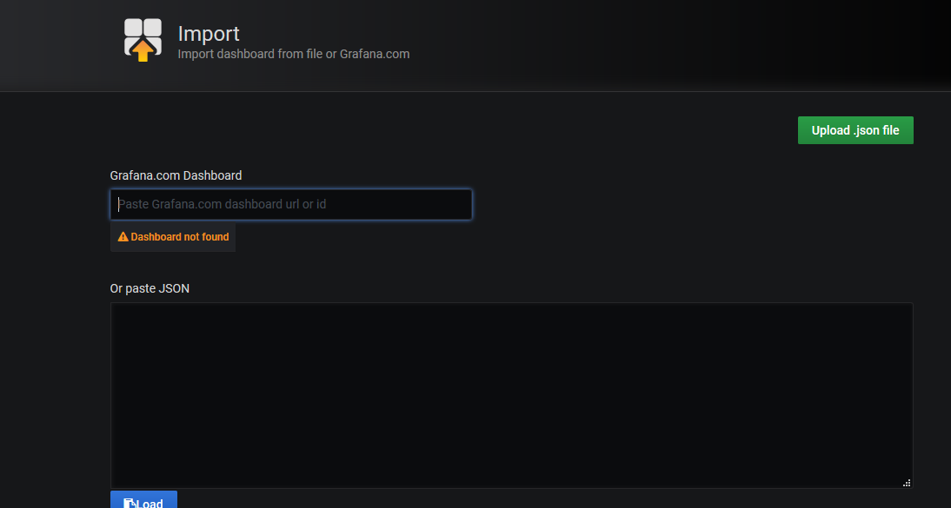

1. Paste the dashboard ID copied earlier (6781) in this case and paste as shown below.

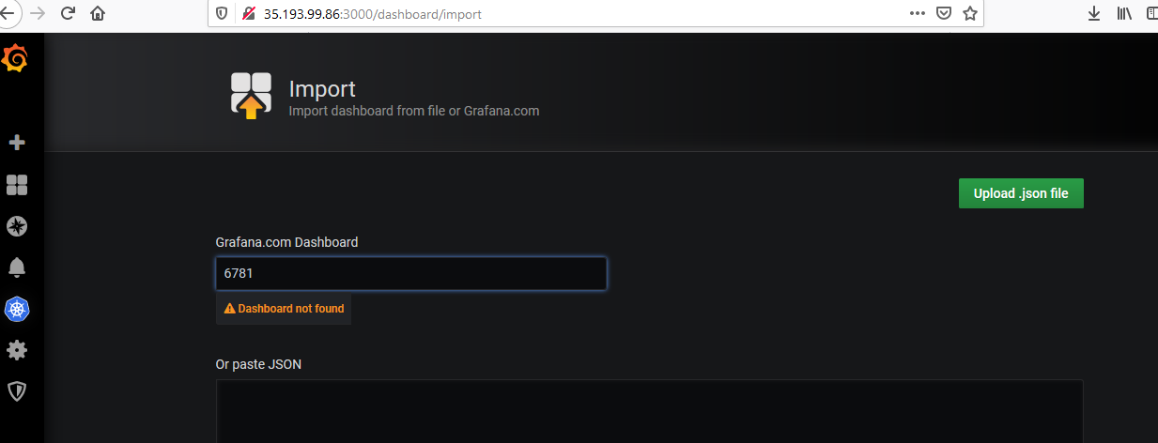

1. As soon as the ID is pasted, the screen changes to as displayed below. Choose folder as “General” and Prometheus as “Prometheus” and click on “Import”.

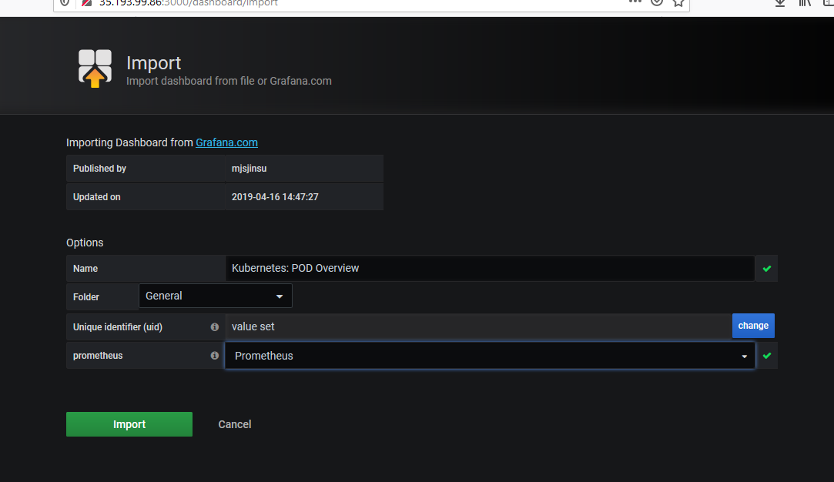

1. The following Dashboard will appear giving POD overview. Namespace can be altered here to get the desired results.

