**Power BI Assignment 5**

1. Explain DAX.

Answer: Data Analysis Expressions (DAX) to solve a number of basic data modelling and analytical problems. DAX is a collection of functions, operators, and constants that can be used in a formula, or expression, to calculate and return one or more values. Stated more simply, DAX helps you create new information from data already in your model.

1. Explain datasets, reports, and dashboards and how they relate to each other?

Answer: A **dataset** is a collection of data that you import or connect to.

A**Report** is a multi-perspective view of a dataset, with visuals representing different findings and insights. A report can have one visual or pages full of visuals.

A **PowerBI dashboard** is a single page, often called a canvas, telling a story through visualizations. Because it is limited to only one page, a well-designed dashboard contains only the highlights of that story.

1. How reports can be created in power BI, explain two ways with Navigation of each.

Answer:

Step 1: Install Power BI Desktop for Power BI Report Server

Step 2: Select a data source

Step 3: Design your report

Step 4: Save your report to the report server

1. How to connect to data in Power BI? How to use the content pack to connect to google analytics? Mention the steps.

Answer: To connect to data, follow these steps:

1. In Power BI Desktop, select Get data from the Home ribbon tab.
2. In the Get Data window, select Online Services from the categories in the left pane.
3. Select Google Analytics from the selections in the right pane.
4. At the bottom of the window, select Connect.

The ability to gather data from different sources into one is the main benefit of utilizing Power BI and Google Analytics together.

## Step 1 – Click on “Get Data Once you have Power BI open, in the ribbon near the top left of the screen you should see a button called **Get Data**.

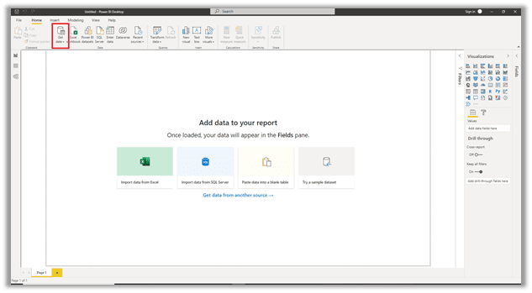

Click on **Get Data** and select the **More** option.

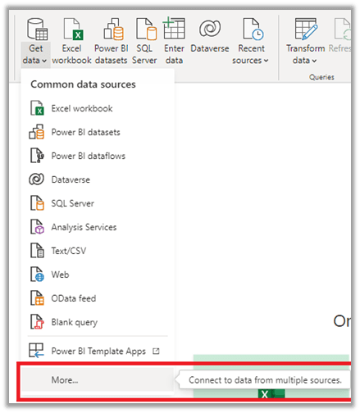

In the **Get Data** dialogue box, scroll down to find or search for the Google Analytics connector.

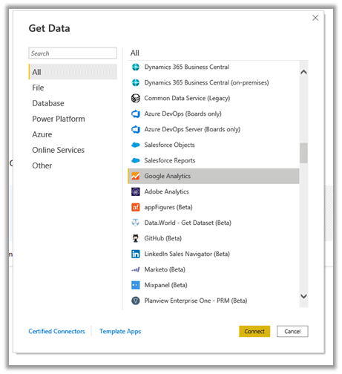

*Figure 4 Select the Google Analytics Connector*

Power BI will then notify you that the Google Analytics connector relies on a 3rd party service. You can just select Continue to move past this dialogue box.

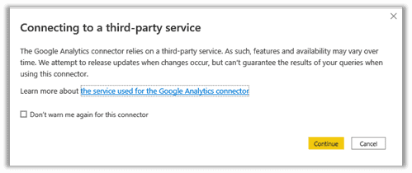

*Figure 5 Notification of Third-Party Service*

## Step 2 – Sign in to Google Analytics and allow Power BI access

Power BI will now prompt you to sign in to your Google Analytics account.

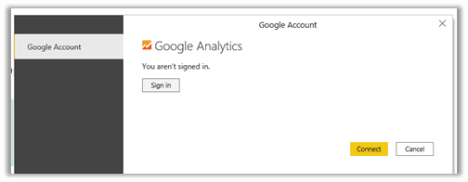

*Figure 6 Sign in to your Google Analytics account*

Select the account that is attached to the Google Analytics account that has the data you wish to access.

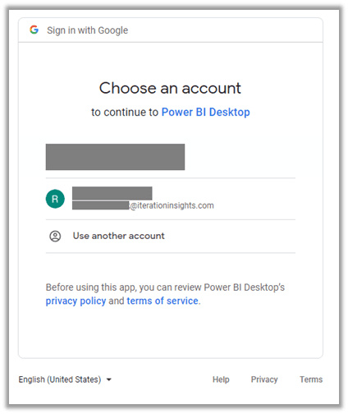

*Figure 7 Select your Google account*

You then must allow Power BI to access your Google Account.

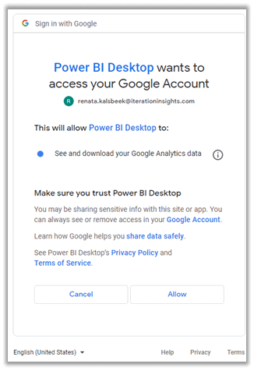

*Figure 8 Allow Analytics Access*

Once you have allowed access, return to your Power BI file and you will see that you are now signed in. Click **Connect** to continue.

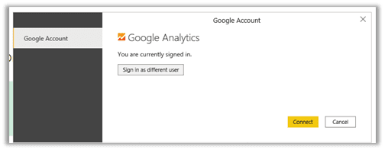

*Figure 9 Logged In*

## Step 3 – Load Google Analytics Data into Power BI

Connecting will open the Navigator box. This is where you will select which data you would like to be loaded into Power BI. The options are set up the same way that the Google Analytics account hierarchy is set up.

The top-level is the Account, the second level is the Property, and the bottom level is the View. Select which account, property, and view that contains the data you are looking for.

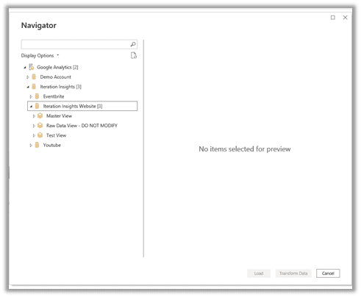

*Figure 10 Navigator Box*

In order to load in the data, you must ensure that you have the proper permissions in Google Analytics. The last step is to select the tables and load the data.

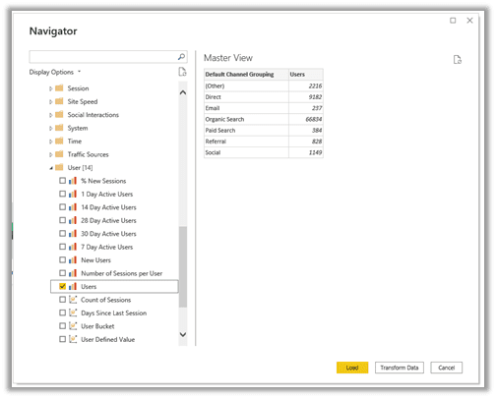

*Figure 11 Select Data to Load*

Here you have two choices. If you select **Load**, the data will come into Power BI and the dialogue box will close. If you choose **Transform Data**, this will load the data into Power BI and open the Power Query Editor so that you may transform and clean the data as necessary.

If you are new to Power BI and are wanting to learn how to transform your data, check out our [Introduction to Power BI 2-day training](https://iterationinsights.com/introduction-to-power-bi/). This is an instructor-led course that will get you on the right track with Power BI.

1. How to import Local files in Power BI? Mention the Steps.

Answer: If we want to import Analytics data manually through Power BI, these are steps:

1. In Power BI, click Get Data in the lower left screen.
2. Under Import or Connect to Data > Files, click Get.

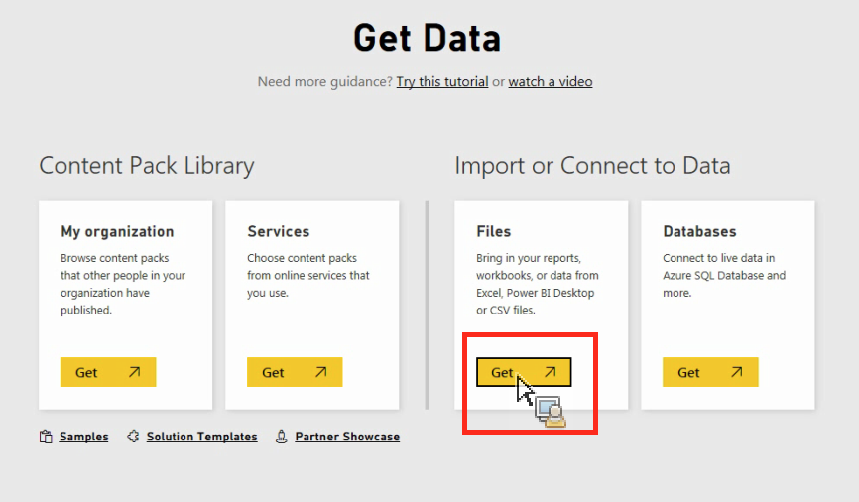

1. Click Local File.

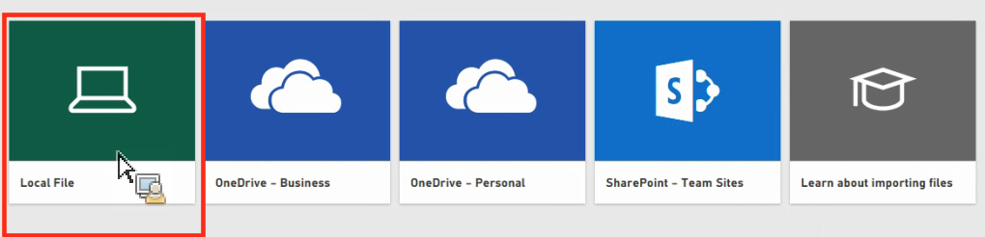

1. Choose which file to upload and click **Open**.
2. Click **Upload** under **Upload your Excel file to Power BI**.

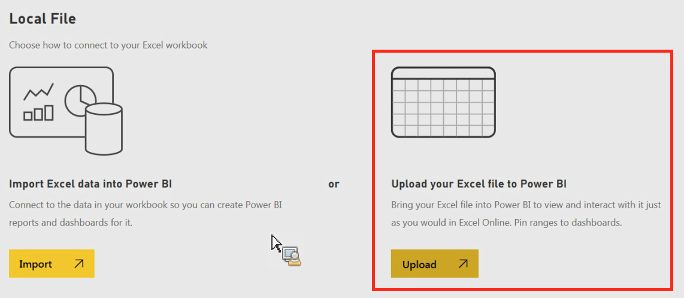

1. The message “Your file has been uploaded” should appear.
2. In Power BI visualization, what are Reading View and editing view?

Answer: Reading view is your way to explore and interact with reports created by colleagues. Even in Reading view, the content isn't static. Editing view is required for the following actions:

* Creating, editing, renaming, sharing, and deleting reports.
* Adding, renaming, rearranging, and deleting report pages.
* Formatting reports.
* Adding visualizations, text boxes, shapes, and buttons to a report.
* Adding visual-level, page-level, and report-level filters and setting visual interactions.
* Creating refresh schedules.
* Using Q&A functionality to create visuals in reports.
* Showing data used to create the visualization.
* Setting up drill through.
* Duplicating a report page.
* [Using report settings](https://learn.microsoft.com/en-us/power-bi/create-reports/power-bi-report-settings) to control your readers' interactions with reports.