Greg Prawdzik

System Analysis Simulation

3/18/2019

The purpose of this program is to play a card game with 4 people. The game shuffles a deck of cards and evenly deals all cards to four players. Each player’s name is then displayed with their cards, and the sum of their cards. The player with the highest sum wins that round. A new round begins with each player discarding 1 card and updating each player’s total for that round.

Software requirements include:

* Creating a card class with rank and suit.
* Creating a deck class to hold 52 unique cards and methods to shuffle and deal.
* Creating a player class to hold a name and 13 cards from the deck.
* Creating a game class to keep players in order and choose a random player to start each round.
* Descriptively display each card.
* Randomly select a new player to begin each round.
* Add the value of a card to a score.

Upon starting the program, a new Deck is created and shuffled randomly. The computer then prompts the user to enter 4 names for the four players. As each players name is entered, the computer deals that player 13 cards and displays the players name, a description of each card in their hand “Queen of Hearts”, and the total of their hand. Each time the user hits enter, a new round is started. For each new round, the starting player is randomly chosen. Each player discards a card, then displays the players name, the discarded card, and updated score. The game ends when all cards have been discarded.

**Structure Chart**

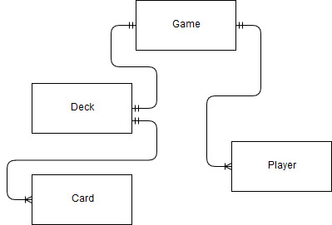

**Logic Flow**

