Consentext AI Gateway Concept Document
Founder-aligned explanation for Phase 3.75 architecture discussion

Why the AI Gateway Exists
The AI Gateway exists because health data is too sensitive for a simple “AI on / AI off” product model. A consumer health platform cannot reasonably ask users to choose only between never using AI and pasting sensitive health information directly into outside AI systems.
Consentext introduces a governed interaction layer between health context and AI systems. That interaction layer is what the project calls the AI Gateway.

What the AI Gateway Is
The AI Gateway is not simply a chat feature and not just an API router. It is a control system inside Consentext that determines how a user’s request is classified, which lane of interaction applies, what data may be used, whether anything may leave Consentext, and how the interaction must be logged.
In plain language: the AI Gateway determines how a user request interacts with AI and what health context is allowed to be used or shared.

What the AI Gateway Is Not
At this stage, the AI Gateway should not be thought of as a giant orchestration brain, a replacement for model labs, or a prompt-optimization engine. Consentext is not trying to replace OpenAI, Anthropic, Google, or other model providers. Consentext is trying to become the trusted consumer-controlled layer that governs how those systems may be used with health context.
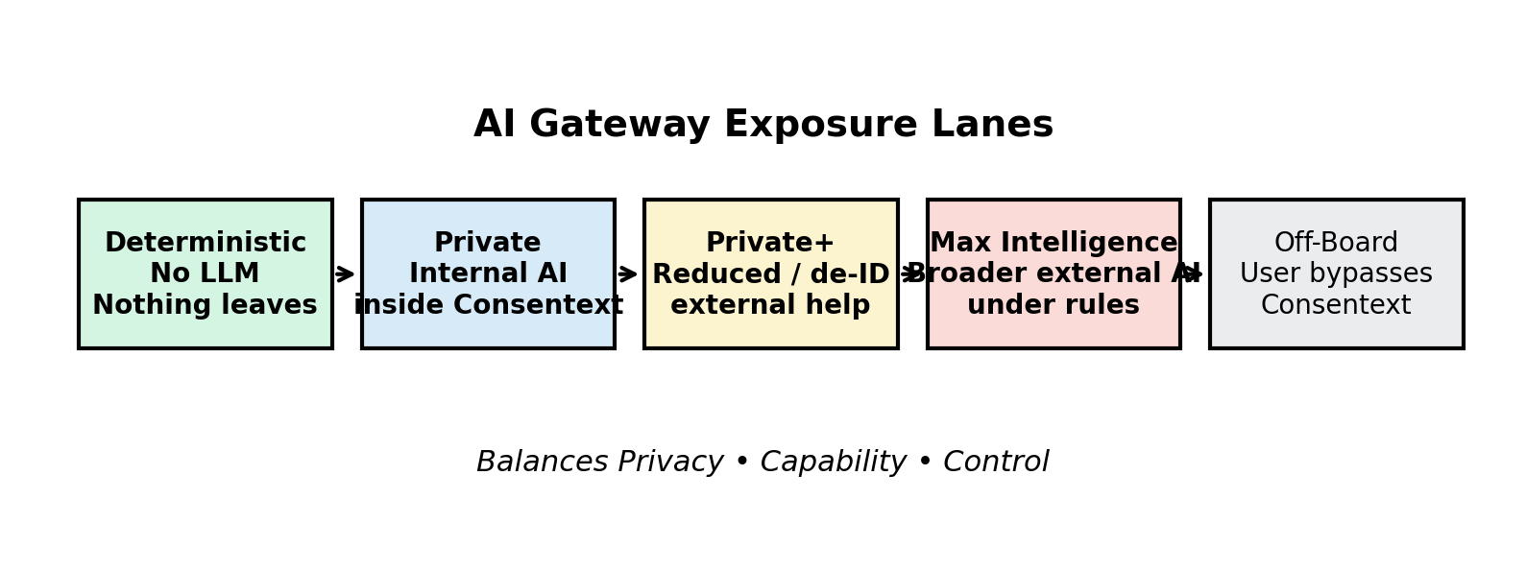
Figure 1. AI Gateway exposure lanes used to balance Privacy, Capability, and Control.

The Exposure Lanes
The lane model is useful because not every request deserves the same exposure level.
Lane | Working Meaning | What Leaves Consentext | Strategic Role
Deterministic | No LLM; calculations, retrieval, thresholds, and templated outputs | Nothing | Trust anchor
Private | Protected AI lane using Consentext-controlled inference | Sensitive record data should stay internal | Highest-privacy AI lane
Private+ | Reduced or de-identified context may be used with external AI | Only minimum-necessary reduced context | Adoption bridge
Max Intelligence | Broader external AI interaction under governance rules | More context may leave depending on user choice and rules | Consumer freedom while keeping Consentext in front of the interaction
Off-Board | User bypasses Consentext and goes directly to outside AI | Potentially anything the user chooses to share | Outside Consentext protections

Gateway Decision Flow
A simplified conceptual flow is: user submits request → gateway identifies task type → consent and trust rules are applied → lane is selected → task executes → response is returned → audit record is created.
This framing matters because it shows the gateway as a control point, not merely a feature. The gateway governs how AI-related features are allowed to behave.

Placement Relative to the Trust Boundary
The AI Gateway sits inside the Consentext platform and inside the governance / control plane. It is not external to the trust boundary. Rather, it is a governed checkpoint that decides whether any approved outbound transmission may occur.
This is why the gateway belongs inside the system architecture, not only at the edge of an outbound arrow.

Longer-Term Significance
Over time, the gateway may become even more important as AI systems become more agentic. A safer future pattern is Agent → Gateway → Vault, not Agent → Vault directly. That means the gateway may eventually function as a permission boundary between humans, agents, models, and sensitive health data.

Working Definition to Carry Forward
Consentext AI Gateway is the governed interaction layer that determines how a user’s health context can be used with AI, routes each request through the appropriate privacy-capability lane, and preserves control through minimization, boundaries, approvals, and auditability.

