Consentext Architecture Overview (Jordan Brief)
Purpose
Provide a one-page architecture view of the Consentext system to support Phase 3.75 architecture discussions.
Key Idea
Vault stores the user’s health context.
The governance layer (Trust Kernel) controls how that data may be accessed or shared.
The AI Gateway governs AI interaction and outbound exposure.
Architecture Model
The system separates a DATA PLANE (where health context lives) from a CONTROL PLANE (where policy and governance decisions occur).
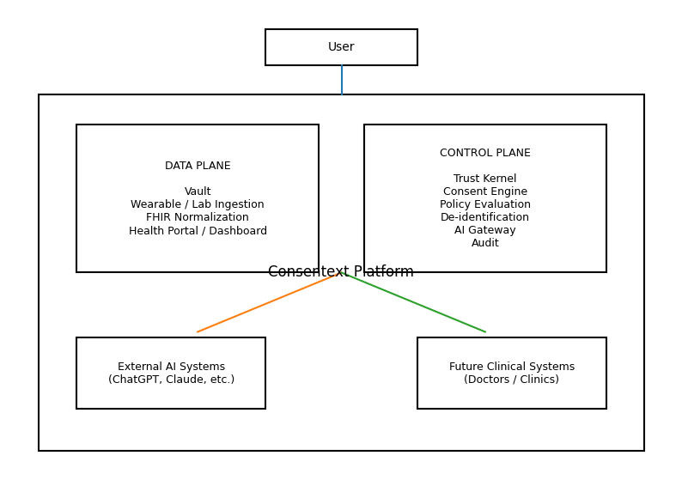
Interpretation for Phase 3.75
Phase 3.75 focuses primarily on the CONTROL PLANE:
• Trust Boundary
• Consent Engine
• Policy Evaluation
• De‑identification
• AI Gateway
• Audit
Existing workstreams (dashboard, ingestion, visualization) live primarily in the DATA PLANE and can integrate with the governance layer once architecture is finalized.

