Gaussian Processes in Practice
Bletchley Park 12th & 13th June 2006
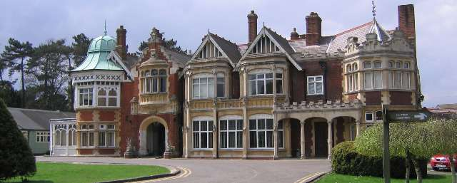
Welcome to the Gaussian Processes in Practice workshop at Bletchley Park. There has been a recent upsurge in interest in Gaussian processes for solving a variety of machine learning problems. Simultaneously there have been recent rapid developments in efficient approximation techniques for Gaussian processes and novel unifying theories of existing approximation techniques.
The aim of this workshop is to bring experts in Gaussian processes together with individuals who are using Gaussian processes at the forefront of research in their fields. We will start with a set of talks that will relate the latest developments in Gaussian while the second portion of talks will discuss application fields where Gaussian processes are being applied as state-of-the-art technologies: Robotics, Graphics and Vision. Interspersed with the invited speakers are six talks by participants who contributed submitted papers to the workshop. These speakers were also given the option of presenting a poster as well as their talk. In addition to these talks there will be six spotlights for further poster presentations. Please take some time during session breaks to look through and discuss some of the posters.
Discussion Panel
At the end of each day there will be a discussion panel, chaired by Anton Schwaighofer, in which we will discuss open problems or specific issues that arise when applying Gaussian processes. Please feel free to raise any questions you have during these sessions. The discussion panel will consist of: David MacKay, Chris Williams, Carl Rasmussen, Dan Cornford and Aaron Hertzmann.
In this pack you will find a schedule for the conference (including short abstracts of most presentations) as well as four page summaries of the work described in the submitted talks.
Post-Proceedings
A refereed post-proceedings for the workshop will be published, the post-proceedings is not restricted to work being presented across these days, we are also very happy to accept submissions from work including ideas that were inspired by the workshop. The submission deadline for the workshop post-proceedings will be 25th August 2006. Many of you will be asked to assist in the refereeing of these proceedings; our thanks in advance for your help with this.
The proceedings will be the first in a new series of on-line proceedings hosted by JMLR. The title of the proceedings will be “Workshops in Machine Learning, No. 1: Gaussian Processes in Practice”.
Bletchley Park
Bletchley Park is in many ways the home of Computer Science in Britain. It was here that during the second world war that German intercepts were decoded, often turning the course of the war. Leading academics from the time worked at Bletchley Park to make this decoding possible, most famous amongst them was Alan Turing. The site was saved from development in the early 90’s by the Bletchley Park trust which now runs the site as a non-profit making charity.
Neil Lawrence
Joaquin Quiñonero Candela
Anton Schwaighofer

