# Squash scoring methods

## Problem

The problem I am investigating is that for the Squash game, there are two different scoring methods. In order to decide which one of these too methods is “better” I will compare each method’s final score by simulating a number of games, considering also the fact that each player has a different probability of winning. Furthermore, I will also take into consideration that each player will have the same ability to measure the effect it has and also the time each rally has due to the fact that shorter matches are usually preferable for example in television.

## Method

In order to approach this problem, I will have to run different simulations. At first, I will implement an algorithm to simulate a single game of squash between players for each scoring method. A scoring system will be applied to each of these algorithms along with each player’s ability and the probability that they win. Each player’s ability will be calculated randomly by a number from 0 to 100. Also, a counter for the rallies of each game will be implemented in order to discriminate which method takes more time. Then I will create a function that simulates a number of the games above (i.e 1000 games) and calculates the probability and the average probability that a player will win. Finally, I will plot these data in two graphs. One graph that shows the probability of a player to win over the other and another and another graph that shows the difference in rallies in each game between the two scoring methods

## Assumptions

In order to apply the methods to this problem I will have to make some assumptions. Firstly, for the English scoring method I will have to select the first server randomly. Moreover, if the score reaches to a tie at 8-8, again I will choose randomly between 9 and 10 at which is going to be the winning condition for that particular game. Additionally, for both methods I will assume that the players' abilities take a value between 0 to 100. Finally, I have to presume that each rally takes the same time in order to calculate the time it takes to end

## Results

Figure A Figure B

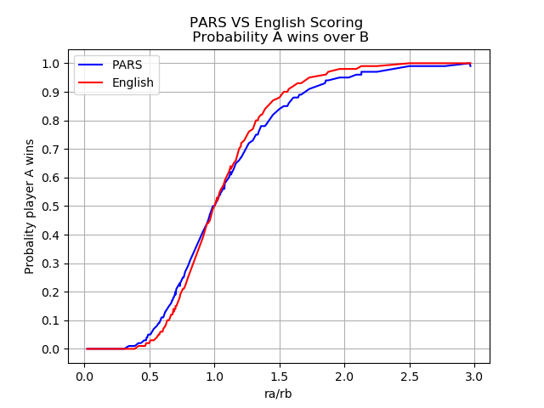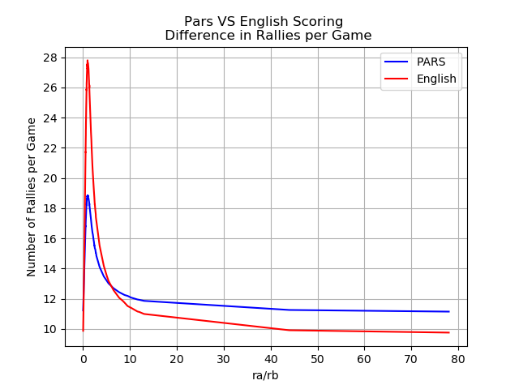

In the end results, we can see in Figure A that the Probability that player A wins is very close in both scoring methods and they do not have significant difference. In fact, they are the same when the probability is 0.5. Also, we can observe that the number of rallies per Game in Figure B are also the same at 13 and 16 rallies. The number of rallies is higher with the English scoring method at first, but then it decreases significantly compared to the PARS scoring method.

## Conclusions

In conclusion, by comparing results, both scoring methods have similar probabilities that player A wins over player B but in my opinion PARS is a “better” scoring method due to the fact that it takes less time according to Figure B. There were no limitation during the process of this report. A potential future extension for this would be to include some more methods to compare between the two scoring methods.