**Gurpreet Singh**

Technical Lead



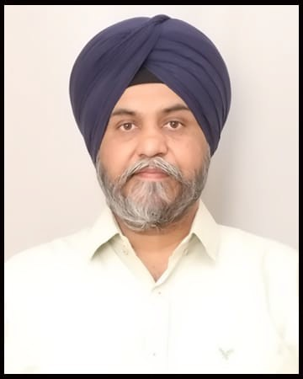

|  |  |  |
| --- | --- | --- |
|  | **TRAINING AND CERTIFICATION:**  **OCJP Certification**   * **TECHNICAL SKILLS:** | **Professional Summary**   * ***Develop robust, scalable, and maintainable web applications using React.js. This involves writing code, implementing reusable components, and ensuring adherence to best practices and coding standards.*** * ***Have development Micro-service architecture with lumen micro framework for Masargy Client.*** * ***Collaborate with architects and developers to design the overall architecture of React.js applications. This includes making decisions on state management, component structure, and data flow.*** * ***Mentor junior developers and help them grow their React.js skills. Provide coaching on advanced React.js concepts, such as hooks, context API, and higher-order components.*** * ***Provide technical expertise and guidance to the development team. This involves helping team members understand React.js best practices, architectural patterns, and coding standards.*** * ***Identify performance in React.js applications and implement optimizations to improve overall performance and user experience.*** |
|  | ***Scripting language***   * **Javascript** * **React Library, Redux** * **Typescript** * **Next Js.**   ***Markup Language***   * **HTML-5** * **CSS-3**   ***Frameworks***   * **Laravel, Lumen** * **Rest api development**   ***Architecture Design***   * **Microservices Architecture** * **Clean Architecture** * **MVC pattern.** * **Design patterns (Dao, Dto, Singleton, Factory, static factory, Repository pattern)**   **EDUCATION:**  **MBA (MARKETING) from**  **IIMT Greater Noida.**  **B.E (Mechanical) from Gulbarga University.**  **Senior School Certificate Examination (CBSE) Kendriya Vidyalaya No.1, India.**  **Secondary School Certificate (CBSE) Kendriya Vidyalaya No.1, India.** |

**PROFESSIONAL EXPERINCE**

**Incedo inc.**

**Role: Technical Lead.**

**Role & Responsibilities:**

**May 24 to till date**

* Write high-quality reusable code to develop the dynamic user interface for various platforms.
* Collaborate with Project manager, senior developers and business partners for work planning, sharing new ideas, code demonstration, troubleshooting and bug fixing.

**Ecosmob Technology Pvt Ltd.**

**Role: Sr. Software Developer. Role & Responsibilities:**

**Jan-2021 to June-2023**

* Understand the requirement and write reusable code to develop.
* Implementing the architectural solution.
* Managing team’s junior developers and help them grow their React.js skills
* Ensure proper documentation of React.js codebase, including API documentation, architectural diagrams, and technical design documents.

**Project: Work Station**

**Role: Sr. Software developer**

**Jan-2022 to March/2023**

**Project Description:**

Project involves multiple roles are admin, contractors and workers for managing construction inventory and time-line and budgeting.

**Roles Responsibilities:**

* Communication with backend API related changes as per new theme design.
* Understanding the requirement and writing the reusable code in React Js.
* Code review and managing and team members by technical guidance.

**Client: Mesargy (US)**

**Role: Sr. Software developer Jan-2021 to Dec-2021**

**Project Description:**

Project is based on micro-service architecture that help in managing the data and calls.

It has custom IVR setup platform for building the custom flow of calling.

Micro-services are manages using Docker and through gateway manage each request authentication.

Integration with external CRM Like zoho, sales force and fetching the data at run time.

**Roles Responsibility:**

* Getting the change lead the micro-service architecture.
* Create eight micro-service in lumen with docker and adding ELK for logging.
* Frontend to develop in the React js and managing the request with permission wise.
* Managing Call logged changes day wise.
* Integration CRM with micro-service systems API with their endpoints.

**Always Infotech Pvt Ltd**

**Role: Sr. Software Developer**

**May-2020 to Dec-2020**

**Roles Responsibility:**

* Development with backend API in Laravel.
* Implementing code and writing the reusable code in React Js.

**Project: Praywhere**

**Role: Sr. Software developer**

**May-2020 to Dec-2020**

**Project Description**:

Admin Panel is in React js used add the all mosque location and how many nearby accommodations to stay as per price listing. Show time of prayer of nearby mosque.

**Khalsasoft**

**Role: Sr. Software Developer**

**May-2015 to April-2020**

**Roles Responsibility:**

* Understanding the requirements and making documentations.
* Web development in Laravel framework
* Implementing code and writing the reusable code in React Js.
* Developing api in lumen for android projects.

**Project: Mortgage mandi**

**Role: Sr. Software developer**

**May-2019 to April-2020**

**Project Description:**

Project is based on multi roles like buyers, sellers, agents. Properties, Houses, Lands, part of building floors to added into portal.

Commission to sellers or agent’s deductions and make the property paper works.

**Roles Responsibility:**



* Web portal developed in Laravel framework front-end and backend side.
* Implementing code and writing the reusable code in React Js.
* Developing api in Laravel for Android and IOS projects.