PART 1: Exporting Data to CSV

// Look at cities in my country. This tells me I should be using Hyderabad data.

SELECT *

FROM city_list

WHERE country = 'India';

// As a sanity test on the global data, I made sure no year is repeated by looking at

SELECT year, COUNT(*) as year_count

FROM global_data

GROUP BY year

ORDER BY year_count DESC

LIMIT 1;

// Fetch the global data

SELECT *

FROM global_data

ORDER BY year;

// Fetch data for Hyderabad. I missed adding the country check first. I saw that each year was repeated twice in the results. There must be another Hyderabad in another country, I inferred.

Indeed there is a city named “Hyderabad” in Pakistan too.

SELECT year, avg_temp

FROM city_data

WHERE city = 'Hyderabad'

AND country = 'India'

ORDER BY year;

// Make sure no repeating year now.

SELECT year, COUNT(*) as year_count

FROM city_data

WHERE city = 'Hyderabad'

AND country = 'India'

GROUP BY year

ORDER BY year_count DESC

LIMIT 1;

PART 2: Moving Averages and Data Visualization

Used Excel for this part of the project.

Considerations:

1. Number of years for moving averages: The data for Hyderabad temperatures had missing data points for 5 years in a row. So, I decided to keep moving average to more than 5 years. Since population census trends are measured every decade in India, a decade seemed like a good number. Plotting the trend with decade moving averages showed that the lines have been smoothed out.
2. Years Range: I took the range where we can have 10 year moving averages for both Hyderabad and Global. This turned out to be 1805 to 2013.

Line Chart with local and global temperature trends:

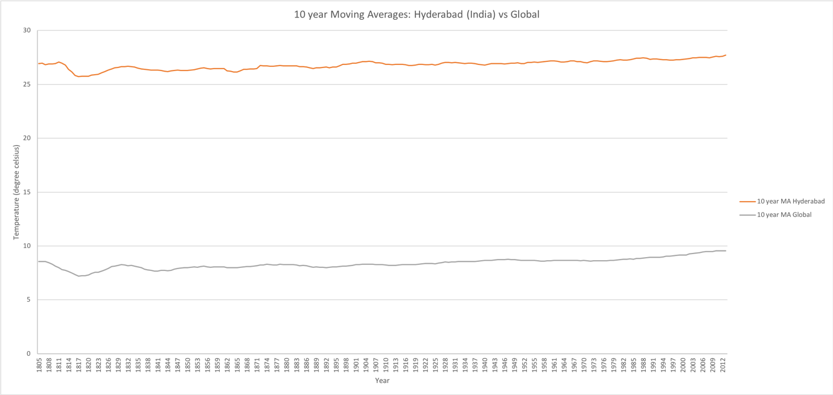

Observations: (All observations mean the “10 YEAR moving average” when they say “average”.)

1. Hyderabad is hotter on average compared to the global average. As the following image shows, the difference has been in the range of 18 to 19.2 degree Celsius.

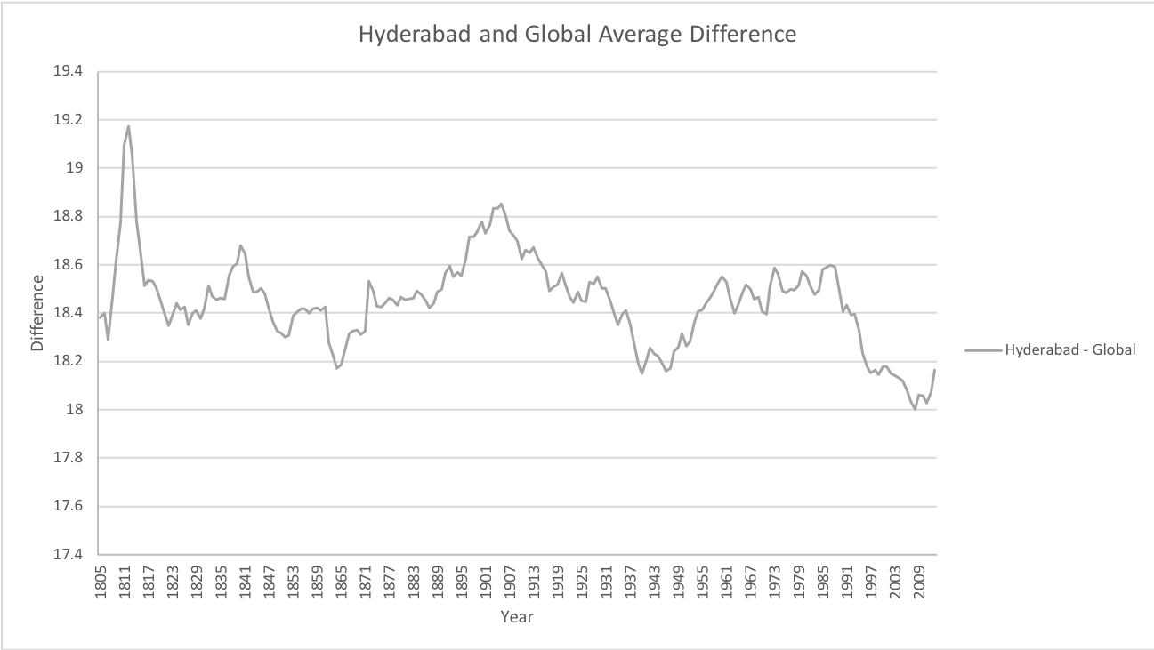

1. A measure of the overall change in this two century period can be the difference between the minimum and maximum values of the moving average. This number is 1.981 degree Celsius for Hyderabad while 2.353 degree Celsius for the global trends. So in this sense, global average has changed more over time, than Hyderabad’s average.
2. The world is hotter now (2013) than in 1805. Interestingly, the world has not gotten hotter every hundred years in the past two centuries. See the global averages below for the years 1805, 1905 and 2005.

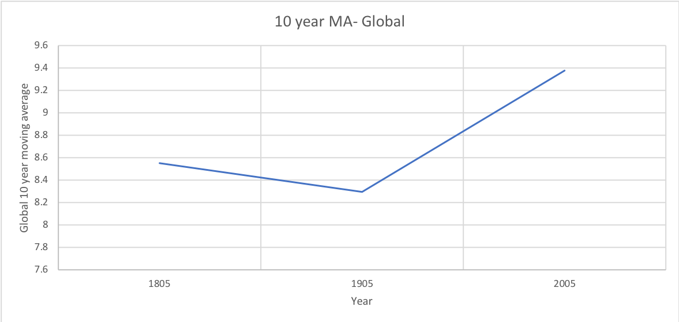

1. Hyderabad is hotter now (2013) than in 1805. And unlike the global trends, it has gotten hotter in both 1805-1905 and 1905-2005 hundred year period.

