Web Design and Development

4COSC011W

Coursework Report

Author: G.P Sachin Lakshan

Student ID: 20200603/w1833545

Group Number:D8

Student Role:Student-2

Link(s) to WebSite

URL: <https://w1833545.users.ecs.westminster.ac.uk/>

Table of Contents

Introduction 3

1. Technical Discussion 4

1.1 Main page 4

1.1.1 UI Design 4

1.1.2 Layout 4

1.1.3 Typography 5

1.1.4 Images 6

1.1.5 Search Engine Optimization 6

1.2 Query Form 7

1.2.1 UI Design 7

1.2.2 Form Validation 7

1.2.3 Submitting the Form 7

2. Janet 8

References 9

Appendices 10

Appendix A: Code 10

index.html 10

contactUs.html 19

styles.css 24

contact.css 33

contactUs.js 43

Appendix B: Screenshots 48

Main Page 48

Contact-us Page / Query-Form 51

Appendix C: Individual Statement 54

# Introduction

The main purpose of this report is to discuss briefly about the development of tasks that I was allocated under the **Web Design and Development:** **4COSC011W** Coursework. Additionally, this report includes the approach taken, and explanations of how the required functionality was implemented during the development of the tasks.

In this group project, I had to work in a team of four members including myself. The names of the team members and their roles are listed below.

**Student 1:** **Mahesh Malintha**

* Presentation Page
* Buy products

**Student 2:** **Sachin Lakshan**

* Main Page &External CSS
* Query Form

**Student 3:** **Tharuka Hirushan**

* Quiz
* Student details

**Student 4:** **Thilan Theekshana**

* Diagram (SVG)
* Thumbnail Images

From the subjects that were given to us, we selected the main subject as ‘**Sports**’ and then designed our web site to be relevant to an **e-commerce website that sells sports items**. Doing so, made the tasks allocated to the team members much clearer and easier to perform.

# Technical Discussion

As described above, my tasks were to create the **Main Page** and the **Query Form** according to the task allocation. This brief discussion will explain approaches taken, and how the required functionalities were implemented in the Main page and Query Form.

## 1.1 Main page

This section will mainly describe the development of tasks under Main page and techniques that were used to achieve the required functionality.

### 1.1.1 UI Design

UI design of the main page is critical when creating an ecommerce website. Good ecommerce main web page design is all about using the right colors, fonts, images, words and graphics to convince visitors to make a purchase. The UI design of the main page is mainly focused to attract potential customers and provide great user experience. Here, are some basic techniques that are used in the UI design.

* Hign Focus is given to branding (This includes the color palette, typography, overall theme and style that is used in marketing materials, on website)
* Use high-quality images
* Set clear and easy navigation
* Use social proof (Customer Reviews)
* Make it responsive

(See Appendix B: Screenshots)

### 1.1.2 Layout

The Layout of the main page consists three main areas.

1. Header area – Navigation bar, Showcase area
2. Body area – (Featured Products section, Latest Products section, Exclusive products Section, Customer Reviews section and Brands section)
3. Footer

(See Appendix B: Screenshots)

In some scenarios, CSS3 FlexBox is used as an approach to layout creation and alignment of elements because laying out elements is much easier and can easily build responsive websites with CSS3 Flexbox layout mode.

Figure 1 - FlexBox Layout Method

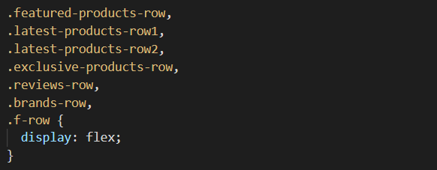

Media queries are used as a technique to make the website layout renders well for different-sized screens and viewports (responsive).

Figure 2 - Using Media Queries

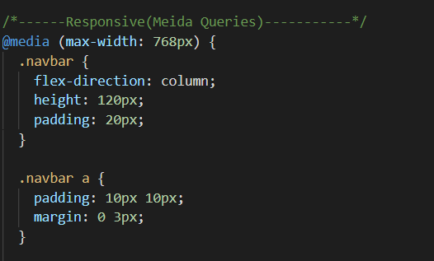

### 1.1.3 Typography

As mentioned earlier, the text arrangement and the aesthetic look of fonts are among the top priorities for an e-commerce website. That is because choosing the right font has a huge impact on how the users experience the website.

For this website, ‘Open Sans’ which is one of the most popular fonts on the Google Font service is used as main font of the text to generate an aesthetic look in terms of typography.

Figure 3 - Using Google Fonts



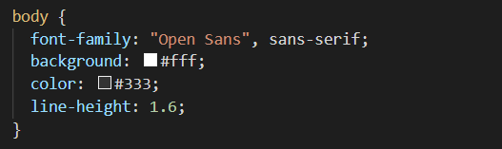

Here, a generic font family (sans-serif) is used as a fallback font to avoid unexpected behaviors.

### 1.1.4 Images

High quality images are used (See Appendix B: Screenshots) in the main page to display what are the products that sells on this ecommerce site. Additionally, the most common image file types (.jpg, .png etc.) are used to ensure that images are supported in all browsers (Chrome, Edge, Firefox, Safari, Opera).

‘Font Awesome Icons’ are used to display the rating stars under the products because of the flexibility of styling available.

Figure 4 - Images and Font Awesome icons

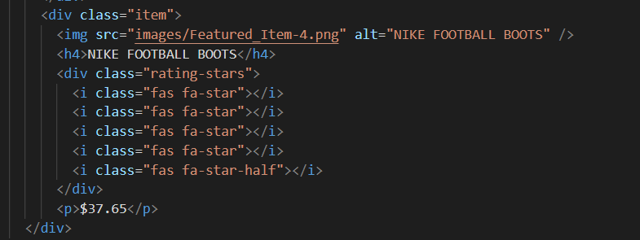

### 1.1.5 Search Engine Optimization

Semantic HTML elements are used (Ex. <header>, <nav>, <main>, <footer>, <section>) in the main page in order to make the web page more informative and adaptable, allowing browsers and search engines to better interpret content.

Additionally, the <title>, <meta>, <h1> and <img> tags are created according to Google guidelines and best practices in SEO.

Figure 5 - Use of semantic HTML elements

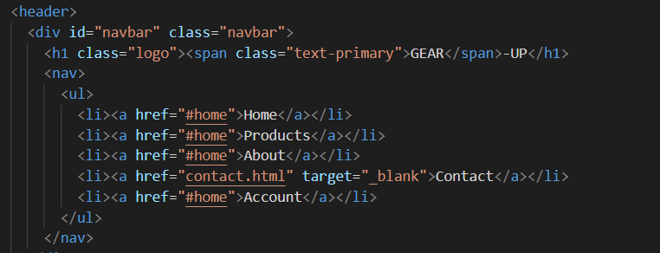

## 1.2 Query Form

This section will mainly describe the development of tasks under Contact-us page (Query Form) and techniques that were used to achieve the required functionality.

### 1.2.1 UI Design

Forms are an important aspect of an e-commerce website because forms can engage with customers online and can sometimes they can be a customer’s first impression of the business. A well-designed form lets e-commerce businesses to gather information from customers while presenting them with a positive user experience.

Therefore, the user interface (UI) of this query form is designed so as to maximize the positive user experience (See Appendix B: Screenshots). Here are some of the UI design techniques which are implemented in this query form to enhance user experience.

* Use a simple layout which allows customers to easily progress from one form field to another with their Tab button rather than manually moving the mouse and clicking each field
* Query form layout renders well for different-sized screens and viewports

In some scenarios, CSS3 FlexBox and Grid is used as an approach to layout creation and alignment of elements because laying out elements is much easier and can easily build responsive websites

### 1.2.2 Form Validation

Before submitting data in the query form to the server, it is important to ensure all required form controls are filled out, in the correct format. This is called client-side form validation, and helps ensure data submitted matches the requirements set forth in the various form controls. Basically, there are two different types of client-side form validation.

1. Built-in form validation - uses HTML5 form validation features
2. JavaScript form validation - is coded using JavaScript.

**JavaScript form validation technique** is used here in the query form because the validation process is completely customizable.

### 1.2.3 Submitting the Form

Since I do not have a proper understanding of server side technologies yet, I used https://formspree.io/ as the backend for this query form.

Formspree is basically a form backend, API, and email service for HTML & JavaScript forms. It's a very simple way to submit custom contact us forms, order forms etc.

-----------------------------------------------------------------------------------------------------------

# Janet

Janet is the name given to an electronic communications network and associated electronic communications networking services and facilities that support the requirements of the UK education and research communities. Organisations in the UK education and research communities use Janet to fulfil, and to undertake activities supporting, their missions of providing education, research, and business and community engagement.

This website is completely in compliance with the conditions set out in the janet’s Acceptable Use Policy document. Because, this website is not used for any activity that may reasonably be regarded as unlawful or potentially so. For example, this website not includes;

* creation or transmission, or causing the transmission, of any offensive, obscene or indecent images, data or other material, or any data capable of being resolved into obscene or indecent images or material.
* creation or transmission of material with the intent to cause annoyance, inconvenience or needless anxiety
* creation or transmission of material with the intent to defraud.
* creation or transmission of defamatory material.
* creation or transmission of material such that this infringes the copyright of another person.

# References

* acceptable Use Policy | Jisc community (2021). Community.jisc.ac.uk. Available from https://community.jisc.ac.uk/library/acceptable-use-policy [Accessed 17 July 2021].
* Client-side form validation - Learn web development | MDN (2021). *Developer.mozilla.org*. Available from https://developer.mozilla.org/en-US/docs/Learn/Forms/Form_validation [Accessed 17 July 2021].
* Coyier, C. (2018). A Complete Guide to Flexbox. CSS-Tricks. Available from https://css-tricks.com/snippets/css/a-guide-to-flexbox/ [Accessed 17 July 2021].
* CSS Google Fonts (2021). *W3schools.com*. Available from https://www.w3schools.com/css/css_font_google.asp [Accessed 17 July 2021].
* House, C. (2021). A Complete Guide to Grid. *CSS-Tricks*. Available from https://css-tricks.com/snippets/css/complete-guide-grid/ [Accessed 20 July 2021].
* How to validate an email address in JavaScript (2020). *Stack Overflow*. Available from https://stackoverflow.com/questions/46155/how-to-validate-an-email-address-in-javascript [Accessed 17 July 2021].
* Image file type and format guide - Web media technologies | MDN (2021). Developer.mozilla.org. Available from https://developer.mozilla.org/en-US/docs/Web/Media/Formats/Image_types [Accessed 17 July 2021].
* Miroslav, G. (2019). Use Semantic HTML5 tags to Improve Webpage SEO. *Pluralsight.com*. Available from https://www.pluralsight.com/guides/semantic-html [Accessed 17 July 2021].
* Responsive Web Design Media Queries (2021). W3schools.com. Available from https://www.w3schools.com/css/css_rwd_mediaqueries.asp [Accessed 20 July 2021].
* Using CSS transitions - CSS: Cascading Style Sheets | MDN (2021). *Developer.mozilla.org*. Available from https://developer.mozilla.org/en-US/docs/Web/CSS/CSS_Transitions/Using_CSS_transitions [Accessed 20 July 2021].
* Yalanska, M. (2021). 11 Profitable Strategies for E-Commerce UI Design. *Tubik Blog: Articles About Design*. Available from https://blog.tubikstudio.com/11-profitable-strategies-for-e-commerce-ui-design/ [Accessed 17 July 2021].

# Appendices

## Appendix A: Code

### index.html

**Filename** - index.html

**Code**

<!DOCTYPE html>

<html lang="en">

  <head>

    <meta charset="UTF-8" />

    <meta http-equiv="X-UA-Compatible" content="IE=edge" />

    <meta name="viewport" content="width=device-width, initial-scale=1.0" />

    <meta

      name="description"

      content="Your one stop sport shop for the biggest brands - browse trainers for Men, Women & Kids. Plus sports fashion, clothing & accessories."

    />

    <meta name="keywords" content="E-Commerce , Sports, Football, Cricket" />

    <link rel="stylesheet" href="css/styles.css" />

    <title>Gear-Up | E-commerce Sporting Store</title>

    <script

      src="https://kit.fontawesome.com/a052ae1ed2.js"

      crossorigin="anonymous"

    ></script>

  </head>

  <body>

    <header>

      <div id="navbar" class="navbar">

        <h1 class="logo"><span class="text-primary">GEAR</span>-UP</h1>

        <nav>

          <ul>

            <li><a href="index.html">Home</a></li>

            <li><a href="Products_page/Products.html">Products</a></li>

            <li><a href="AboutUs_page/aboutUS.html">About</a></li>

            <li><a href="contactUs.html">Contact</a></li>

            <li><a href="account.html">Account</a></li>

          </ul>

        </nav>

      </div>

      <div id="showcase">

        <div class="showcase-content">

          <h1>STAY ACTIVE</h1>

          <p class="lead">

            ORIGINAL SPORTS EQUIPMENT AT THE COMFORT OF ORDERING FROM YOUR HOME

          </p>

          <a class="btn" href="Products_page/Products.html"

            >About Our Products</a

          >

        </div>

      </div>

    </header>

    <!-- Featured Products-->

    <main>

      <section class="products-container featured-products">

        <h2 class="section-heading">Featured Products</h2>

        <div class="featured-products-row">

          <div class="item">

            <img

              src="images/Featured_Item-1.png"

              alt="ADDIDAS TANGO FOOTBALL"

            />

            <h4>ADDIDAS TANGO FOOTBALL</h4>

            <div class="rating-stars">

              <i class="fas fa-star"></i>

              <i class="fas fa-star"></i>

              <i class="fas fa-star"></i>

              <i class="fas fa-star"></i>

              <i class="far fa-star"></i>

            </div>

            <p>$35.00</p>

          </div>

          <div class="item">

            <img

              src="images/Featured_Item-2.png"

              alt="KOOKABURRA CRICKET BAT"

            />

            <h4>KOOKABURRA CRICKET BAT</h4>

            <div class="rating-stars">

              <i class="fas fa-star"></i>

              <i class="fas fa-star"></i>

              <i class="fas fa-star"></i>

              <i class="fas fa-star"></i>

              <i class="fas fa-star-half"></i>

            </div>

            <p>$50.60</p>

          </div>

          <div class="item">

            <img

              src="images/Featured_Item-3.png"

              alt="DSC GUARD CRICKET HELMET"

            />

            <h4>DSC CRICKET HELMET</h4>

            <div class="rating-stars">

              <i class="fas fa-star"></i>

              <i class="fas fa-star"></i>

              <i class="fas fa-star"></i>

              <i class="fas fa-star"></i>

              <i class="far fa-star"></i>

            </div>

            <p>$40.50</p>

          </div>

          <div class="item">

            <img src="images/Featured_Item-4.png" alt="NIKE FOOTBALL BOOTS" />

            <h4>NIKE FOOTBALL BOOTS</h4>

            <div class="rating-stars">

              <i class="fas fa-star"></i>

              <i class="fas fa-star"></i>

              <i class="fas fa-star"></i>

              <i class="fas fa-star"></i>

              <i class="fas fa-star-half"></i>

            </div>

            <p>$37.65</p>

          </div>

        </div>

      </section>

      <!-- Latest Products-->

      <section class="products-container latest-products">

        <h2 class="section-heading">Latest Products</h2>

        <div class="latest-products-row1">

          <div class="item">

            <img src="images/LI-1.png" alt="ADDIDAS FOOTBALL JERSY" />

            <h4>ADDIDAS FOOTBALL JERSY</h4>

            <div class="rating-stars">

              <i class="fas fa-star"></i>

              <i class="fas fa-star"></i>

              <i class="fas fa-star"></i>

              <i class="fas fa-star"></i>

              <i class="far fa-star"></i>

            </div>

            <p>$25.87</p>

          </div>

          <div class="item">

            <img src="images/LI-2.png" alt="WILSON TENNIS PACK" />

            <h4>WILSON TENNIS PACK</h4>

            <div class="rating-stars">

              <i class="fas fa-star"></i>

              <i class="fas fa-star"></i>

              <i class="fas fa-star"></i>

              <i class="fas fa-star"></i>

              <i class="fas fa-star-half"></i>

            </div>

            <p>$50.76</p>

          </div>

          <div class="item">

            <img src="images/LI-3.png" alt="SS LEATHER CRICKET BALL" />

            <h4>SS LEATHER CRICKET BALL</h4>

            <div class="rating-stars">

              <i class="fas fa-star"></i>

              <i class="fas fa-star"></i>

              <i class="fas fa-star"></i>

              <i class="fas fa-star"></i>

              <i class="fas fa-star-half"></i>

            </div>

            <p>$12.89</p>

          </div>

          <div class="item">

            <img src="images/LI-4.png" alt="RBK CRICKET BAT" />

            <h4>RBK CRICKET BAT</h4>

            <div class="rating-stars">

              <i class="fas fa-star"></i>

              <i class="fas fa-star"></i>

              <i class="fas fa-star"></i>

              <i class="fas fa-star"></i>

              <i class="far fa-star"></i>

            </div>

            <p>$30.75</p>

          </div>

        </div>

      </section>

      <section class="products-container latest-products">

        <div class="latest-products-row2">

          <div class="item">

            <img src="images/LI-5.png" alt="WILSON BASKETBALL" />

            <h4>WILSON BASKETBALL</h4>

            <div class="rating-stars">

              <i class="fas fa-star"></i>

              <i class="fas fa-star"></i>

              <i class="fas fa-star"></i>

              <i class="fas fa-star"></i>

              <i class="fas fa-star-half"></i>

            </div>

            <p>$20.25</p>

          </div>

          <div class="item">

            <img src="images/LI-6.png" alt="YONEX BADMINTON PACK" />

            <h4>YONEX BADMINTON PACK</h4>

            <div class="rating-stars">

              <i class="fas fa-star"></i>

              <i class="fas fa-star"></i>

              <i class="fas fa-star"></i>

              <i class="fas fa-star"></i>

              <i class="far fa-star"></i>

            </div>

            <p>$34.68</p>

          </div>

          <div class="item">

            <img src="images/LI-7.png" alt="GM CRICKET GLOVES" />

            <h4>GM CRICKET GLOVES</h4>

            <div class="rating-stars">

              <i class="fas fa-star"></i>

              <i class="fas fa-star"></i>

              <i class="fas fa-star"></i>

              <i class="fas fa-star"></i>

              <i class="fas fa-star-half"></i>

            </div>

            <p>$12.55</p>

          </div>

          <div class="item">

            <img src="images/LI-8.png" alt="ADDIDAS SPORTS SHOES" />

            <h4>ADDIDAS SPORTS SHOES</h4>

            <div class="rating-stars">

              <i class="fas fa-star"></i>

              <i class="fas fa-star"></i>

              <i class="fas fa-star"></i>

              <i class="fas fa-star"></i>

            </div>

            <p>$24.87</p>

          </div>

        </div>

      </section>

    </main>

    <!-- Exclusive Products-->

    <aside class="exclusive-products">

      <div class="products-container">

        <div class="exclusive-products-row">

          <div class="exclusive-product">

            <img

              src="images/Exclusive-Product.png"

              alt="ADDIDAS ICONIC TRICOT JACKET"

              class="offer-img"

            />

          </div>

          <div class="exclusive-product">

            <p>Exclusively available on GEAR-UP</p>

            <h2>ICONIC TRICOT JACKET</h2>

            <small

              >There's no substitute for the original. This version of the

              iconic adidas track jacket is made of smooth polyester fabric with

              a soft sheen. It's finished with classic 3-Stripes on the

              sleeves.</small

            >

            <a href="" class="btn">Buy Now <i class="fa fa-arrow-right"></i></a>

          </div>

        </div>

      </div>

    </aside>

    <!-- Customer Reviews-->

    <section class="reviews">

      <div class="reviews-container">

        <div class="reviews-row">

          <div class="review">

            <i class="fa fa-quote-left"></i>

            <p>

              Lorem ipsum dolor sit amet consectetur adipisicing elit. Commodi

              maiores culpa quasi? Omnis neque deleniti quos, fugit quod et esse

              vitae. Eum, repudiandae nulla deleniti vitae illo iusto nihil

              velit.

            </p>

            <div class="rating-stars">

              <i class="fas fa-star"></i>

              <i class="fas fa-star"></i>

              <i class="fas fa-star"></i>

              <i class="fas fa-star"></i>

              <i class="fas fa-star-half"></i>

            </div>

            <img src="images/User-1.jpg" alt="" />

            <h3>Alex Johnson</h3>

          </div>

          <div class="review">

            <i class="fa fa-quote-left"></i>

            <p>

              Lorem ipsum dolor sit amet consectetur adipisicing elit. Commodi

              maiores culpa quasi? Omnis neque deleniti quos, fugit quod et esse

              vitae. Eum, repudiandae nulla deleniti vitae illo iusto nihil

              velit.

            </p>

            <div class="rating-stars">

              <i class="fas fa-star"></i>

              <i class="fas fa-star"></i>

              <i class="fas fa-star"></i>

              <i class="fas fa-star"></i>

              <i class="fas fa-star"></i>

            </div>

            <img src="images/User-2.jpg" alt="" />

            <h3>Mary James</h3>

          </div>

          <div class="review">

            <i class="fa fa-quote-left"></i>

            <p>

              Lorem ipsum dolor sit amet consectetur adipisicing elit. Commodi

              maiores culpa quasi? Omnis neque deleniti quos, fugit quod et esse

              vitae. Eum, repudiandae nulla deleniti vitae illo iusto nihil

              velit.

            </p>

            <div class="rating-stars">

              <i class="fas fa-star"></i>

              <i class="fas fa-star"></i>

              <i class="fas fa-star"></i>

              <i class="fas fa-star"></i>

              <i class="far fa-star"></i>

            </div>

            <img src="images/User-3.jpg" alt="" />

            <h3>John Smith</h3>

          </div>

        </div>

      </div>

    </section>

    <!-- Brands-->

    <aside class="brands">

      <div class="brands-container">

        <div class="brands-row">

          <div class="brand">

            <img src="images/addidas.png" alt="" />

          </div>

          <div class="brand">

            <img src="images/nike.jpg" alt="" />

          </div>

          <div class="brand">

            <img src="images/Kookaburra.png" alt="" />

          </div>

          <div class="brand">

            <img src="images/GM.jpg" alt="" />

          </div>

          <div class="brand">

            <img src="images/RBK.png" alt="" />

          </div>

        </div>

      </div>

    </aside>

    <!-- Footer-->

    <footer>

      <div class="f-container">

        <div class="f-row">

          <div class="footer-col">

            <h3>Extras</h3>

            <ul>

              <li>

                <a href="other/pageDeveloper-mainPage.html">Page Developer</a>

              </li>

              <li><a href="">Affiliate</a></li>

              <li><a href="quiz/quiz.html">Quiz</a></li>

              <li><a href="images/Sitemap.svg">Site Map</a></li>

            </ul>

          </div>

          <div class="footer-col">

            <h3>INFORMATION</h3>

            <ul>

              <li><a href="AboutUs_page/aboutUS.html">About Us</a></li>

              <li><a href="other/privacy.html">Privacy Policy</a></li>

              <li>

                <a href="other/terms&conditions.html">Terms & Conditions</a>

              </li>

              <li><a href="contactUs.html">Contact Us</a></li>

            </ul>

          </div>

          <div class="footer-col">

            <h3>MY ACCOUNT</h3>

            <ul>

              <li><a href="account.html">Account</a></li>

              <li><a href="">Order History</a></li>

              <li><a href="">Newsletter</a></li>

              <li><a href="other/returns.html">Return Policy</a></li>

            </ul>

          </div>

          <div class="footer-col">

            <h3>FOLLOW US</h3>

            <ul>

              <li>

                <a href="https://www.facebook.com/" target="_blank">Facebook</a>

              </li>

              <li>

                <a href="https://twitter.com/" target="_blank">Twitter</a>

              </li>

              <li>

                <a href="https://www.instagram.com/" target="_blank"

                  >Instagram</a

                >

              </li>

              <li>

                <a href="https://www.youtube.com/" target="_blank">Youtube</a>

              </li>

            </ul>

          </div>

        </div>

        <p id="copyright">Copyright &copy; 2021 - GEAR UP</p>

      </div>

    </footer>

  </body>

</html>

### contactUs.html

**Filename** - contactUs.html

**Code**

<!DOCTYPE html>

<html lang="en">

  <head>

    <meta charset="UTF-8" />

    <meta http-equiv="X-UA-Compatible" content="IE=edge" />

    <meta name="viewport" content="width=device-width, initial-scale=1.0" />

    <link rel="stylesheet" href="css/contact.css" />

    <title>GEAR-UP | Contact-Us</title>

    <script

      src="https://kit.fontawesome.com/a052ae1ed2.js"

      crossorigin="anonymous"

    ></script>

    <script defer src="js/contactUS.js"></script>

  </head>

  <body>

    <header>

      <div id="navbar" class="navbar">

        <h1 class="logo"><span class="text-primary">GEAR</span>-UP</h1>

        <nav>

          <ul>

            <li><a href="index.html">Home</a></li>

            <li><a href="Products_page/Products.html">Products</a></li>

            <li><a href="AboutUs_page/aboutUS.html">About</a></li>

            <li><a href="contactUs.html">Contact</a></li>

            <li><a href="account.html">Account</a></li>

          </ul>

        </nav>

      </div>

    </header>

    <main>

      <div class="container-showcase">

        <div class="title">

          <h1>Contact Us</h1>

        </div>

        <article class="content">

          <div class="article">

            <h2>

              Lorem, ipsum dolor sit amet consectetur adipisicing elit. Tenetur,

              culpa.

            </h2>

            <p>

              Lorem ipsum dolor sit amet consectetur, adipisicing elit. Sapiente

              dolores amet iusto. Quis voluptas, perspiciatis laborum dolor,

              placeat delectus non consequatur veniam voluptatum aliquid sit

              sed. Quam quis eveniet beatae laborum amet illum tenetur totam

              consequatur dolor ad harum, accusamus porro aliquam commodi,

              asperiores ut, praesentium eius eum suscipit vero.

            </p>

            <a href="" class="btn">Read More</a>

          </div>

          <div class="image-section">

            <img src="images/ContactUs.jpg" alt="football player" />

          </div>

        </article>

      </div>

      <section>

        <div class="container">

          <div class="contactInfo">

            <div>

              <h2>Contact Info</h2>

              <ul class="info">

                <li>

                  <span><i class="fas fa-map-marker-alt"></i></span>

                  <span

                    >123, <br />

                    Galle Road, <br />

                    Colombo-4</span

                  >

                </li>

                <li>

                  <span><i class="far fa-envelope"></i></span>

                  <span>info@gearup.com</span>

                </li>

                <li>

                  <span><i class="fas fa-phone-alt"></i></span>

                  <span>123-456-789</span>

                </li>

              </ul>

            </div>

            <ul class="social">

              <li>

                <a href=""><i class="fab fa-facebook-f"></i></a>

              </li>

              <li>

                <a href=""><i class="fab fa-twitter"></i></a>

              </li>

              <li>

                <a href=""><i class="fab fa-google-plus-g"></i></a>

              </li>

              <li>

                <a href=""><i class="fab fa-instagram"></i></a>

              </li>

            </ul>

          </div>

          <div class="contactForm" id="contactForm">

            <h2>Query Form</h2>

            <form class="formBox" id="query-form">

              <div class="inputBox w50">

                <input

                  type="text"

                  name="First Name"

                  id="firstName"

                  placeholder="First Name"

                />

              </div>

              <div class="inputBox w50">

                <input

                  type="text"

                  name="Last Name"

                  placeholder="Last Name"

                  id="lastName"

                />

              </div>

              <div class="inputBox w50">

                <input

                  type="text"

                  name="Email Adress"

                  id="email"

                  placeholder="Email Adress"

                />

              </div>

              <div class="selectBox w50">

                <select name="Contact-subject" id="contact-subject">

                  <option value="Subject">Subject</option>

                  <option value="Delivery">Delivery</option>

                  <option value="Purchase">Purchase</option>

                  <option value="Return">Return</option>

                </select>

              </div>

              <div class="inputBox w100">

                <textarea

                  name="Query-details"

                  id="query-details"

                  placeholder="Write Your Message here.."

                ></textarea>

              </div>

              <div class="inputBox w100">

                <button type="submit" id="view-query-button">View Query</button>

              </div>

            </form>

          </div>

        </div>

      </section>

    </main>

    <footer>

      <div class="f-container">

        <div class="f-row">

          <div class="footer-col">

            <h3>Extras</h3>

            <ul>

              <li>

                <a href="other/pageDeveloper-contactUs.html">Page Developer</a>

              </li>

              <li><a href="">Affiliate</a></li>

              <li><a href="quiz/quiz.html">Quiz</a></li>

              <li><a href="images/Sitemap.svg">Site Map</a></li>

            </ul>

          </div>

          <div class="footer-col">

            <h3>INFORMATION</h3>

            <ul>

              <li><a href="AboutUs_page/aboutUS.html">About Us</a></li>

              <li><a href="other/privacy.html">Privacy Policy</a></li>

              <li>

                <a href="other/terms&conditions.html">Terms & Conditions</a>

              </li>

              <li><a href="contactUs.html">Contact Us</a></li>

            </ul>

          </div>

          <div class="footer-col">

            <h3>MY ACCOUNT</h3>

            <ul>

              <li><a href="account.html">Account</a></li>

              <li><a href="">Order History</a></li>

              <li><a href="">Newsletter</a></li>

              <li><a href="other/returns.html">Return Policy</a></li>

            </ul>

          </div>

          <div class="footer-col">

            <h3>FOLLOW US</h3>

            <ul>

              <li>

                <a href="https://www.facebook.com/" target="_blank">Facebook</a>

              </li>

              <li>

                <a href="https://twitter.com/" target="_blank">Twitter</a>

              </li>

              <li>

                <a href="https://www.instagram.com/" target="_blank"

                  >Instagram</a

                >

              </li>

              <li>

                <a href="https://www.youtube.com/" target="_blank">Youtube</a>

              </li>

            </ul>

          </div>

        </div>

        <p id="copyright">Copyright &copy; 2021 - GEAR UP</p>

      </div>

    </footer>

  </body>

</html>

### styles.css

**Filename** – styles.css

**Code**

@import url("https://fonts.googleapis.com/css2?family=Open+Sans:wght@300;400;800&display=swap");

* {

  box-sizing: border-box;

  padding: 0;

  margin: 0;

}

body {

  font-family: "Open Sans", sans-serif;

  background: #fff;

  color: #333;

  line-height: 1.6;

}

ul {

  list-style: none;

}

a {

  color: #333;

  text-decoration: none;

}

p {

  margin: 10px 0;

}

.text-primary {

  color: #28a745;

}

.text-secondary {

  color: #0284d0;

}

.lead {

  font-size: 20px;

}

.btn {

  display: inline-block;

  font-size: 18px;

  background-color: green;

  color: #fff;

  padding: 13px 20px;

  border: none;

  border-radius: 5px;

}

.btn:hover {

  background-color: red;

}

.contact-form .input-box button:hover {

  background-color: #3dd954;

}

/*---------------------------------------Navbar----------------------------------------------*/

.navbar {

  display: flex;

  z-index: 1;

  align-items: center;

  justify-content: space-between;

  background-color: #333;

  opacity: 0.8;

  color: #fff;

  width: 100%;

  height: 70px;

  position: fixed;

  top: 0;

  padding: 0 30px;

}

.navbar a {

  color: #fff;

  padding: 10px 20px;

  margin: 0 5px;

}

.navbar a:hover {

  border-bottom: 2px solid #28a745;

}

.navbar ul {

  display: flex;

}

.navbar .logo {

  font-weight: 400;

}

/*-------------------Showcase-----------------------------------*/

#showcase {

  background: url("../images/bg-sports.jpg") no-repeat center center/cover;

  height: 600px;

}

#showcase::before {

  content: "";

}

#showcase .showcase-content {

  color: #fff;

  text-align: center;

  padding-top: 170px;

}

#showcase .showcase-content h1 {

  font-size: 60px;

  font-weight: 800;

  line-height: 1.2em;

}

#showcase .showcase-content p {

  font-weight: 400;

  letter-spacing: 1px;

  word-spacing: 7px;

  padding-bottom: 20px;

  line-height: 1.7em;

}

/*------------------------Featured Products & Latest Products----------------------*/

.products-container,

.reviews-container,

.brands-container {

  margin: auto;

  padding: 0 25px;

  max-width: 1080px;

}

.section-heading {

  margin: 70px auto 80px;

  font-weight: 700;

  font-size: 2rem;

  line-height: 60px;

  color: #555;

  text-align: center;

  position: relative;

}

.products-container h4 {

  font-weight: 600;

  color: #555;

}

.products-container p {

  font-weight: 600;

}

.featured-products-row,

.latest-products-row1,

.latest-products-row2,

.exclusive-products-row,

.reviews-row,

.brands-row,

.f-row {

  display: flex;

}

.item {

  flex-basis: 25%;

  min-width: 200px;

  padding: 10px;

  margin: 20px 5px 50px 5px;

  border-radius: 20px;

  background: #f5f3f0;

  transition: transform 0.5s;

}

.item p {

  font-size: 15px;

}

.item img {

  width: 100%;

}

.item:hover {

  transform: translateY(-5px);

}

.rating-stars .fa-star,

.rating-stars .fa-star-half {

  color: #3dd954;

}

/*--------------------------------Exclusive Products-------------------------------------------*/

.exclusive-products {

  background: linear-gradient(

    90deg,

    rgba(69, 250, 21, 1) 0%,

    rgba(194, 233, 79, 1) 100%

  );

  margin: 80px 0;

}

.exclusive-product {

  display: flex;

  flex-direction: column;

  justify-content: center;

}

.exclusive-product .btn {

  flex-basis: 30px;

  align-self: flex-start;

  margin-top: 20px;

}

.exclusive-product .offer-img {

  padding: 50px;

}

.exclusive-product h2 {

  font-size: 2rem;

  font-weight: 700;

}

/*-----------------------Customer Reviews---------------------------*/

.reviews .review {

  padding: 40px 40px;

  margin: 20px 16px;

  text-align: center;

  box-shadow: 0 0 20px 0px rgba(0, 0, 0, 1);

  border-radius: 20px;

  cursor: pointer;

  transition: transform 0.5s;

}

.reviews .review img {

  width: 50px;

  margin-top: 20px;

  border-radius: 50%;

}

.reviews .review:hover {

  transform: translateY(-10px);

}

.review p {

  font-size: 12px;

  margin: 12px 0;

}

.review h3 {

  font-weight: 600;

  font-size: 16px;

}

/*--------------------------------Brands------------------------*/

.brands {

  margin: 100px auto;

}

.brand {

  width: 150px;

  margin-right: 50px;

}

.brand img {

  width: 100%;

  cursor: pointer;

}

/* ------------------------------Footer--------------------------- */

.f-container {

  max-width: 1300px;

  margin: auto;

  padding: 0 25px;

}

footer {

  background: #000;

  color: #b0b5b0;

  font-size: 14px;

  padding: 60px 0;

}

.footer-col {

  flex-basis: 25%;

  margin: 0 3.5rem;

}

footer h3 {

  color: #fff;

  margin-bottom: 20px;

}

footer a {

  color: #b0b5b0;

}

footer a:hover {

  color: #3dd954;

}

#copyright {

  position: relative;

  top: 40px;

  text-align: center;

}

/*-----------------------------Responsive(Meida Queries)------------------------------*/

@media (max-width: 768px) {

  .navbar {

    flex-direction: column;

    height: 120px;

    padding: 20px;

  }

  .navbar a {

    padding: 10px 7px;

    margin: 0 3px;

  }

  .featured-products-row,

  .latest-products-row1,

  .latest-products-row2,

  .exclusive-products-row,

  .reviews-row,

  .brands-row,

  .f-row {

    flex-direction: column;

  }

  .exclusive-product .btn {

    margin-top: 20px;

    flex-basis: 30px;

    align-self: center;

    margin-bottom: 10px;

  }

  .brands .brands-row {

    align-items: center;

  }

  .brands img {

    margin-bottom: 10px;

  }

  footer .f-row {

    align-items: flex-start;

  }

  footer {

    padding: 10px 0;

  }

  footer h3 {

    margin: 10px 0 0 0;

  }

  .footer-col {

    flex-basis: 25%;

    margin: 1.5rem 0;

  }

  #copyright {

    text-align: center;

    position: relative;

    top: -20px;

  }

  .contact {

    padding: 50px;

    margin-top: 0;

  }

  .contact-content h2 {

    margin-top: 40px;

  }

  .container-contact {

    flex-direction: column;

  }

  .contactInfo {

    margin-bottom: 40px;

    width: 100%;

  }

  .contact-form {

    width: 100%;

  }

}

@media (max-width: 350px) {

  .navbar {

    flex-direction: column;

    height: 200px;

    padding: 20px;

  }

  .navbar ul {

    flex-direction: column;

  }

}

### contact.css

**Filename** – contact.css

**Code**

@import url("https://fonts.googleapis.com/css2?family=Open+Sans:wght@300;400;800&display=swap");

* {

  font-family: "Open Sans", sans-serif;

  padding: 0;

  margin: 0;

  box-sizing: border-box;

}

/*-------------------------------NavBar---------------------*/

.navbar {

  display: flex;

  z-index: 100;

  align-items: center;

  justify-content: space-between;

  background-color: #333;

  opacity: 0.8;

  color: #fff;

  width: 100%;

  height: 70px;

  position: fixed;

  top: 0;

  padding: 0 30px;

}

.navbar a {

  color: #fff;

  padding: 10px 20px;

  margin: 0 5px;

  text-decoration: none;

}

.navbar a:hover {

  border-bottom: 2px solid #28a745;

}

.navbar ul {

  display: flex;

  list-style: none;

}

.navbar .logo {

  font-weight: 400;

}

.text-primary {

  color: #28a745;

}

/*------------------Showcase Area----------------------------------*/

.container-showcase {

  width: 100%;

  min-height: 100vh;

}

.container-showcase .title {

  width: 100%;

  display: flex;

  align-items: center;

  justify-content: center;

  text-transform: uppercase;

  font-size: 1.75rem;

  color: #222;

  letter-spacing: 1.5px;

  padding: 50px 0px;

  margin-top: 20px;

}

.container-showcase .title h1::after {

  content: "";

  height: 6px;

  width: 180px;

  background-color: #222;

  border-radius: 6px;

  position: relative;

  display: block;

  margin: auto;

}

.content {

  width: 85%;

  display: grid;

  grid-template-columns: repeat(2, 1fr);

  grid-gap: 40px;

  margin: 30px auto;

}

.content .article {

  box-shadow: 0 0 2px 0 rgba(0, 0, 0, 0.2);

  background-color: #eee;

  padding: 25px;

}

.content .article h2 {

  color: #28a745;

  font-size: 22px;

  line-height: 1.5;

  letter-spacing: 1px;

}

.content .article p {

  margin-top: 30px;

  font-size: 19px;

  line-height: 1.5;

  color: #222;

}

.content .article a {

  text-decoration: none;

  font-size: 22px;

  display: inline-block;

  padding: 12px 35px;

  background-color: #cc0000;

  border-radius: 25px;

  color: #fff;

  border: 1px solid #cc0000;

  letter-spacing: 1.5px;

  margin-top: 20px;

}

.content .article a:hover {

  background-color: #fff;

  color: #cc0000;

  transition: 0.2s ease;

}

.image-section {

  width: 100%;

  margin: auto;

}

.image-section img {

  width: 100%;

  height: auto;

}

/*-----------------------------Query Form section---------------------------------*/

section {

  margin-top: 20px;

  display: flex;

  justify-content: center;

  align-items: center;

  min-height: 100vh;

  background-color: #e6ebe6;

}

.container {

  min-width: 1100px;

  min-height: 550px;

  display: flex;

  position: relative;

  z-index: 2;

}

.container .contactInfo {

  width: 350px;

  height: 80%;

  background: #28a745;

  z-index: 1;

  padding: 40px;

  position: absolute;

  top: 40px;

  display: flex;

  justify-content: center;

  flex-direction: column;

  justify-content: space-between;

  box-shadow: 0 20px 25px rgba(0, 0, 0, 0.15);

}

.fa-facebook-f,

.fa-twitter,

.fa-google-plus-g,

.fa-instagram {

  color: #fff;

  font-size: 1.5rem;

}

.fa-map-marker-alt,

.fa-envelope,

.fa-phone-alt {

  font-size: 1.5rem;

}

.container .contactInfo h2 {

  color: #fff;

  font-size: 24px;

  font-weight: 500;

}

.container .contactInfo ul.info {

  position: relative;

  margin: 50px 0;

}

.container .contactInfo ul.info li {

  display: flex;

  align-items: flex-start;

  margin: 20px 0;

  color: #fff;

  list-style: none;

  cursor: pointer;

}

.container .contactInfo ul.info li span:nth-child(1) {

  width: 30px;

  min-width: 30px;

  margin-left: 10px;

  font-weight: 300;

}

.container .contactInfo ul.info li span:nth-child(2) {

  font-size: 16px;

  margin-left: 15px;

}

.container .contactInfo ul.social {

  display: flex;

  justify-content: center;

  position: relative;

  bottom: 40px;

}

.container .contactInfo ul.social li {

  list-style: none;

  margin-right: 25px;

}

.container .contactInfo ul.social li a {

  text-decoration: none;

}

.container .contactForm {

  position: absolute;

  padding: 70px 50px 70px 250px;

  margin-left: 150px;

  width: 80%;

  height: 100%;

  background: #fff;

  box-shadow: 0 50px 50px rgba(128, 66, 66, 0.25);

}

.container .contactForm h2 {

  color: #0f3959;

  font-size: 24px;

  font-weight: 500;

}

.container .contactForm .formBox {

  position: relative;

  display: flex;

  justify-content: space-between;

  flex-wrap: wrap;

  padding-top: 30px;

}

.container .contactForm .formBox .inputBox,

.container .contactForm .formBox .selectBox {

  position: relative;

  margin-bottom: 35px;

}

.container .contactForm .formBox .inputBox.w50,

.container .contactForm .formBox .selectBox.w50 {

  width: 45%;

}

.container .contactForm .formBox .inputBox.w100 {

  width: 100%;

}

.container .contactForm .formBox .selectBox select {

  width: 100%;

  resize: none;

  padding: 5px 0;

  position: relative;

  bottom: 2px;

  border: none;

  border-bottom: 1px solid #777;

  outline: none;

  font-size: 18px;

  font-weight: 300;

  color: #333;

}

.container .contactForm .formBox .inputBox input,

.container .contactForm .formBox .inputBox textarea {

  width: 100%;

  resize: none;

  padding: 5px 0;

  font-size: 18px;

  font-weight: 300;

  color: #333;

  border: none;

  outline: none;

  border-bottom: 1px solid #777;

}

.container .contactForm .formBox .inputBox textarea {

  height: 120px;

}

.container .contactForm .formBox .inputBox button {

  background: #0d948b;

  color: #fff;

  position: relative;

  cursor: pointer;

  border: none;

  max-width: 150px;

  padding: 12px;

  width: 100%;

}

.container .contactForm .formBox .inputBox button:hover {

  background: #a3e823;

}

/*---------------Footer---------------------------------------*/

.f-container {

  max-width: 1300px;

  margin: auto;

  padding: 0 25px;

}

.f-row {

  display: flex;

}

footer {

  background: #000;

  color: #b0b5b0;

  font-size: 14px;

  padding: 60px 0;

}

footer ul {

  list-style: none;

}

footer ul li {

  margin-bottom: 5px;

}

footer a {

  text-decoration: none;

}

.footer-col {

  flex-basis: 25%;

  margin: 0 3.5rem;

}

footer h3 {

  color: #fff;

  margin-bottom: 20px;

}

footer a {

  color: #b0b5b0;

}

footer a:hover {

  color: #3dd954;

}

#copyright {

  position: relative;

  top: 40px;

  text-align: center;

}

/*--------------Responsive Media Queries ---------------- */

@media (max-width: 1125px) {

  .navbar {

    flex-direction: column;

    height: 120px;

    padding: 20px;

  }

  .navbar a {

    padding: 10px 7px;

    margin: 0 3px;

  }

  .container-showcase .title {

    margin-top: 70px;

  }

  .content {

    grid-template-columns: repeat(1, 1fr);

  }

  .article {

    text-align: center;

  }

  section {

    position: relative;

    top: 80px;

  }

  .container {

    width: 100%;

    height: 100%;

    min-width: auto;

    margin: 20px;

    box-shadow: none;

    display: flex;

    flex-direction: column-reverse;

  }

  .container .contactForm {

    position: relative;

    right: 150px;

    padding: 40px;

    box-shadow: none;

    width: 100vw;

    height: 100%;

  }

  .container .contactInfo {

    position: relative;

    top: 0;

    box-shadow: none;

    width: 100vw;

    height: auto;

    flex-direction: row;

  }

  .container .contactInfo ul.social {

    position: relative;

    top: 15px;

    display: flex;

    flex-direction: column;

    justify-content: center;

    align-items: center;

  }

  .container .contactInfo ul.social li {

    margin: 10px 0;

  }

  .f-row {

    flex-direction: row;

  }

  footer .f-row {

    align-items: flex-start;

  }

  footer {

    padding: 60px 0 0 0;

  }

  footer h3 {

    margin: 10px 0 0 0;

  }

  .footer-col {

    flex-basis: 25%;

    margin: 1.5rem 0;

  }

  #copyright {

    text-align: center;

    position: relative;

    top: -20px;

  }

}

@media (max-width: 600px) {

  .container .contactInfo {

    padding: 25px;

  }

  .container .contactForm .formBox .inputBox.w50,

  .container .contactForm .formBox .selectBox.w50 {

    width: 100%;

  }

  .f-row {

    flex-direction: column;

  }

}

### contactUs.js

**Filename** – contactUs.js

**Code**

let firstName = document.getElementById('firstName');

let lastName = document.getElementById('lastName');

let email = document.getElementById('email');

let subject = document.getElementById('contact-subject');

let message = document.getElementById('query-details');

let queryBtn = document.getElementById('view-query-button');

let queryForm = document.getElementById('query-form');

let contactForm = document.getElementById('contactForm');

queryBtn.addEventListener('click', function(e){

    if(firstName.value !== '' &&  lastName.value != '' &&  email.value !== '' && subject.value !== 'Subject' && message.value !== '' && isEmail(email.value)){

        viewQuery();

    }

    else{

        checkInputs();

    }

    e.preventDefault();

})

function checkInputs(){

    if(firstName.value === '' || firstName.value == null){

        alert('First Name is required');

    }

    if(lastName.value === '' || lastName.value == null){

        alert('Last Name is required');

    }

    if (email.value === '' || email.value == null){

        alert('Email is required');

    }

    if (!isEmail(email.value)){

        alert('Email is not valid');

    }

    if (subject.value === 'Subject'){

        alert('Subject is required');

    }

    if (message.value === '' || message.value == null){

        alert('Message is required');

    }

}

function isEmail(emailValue){

    return /^(([^<>()[\]\\.,;:\s@\"]+(\.[^<>()[\]\\.,;:\s@\"]+)*)|(\".+\"))@((\[[0-9]{1,3}\.[0-9]{1,3}\.[0-9]{1,3}\.[0-9]{1,3}\])|(([a-zA-Z\-0-9]+\.)+[a-zA-Z]{2,}))$/.test(emailValue);

}

function viewQuery(){

    if(firstName.value !== '' && lastName.value !== '' && email.value !== '' && subject.value !== 'Subject' && message.value !== '' && isEmail(email.value)){

        queryForm.innerHTML = `

        <h2 style="margin-bottom: 30px; width:100%">Query Summary</h2>

        <ul style="margin-left: 60px;">

            <li style="margin-bottom: 5px"><strong>Name:</strong>${firstName.value} </li>

            <li style="margin-bottom: 5px"><strong>Email: </strong>${email.value}</li>

            <li style="margin-bottom: 5px"><strong>Subject:</strong>${subject.value}</li>

            <li style="margin-bottom: 5px"> <strong>Details: </strong> ${message.value}</li>

            <button style="font-size:0.8rem; margin: 5px; cursor: pointer; border: none; padding: 12px; background: #28a745; color:#fff; border-radius: 20px" onclick="viewPrevious()">Edit</button>

            <button style="font-size:0.8rem; margin: 5px; cursor: pointer; border: none; padding: 12px; background: #28a745; color:#fff; border-radius: 20px" onclick="submitForm()">Send</button>

        </ul>

        `

    }

    else{

        checkInputs();

        viewPrevious();

    }

}

function viewPrevious(){

    queryForm.innerHTML = `

    <div class="inputBox w50">

        <input

        type="text"

        name="FirstName"

        id="firstName"

        value=${firstName.value}

        placeholder="First Name"

        />

    </div>

    <div class="inputBox w50">

        <input

        type="text"

        name="LastName"

        value=${lastName.value}

        placeholder="Last Name"

        id="lastName"

        />

    </div>

    <div class="inputBox w50">

        <input

        type="text"

        name="Email Address"

        value=${email.value}

        id="email"

        placeholder="Email Adress"

        />

    </div>

    <div class="selectBox w50">

        <select name="Contact-subject" id="contact-subject">

        <option value="${subject.value}">${subject.value}</option>

        <option value="Delivery">Delivery</option>

        <option value="Purchase">Purchase</option>

        <option value="Return">Return</option>

        </select>

    </div>

    <div class="inputBox w100">

        <textarea

        name="Query-details"

        id="query-details"

        placeholder="Write Your Message here.."

        >${message.value}</textarea>

    </div>

    <div class="inputBox w100">

        <button type="submit" id="view-query-button" onclick="viewQuery()">View Query</button>

    </div>

    `

     firstName = document.getElementById('firstName');

     lastName = document.getElementById('lastName');

     email = document.getElementById('email');

     subject = document.getElementById('contact-subject');

     message = document.getElementById('query-details');

}

function submitForm(){

    queryForm.setAttribute("action", "https://formspree.io/f/mdoydbyz");

    queryForm.setAttribute("method", "POST");

    queryForm.innerHTML = `

    <div class="inputBox w50">

        <input

        type="text"

        name="First Name"

        id="firstName"

        value=${firstName.value}

        placeholder="First Name"

        />

    </div>

    <div class="inputBox w50">

        <input

        type="text"

        name="Last Name"

        value=${lastName.value}

        placeholder="Last Name"

        id="lastName"

        />

    </div>

    <div class="inputBox w50">

        <input

        type="text"

        name="Email Adress"

        value=${email.value}

        id="email"

        placeholder="Email Adress"

        />

    </div>

    <div class="selectBox w50">

        <select name="Contact-subject" id="contact-subject">

        <option value="${subject.value}">${subject.value}</option>

        <option value="Delivery">Delivery</option>

        <option value="Purchase">Purchase</option>

        <option value="Return">Return</option>

        </select>

    </div>

    <div class="inputBox w100">

        <textarea

        name="Query-details"

        id="query-details"

        placeholder="Write Your Message here.."

        >${message.value}</textarea>

    </div>

    <div class="inputBox w100">

        <button type="submit" id="view-query-button" onclick="viewQuery()">View Query</button>

    </div>

    `

    queryForm.submit();

}

## Appendix B: Screenshots

### Main Page

**Filename**  - index.html

**Screenshot(s)**

Figure 6 -Header & Showcase area

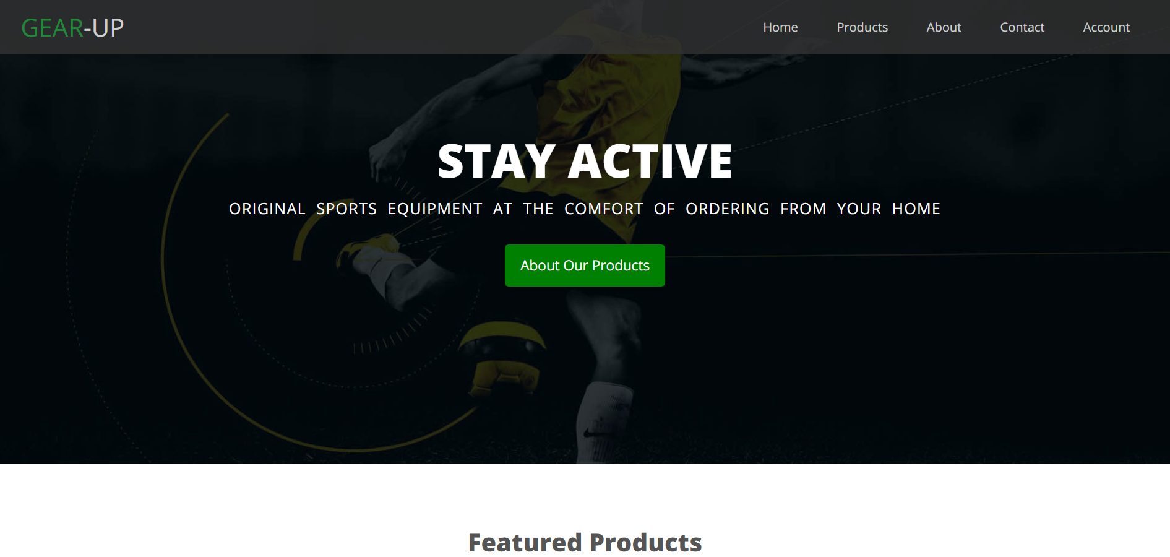

Figure 7 - Featured products section

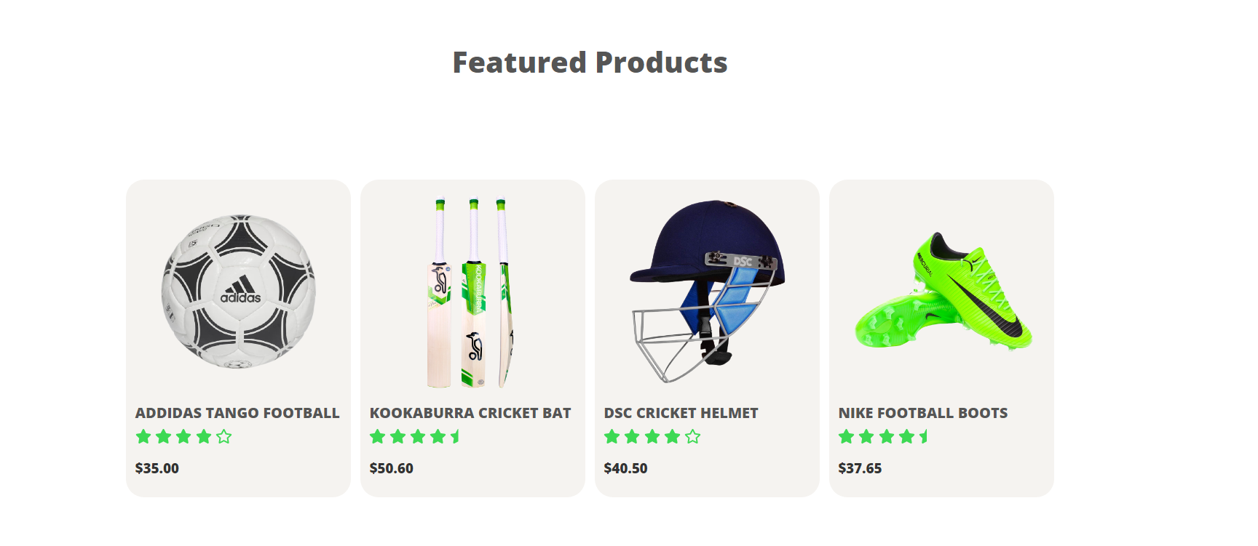

Figure 8 - Latest products section

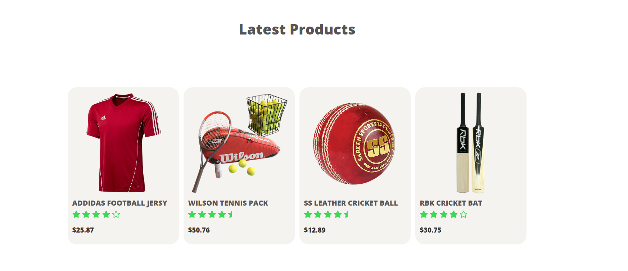

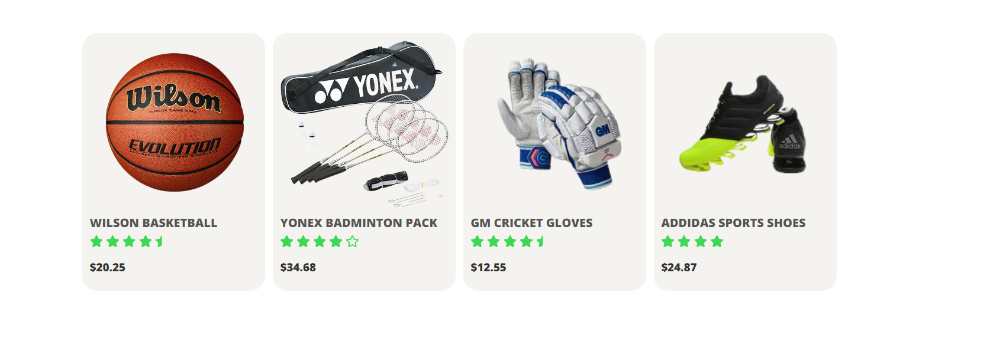

Figure 9 - Exclsive products section

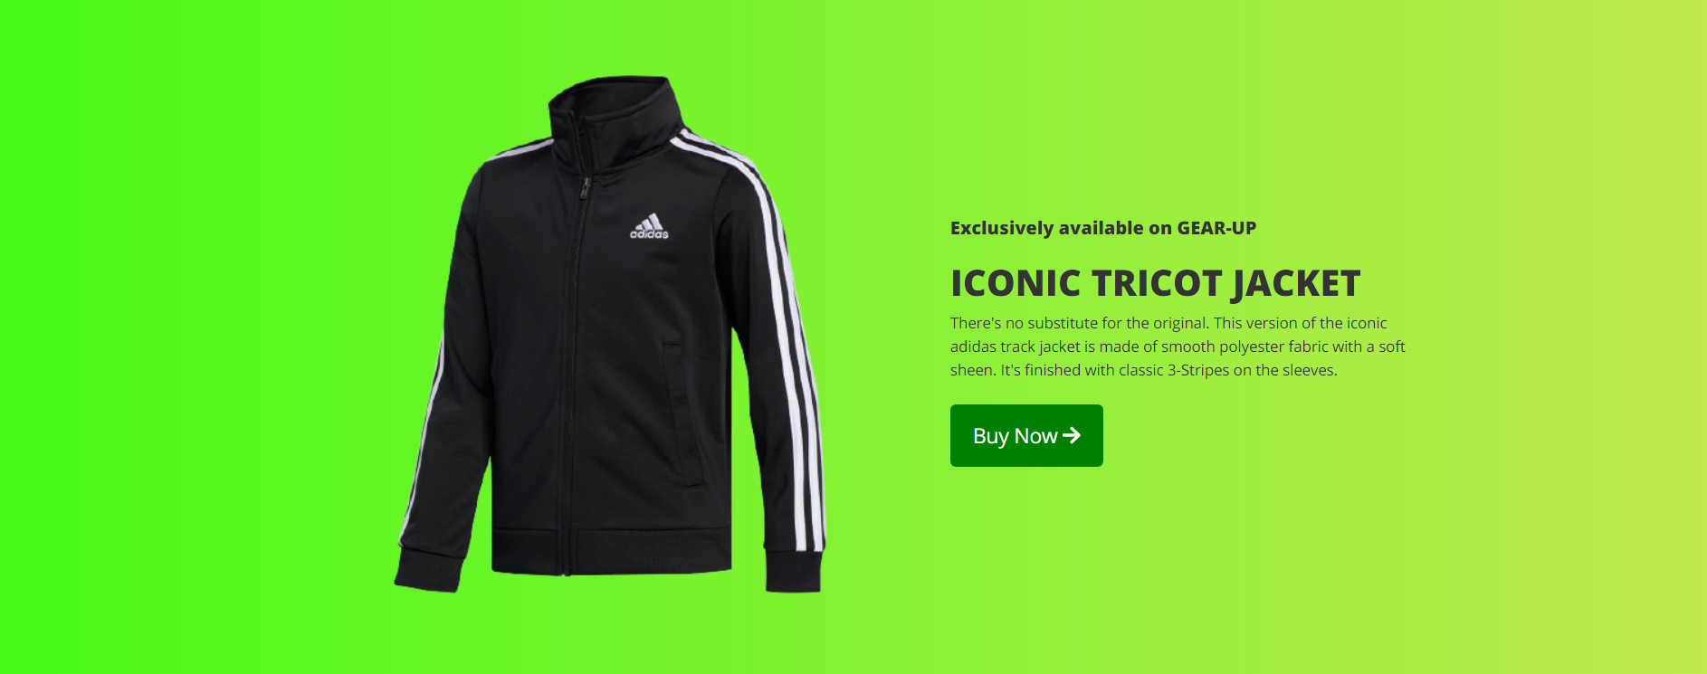

Figure 10 - Customer reviews section

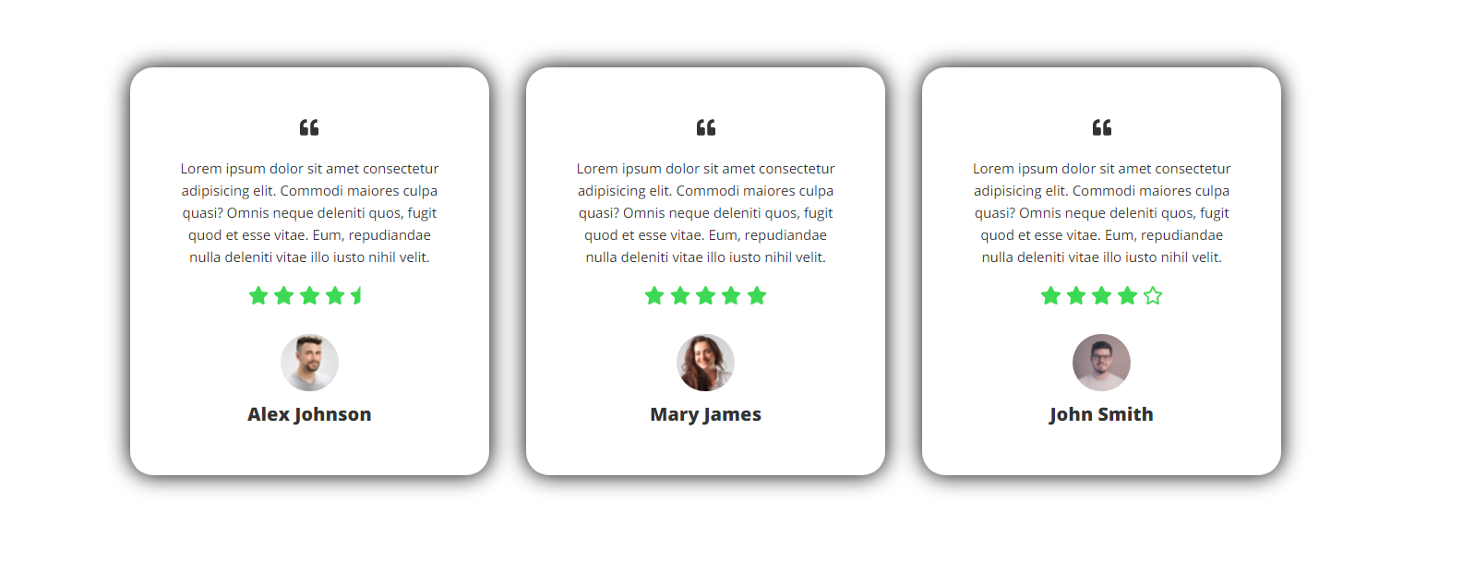

Figure 11 - Brand names & Footer section

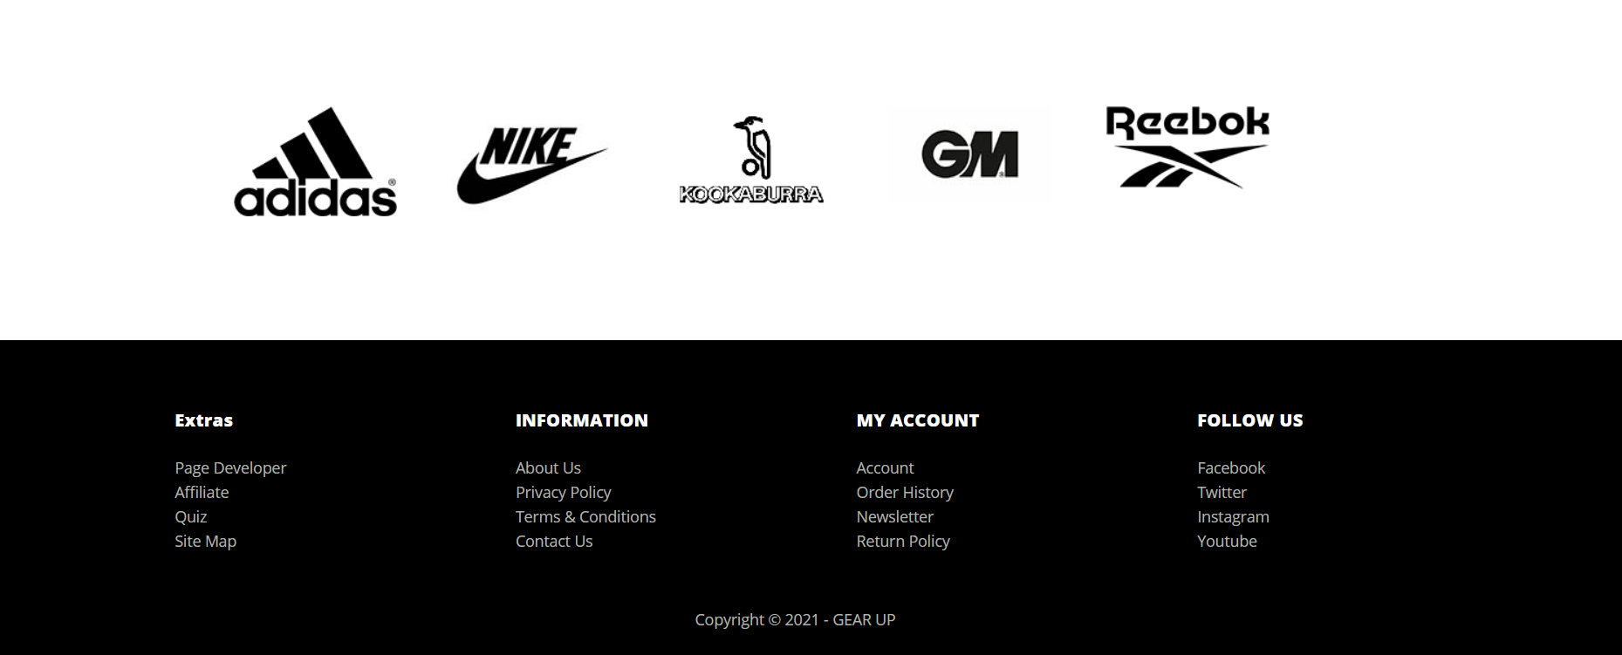

### Contact-us Page / Query-Form

**Filename**  - contactUs.html

**Screenshot(s)**

Figure 12 – Contact Us showcase area

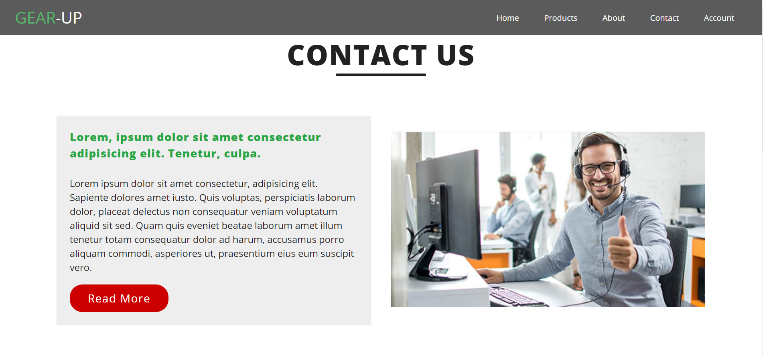

Figure 13 - Query Form

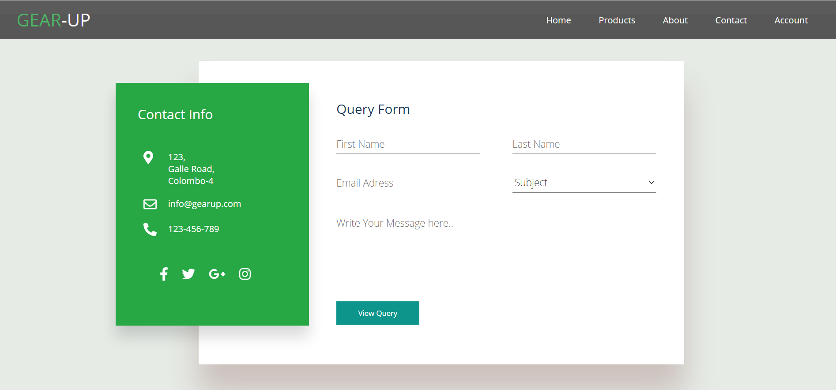

Figure 14 - Responisive Design

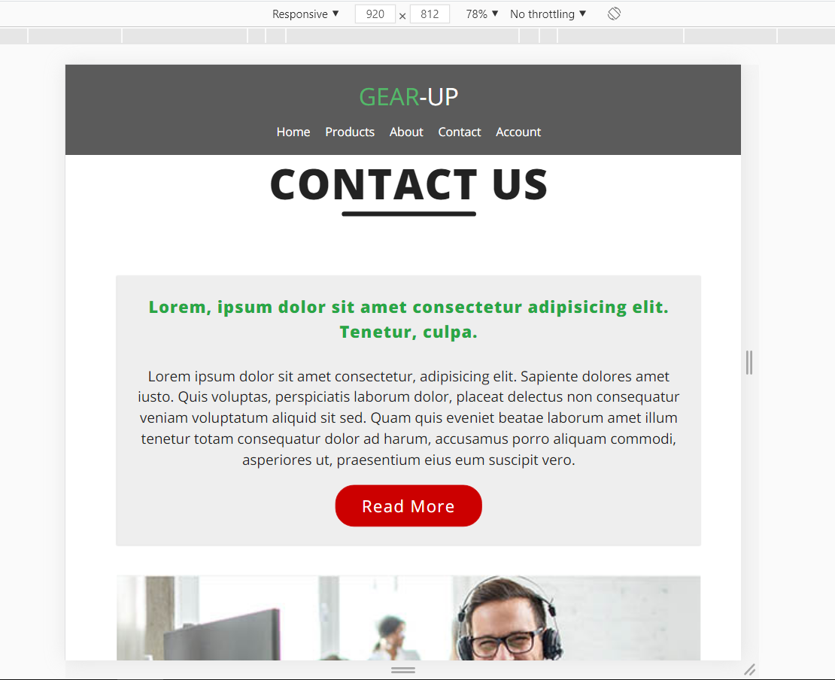 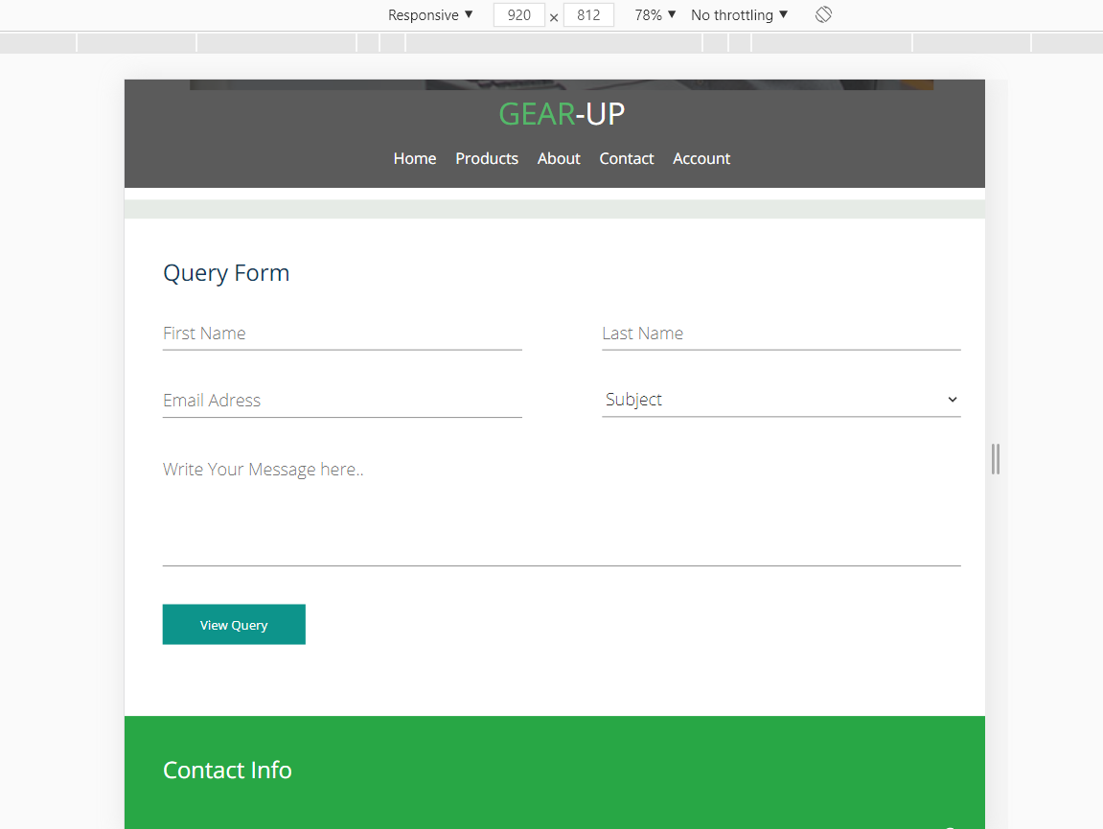

Figure 15 - Query Summary (When the user press ‘View Query’ button)

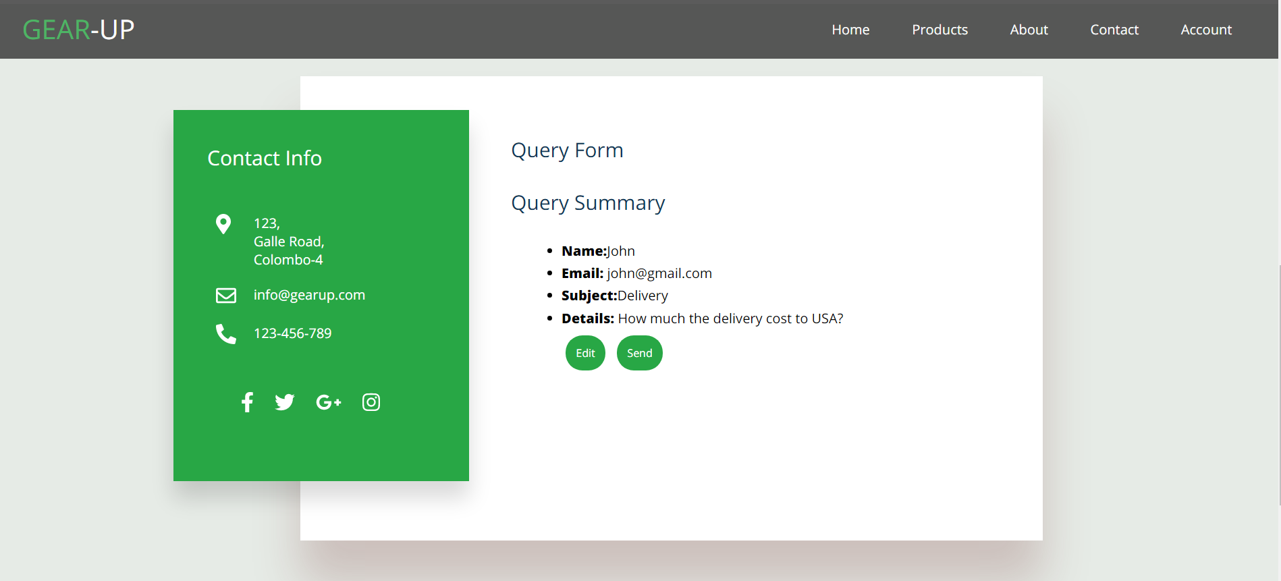

Figure 16 - Preview of the email when someone submits the form

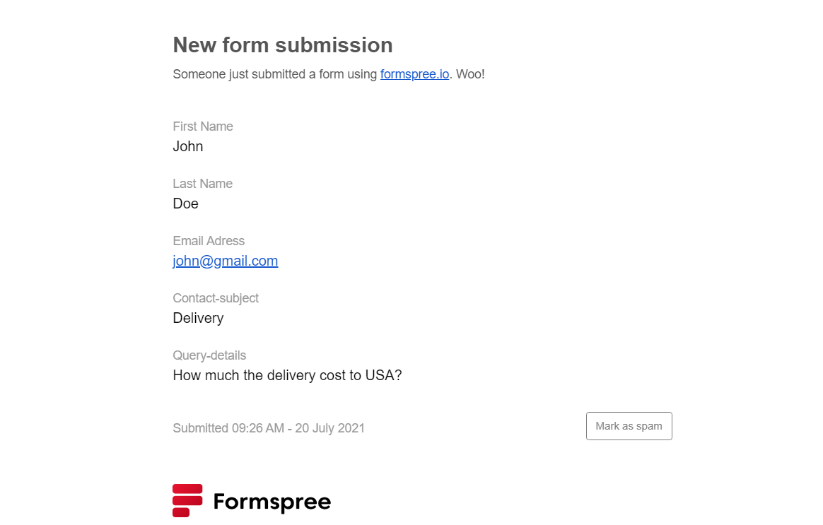

## Appendix C: Individual Statement

|  |  |  |  |
| --- | --- | --- | --- |
| Student Name: | G.P Sachin Lakshan | Student Id: | 20200603/w1833545 |
| State what tasks you carried out in the project. | | | |
| * Design & Development of the Main Page. * Design & Development of the Contact-us page including Query Form * Query form validation using JavaScript. | | | |
| State what you enjoyed and did not enjoy about teamwork. | | | |
| * Sharing the workload reduced the stress level. * Working together facilitated the idea generation and creativity * Teamwork improved the productivity * Collaborative teamwork is little bit challenging in socially distanced and virtual contexts. (Due to COVID-19) | | | |
| State what you learnt about teamwork. | | | |
| Teamwork unites people together and motivates them to rely on one another to get things done. Teamwork also makes progress easier and allows the group to overcome obstacles that would have impeded an individual. | | | |
| State what skills you gained/learnt from undertaking the project. | | | |
| Gain a fundamental knowledge about;   * How to create several linked HTML documents, following certain style guidelines and satisfying a simple specification. * How to use JavaScript to create interactive documents. * How to work in a group, with each individual having a distinct role and tasks. | | | |
| State any strengths about yourself that emerged whilst undertaking the project. | | | |
| * Leadership * Collaboration * Problem-solving * Time management | | | |
| State any weaknesses about yourself that emerged whilst undertaking the project. | | | |
| * Sometimes got demotivated | | | |
| State how you would do things better if you were to undertake the project again. | | | |
| * Make sure to keep a close track of every team member’s responsibilities and their performance using project management tools and software (Ex: MS Project) * Make sure to evaluate the effectiveness of the project on daily basis. | | | |
| Additional general or project specific comments: | | | |
|  | | | |
| Student Signature: |  | Date: | 2021/07/21 |