GROUND STATION FOR TRACKING LoRa SATELLITES

PROJECT SYNOPSIS

OF MINOR PROJECT

BACHELOR OF TECHNOLOGY
(Electronics & Communication Engineering)

SUBMITTED BY:

GURNOOR KAUR
GURPUNEET SINGH HUNJAN

University Roll No: 2302873, 2339611

Class Roll No: 2317102, 2317093

January – June 2026



Batch: 2023 – 2027

Proposed Topic: Ground Station for Tracking LoRa Satellites

GURU NANAK DEV ENGINEERING COLLEGE, LUDHIANA

(An Autonomous College Under UGC ACT)

 | TABLE OF CONTENT
S No. | Topic | Page No.
1 | Introduction | 3-4
2 | Historical background | 5
3 | State of Art | 6
4 | Problem Formulation | 7
5 | Objective | 8
6 | Methodology | 9
7 | Approximation Cost Budget | 10
8 | Applications | 11
9 | References | 12

INTRODUCTION

LoRa (Long Range) is a wireless communication technology that enables the transmission of small amounts of data over very long distances while consuming extremely low power. It is especially suitable for Internet of Things (IoT) applications where devices such as sensors and monitoring systems need to send data periodically without requiring high data rates or continuous internet connectivity. Due to its low power requirement, LoRa-based devices can operate for years on small batteries, making it an efficient and cost-effective communication solution.
The unique feature of LoRa technology is its use of Chirp Spread Spectrum (CSS) modulation, which spreads the signal over a wide frequency range. This technique provides strong resistance to noise and interference, allowing reliable communication over several kilometers, even in environments with obstacles such as buildings, trees, or uneven terrain. LoRa operates in unlicensed ISM (Industrial, Scientific, and Medical) frequency bands, eliminating the need for expensive spectrum licenses and reducing overall deployment costs.
In recent years, LoRa technology has also been successfully adapted for satellite communication, particularly with the emergence of Low Earth Orbit (LEO) CubeSats. Several experimental and educational satellites now use LoRa modulation to transmit telemetry data back to Earth. This has made satellite communication more accessible to students, researchers, and enthusiasts without the need for complex or costly ground station infrastructure.
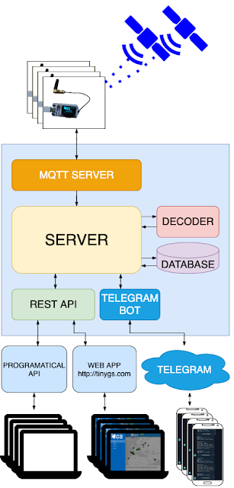
Fig 1. – Block Diagram of Proposed Idea [3]
This project focuses on the development of a low-cost LoRa-based satellite ground station using the TinyGS network. TinyGS is an open-source global network of ground stations designed to receive data packets from LoRa-enabled satellites. By using affordable hardware such as ESP32/ESP8266 microcontrollers and RA-02 LoRa modules, the proposed system demonstrates how satellite data can be received, monitored, and shared using minimal resources. The project aims to provide hands-on experience in satellite communication, LPWAN technology, and embedded systems while contributing to a community-driven satellite tracking network.

HISTORICAL BACKGROUND

LoRa (Long Range) technology is a wireless communication method designed to send small amounts of data over long distances using very little power. It was originally invented in 2009 by a French startup called Cycleo, which specialized in low-power wireless communication systems. What made their invention unique was the use of a new modulation technique called Chirp Spread Spectrum (CSS). This method allows data signals to travel over several kilo meters while consuming minimal energy, making it ideal for battery-powered devices.
In 2012, Semtech Corporation, a major American semiconductor company, recognized the potential of LoRa technology and acquired Cycleo. Semtech then took charge of expanding and developing the technology further, eventually making it commercially available for large- scale use, especially in industrial and Internet of Things (IoT) applications.
Satellite communication has traditionally been associated with large, expensive ground stations and complex infrastructure, accessible only to government agencies and research organizations. Early satellite communication systems required high-power transmitters, large parabolic antennas, and licensed frequency bands.
With advancements in electronics and miniaturization, CubeSats were introduced—small, low-cost satellites used for education, research, and experimental purposes. These satellites significantly reduced launch and development costs. At the same time, Low Power Wide Area Network (LPWAN) technologies such as LoRa were developed to support long-range communication with minimal power consumption.
In recent years, projects like FossaSAT demonstrated that LoRa modulation could be successfully used for satellite communication. This led to the development of TinyGS, an open-source initiative that allows individuals to build low-cost ground stations capable of receiving data from LoRa-enabled satellites. TinyGS transformed satellite communication into a community-driven, accessible technology for students, researchers, and radio enthusiasts.

STATE OF ART

LoRa-based satellite communication is a rapidly developing area that combines Low Power Wide Area Network (LPWAN) technology with modern satellite systems. With the increasing launch of Low Earth Orbit (LEO) CubeSats for educational and research purposes, LoRa has emerged as a suitable communication method due to its long-range capability, low power consumption, and strong resistance to interference.
Recent studies and practical implementations have shown that LoRa modulation can be effectively used for satellite-to-ground communication to transmit essential telemetry and health parameters such as battery voltage, battery temperature, solar panel voltage, CPU status, payload condition, and overall satellite health. Open-source initiatives such as TinyGS have significantly reduced the cost and complexity of satellite ground stations, enabling students and academic institutions to build functional systems using affordable hardware.
Modern LoRa-based ground stations commonly use the ESP32 microcontroller with RA-02 (SX1278) LoRa modules, supporting automatic tuning to satellite transmission frequencies.
Advanced implementations include cloud-connected dashboards that store and display received satellite data over long durations. These dashboards record the total number of satellites tracked, packet success and failure rates, signal quality, and long-term system performance from the initial deployment until the satellite’s operational lifetime.
In India, academic collaborations such as the Thapar Institute of Engineering and Technology and ISRO have successfully deployed operational ground stations for several years, demonstrating the practicality and reliability of LoRa-based satellite communication. The current state of the art indicates a shift toward satellite-based IoT, where future IoT systems will increasingly rely on satellites instead of traditional internet infrastructure. This project aligns with this trend by implementing a low-cost, scalable LoRa satellite ground station for continuous satellite health monitoring and data analysis.

PROBLEM FORMULATION

With the rapid growth of the Internet of Things (IoT) and space-based communication systems, there is an increasing demand for reliable, long-range, and low-power communication technologies capable of operating beyond the limits of conventional terrestrial networks. Many IoT applications are deployed in remote or geographically isolated areas where internet connectivity, cellular coverage, or wired infrastructure is unavailable or unreliable.
Traditional wireless communication technologies such as Wi-Fi and Bluetooth are limited to short-range operation and cannot support wide-area or global coverage. Cellular technologies like 3G, 4G, and 5G, although capable of long-distance communication, consume high power, require costly infrastructure, and depend on network availability. These limitations make them unsuitable for IoT devices and space systems that are expected to operate continuously for long durations with minimal power and maintenance.[1,2]
In satellite communication, access to real-time satellite telemetry data is often restricted due to the high cost and complexity of conventional ground station systems. Educational institutions and student projects typically lack affordable solutions to receive and analyze satellite health parameters such as battery voltage, temperature, solar panel status, CPU health, and payload condition. Existing professional ground stations require expensive radio equipment, large antennas, and licensed frequency usage, making them impractical for academic and low-budget applications.
Furthermore, there is a growing need to monitor satellite performance over long periods, maintain historical records of received data, evaluate signal quality, and track multiple satellites using a single, scalable system. The absence of a low-cost, automated, and user-friendly ground station limits hands-on learning and experimentation in satellite-based IoT communication.
To address these challenges, there is a need for a cost-effective LoRa-based satellite ground station that can automatically tune to satellite frequencies, reliably receive telemetry data, display real-time parameters, and store long-term performance data on a centralized dashboard. [3,4]

PROPOSED OBJECTIVES
- To design and implement a low-cost LoRa-based satellite ground station capable of receiving telemetry data from LoRa-enabled Low Earth Orbit (LEO) satellites.
- To automatically tune and configure the ground station according to satellite transmission frequencies and parameters for reliable satellite data reception.
- To receive, decode, and monitor essential satellite health parameters, including battery voltage, battery temperature, solar panel voltage, CPU status, payload condition, and overall satellite health.
- To track multiple satellites and evaluate communication performance, including the number of satellites received, successful and failed packets, and signal quality metrics.
- To demonstrate the feasibility of LoRa technology for future satellite-based IoT communication, highlighting its potential to reduce dependency on traditional internet and cellular networks.
- To provide a scalable and educational platform that can be used by students and researchers for hands-on learning in satellite communication, LPWAN technology, and space-based IoT systems.

METHODOLOGY

CIRCUIT DIAGRAM: 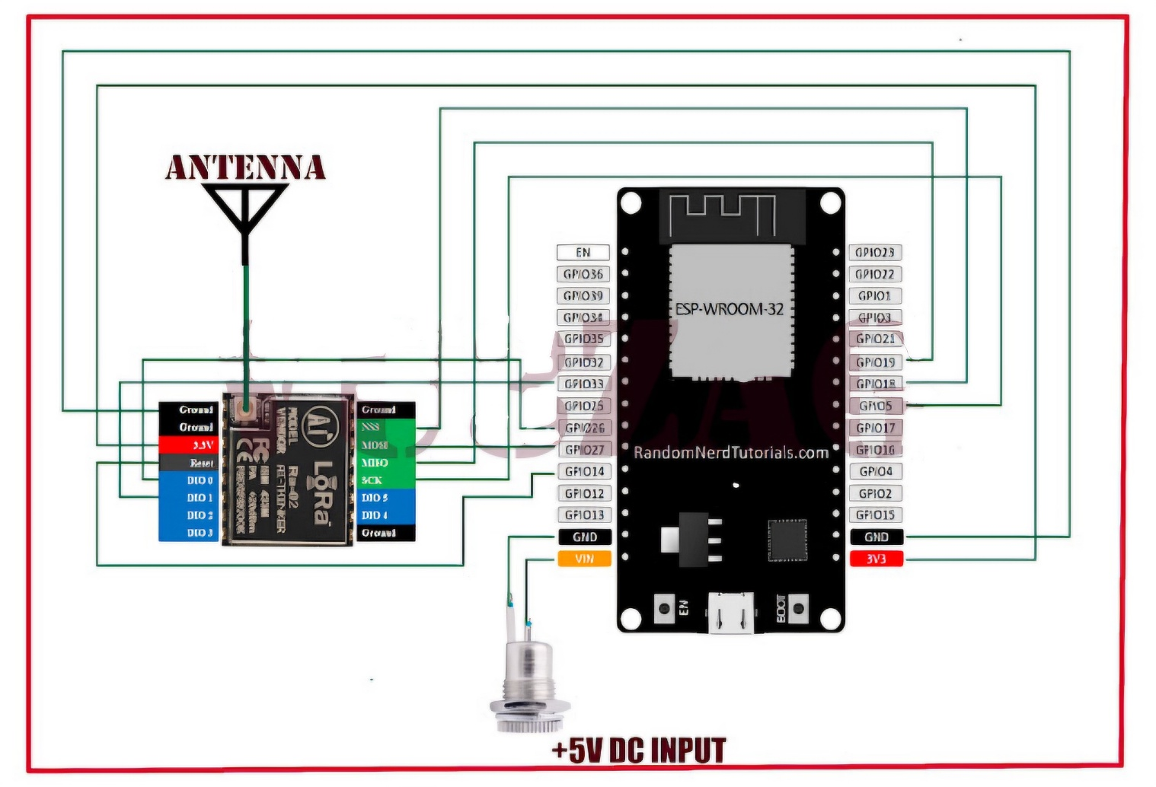
Fig 2. Circuit Diagram of Proposed Idea [3]

List of components:

HARDWARE | QUANTITY
RA-02 LoRa Module | 1
ESP32 | 1
0.95-inch OLED Display | 1
Buck (Step-Down) Converter | 1
Antenna & U.FL to SMA Patch Cord | 2
PCB | 2
Data Cable | 2

APPROXIMATED COST BUDGET

HARDWARE | PRICE
RA-02 | 850
ESP32 | 400
0.95-inch OLED Display | 200
Buck (Step-Down) Converter | 170
Antenna & U.FL to SMA Patch Cord | 1000*2
PCB | 60*2
Data Cable | 80*2
TOTAL | 3900

Estimated Budget: Rs 4000/-

APPLICATIONS
- Satellite Telemetry and Health Monitoring – Continuous monitoring of satellite parameters such as battery voltage, battery temperature, solar panel voltage, CPU status, payload health, and overall satellite performance using a ground station.
- Educational and Research Applications – Used by students and academic institutions to gain hands-on experience in satellite communication, LoRa technology, LPWAN systems, and space-based IoT experiments.
- Satellite-Based IoT Communication – Enables experimentation and validation of next-generation IoT systems where devices communicate through satellites instead of relying on terrestrial internet or cellular networks.
- Remote and Disaster-Resilient Communication – Useful in remote areas, disaster zones, or regions without reliable internet connectivity, where satellite-based LoRa communication can provide essential data links.
- Long-Term Satellite Data Analysis – Collection and storage of satellite telemetry data over long durations for performance analysis, signal quality evaluation, and lifecycle monitoring of satellites.
- Ground Station Network Expansion – Can be deployed as part of a distributed ground station network to increase satellite coverage, improve data reception, and support multiple satellite missions.

REFERENCES

- Roshan E.C., Dechakka M.P. (2021) – LoRaWAN, International Journal of Engineering Research & Technology (IJERT).
- Overview of LoRaWAN technology, its modulation technique, and operation within India’s 865–867 MHz ISM band (IJERT).
- VU3ZAG Expedition: LoRa 433MHz TinyGS Satellite Ground Station – Blog by Suraj Shenoys
- LoRa communication with Satellite on a Budget - Blog by Kunal
- LoRaWAN Deployment at IIT Bombay (2018) – SenRa provides LoRaWAN connectivity to IIT Bombay for R&D, expanding the national LoRaWAN ecosystem.
- PR Newswire - iiotnewshub.com

- Tata Communications & Semtech (2025) – Launch of India's first Applications Center for LoRa Technology in Mumbai to support 35 IoT PoCs in Delhi, Bengaluru, and Mumbai - enterpriseitworld.com , tatacommunications.com .

