# **Practical No – 01**

# **Introduction to Excel**

A. Perform Conditional formatting on a dataset using various criteria.

**Step1**: Create a Table as Given Below

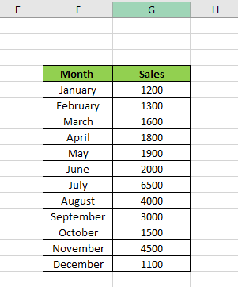

**Step2**: Conditional Formatting for Greater than

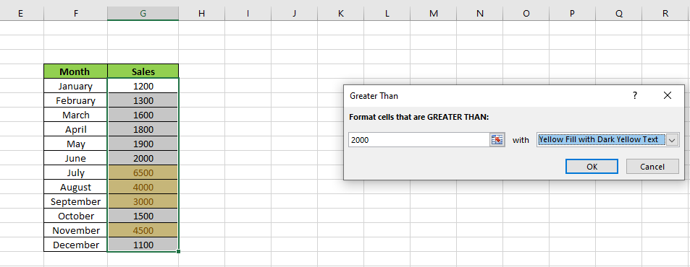

**Step3**: Conditional Formatting for Less than

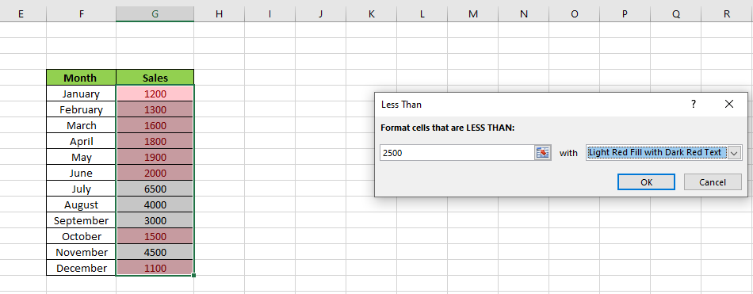

**Step4**: Conditional Formatting for in Between Values

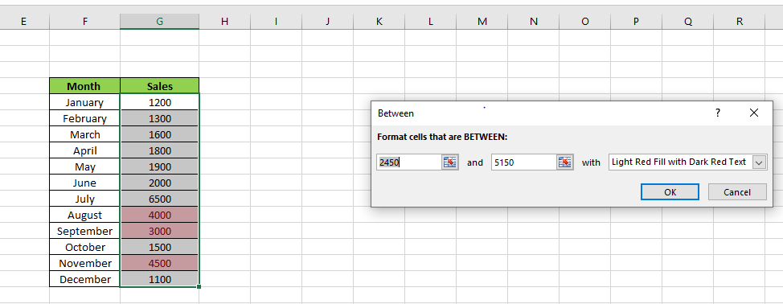

**Step5**: Conditional Formatting for Equal to Values

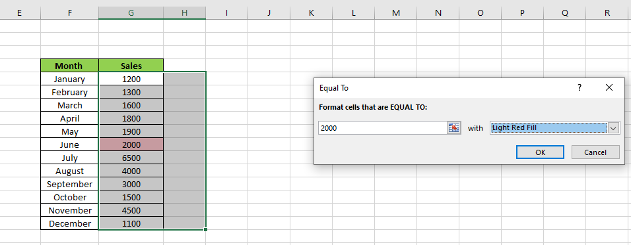

**Step6**: Conditional Formatting for Text That Contains NA

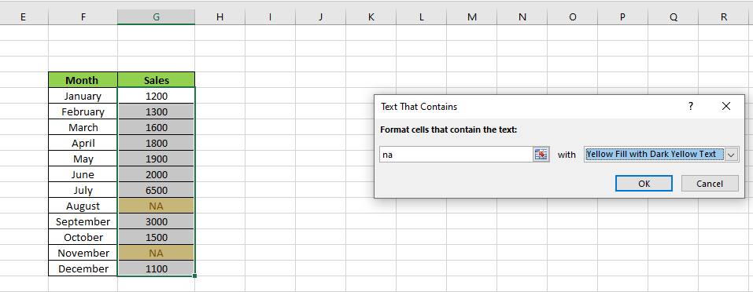

**Step7**: Conditional Formatting for Duplicate Values

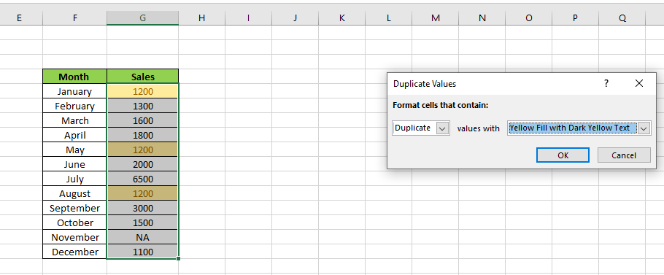

**Step8**: Conditional Formatting for Data Bars

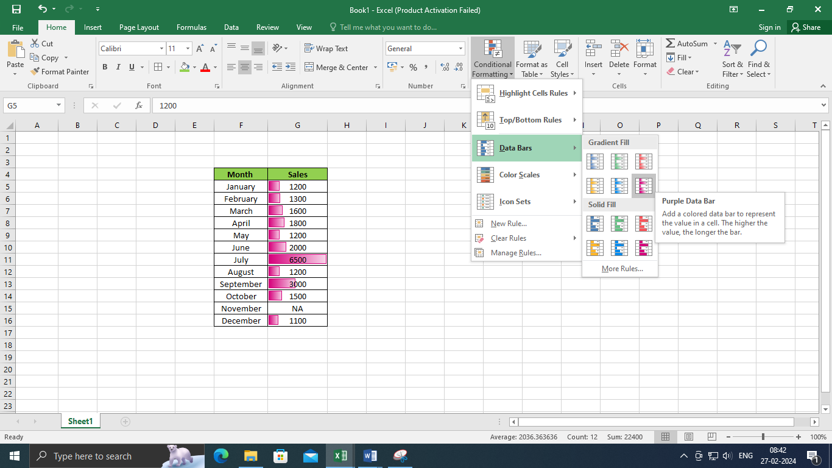

**Step9**: Conditional Formatting for Icons Set

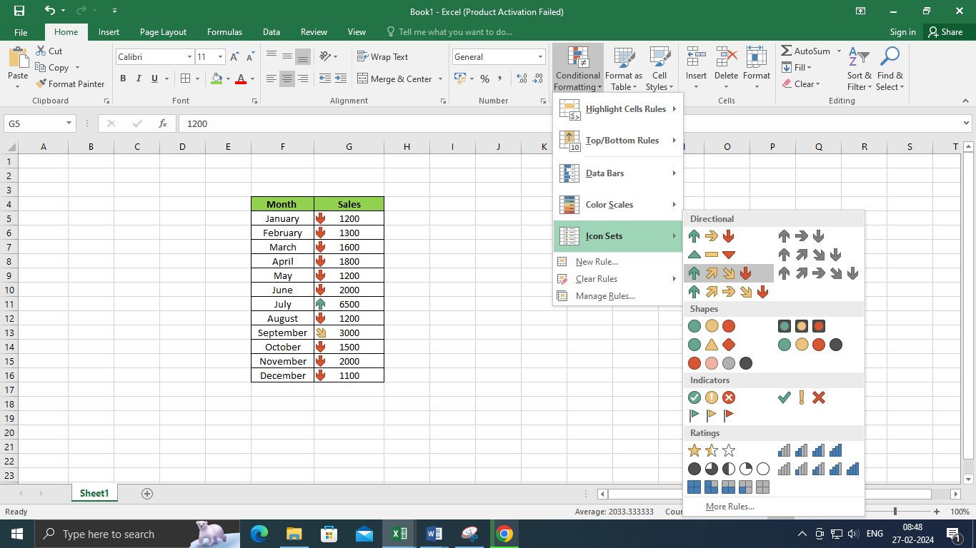

B. Create A pivot table to analyze and summarize data.

**Step1**: Create a Sample data

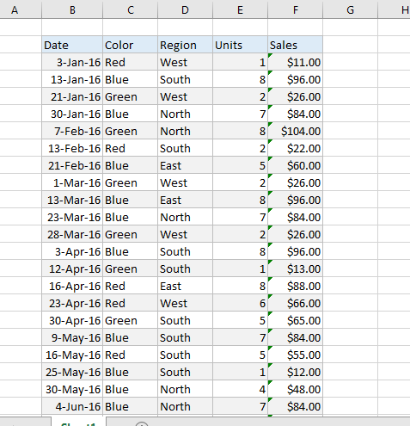

**Step2**: Insert pivot table

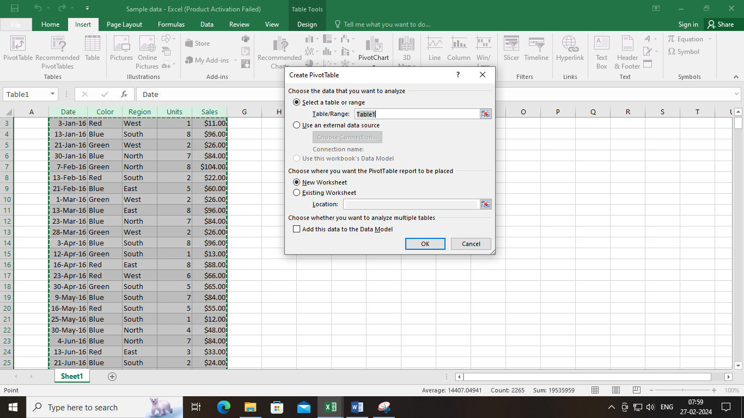

**Step3**: Analysis and Summary of data

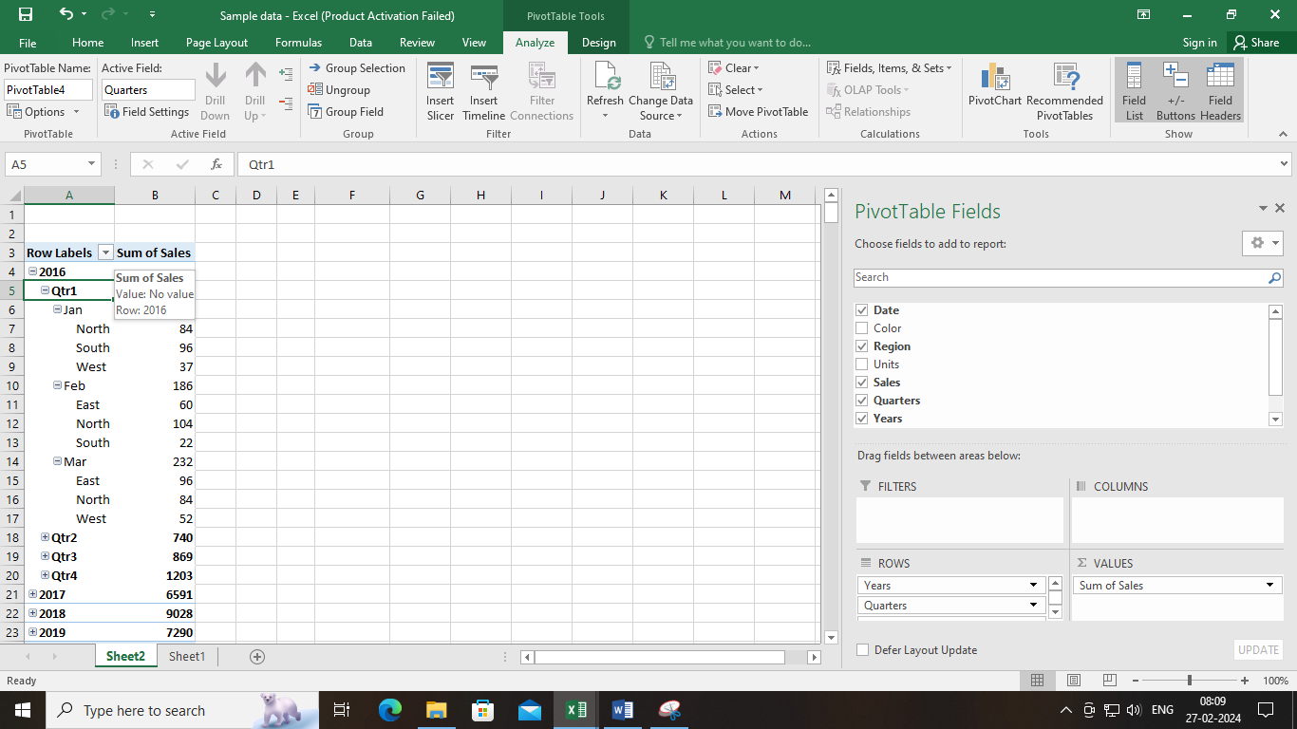

C. Use VLOOKUP function to retrieve information from a different worksheet or table.

The VLOOKUP formula in Microsoft Excel is :

**=VLOOKUP(lookup_value,table_array,col_index_num,[range_lookup])**

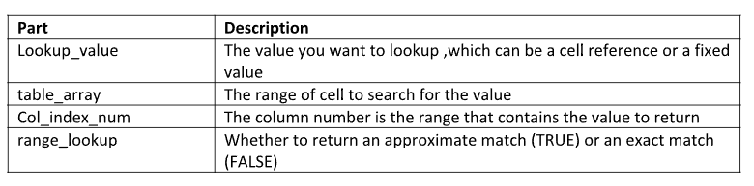

**Step1**: Retrieve the First Name

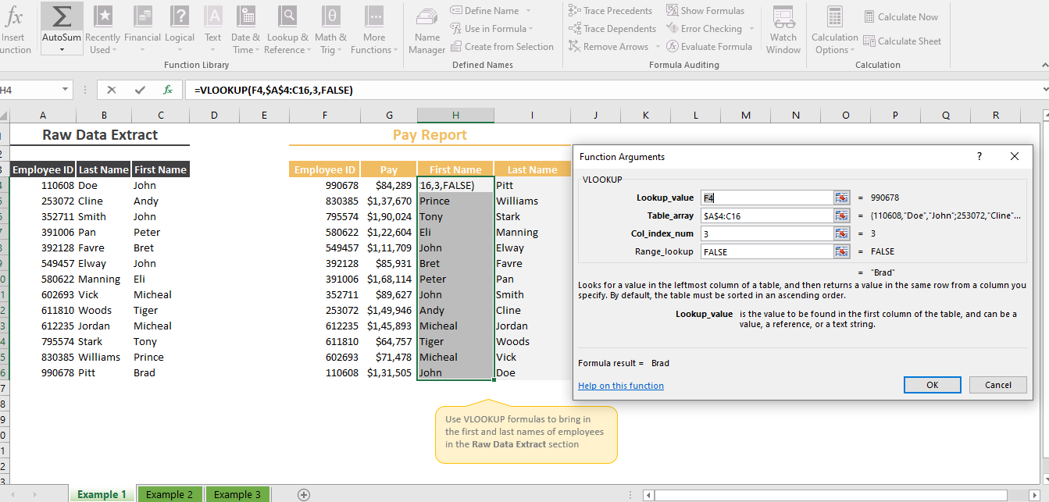

**Step2**: Retrieve the Last Name

=VLOOKUP(F4,$A$3:$C$16,3,FALSE)

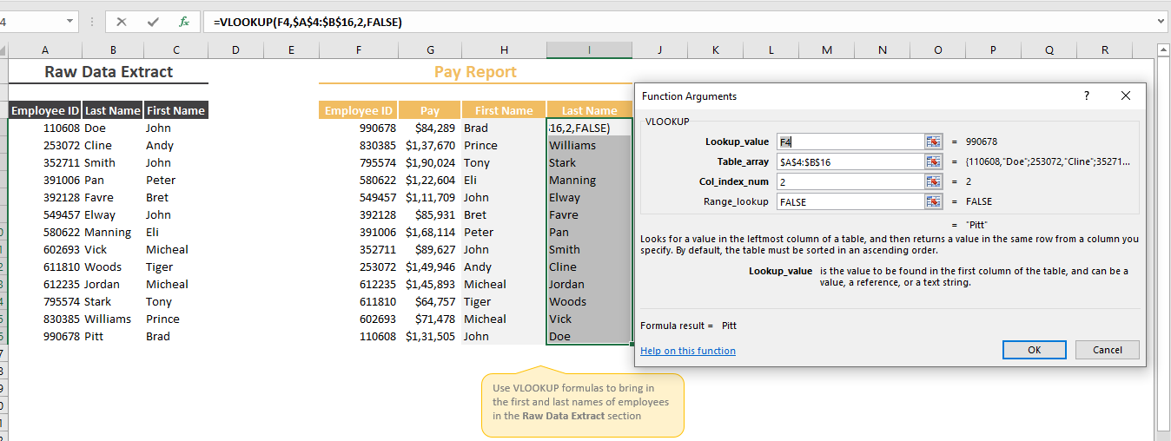

**Step3**: Retrieve the City Name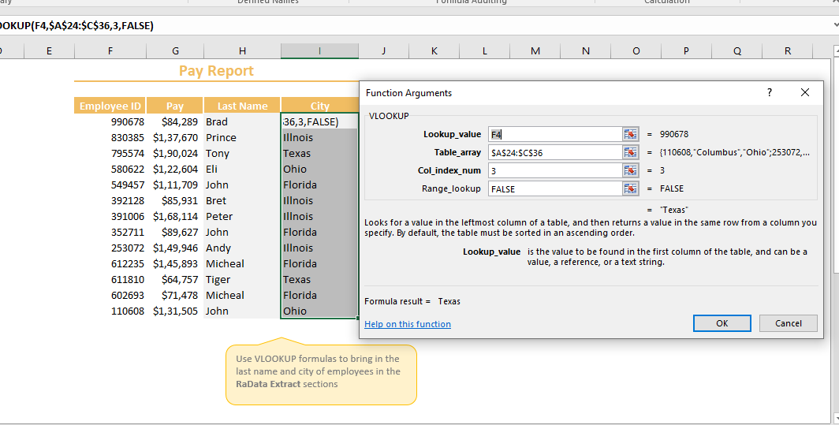

**Step4**: Retrieve the Pay Band

