# **Practical No – 10**

# **Data Visualization and Storytelling**

a) Create meaningful visualizations using data visualization tools.

**Pre-Requirements:**

To Install **Power BI Desktop follow these steps:**

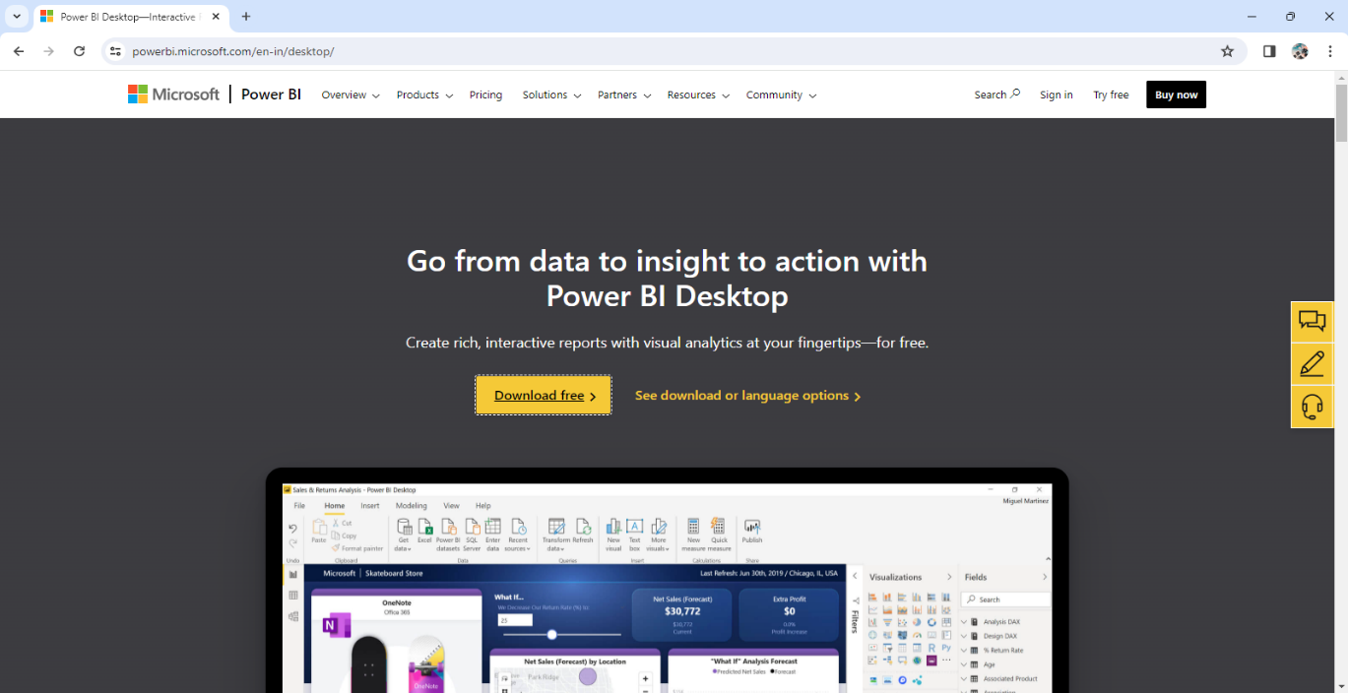

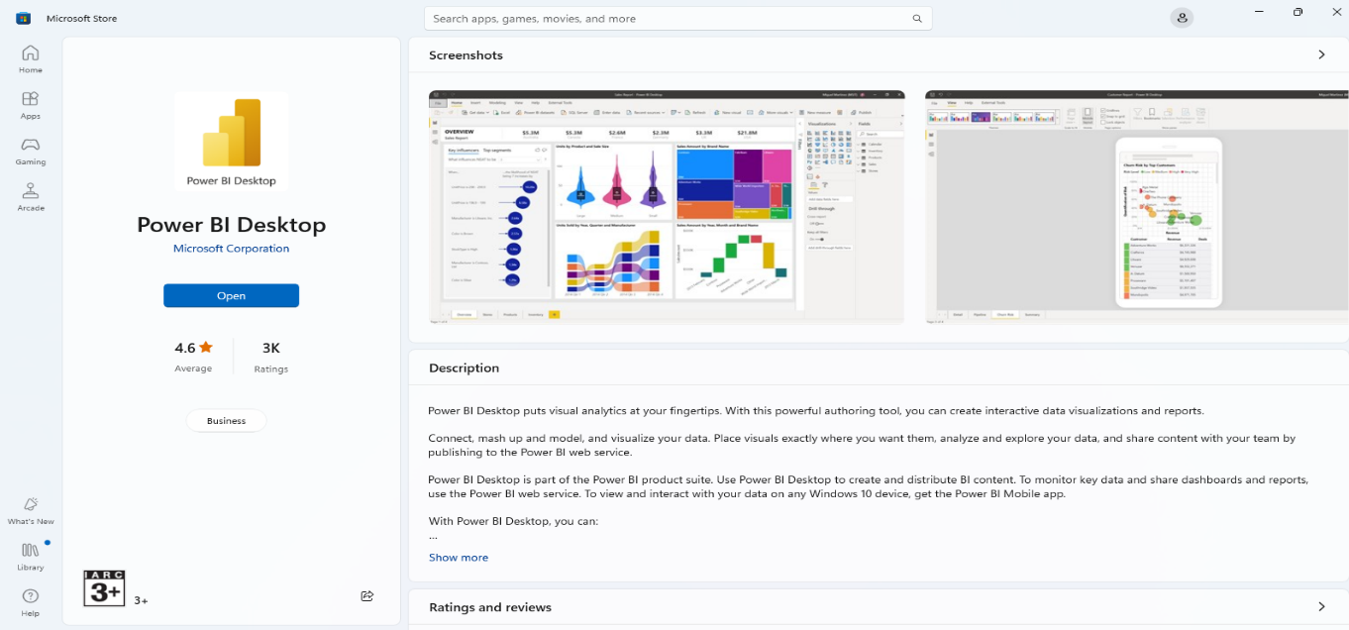

you can also start it with anacoda

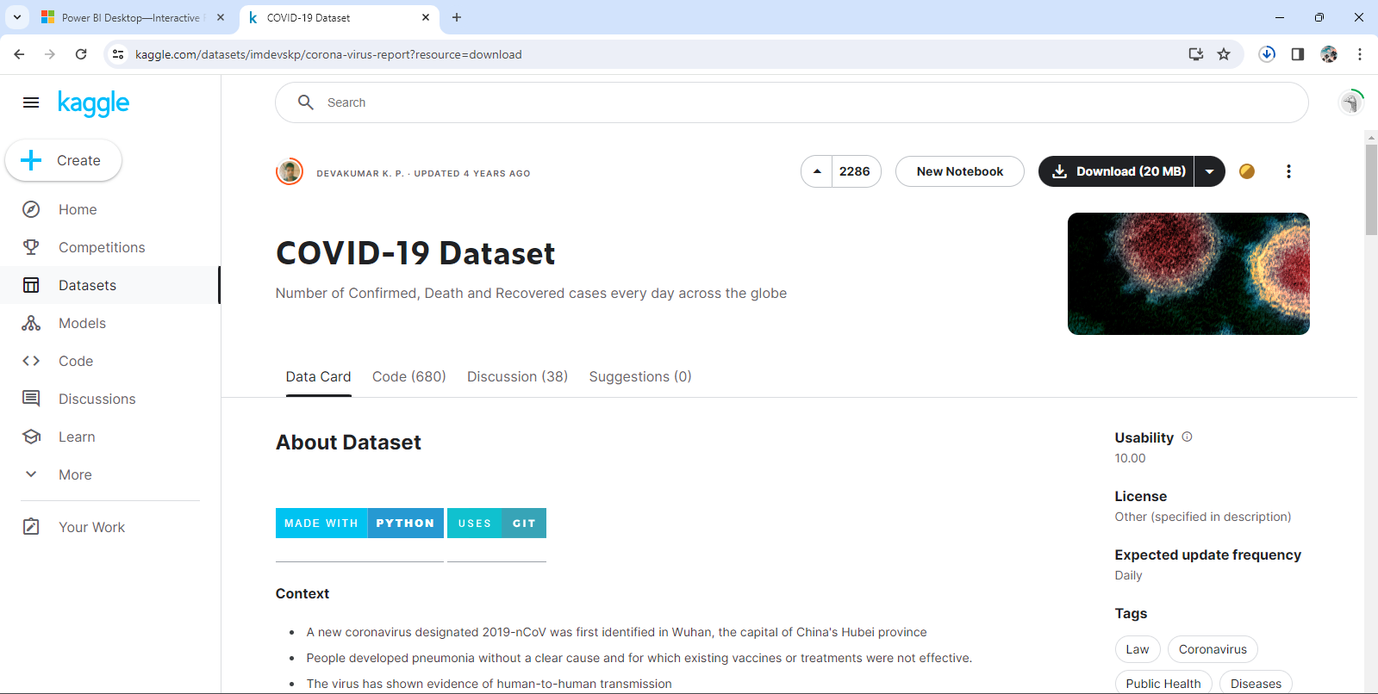

download 20 mb file

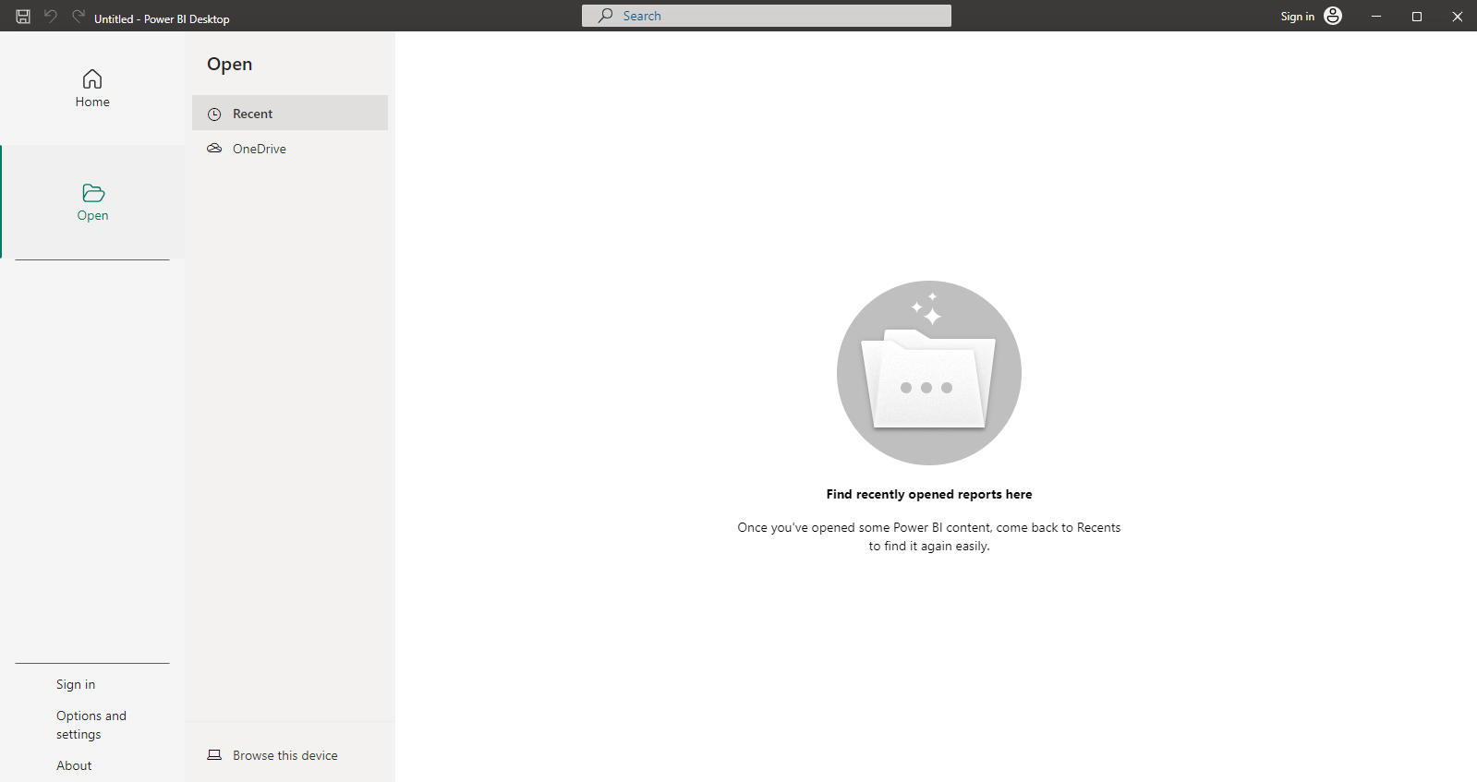

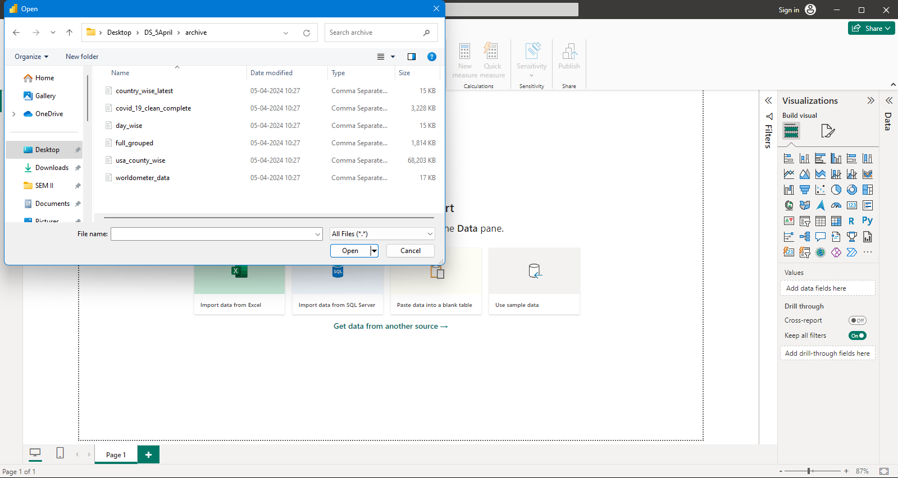

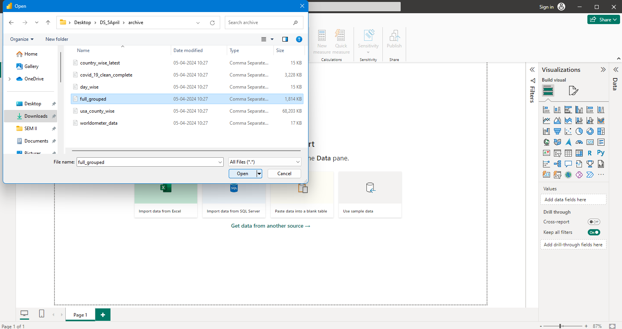

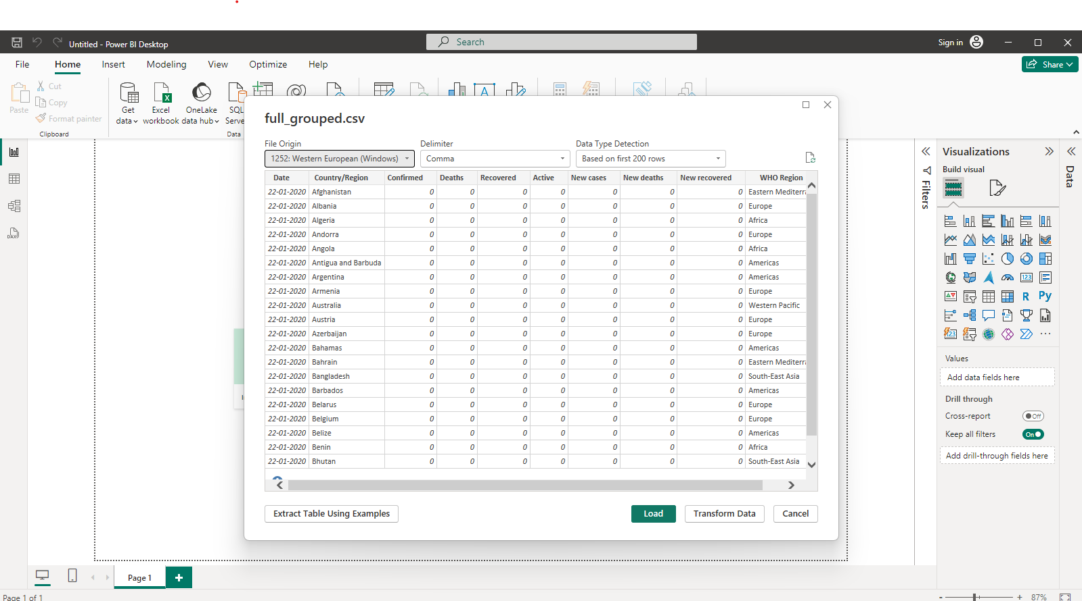

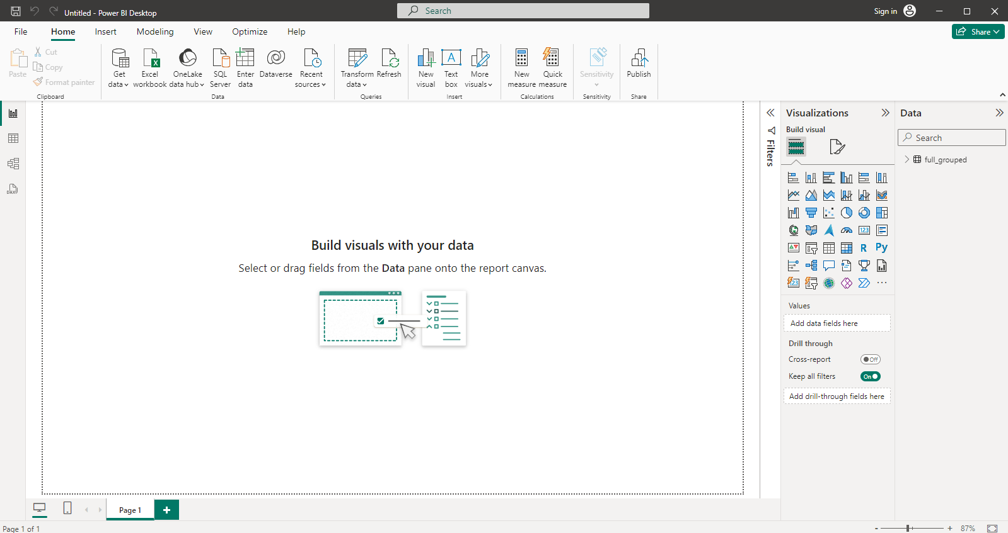

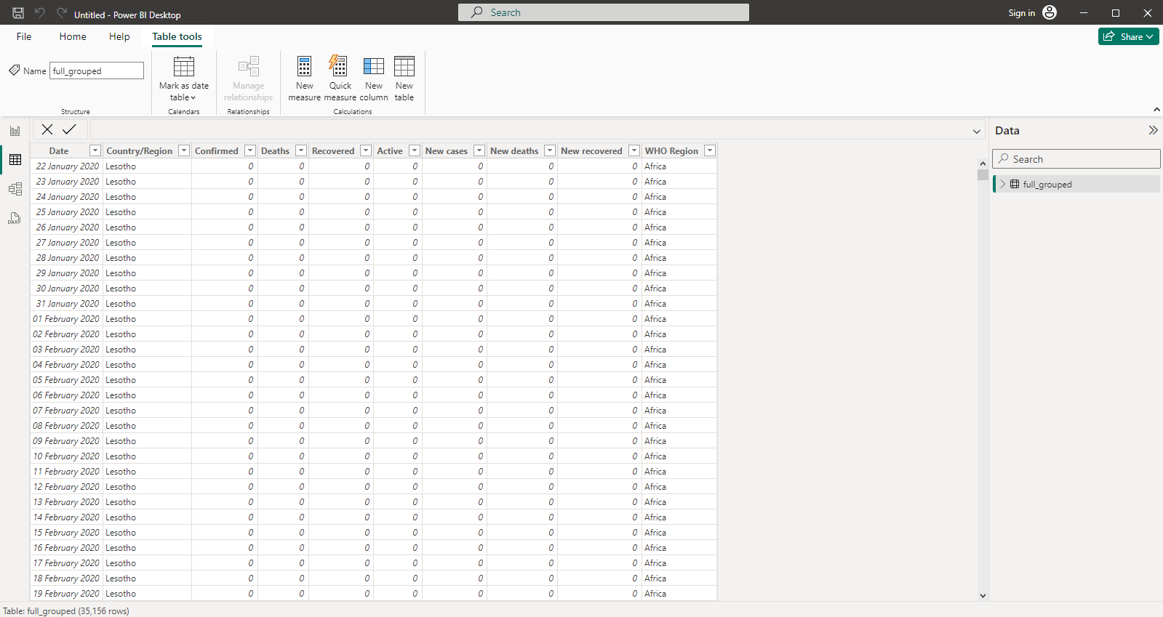

Select country accordingly in filter

1. bar chart

DataSet: full_grouped.csv(selected file)

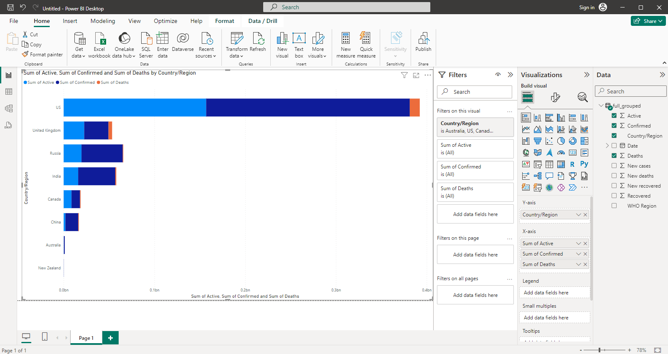

2. line chart

DataSet: full_grouped.csv

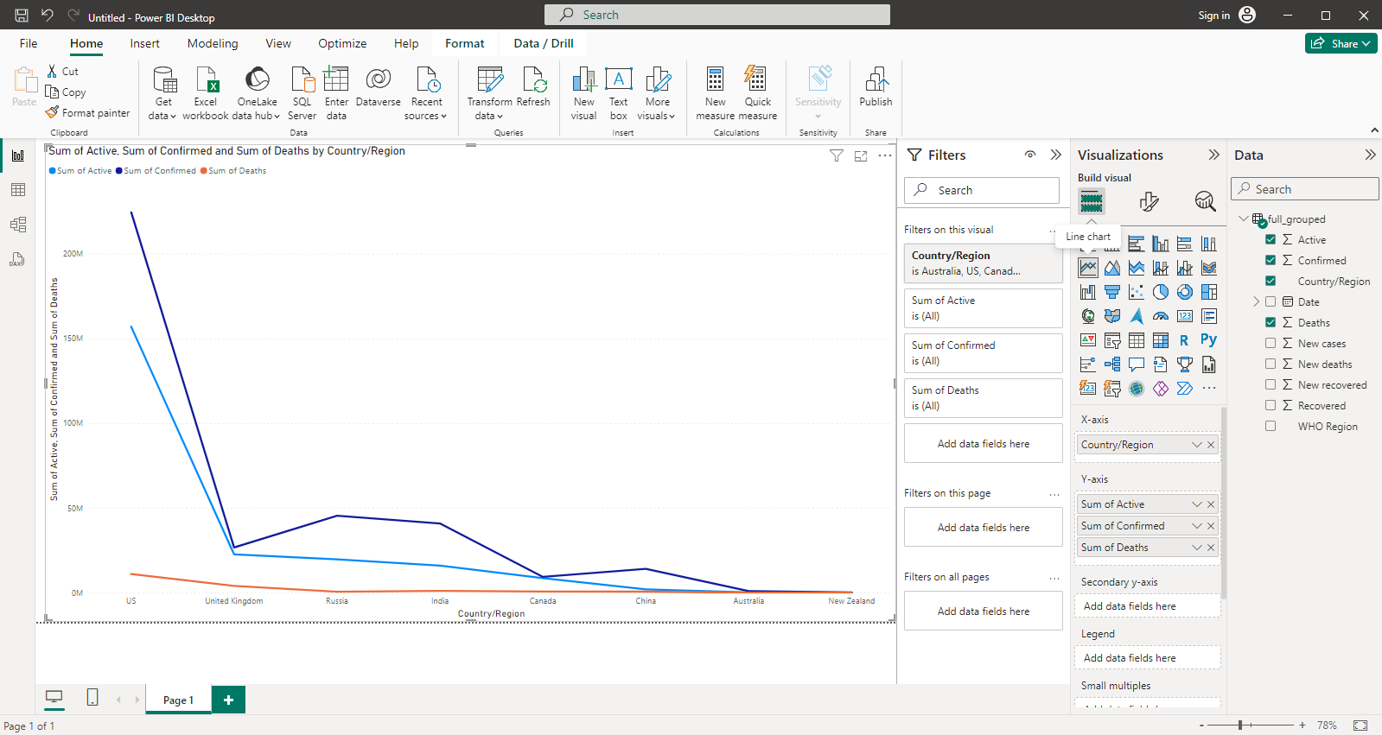

1. COLUMN CHART

DataSet: usa_county_wise.csv

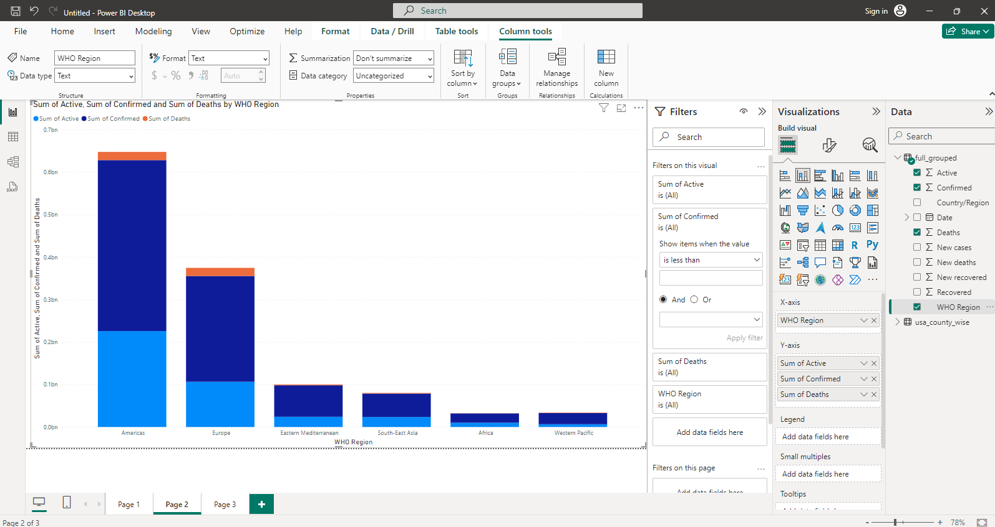

1. DOTNUT CHART

DataSet: covid_19_clean_complete.csv(selected file)

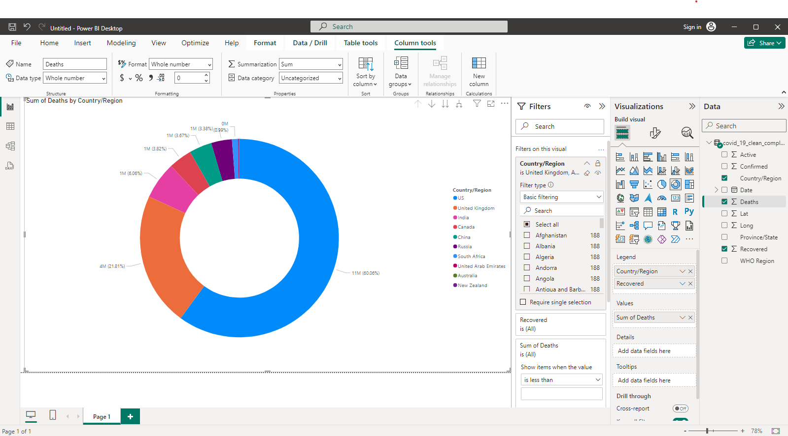

1. DECOMPOSITION TREE

DataSet: covid_19_clean_complete.csv

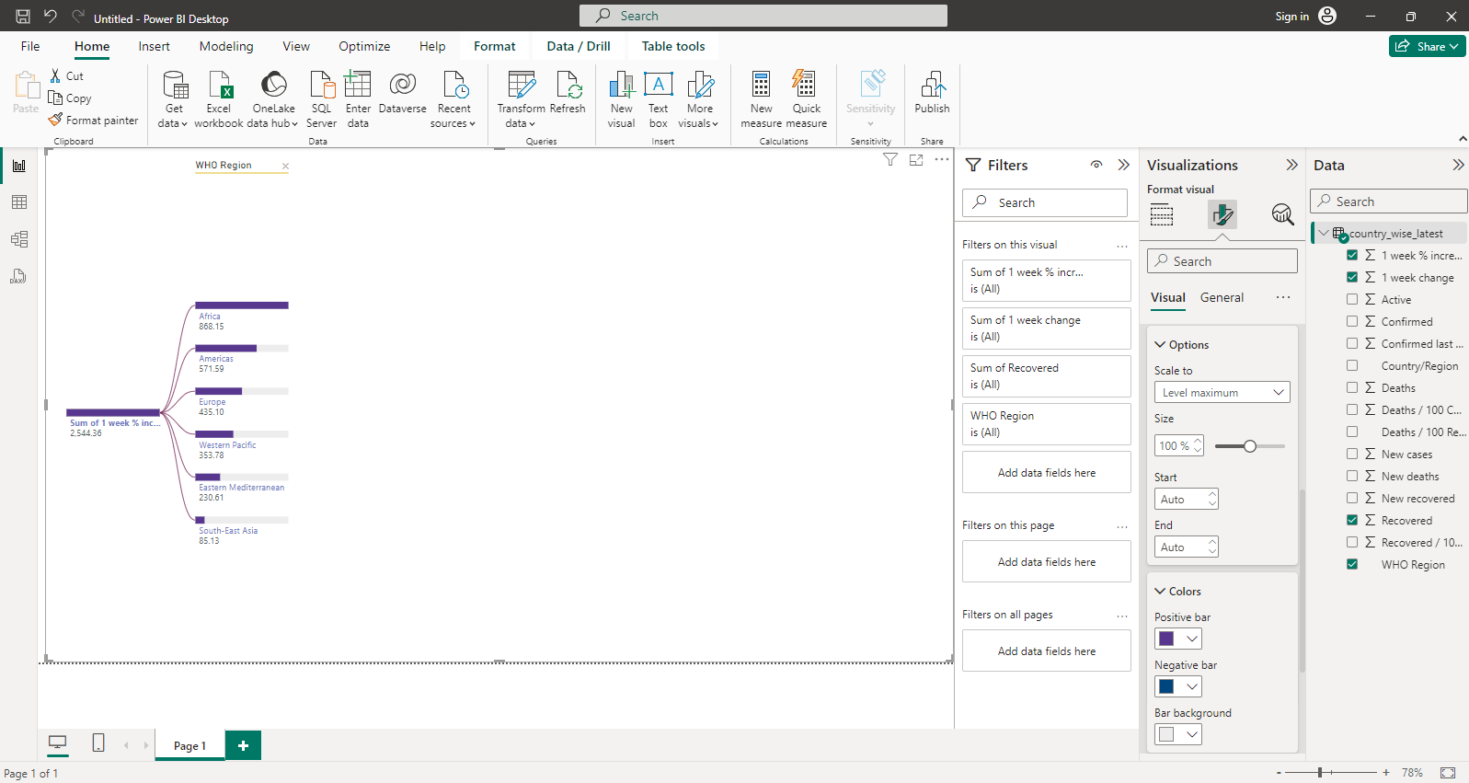

1. Funnel chart

DataSet: full_grouped.csv

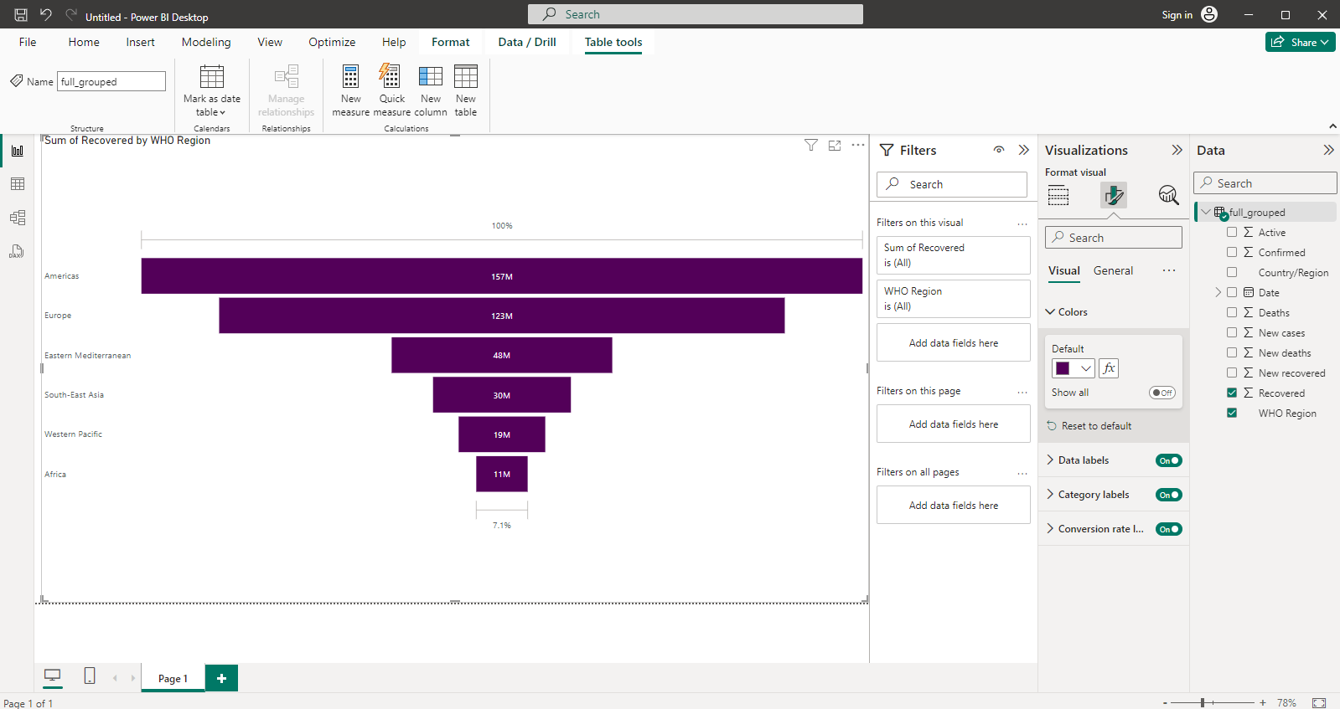

7.Scatter chart

DataSet: full_grouped.csv(selected file)

