# **Practical No – 07**

# **Logistic Regression and Decision Tree**

a) Build a logistic regression model to predict a binary outcome.

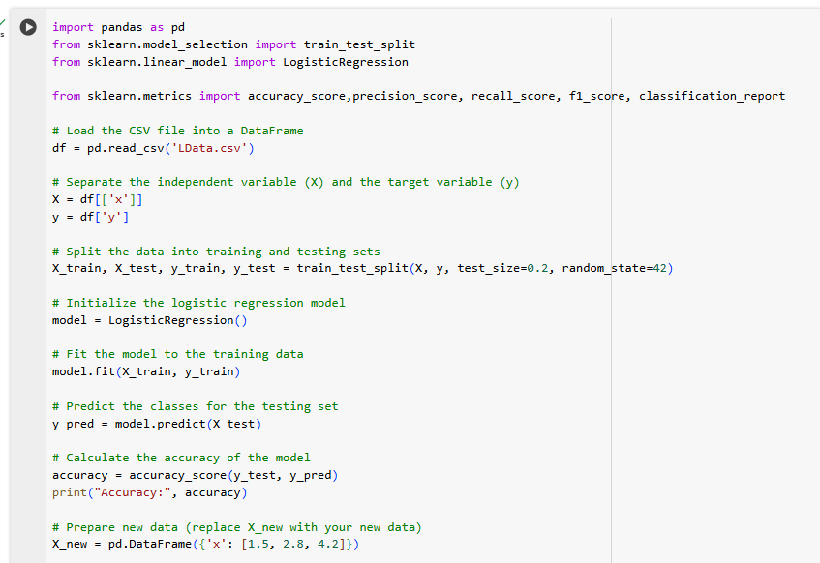

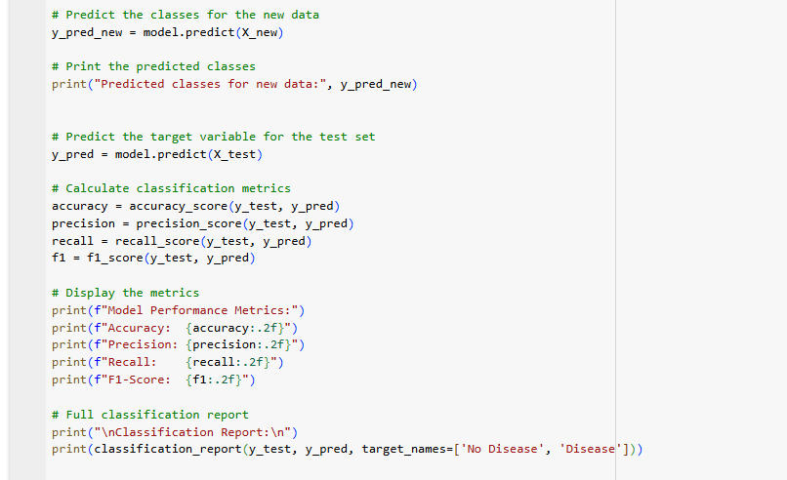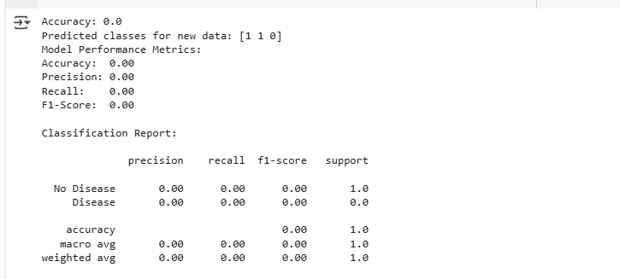

b) Evaluate the model's performance using classification metrics (e.g., accuracy, precision, recall).

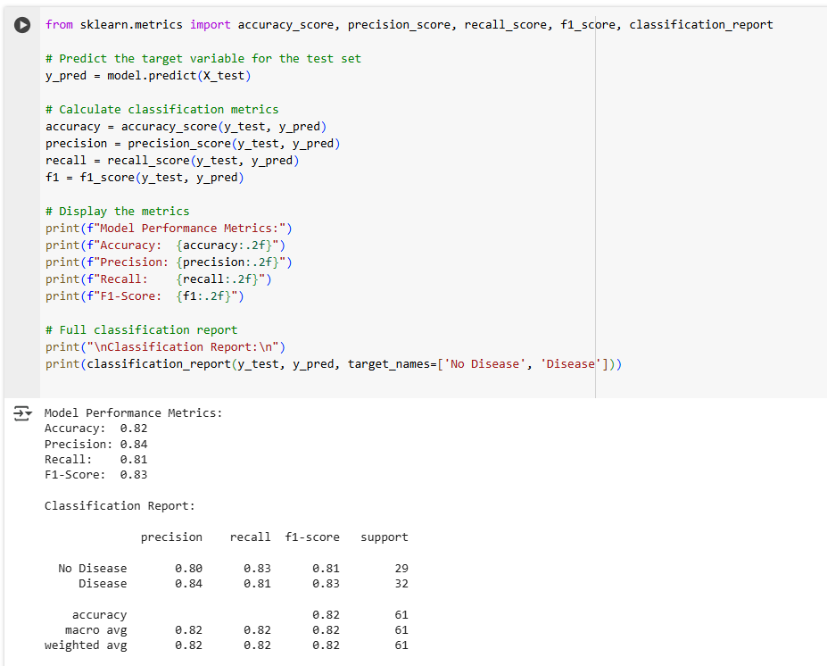

c) Construct a decision tree model and interpret the decision rules for classification.

