# **Practical No – 08**

# **K-Means Clustering**

a) Apply the K-Means algorithm to group similar data points into clusters.

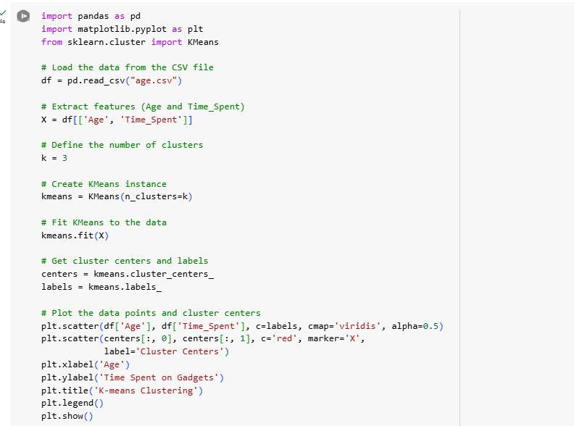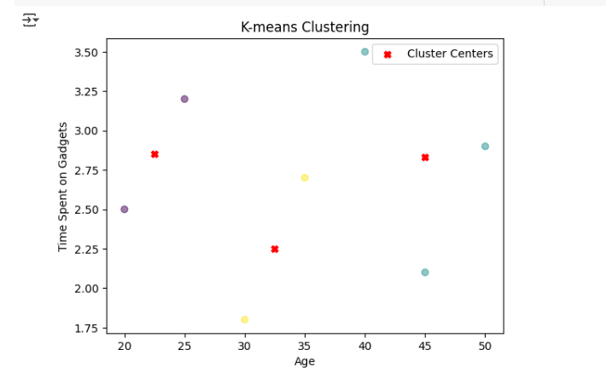

b) Determine the optimal number of clusters using elbow method or silhouette analysis.

c) Visualize the clustering results and analyze the cluster characteristics.

