

MoneyView NetSuite User Guide
(Fixed Deposit)



Table of Contents:
Creation of Fixed Deposit 3
Import CSV 6
Approval Process 9
Money Receipt JE (When the first FD Details are input in the System) 13
Interest Accrued Monthly JE (Every Month Interest Accrual) 13
Every Month Interest Accrual- Reversal of Previous Month Entry 15
When the Interest received is Updated 15
When Renewal Tag is updated- With Capitalization 17
When Renewal Tag is updated- Without Capitalization 19
Renew FD 20
When Redemption tag is updated 23

Note:
- The Admin role has full system access, including all modules, records, and configurations.
- All the fields with (*) in UI are mandatory.
User can create the Fixed Deposit record by 2 ways:
- Creation of Fixed Deposit (by filling up all the details one by one in the form)
- Import Of CSV Records (by importing the bulk fixed deposit records in one-go)

Creation of Fixed Deposit
To create a Fixed Deposit via A/P role, user needs to navigate to:
Vendors -> Other -> Fixed Deposit
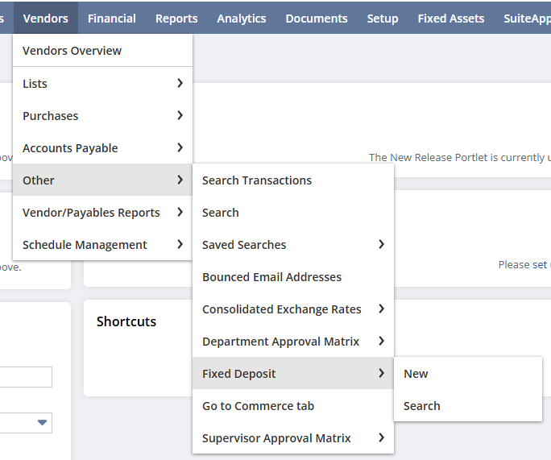
Click on New Fixed Deposit button, Custom Fixed Deposit Form will display.
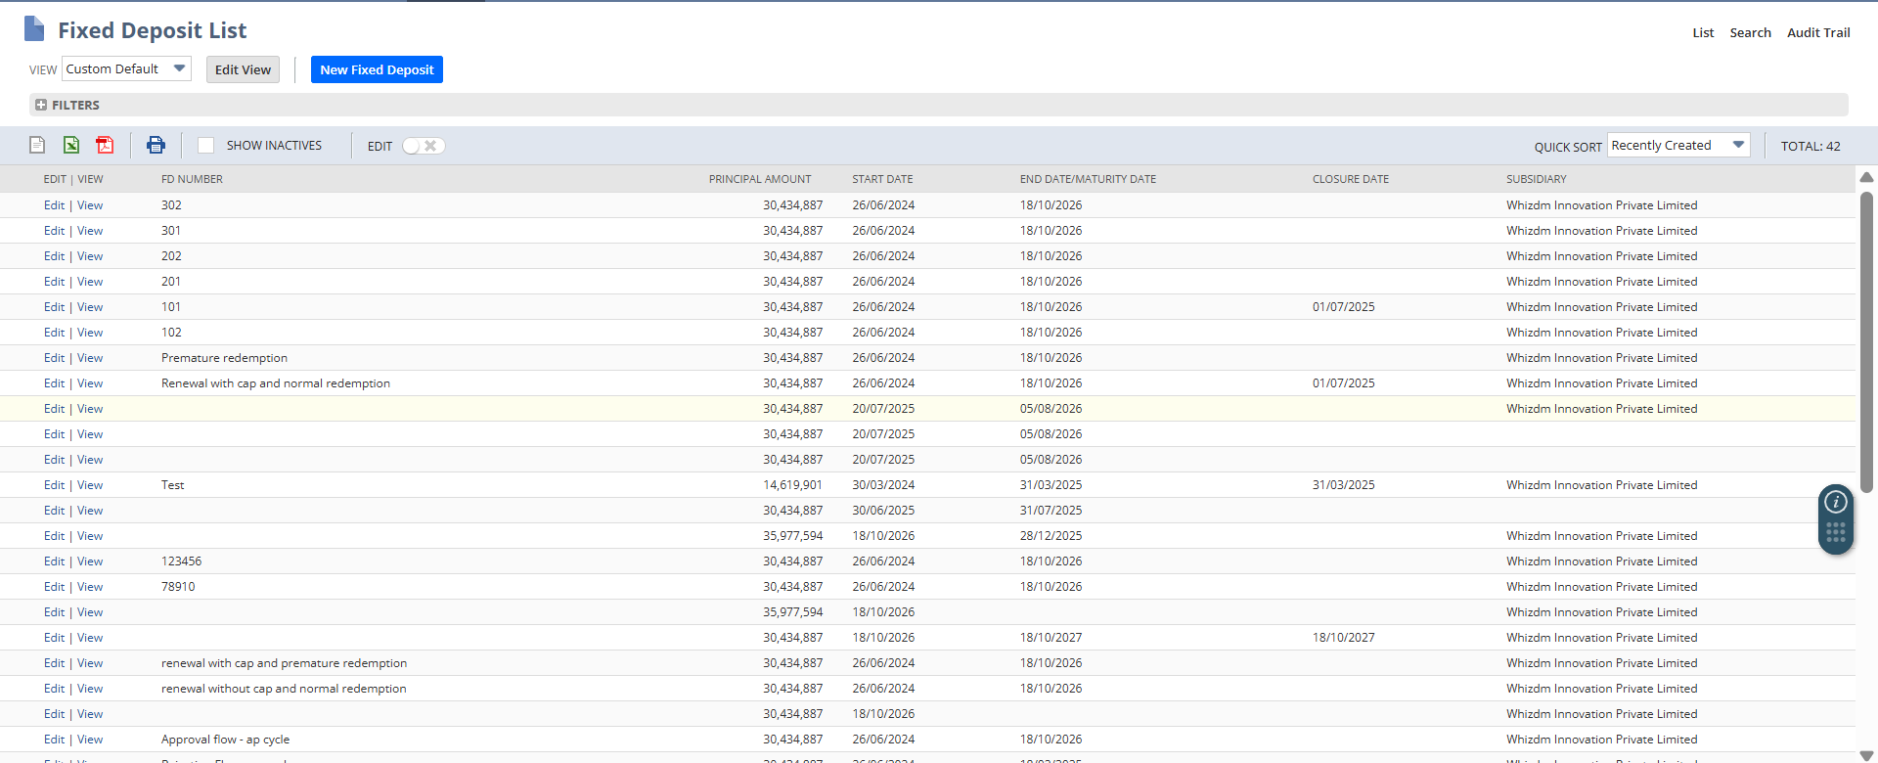
User needs to fill up all the required fields present in Custom Fixed Deposit Form:
Details:
- Custom Form (auto-populate with Custom Fixed Deposit Form)
- Subsidiary
- FD number
- Deposit Account Number
- Higher Category
- Fixed Deposit Category (will auto-populate as Fresh)
- Fixed Deposit Type (Specify whether the fixed deposit is of Current or Non- Current)
- Bank Name
- Category of Bank
- Start Date
- End Date/Maturity Date
- ROI (in percentage)
- Principal Amount
- Maturity Amount (This field reflects the total of the amount credited to the bank account along with the TDS deducted on it.)
- ALM Bucket
- Starting Date of Fiscal Year (auto populated, however can change the date and the calculations fields will be updated according to the updated date in Starting Date of Fiscal Year)
- Reporting Date (auto populated, however can change the date and the calculations fields will be updated according to the updated date in Reporting Date)
- Memo (in this field we can add any Narration)
- TDS Percentage
- Opening TDS Amount (This is used only for fixed deposits that are created before 1st April, 2025)
- Opening Interest Accured FY Start (This is used only for fixed deposits that are created before 1st April, 2025)
- Interest Realized Type (Specify whether the interest to be realized is of Payout type or Compounding type.)
- Frequeny of Payout (Specify whether the frequency of interest realized payout is of Monthly or Quarterly)

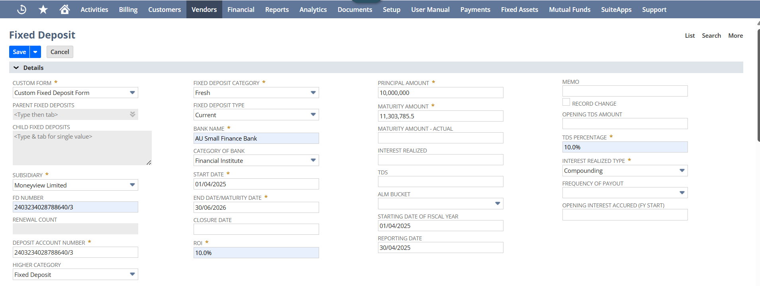
Lien Details:
- Lien Marked (checkbox), if checked below fields will display.
  - Lien Marked Date (will auto-populate with today’s date)
  - Lien Marked Amount
  - Lien Marked Party
  - GL Accounts
GL Accounts:
- Fixed Deposit Account
- Accrued Interest on Fixed Deposit Account
- Interest Income on Fixed Deposit Account
- TDS Receivable Account
- Bank Account
On filling up all the mandatory fields, click on Save button.
On click of Save,
Calculations section will get update based on the data filled in the top Details section:
- Remaining Days (will get auto update if user make any update to Reporting Date field (present in Details section))
- Total Interest Amount
- Interest Per Day
- Number of Days During FY (will get auto update if user make any update either to Reporting Date or Starting Date of Fiscal Year fields (present in Details section))
- No.of Days till the Starting Date of Fiscal Year
- Income Recognized Till The Starting Date Of Fiscal Year
- New (will get auto update if user make any update to Starting Date of Fiscal Year field (present in Details section))
- Opening
- Redemption
- Opening Interest Accrued
- Closing Interest Accrued
- FD Incl Int Acc
- Tenor (in Days)
- TDS Receivable FY
- FD Balance As On
- Compounding Value (will display the compounded principal value if the Interest Realized is of Compounding type)
- The below field should not be filled while creating the fresh Fixed Deposit record.
  - Interest Realized
  - TDS
  - Closure Date
  - Record Change checkbox
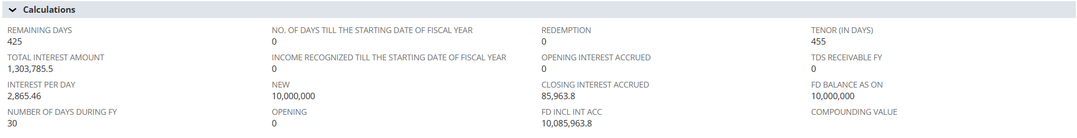
Created By field gets updated with the creator’s name in Approval Details section:
Submit for Approval button displays on top.
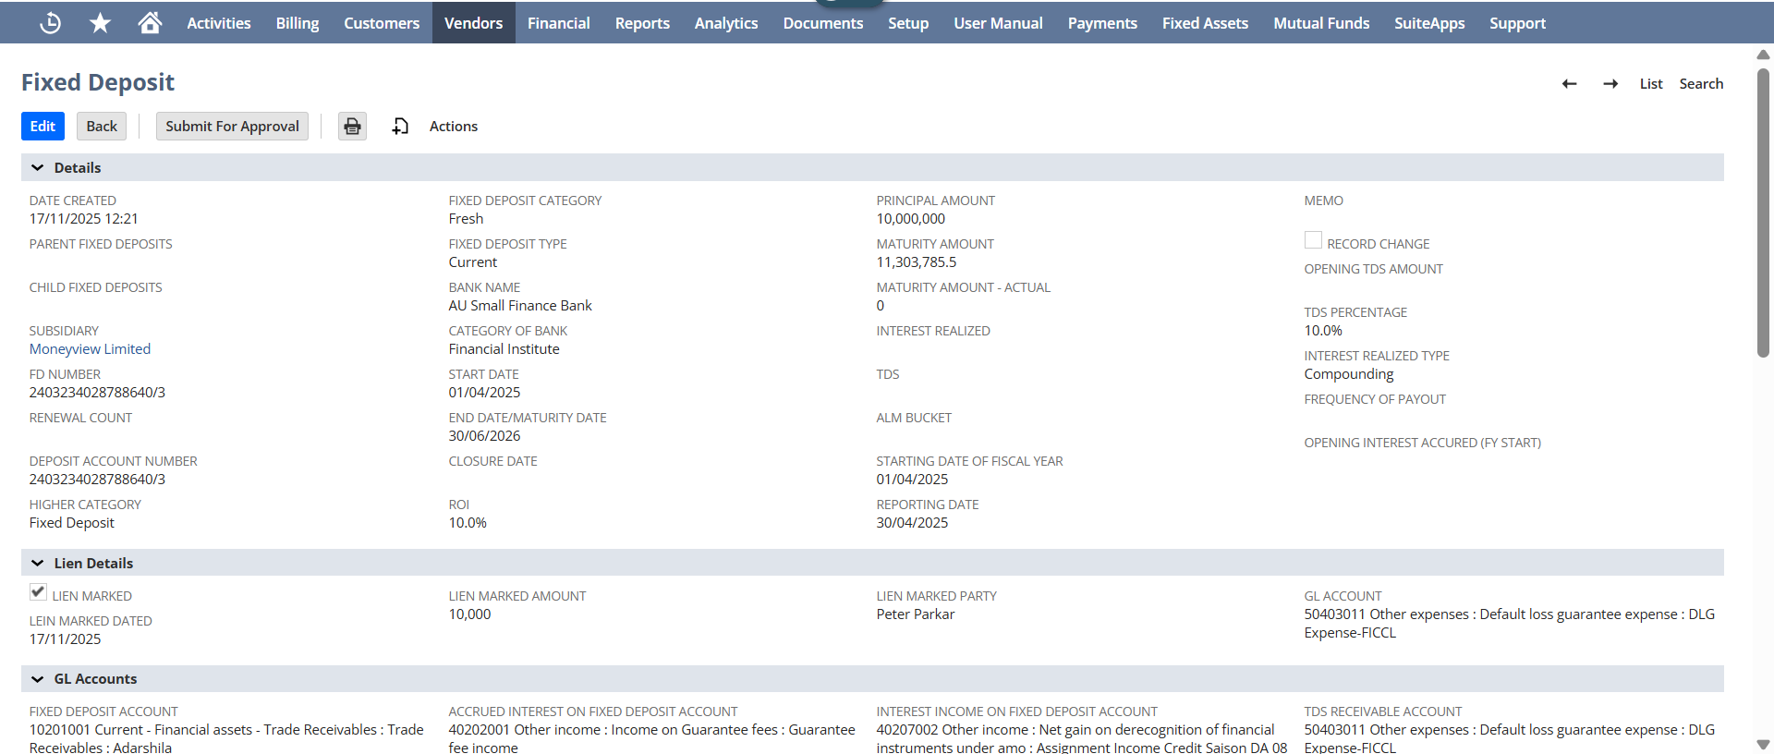

Import CSV
To import CSV, user needs to navigate to:
Setup → Import/Export → Saved CSV Imports.
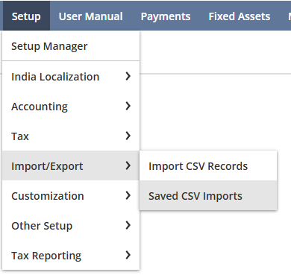
Saved CSV Imports page display.
Filter out the list and select Custom Record and select the Fixed Deposit Import option
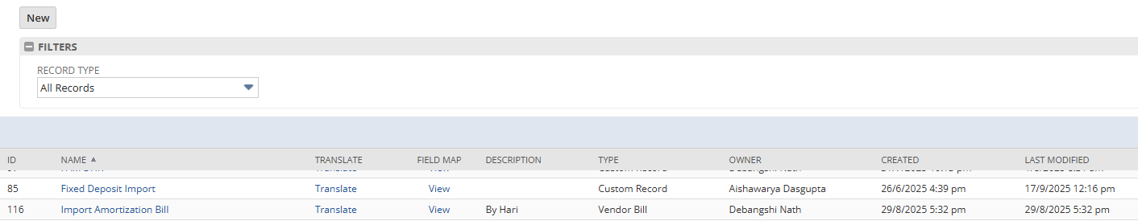Import Assistant page displays.
Click on Select button and upload the CSV document.
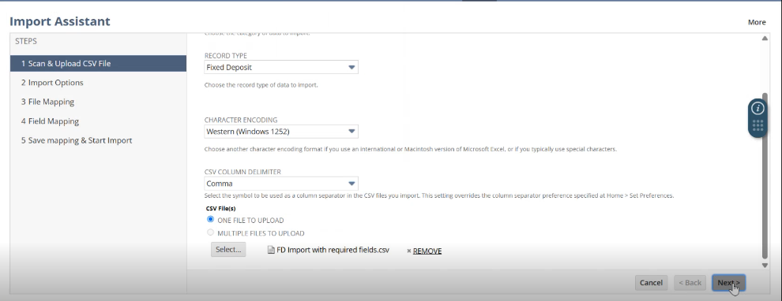
Click on Next button.
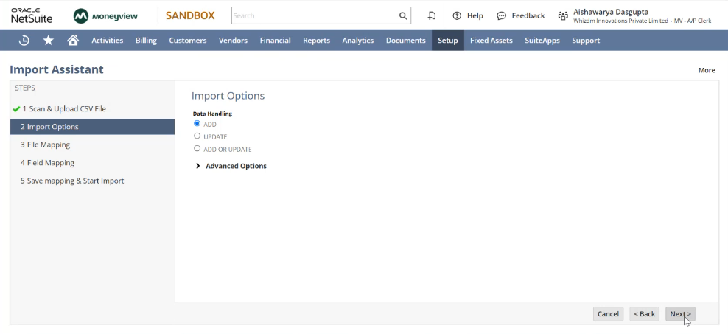Click on Next button.
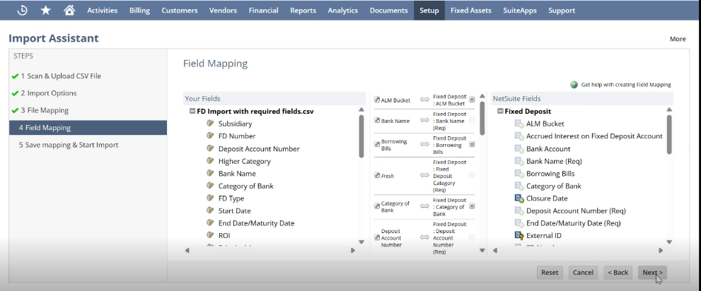Click on Next Button.
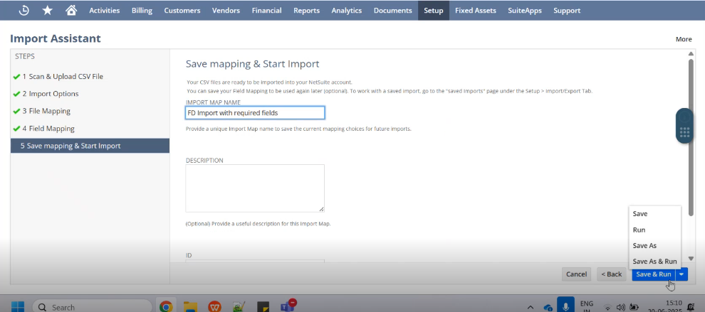
Hover over the Save & Run button and select the Run option.
Confirmation popup will display and then click on the hyperlink "Click to view the Import Job Status".
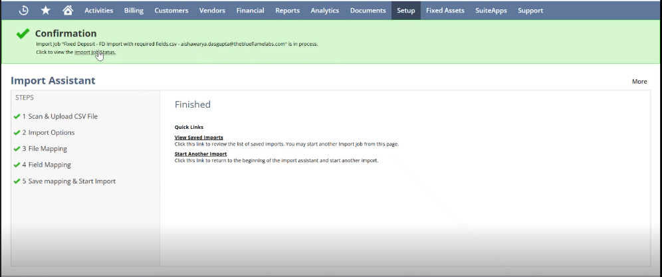
Verify if the Job Status gets completed.
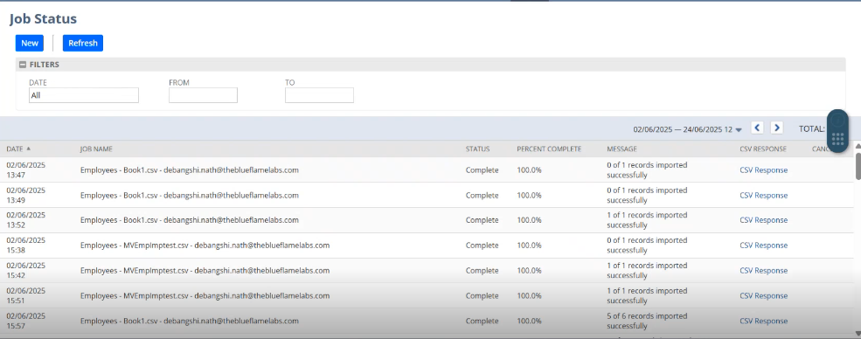
And then, navigate to the Fixed Deposit List and verify the imported records get created and are displayed on the list.
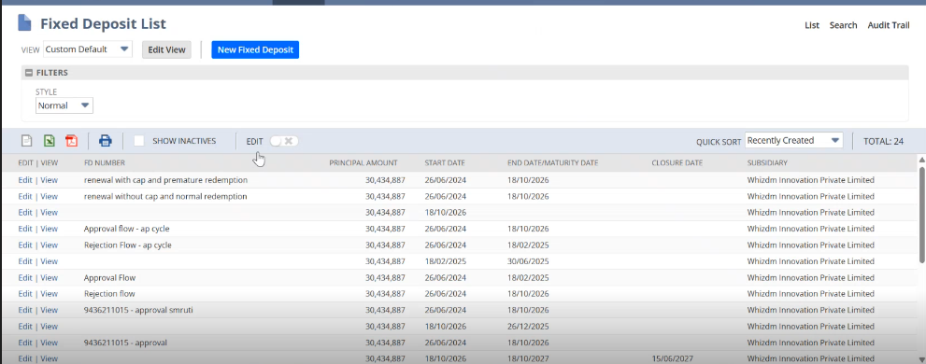
NOTE: When we create the Fixed Deposit record for First time the “Fixed Deposit Category” is always set as “Fresh” marking the beginning of its lifecycle.
Click on View hyperlink to view the detailed record, and then click on Submit for Approval button for the further Approval process.
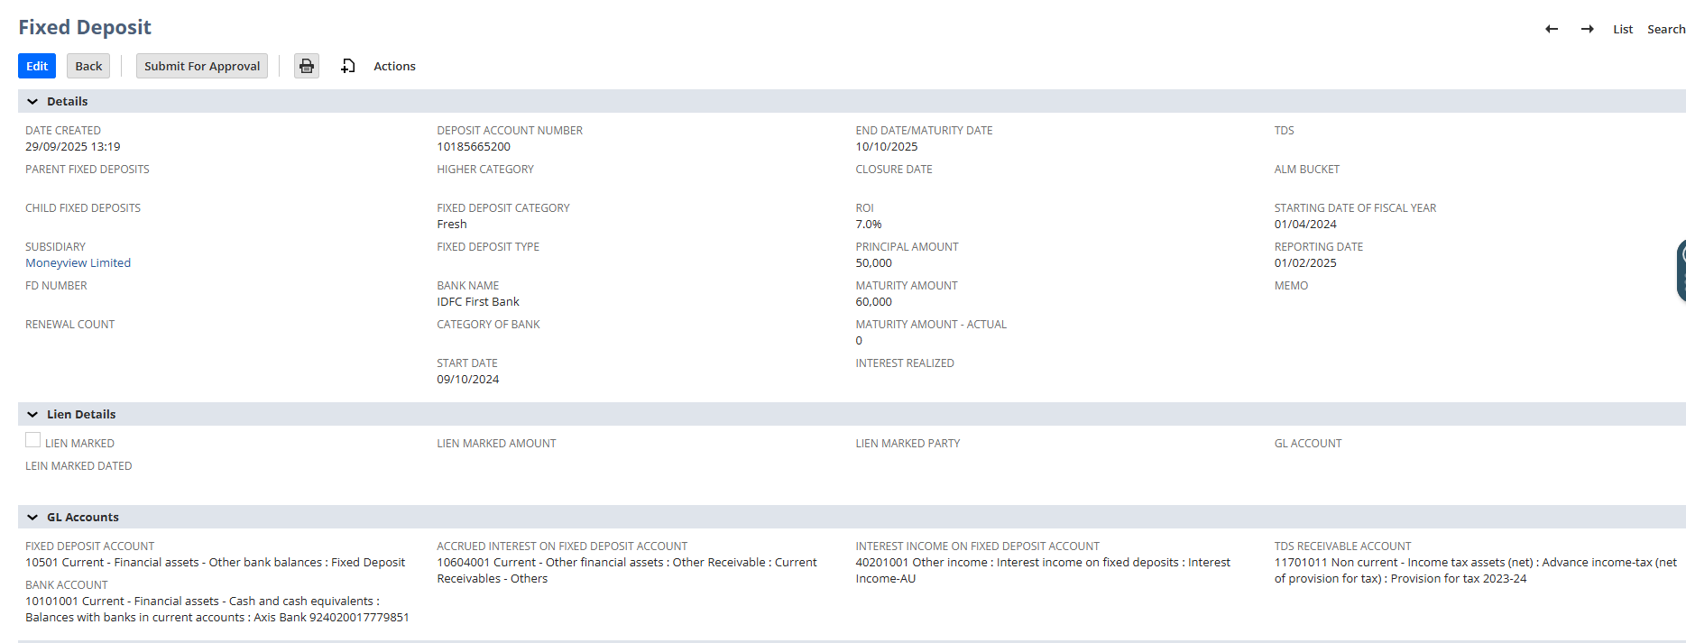

Approval Process
On click of Submit for Approval button,
- Edit button gets disabled and the record gets locked.
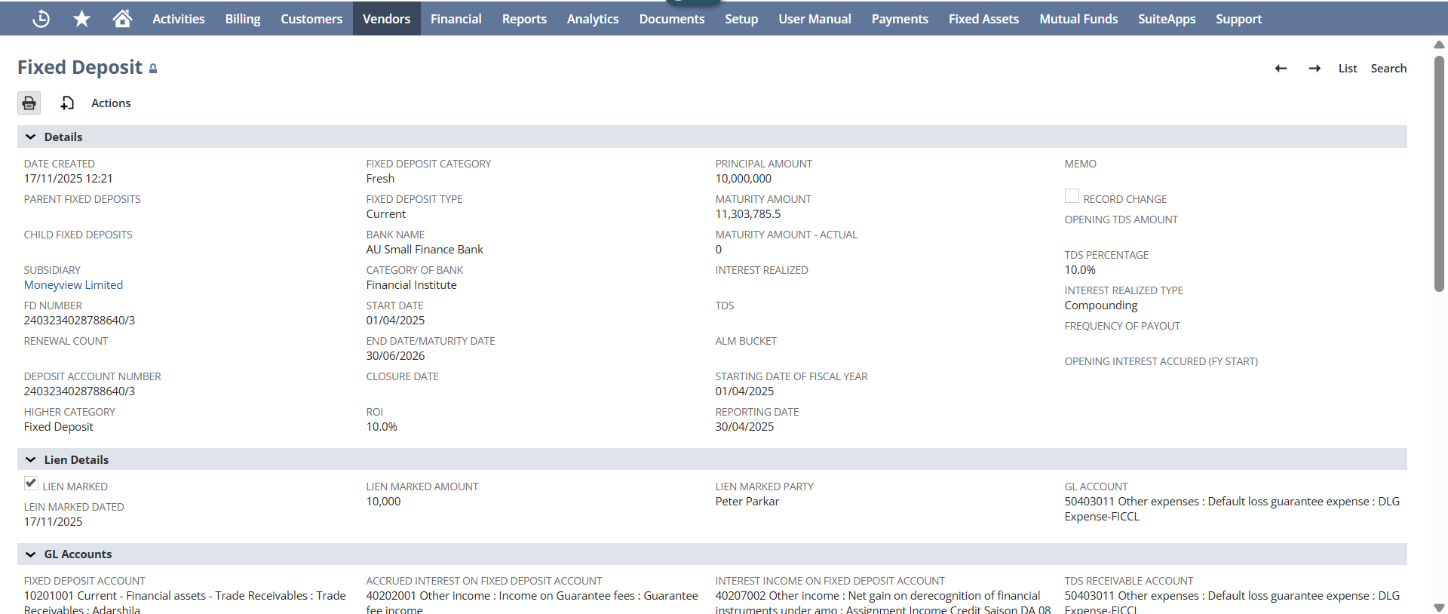
- Approval Status and Approver(s) Name gets auto updated.
- The approval request is sent to user via both email and UI
UI Approval Process:
User needs to login via Supervisor’s account (Peer-to-Peer role )and needs to navigate to:
Lists -> Custom -> Fixed Deposit
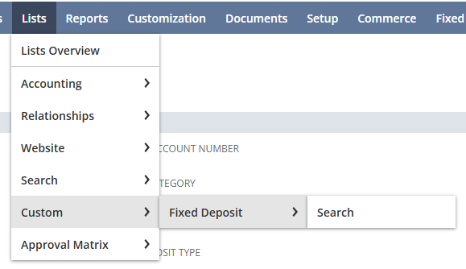
Fixed Deposit List displays, then click on the number to open the record that needs to be approved.
Approve and Reject buttons should be present to allow user to either Approve or Reject the record.
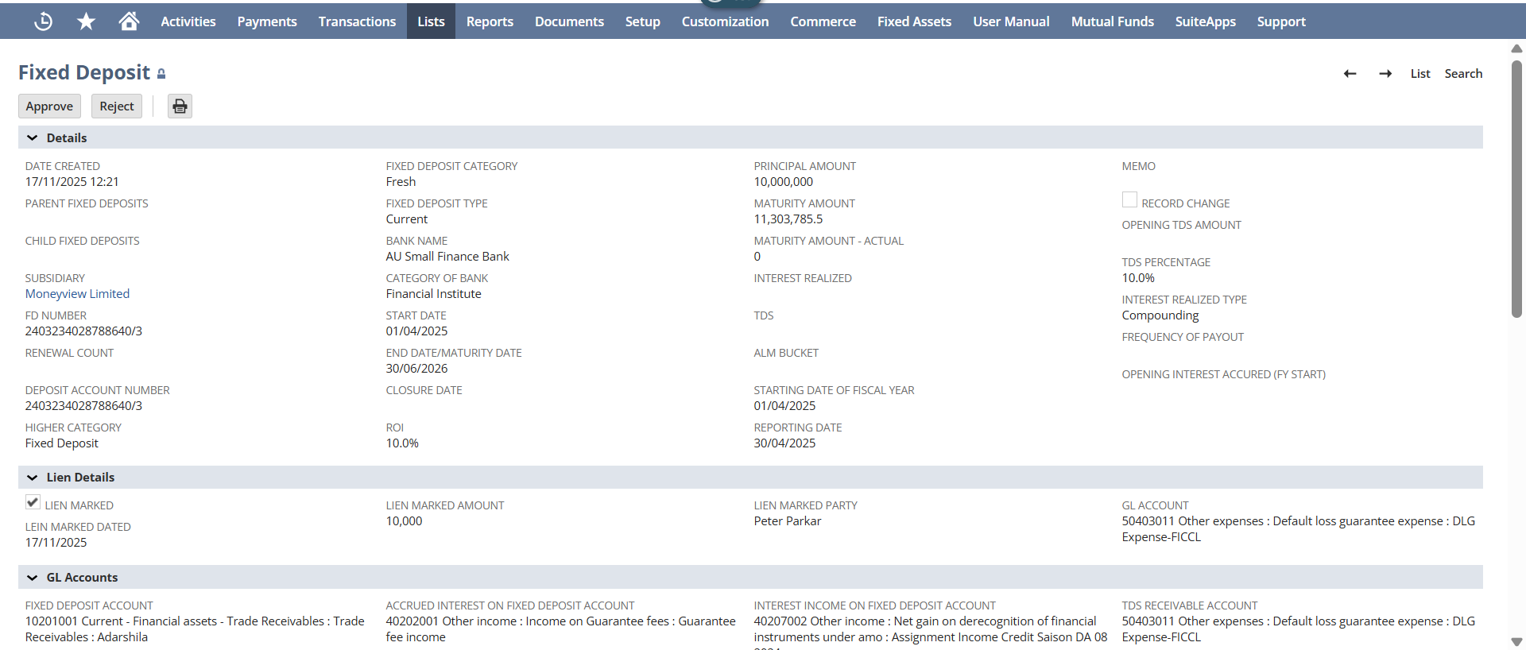
Email Approval Process:
- Only the Supervisors will receive the email when user clicks on Submit for Approval button.
- User must be able to view the FD Number, Bank Name, Deposit Account Number, Principal Amount, ROI, Maturity Amount, Start Date and End Date.
- View Record link should be present on click of which user should be navigated to the Record detail page. (However, the user should login to their dedicated role first to view the record)
- Approve and Reject buttons should be present to let user approve or reject the record.
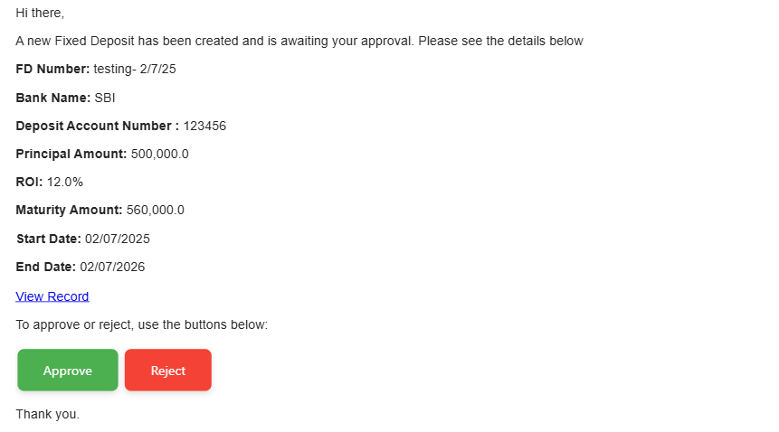
On click of Reject button either from Email or UI:
On click of Reject button,
A popup will display to enter the valid Rejection reason.
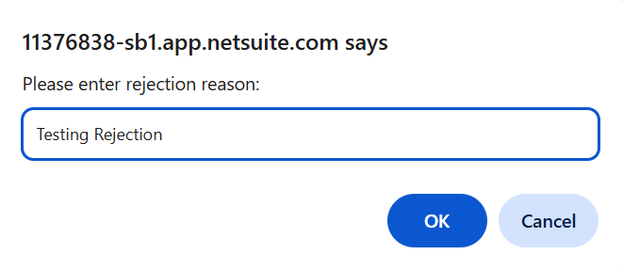

Enter the valid Rejection reason and click on Ok button.
On click of which, Approval Status and Rejection Reason will display in the Approval Details section.
The record is redirected back to the Creator, where the Resubmit for Approval button becomes available. The user can edit the record and resubmit it for the Supervisor’s approval.
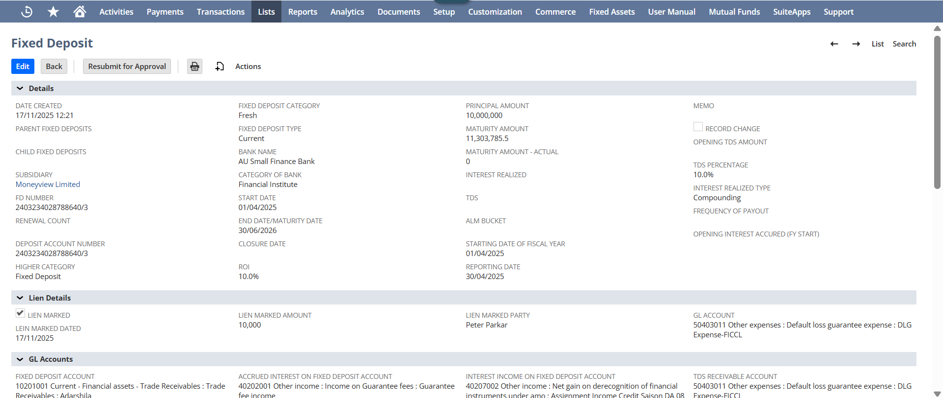

On click of Approve button either from Email or UI:
On click of Approve button,
The page refreshes and the record gets approved and the Approval Status gets updated as Approved.

When Approved, the script is executed, The Investment Entry JE will get created and gets link in the Investment Entry JE field.

Investment Entry JE (When the first FD Details are input in the System)
Once the script is executed and FD is approved. The Journal for the Investment Entry will get created.
- The created Journal should display as the hyperlink in the Journal section under the Investment Entry JE field.
- The checkbox Money Receipt JE Created gets checked.
On click of Journal hyperlink, user should be redirected to the Journal detailed page.
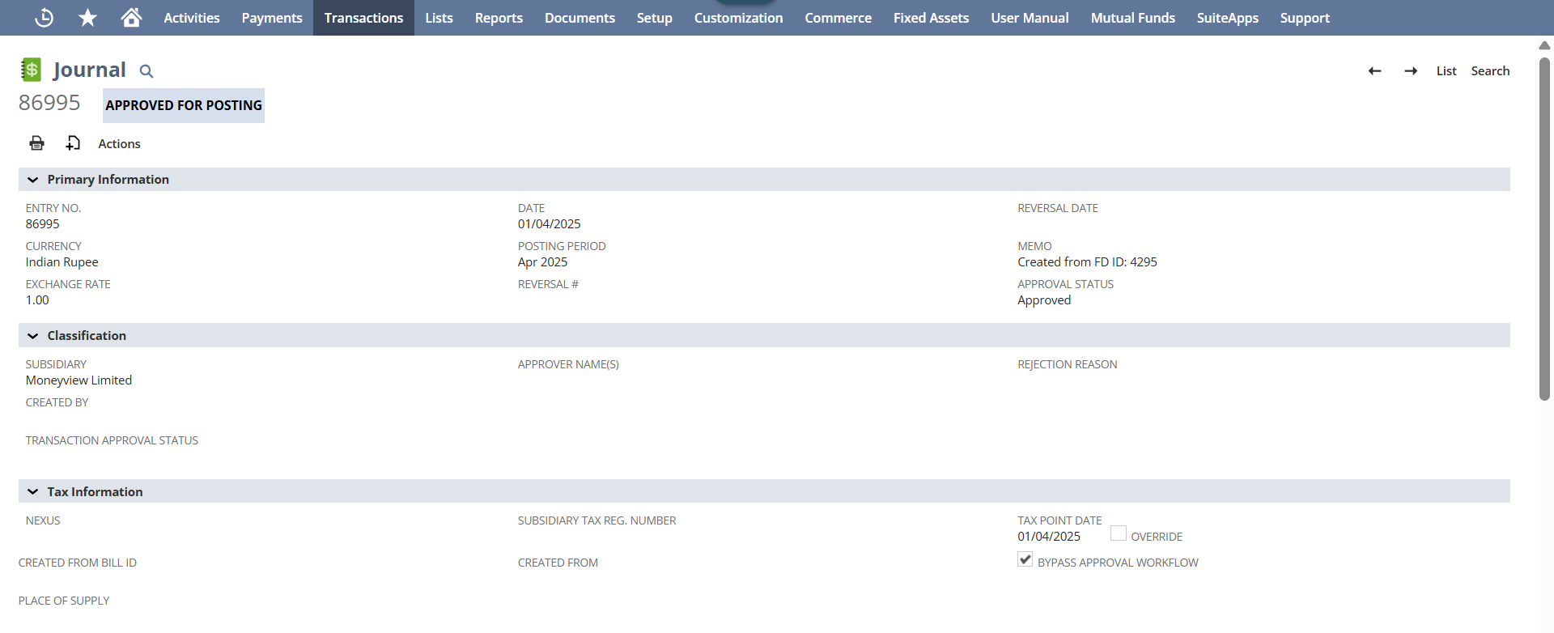
User needs to verify the Start Date present in the Fixed Deposit record is set on the Date field of the Journal entry page.
Now, navigate to Lines subtab where:
- FD Account gets Debit
- Bank Account gets Credit
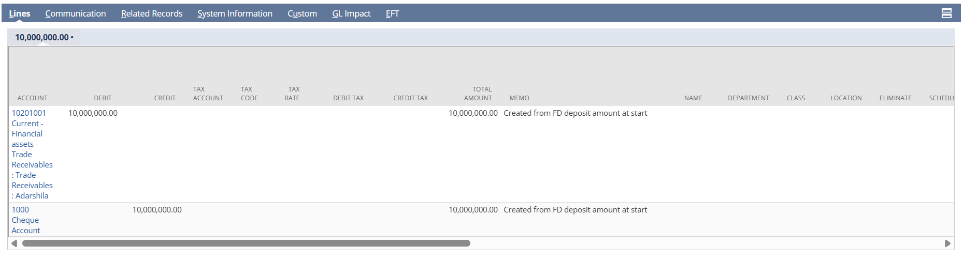
Interest Accrued Monthly JE (Every Month Interest Accrual)
Once the record gets approved and the money receipt JE is created the FD lifecycle starts and the script with get auto-run on the backend on the last day of each month till the end of the fixed Deposit lifecycle. And the Journal for the Interest Accrued Monthly JE will get created.
The created Journal should display as the hyperlink in the Journal section under the Interest Accrued Monthly JE field.
On click of Journal hyperlink, user should be redirected to the Journal detailed page.
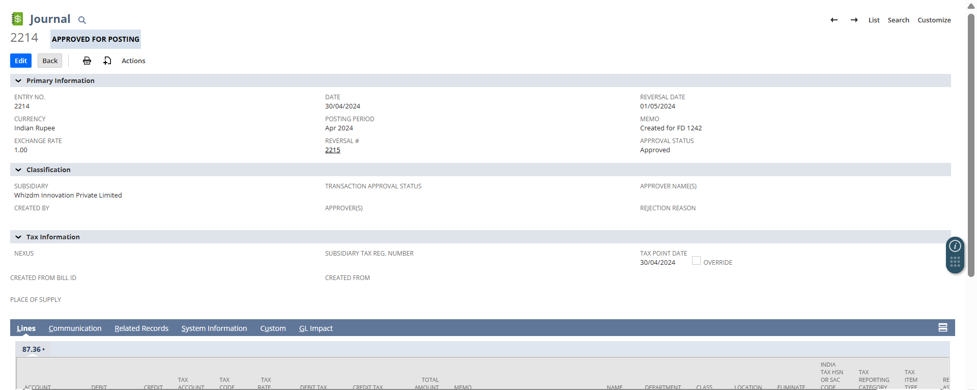
Scenario 1:
- Date field- shows the Date of the last date of the month (on which the record is created here- 30/04/2024)
- Reversal Date- shows the date of the first date of the upcoming month. (here- 01/05/2024)
- Reversal #- Displays the Reversal Journal link with a date of the first date of the next month
Scenario 2:
If Reversal Date is of future date (the Date which has not yet past for example- 01/08/2025), then in this scenario on the field Reversal #- Deferred will display, and once the date gets past through the Reversal # journal gets auto create.
The monthly Accrual interest JE will show Cumulative interest accrued for the days passed from Start date to month end date (on which JE is created).
Please refer the below screenshot from the old record.
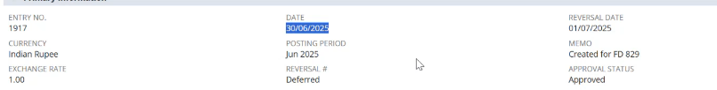
Now, navigate to Lines subtab where Accrued Interest gets Debit
- Interest Income gets Credit
- And the Memo will display the no. Of days passed from Start Date to today’s Date.
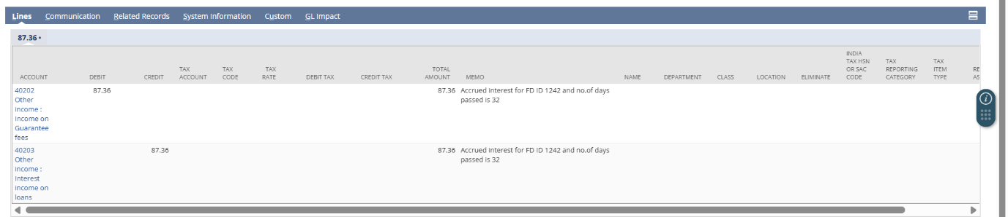
Every Month Interest Accrual- Reversal of Previous Month Entry
Navigate to the above created Interest Accrued Monthly JE Journal, look for the Reversal# field, and open the Reversal Journal record created for the same field.
The status will display as the Reversal Approved For Posting.
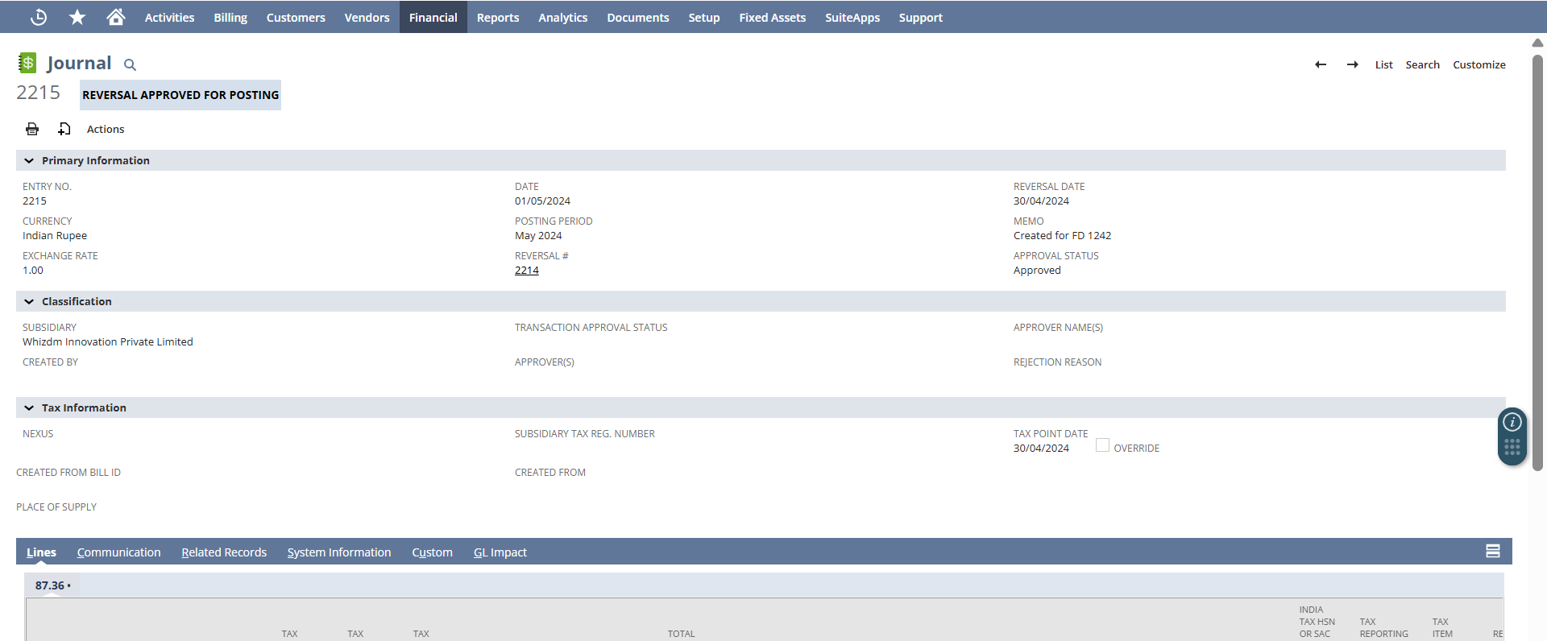
On Date field the Reversal Date of the Month End Journal entry get set. (i.e. the 1st day of the next month.)
Now, navigate to Lines subtab where:
- Interest Income gets Debit
- Accrued Interest gets Credit
- And the Memo will display the no. Of days passed from Start Date to today’s Date.
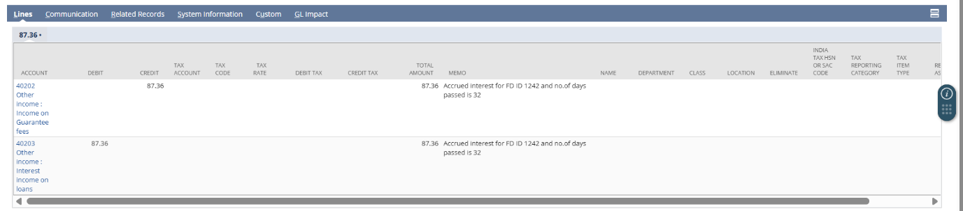

When the Interest received is Updated
Open your created Fixed Deposit record, and edit the Interest Realized and TDS fields present in Details section.
Please check the Record Change checkbox, as the record has been modified and needs to go through the approval process again.
Click on Save button with Interest Realized=1000, and TDS= 100.
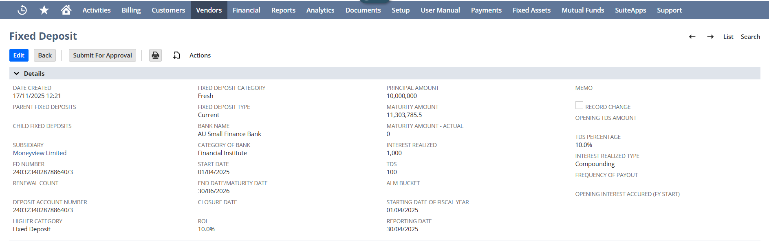

Upon saving and approving the fixed deposit record, Interest Realized JE gets created within the Journal section under the Interest Realized JE field.
Every time when the Interest will be realized user needs to re-click on Edit button and have to update Interest Realized and TDS fields present in Details section.
Click on Save button with Interest Realized=10,000, and TDS= 1000.
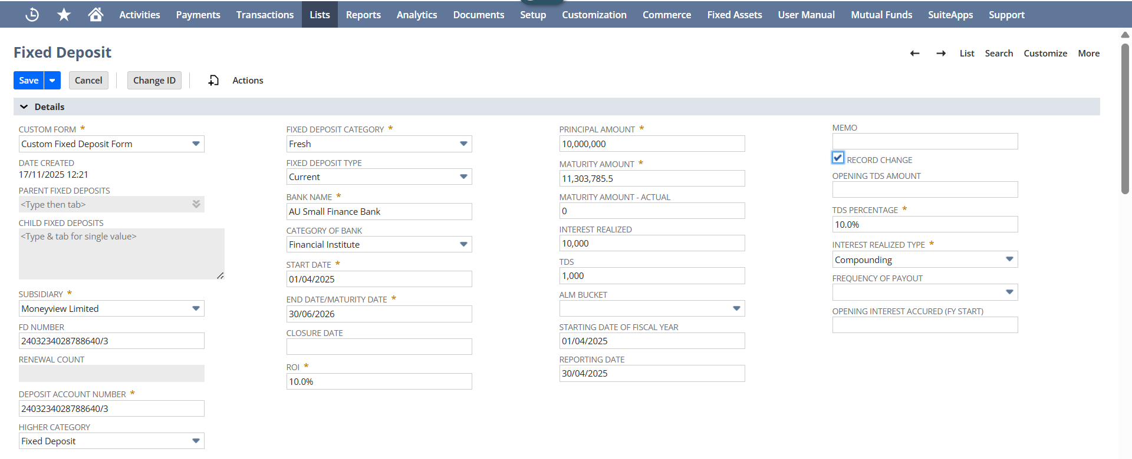
Upon saving and approving the fixed deposit record, second Interest Realized JE gets created.
On click of Journal hyperlink, user should be redirected to the Journal detailed page.
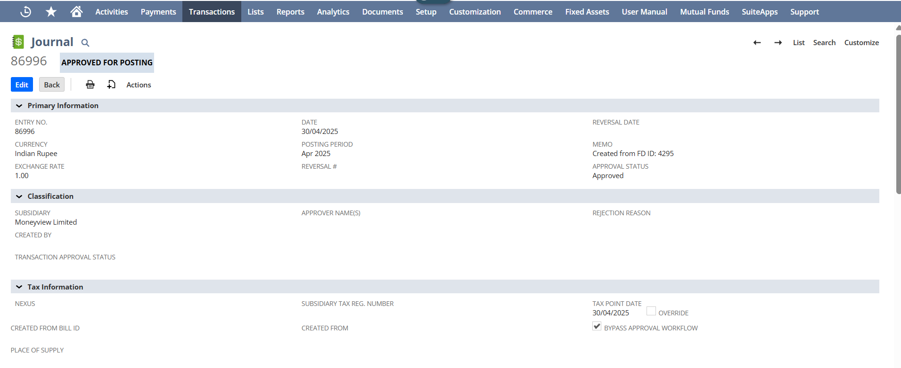

Date field of the Journal Entry page is the same date as the Reporting Date.
Scenario 1:

- The user must also verify that the "Debit" and "Credit" values under the Lines sub-tab are balanced.
- The "Credit" amount on the Journal Entry page should match the Interest Realized shown on the Fixed Deposit page, while the "Debit" side should include both the TDS amount and the net Interest amount (after TDS deduction) credited to the Bank account specified on the Fixed Deposit page.

Fixed Deposit page
- Interest realized: 1,000
- TDS: 100


Interest Realized JE
- Bank Account gets Debit: 900 [ Note: In case the interest realized is of payout type, the amount debited from the FD Account will instead be debited to the Bank Account ]
- TDS Amount gets Debit: 100
- Interest Income gets Credit: 1000
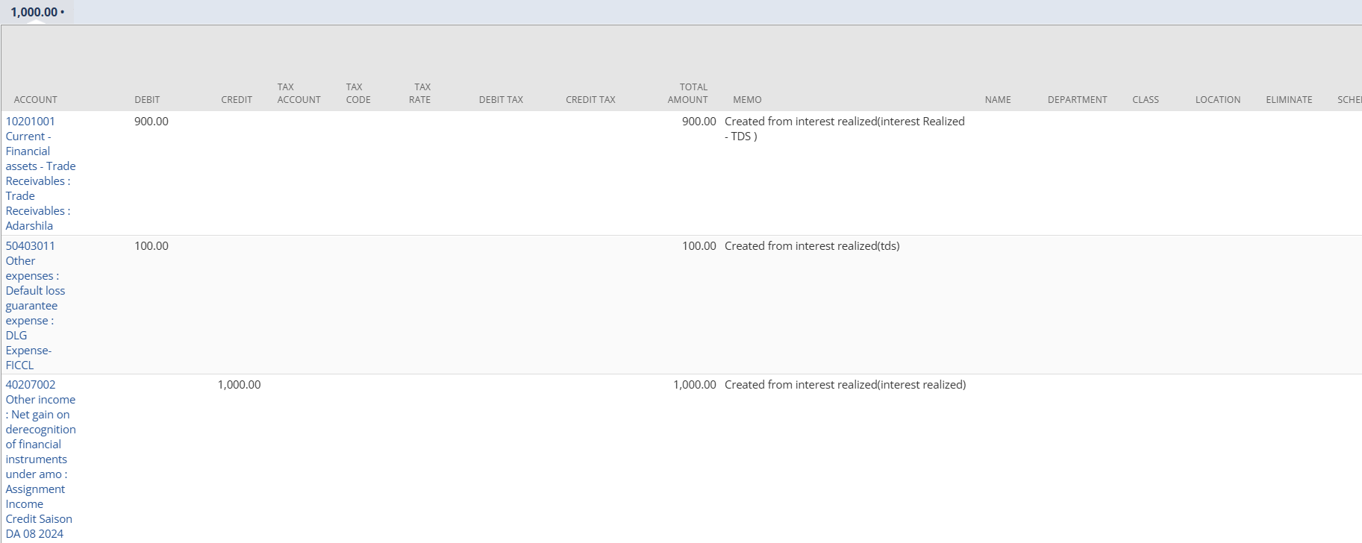

Scenario 2:
Click on the Edit button and navigate to the Interest Realized and TDS field and update the amount. Check if the new JE will be generated in the Interest Realized JE field under the Journals section.
The user must also verify that the "Debit" and "Credit" values under the Lines sub-tab are balanced.
The "Debit" amount on the Journal Entry page will be the remaining amount according to the previously entered amount in Interest Realized field on the Fixed Deposit page, while the "Debit" side for the TDS field will be the remaining amount which was previously entered and the net Interest amount will be the remaining amount credited to the Bank account specified on the Fixed Deposit page.
Fixed Deposit page
- Interest realized :10,000
- TDS: 1000
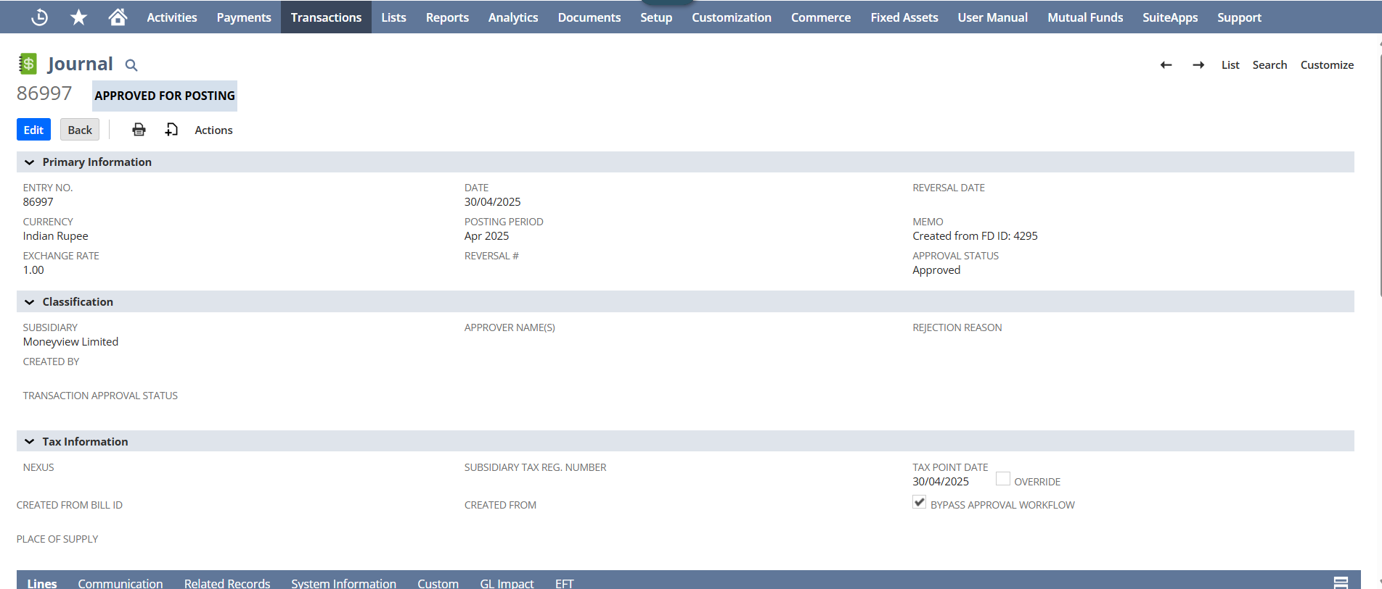

Interest Realized JE
- Bank Account gets Debit: 81,000 (Remaining Interest Realised - TDS) [ Note: In case the interest realized is of payout type, the amount debited from the FD Account will instead be debited to the Bank Account ]
- TDS Amount gets Debit: 900 (Remaining TDS)
- Interest Income gets Credit: 9000

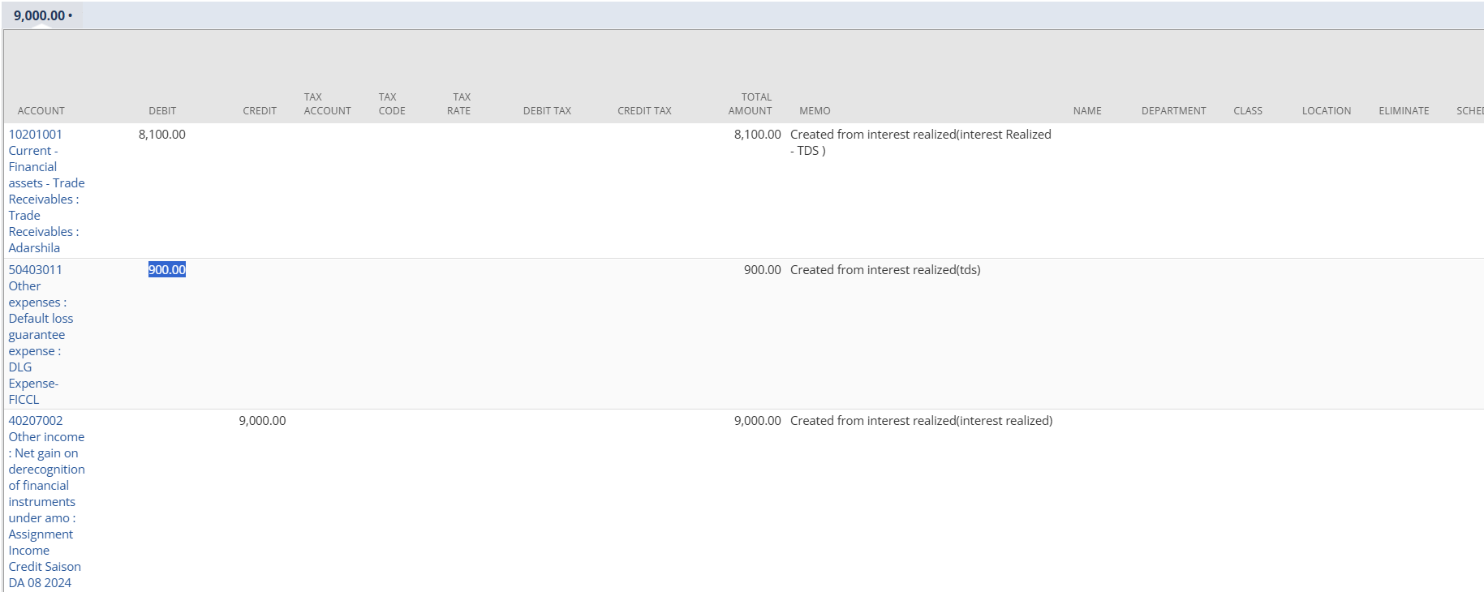

In the case of compounding-type interest realized, the compounding amount added to the original principal is displayed in the Compounding Value field under the Calculation section.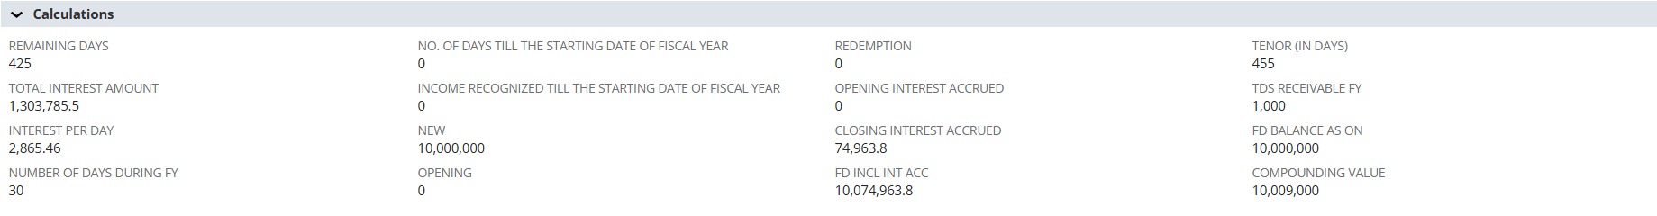
When Renewal Tag is updated- With Capitalization
Every time when user wants to renew the FD, user needs to open the created Fixed Deposit record.
Click on Edit button and update the Fixed Deposit Category as Renewal – with Capitalization along with that check the Record Change checkbox (again approval flow will trigger).
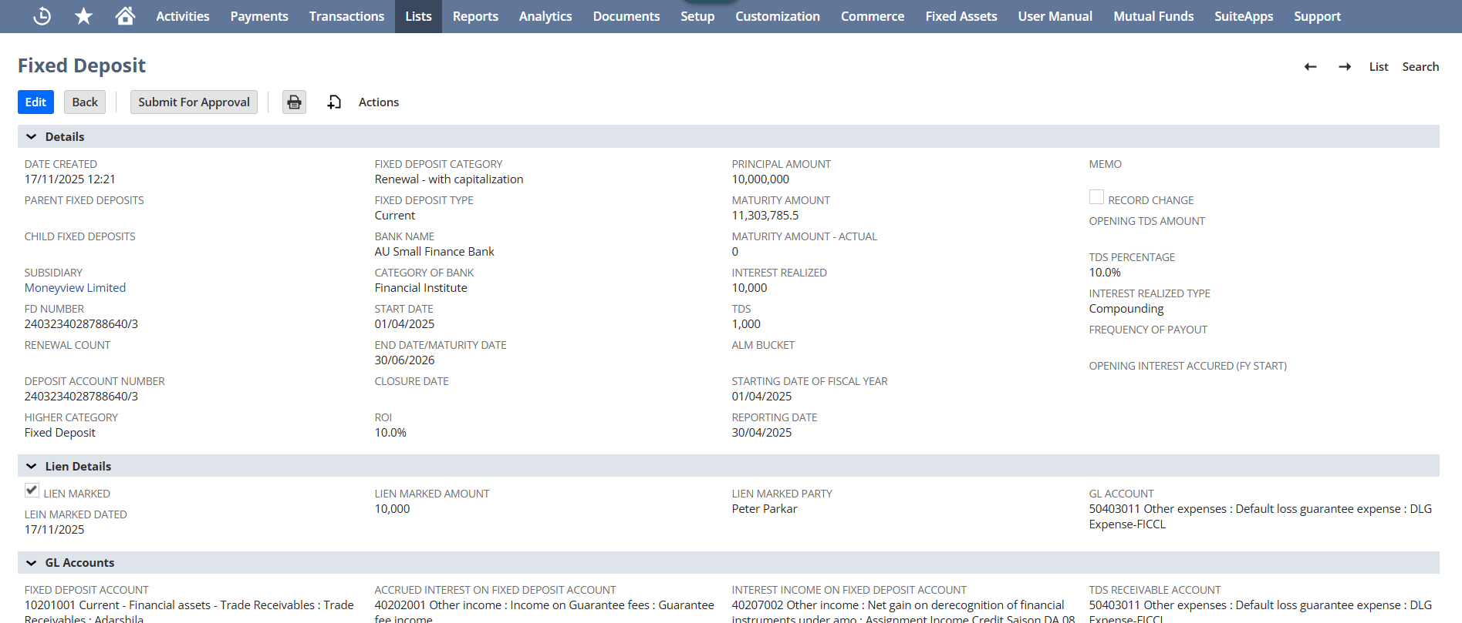
Click on Save button.
Upon saving and approving the fixed deposit record,, the Renewal with Capitalization JE gets created under the Journals section within the Renewal with Capitalization JE field.
On click of Journal hyperlink, user should be redirected to the Journal detailed page.
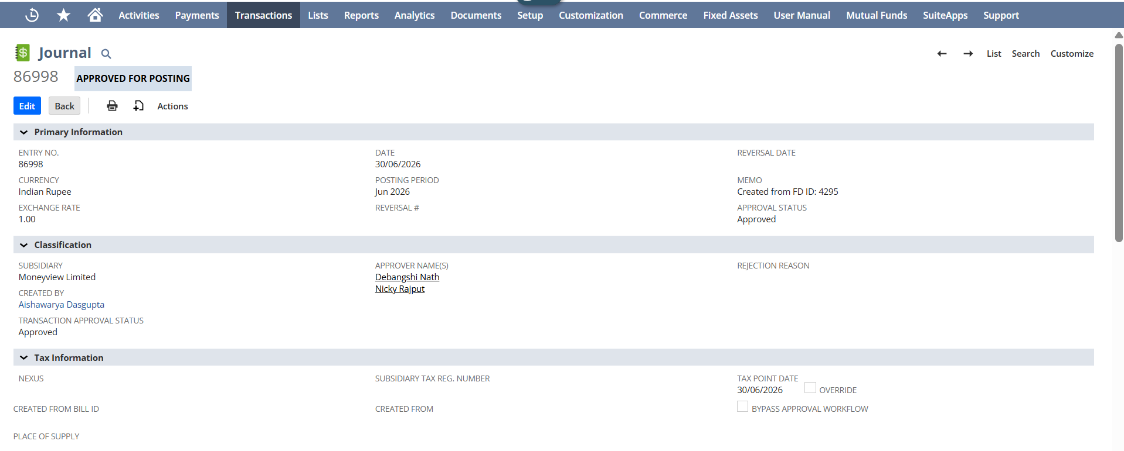
Date field on the Journal page is set as the End Date/Maturity Date that is present on the fixed deposit record.
Now, navigate to Lines subtab where:
- Full interest to FD account gets Debit
- TDS Account gets Debit
- Interest Income gets Credit
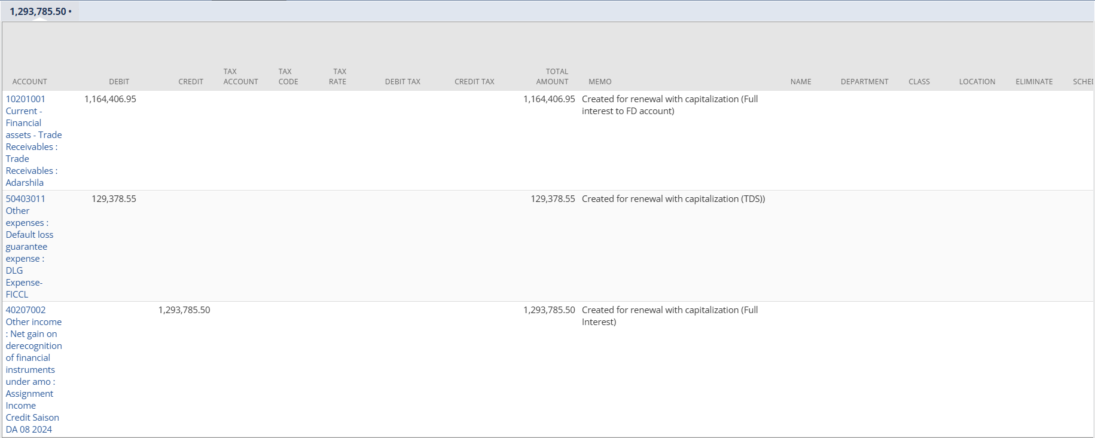

When Renewal Tag is updated- Without Capitalization
Whenever the user wants to renew the Fixed Deposit, user needs to open the created Fixed Deposit record and click on Edit button to update the record.
Update the Fixed Deposit Category as Renewal – without Capitalization and click on Save button.
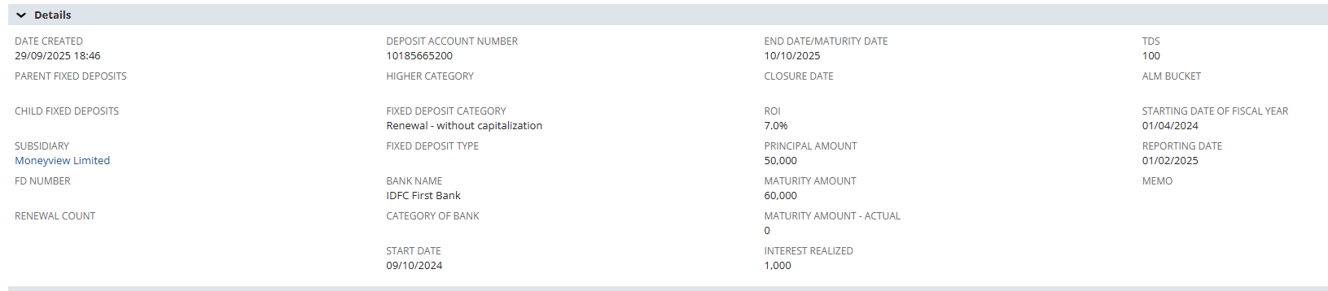
On save, the Renewal without Capitalization JE gets created under the Journals section within the Renewal without Capitalization JE field.
On click of Journal hyperlink, user should be redirected to the Journal detailed page.
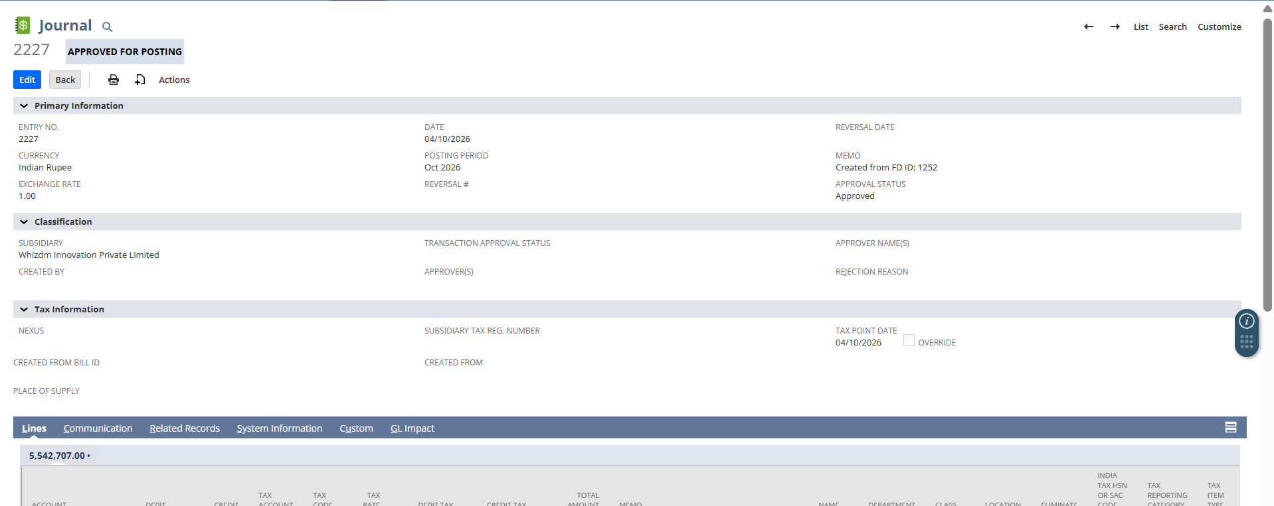
Date field on the Journal page is set as the End Date/Maturity Date that is present on the fixed deposit record.
Now, navigate to Lines subtab where:
- Bank Account gets Debit
- TDS Account gets Debit
- Interest Income gets Credit
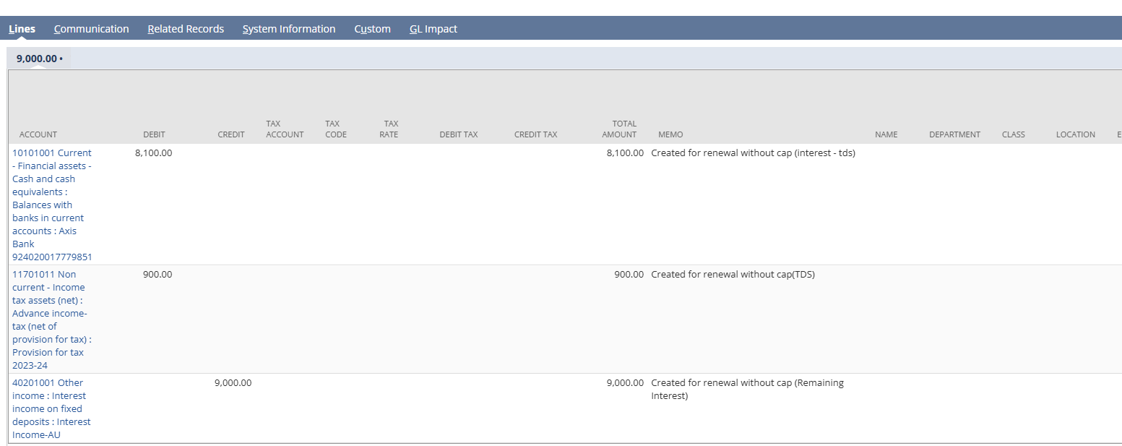

Renew FD
After successful Save and ensuring that Fixed Deposit Category is either - “Renewal - without Capitalization” or “Renewal- with Capitalization”, the Renewal FD button appears on top to allow users to renew their Fixed Deposits.
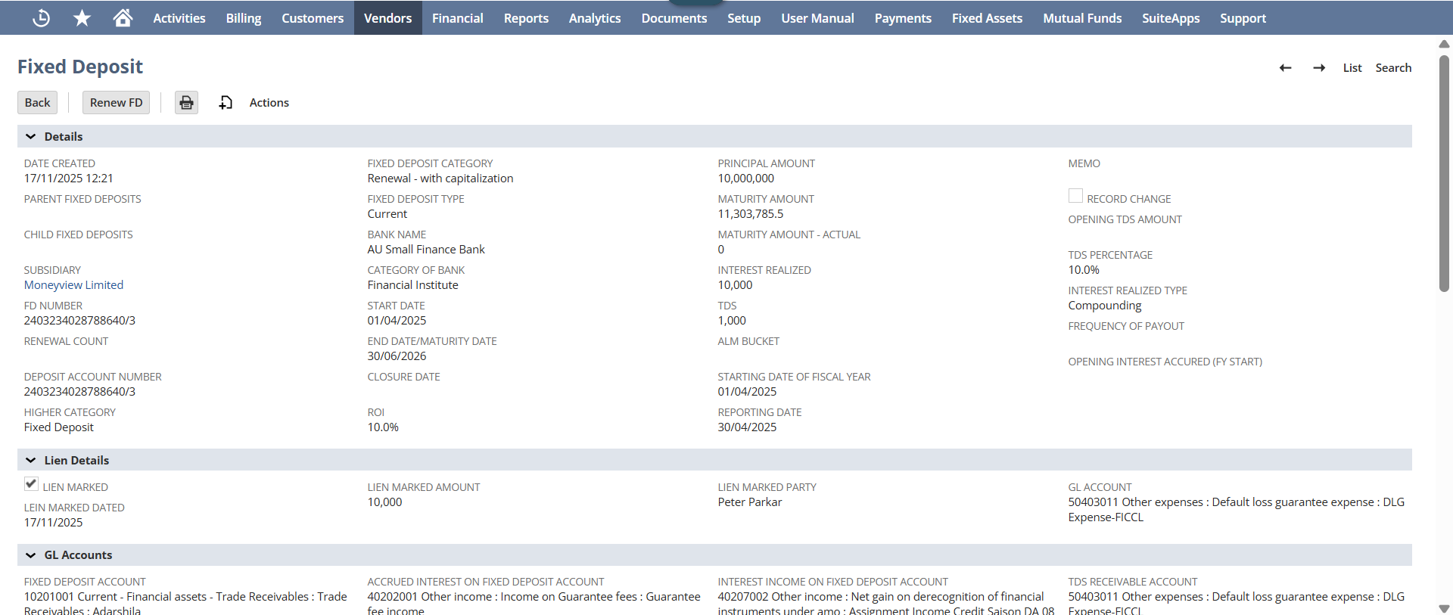
On click of Renew FD button:
- The record is displayed.
- End Date of Parent FD will be set as the Start Date.
- ROI, End Date/Maturity Date and Maturity Amount will get update as 0 and needs to be entered manually by the user.
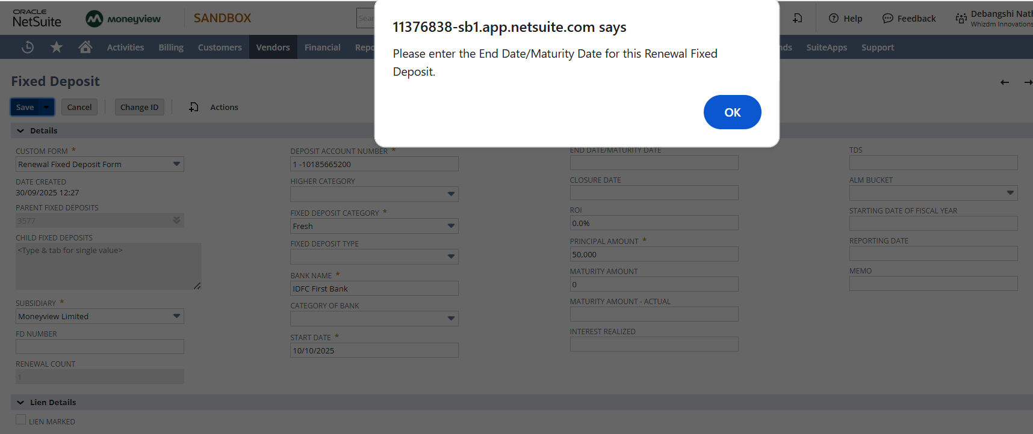
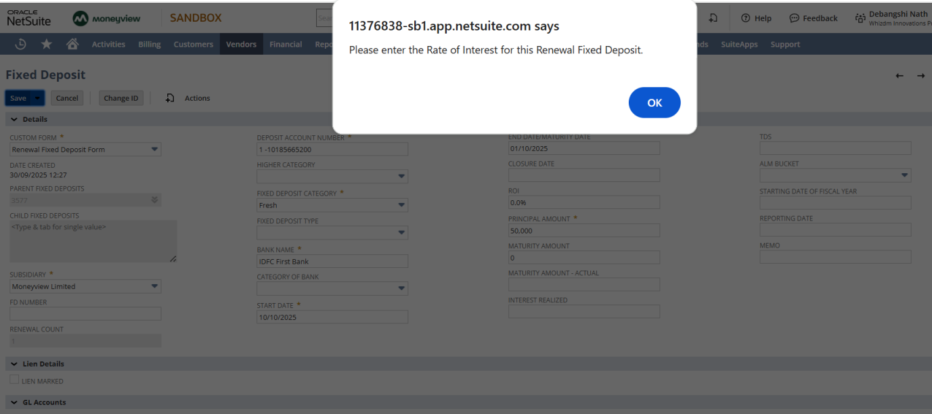
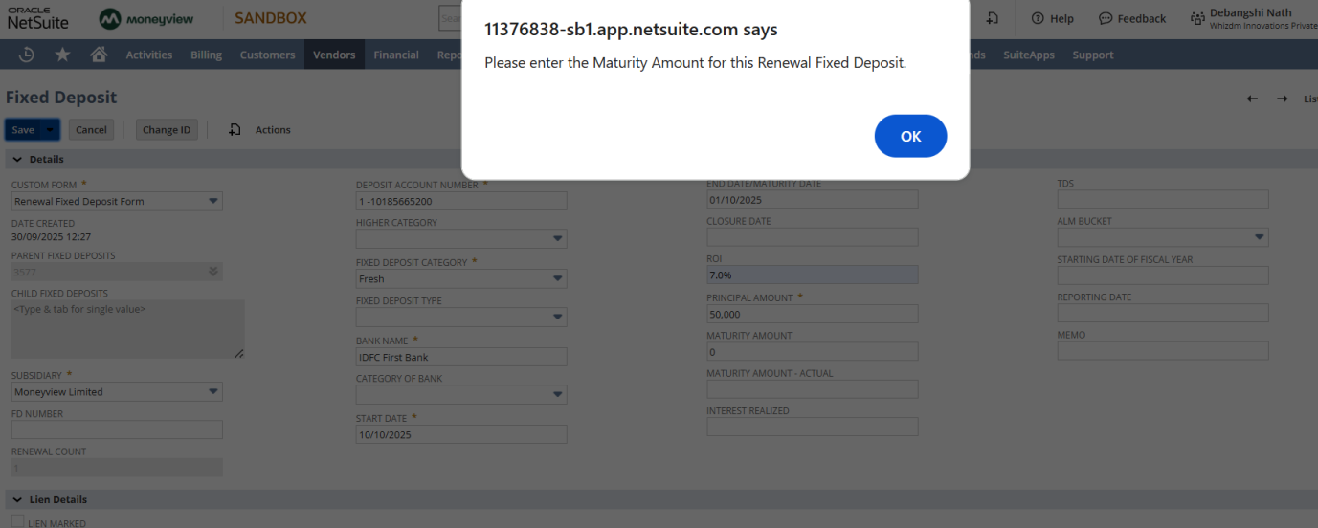
- Interest Realized and TDS field value gets blank. (needs to be updated again)
- On the Renewed Fixed Deposit record, the Internal ID of the parent fixed deposit record gets link to the Parents Fixed Deposit field.
- Custom Form gets update to- Renewal Fixed Deposit Form.
- Deposit Account number gets a prefix 1- (which indicates the number of times the record has been renewed)
- Fixed Deposit Category updates as Fresh by default.
- After the Bank Name “- Renewed” prefix gets added.
- End Date/ Maturity Date needs to be updated.
- Renewal Count field displays the number of times the record gets renewed.
- And the Money Receipt JE for the Renewed record gets copied from its Parent Fixed Deposit record.
Update the above fields and click on Save button.
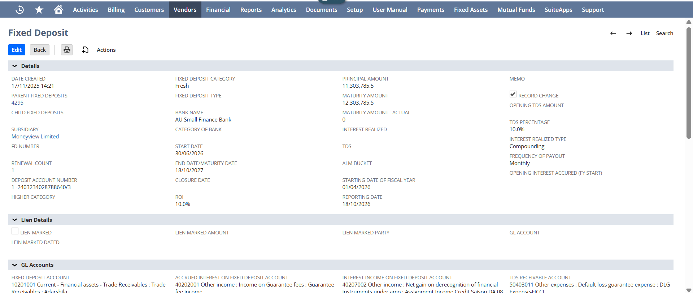
Once saved the renew FD will follow the same process when Interest realized is updated the JE will get created, and on Month end the Monthly Accrual JE will be created.

When Redemption tag is updated
On your Fixed Deposit Record, update the Fixed Deposit Category as Redemption, for scenario when user wants to redeem the Fixed Deposit. 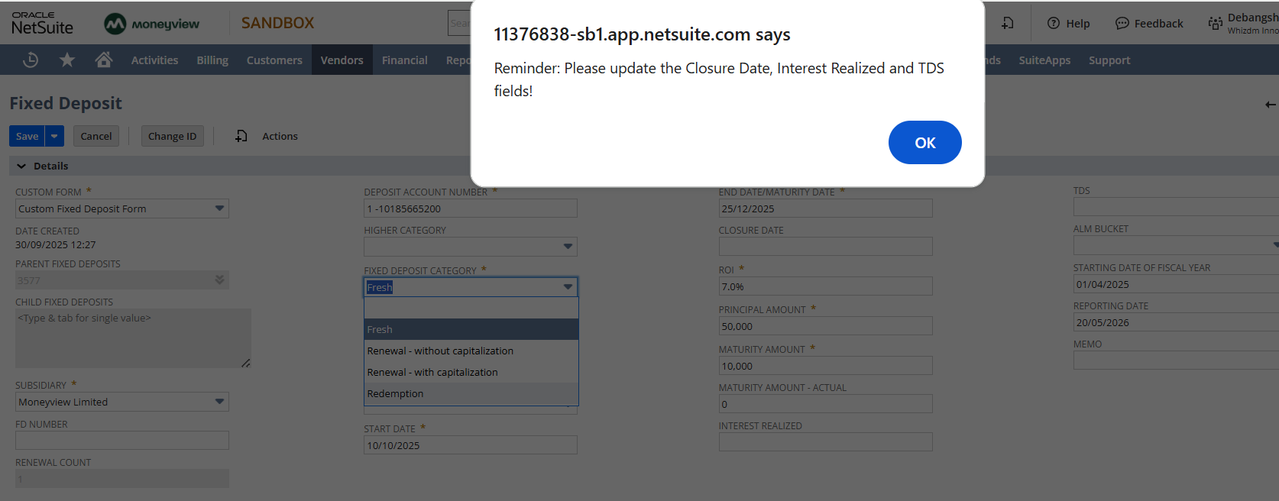
Reminder message popups to update Closure Date, Interest Realized and TDS fields.
Click on Ok button.
Update the Closure Date field same as the Maturity Date, update the Interest Realized and TDS correctly. Then click on Save button.
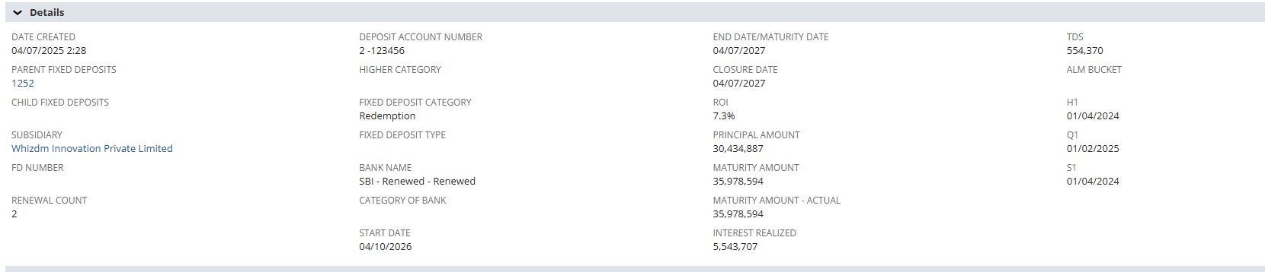On Save, the Redemption JE will get created present on the Journal section within the Redemption JE field.
On click of Journal hyperlink, user will be navigated to the Journal detailed page.
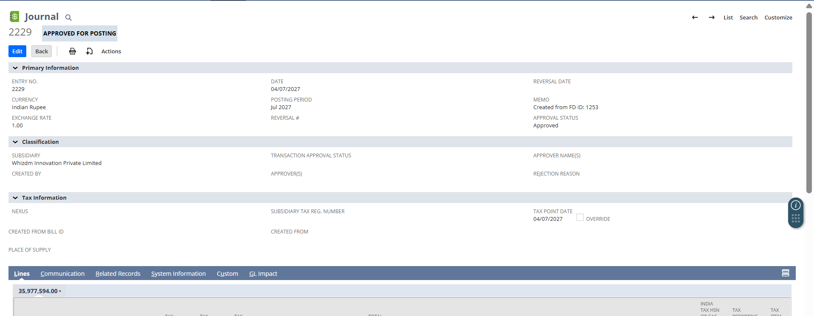
Date field on the Journal page is set as the Closure Date that is present on the fixed deposit record.
Now, navigate to Lines subtab where:
- Bank Account gets Debit
- TDS Account gets Debit
- Remaining Interest gets Credit
- Principal Amount gets Credit
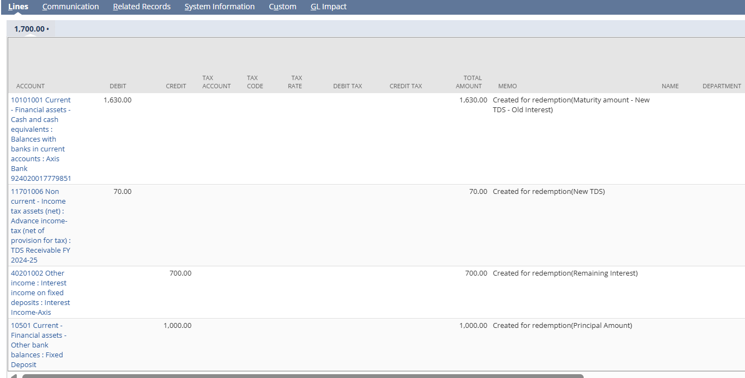

Premature Fixed Deposit
Premature Fixed Deposit case occurs when user wants to close the Fixed Deposit record before the Maturity Date.
To process the Premature Fixed Deposit,
User needs to Edit the created record.
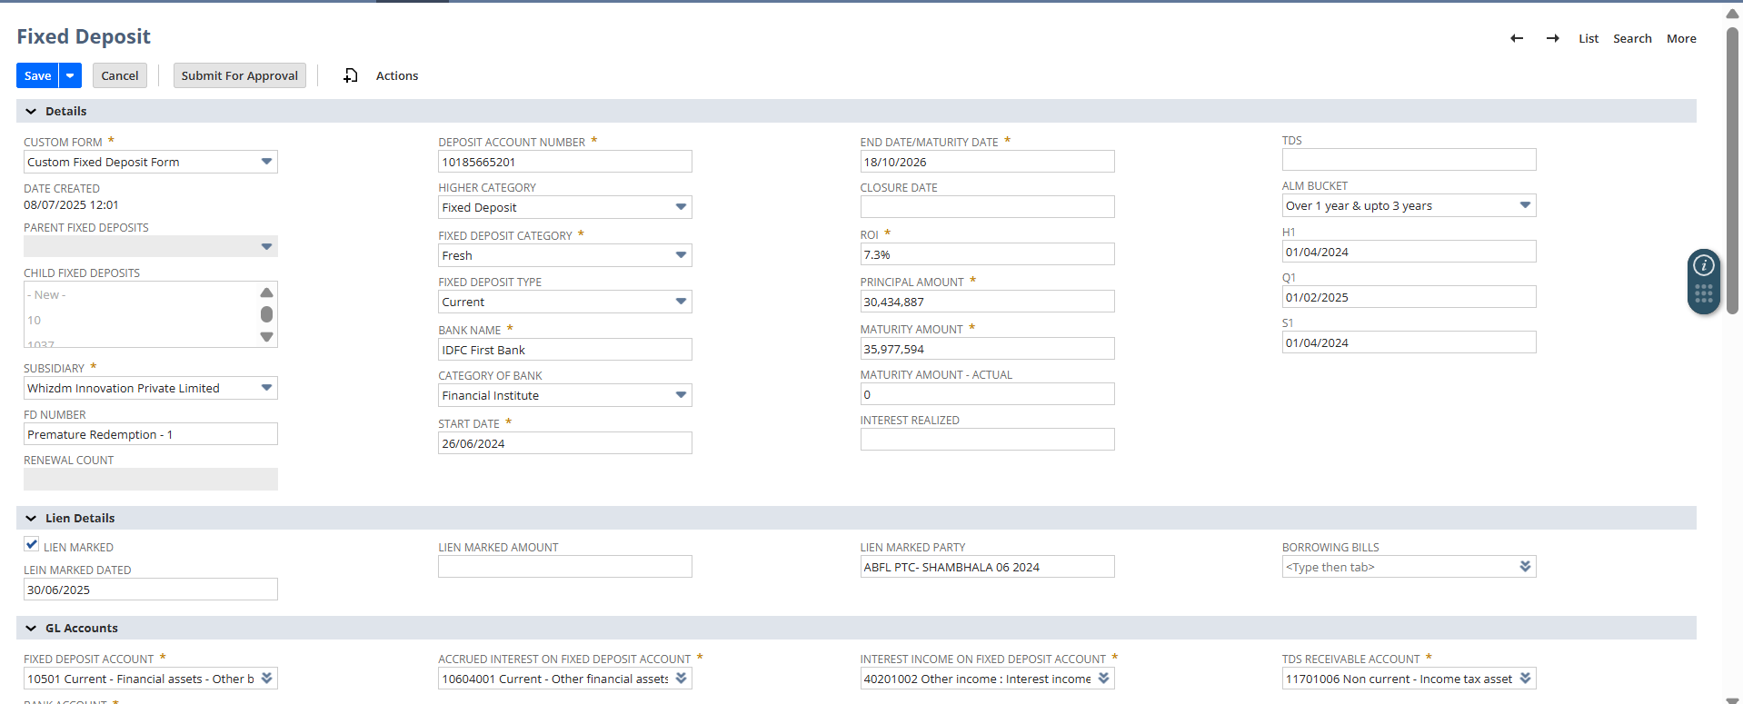
Scenario 1:
Enter the Closure date which is less than or equal to the Maturity Date.
For example- Maturity Date is 18/10/2026, then here the Closure Date can be 18/10/2025.
On selection of which Premature FD warning popup will display.
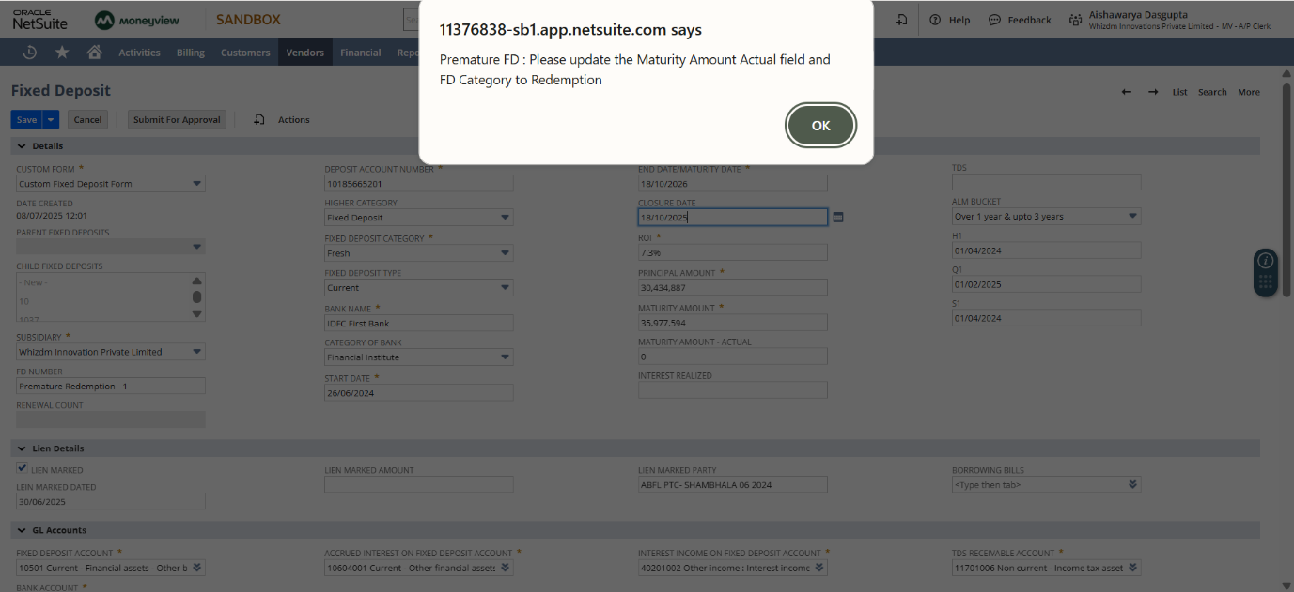
Click on Ok button.
Here,
- Update the Fixed Deposit Category as Redemption.
- User needs to update the Maturity Amount- Actual as it will be less than the before Maturity Amount entered because we are closing this record on the Premature stage.
- Update the Interest Realized and TDS fields.
  - For scenario, if User input the Invalid Interest Realized, then the below warning message will popup.
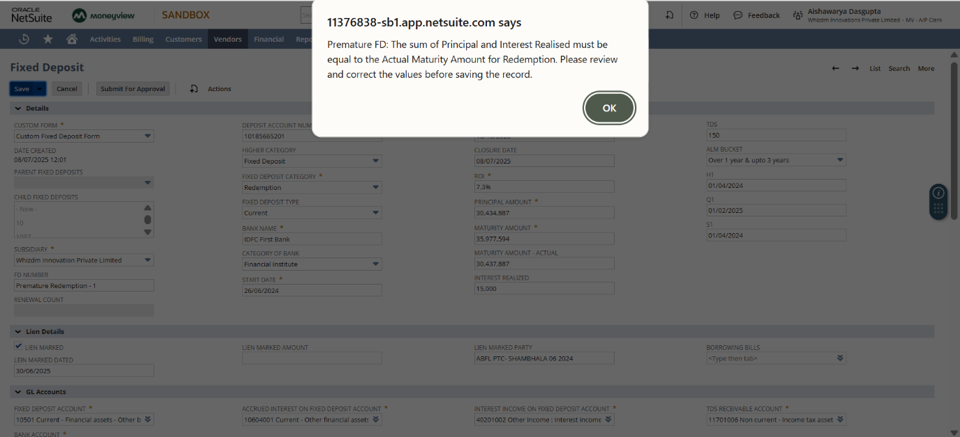
Once the below fields are updated correctly, click on Save button.
- Fixed Deposit Category
- Maturity Amount – Actual (This field contains the sum of the amount credited to the bank and the TDS deducted on it.)
- Interest Realized
- TDS
- Closure Date (less than Maturity Date)
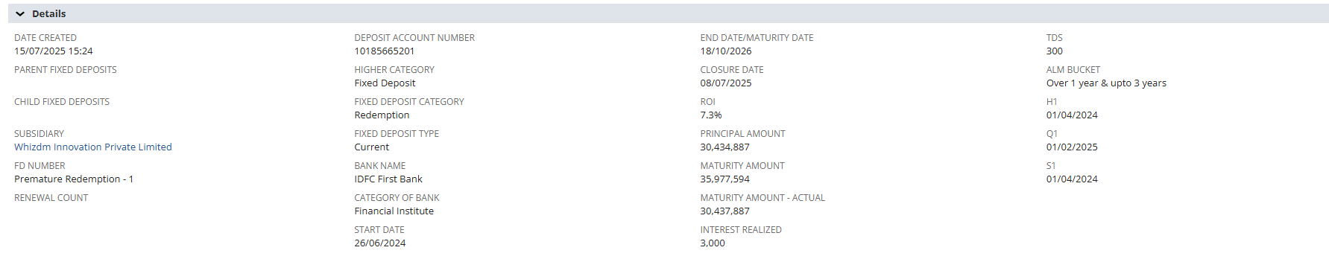
On click of Save button,
- The Redemption JE will get created under the Journals section within the Redemption JE field.
- Calculations will get impacted.
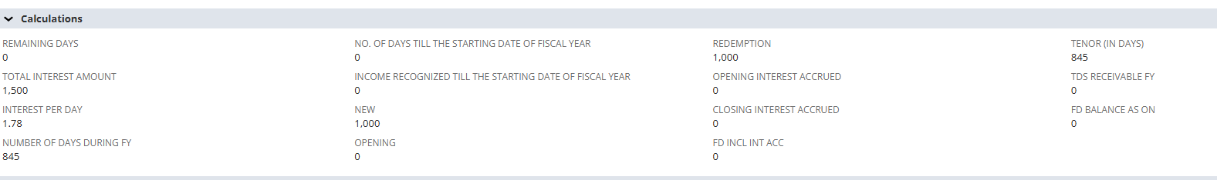
On click of Journal hyperlink, user will be navigated to the Journal detailed page.
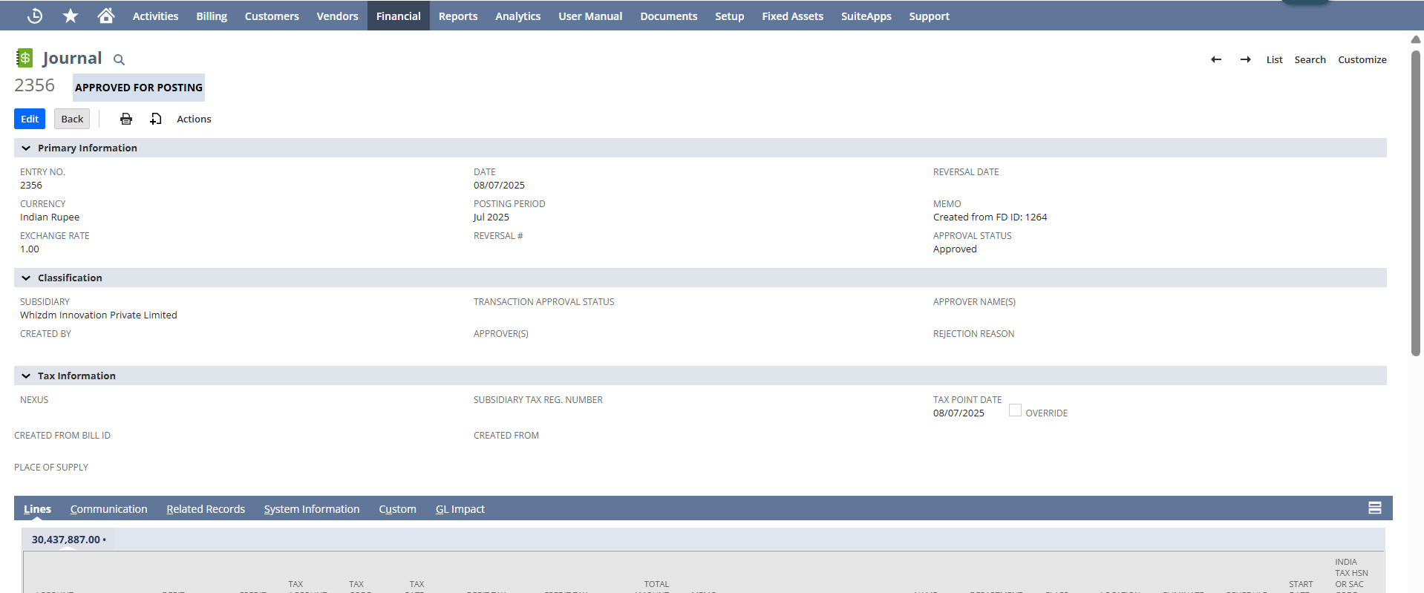
Date field on the Journal page is set as the date when the Redemption tag is updated.
Now, navigate to Lines subtab where:
- The Debit and Credit values under the Lines sub-tab are balanced.
- The Credit amount reflects the remaining amount based on the Interest Realized.
- Interest Income will be equal to the Principal amount entered on the Fixed deposit record.
- The Debit for TDS will be the previously entered remaining amount.
- The Redemption amount (Maturity – New TDS – Old Interest) will be debited from the specified Bank Account.

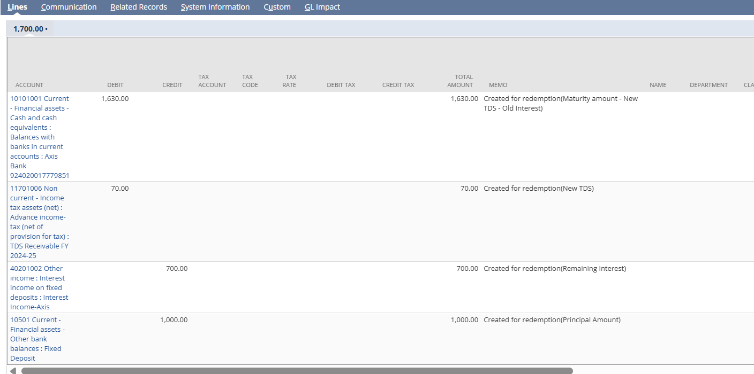

After that navigate to the Journals section in Fixed Deposit record and under the Interest Accrued Monthly JE field a new Journal Entry must be generated.

Click on the new generated Journal hyperlink.
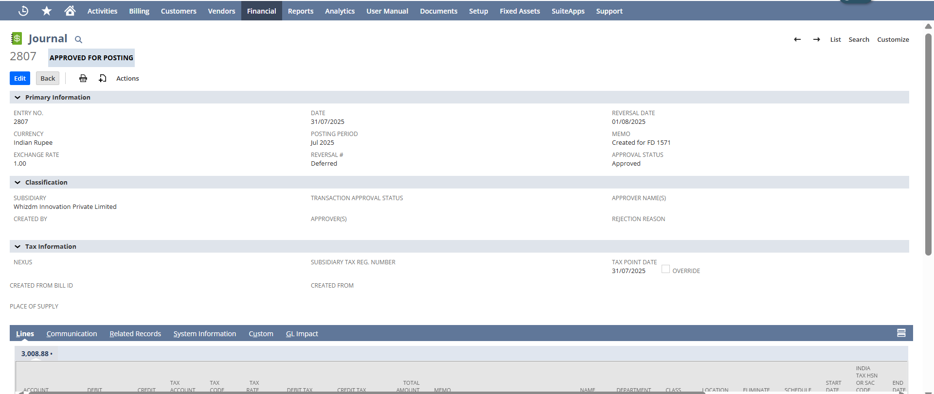

And verify,

- The "Debit" and "Credit" amounts under the Lines sub-tab of the Journal Entry page are equal to the number of days passed from the Start Date to the closed date (on which the JE is created), multiplied by the value in the "Interest per Day" field (this interest will be the new interest). Additionally, the line-level Memo field will display the total number of days that have passed.
- Check if the “Reversal Date” field is auto-filled with the first day of the next month, based on the date of “Date” field of the Journal Entry page.
- Check if the date in "Reversal Date" field is future date, the “Reversal #” field status must be auto set to Deferred. (example- The calendar has not rolled over to a new month or not approached yet to that date.)
- Check if the date in "Reversal Date" field on the JE detail page is passed, a reference link must be generated in the “Reversal #” field for the Reversal JE. (eg: The calendar has rolled over to a new month, but the date is from the previous month)
- The user must be able to click on the generated “Reversal #” JE reference link and must be redirected to the Reversal JE detail page.
- Also, check that the “Debit” and “Credit” values under the Lines sub-tab on the Interest Accrued Monthly JE are swapped with the “Debit” and “Credit” values on the Reversal JE.

