**1. What is IoT (Internet of Things)?**

* **IoT means connecting everyday physical objects (like your phone, fridge, or even a car) to the Internet, so they can communicate and share data with each other.**
* **It’s not just machines talking to machines, but also machines interacting with people and vice versa. For example, your smart watch notifying you about your heart rate or a security camera alerting you when it detects motion.**

**2. Main Parts of IoT**

* **Connectivity: Devices need to connect to the Internet or a network to share data.**
* **Smart Devices: Things like sensors and chips are added to objects to make them "smart" so they can collect information.**
* **Data Collection & Analysis: IoT devices collect lots of data, which is then analyzed to make better decisions. For example, smart thermostats learn your schedule to adjust temperatures automatically.**

**3. How IoT Devices Communicate**

* **Machine-to-Machine (M2M): Devices talking directly to each other, like printers getting alerts to order ink.**
* **Machine-to-People (M2P): Devices sending updates to humans, like fitness trackers showing your daily steps.**
* **People-to-Objects: You controlling devices using your phone, like turning off lights with an app.**

**4. How IoT Works (Architecture)**

* **Device Layer: This includes sensors (which collect data) and actuators (which perform actions). For example, a smart light bulb has a sensor to detect motion and an actuator to turn on/off.**
* **Network Layer: This is how devices talk to each other—using Wi-Fi, Bluetooth, etc.**
* **Service Layer: Handles the processing of data, often using cloud services (like Google Drive or iCloud).**
* **Application Layer: The part that you interact with, like using an app on your phone to control smart devices.**

**5. Where is IoT Used?**

* **Smart Homes: Controlling lights, security cameras, or thermostats with your phone.**
* **Wearables: Devices like fitness trackers or smartwatches that monitor your health.**
* **Smart Cities: Traffic lights that adjust to reduce congestion, or sensors that detect when trash bins are full.**
* **Factories (Industrial IoT): Machines monitoring themselves to detect problems early.**
* **Healthcare: Smart devices that track patient health and send updates to doctors.**

**6. Technologies that Make IoT Possible**

* **Sensors: Devices that collect information, like temperature, light, or movement.**
* **Communication Protocols: The “languages” devices use to talk, such as Wi-Fi or Bluetooth.**
* **Cloud Computing: Storing and processing large amounts of data online.**
* **Security: Protecting data so that hackers can’t misuse it. For example, using passwords and encryption.**

**7. How IoT Has Changed Over Time**

* **Early Days: Devices were mostly limited to local networks (like using a remote control).**
* **Today: Everything is connected to the Internet—like smart speakers and smart appliances.**
* **Future: We will see even more automation, like self-driving cars and homes that take care of themselves.**

**8. IoT in Buildings and Automation**

* **Smart Buildings: IoT systems control lighting, heating, and security to make buildings safer and more efficient.**
* **Energy Savings: Automatically turning off lights and adjusting temperatures to save energy.**
* **Safety: Detecting smoke, gas leaks, or unauthorized access to secure buildings**

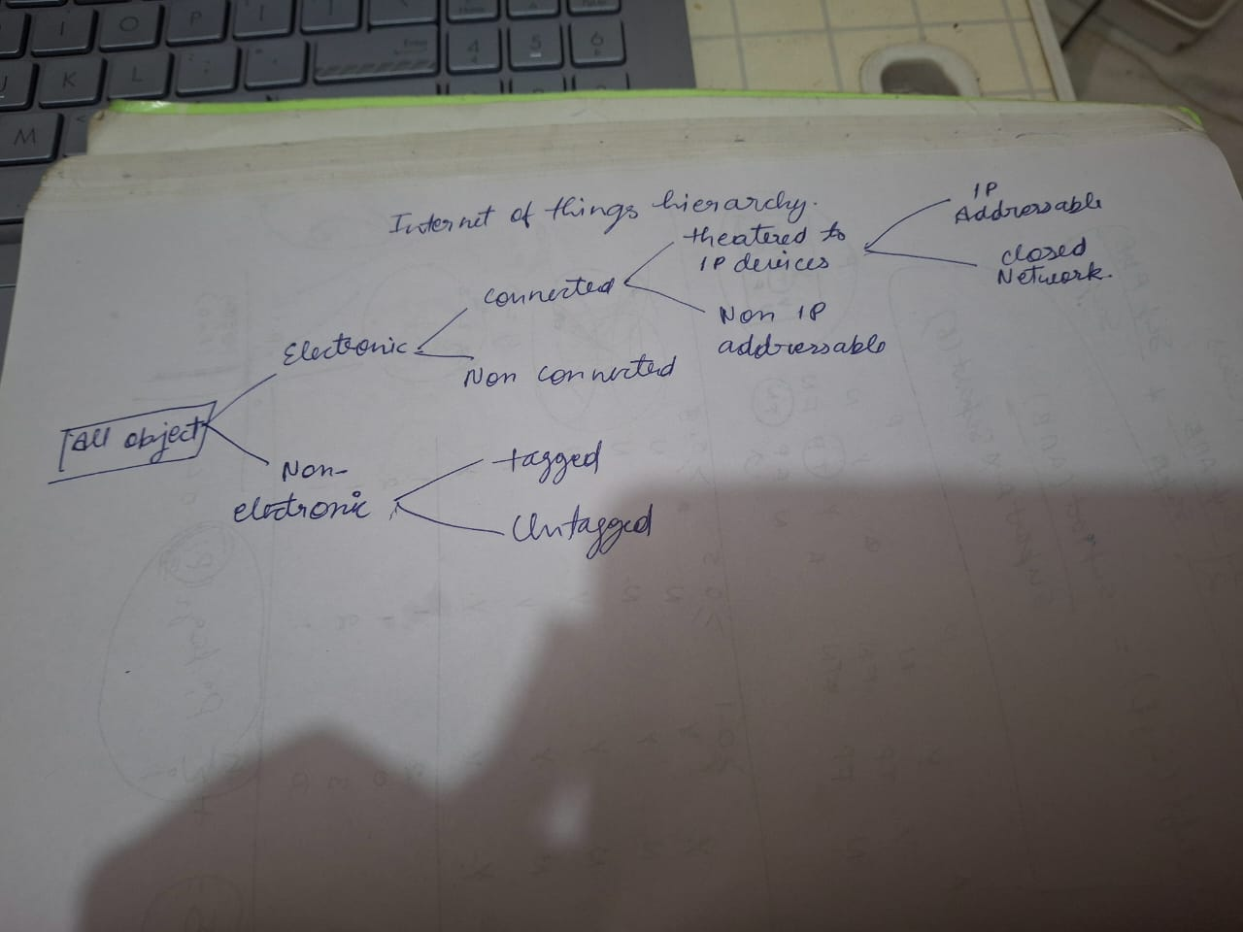

Here is a detailed description of the topics you’ve mentioned:

**Internet of Things (IoT) Technology**

IoT refers to the network of physical objects embedded with sensors, software, and other technologies to connect and exchange data with other devices and systems over the internet.  
Key components include:

1. **Sensors and Actuators**: Devices to collect data from the environment and perform actions based on commands.
2. **Connectivity**: Technologies like Wi-Fi, Bluetooth, Zigbee, and cellular networks to enable communication.
3. **IoT Platforms**: Middleware that processes, stores, and manages data collected from IoT devices.
4. **Edge Computing**: Processing data close to the source rather than a central server.
5. **Cloud Computing**: Centralized storage and analytics for IoT data.

Applications range from smart homes, wearables, and healthcare to industrial automation and agriculture.

**IoT Application Segments**

IoT can be categorized based on its application areas:

1. **Smart Homes**: Devices like smart thermostats, lighting systems, and security cameras.
2. **Wearables**: Fitness trackers, smartwatches, and medical monitoring devices.
3. **Industrial IoT (IIoT)**: Connected machinery, predictive maintenance, and factory automation.
4. **Smart Cities**: Waste management, traffic monitoring, and public safety systems.
5. **Healthcare**: Remote patient monitoring, diagnostic devices, and telemedicine.
6. **Agriculture**: Soil monitoring, precision farming, and automated irrigation.

**Internet of Things Evolution**

IoT has evolved significantly over time:

1. **First Generation (1990s)**: Basic M2M (Machine-to-Machine) communication using proprietary protocols.
2. **Second Generation (2000s)**: Introduction of internet-enabled devices and cloud integration.
3. **Third Generation (2010s)**: Rise of platforms, big data analytics, and AI-driven insights.
4. **Current Trends (2020s)**: Expansion into 5G, edge computing, blockchain integration, and enhanced security.

**IoT in Automation & Building Technology**

IoT is transforming automation and building technologies:

1. **Building Management Systems (BMS)**: Automated control of lighting, HVAC, and security systems.
2. **Smart Buildings**: IoT sensors to monitor energy consumption, optimize occupancy, and enhance safety.
3. **Predictive Maintenance**: IoT-enabled equipment monitors performance to predict and prevent failures.
4. **Energy Efficiency**: Smart meters and real-time energy monitoring reduce consumption.
5. **Access Control**: IoT-based systems enhance security with facial recognition and remote monitoring.

**Characteristics of Big Data**

Big Data refers to extremely large datasets that require advanced methods for storage, analysis, and processing. Key characteristics include:

1. **Volume**: Vast amounts of data generated from IoT, social media, and other sources.
2. **Velocity**: High speed at which data is generated and processed.
3. **Variety**: Structured, semi-structured, and unstructured data from diverse sources.
4. **Veracity**: Ensuring data accuracy and reliability.
5. **Value**: Extracting actionable insights to drive decisions.

**Common Big Data Customer Scenarios**

Big Data is widely used in various industries to address specific challenges:

1. **Retail**: Customer behavior analysis, personalized recommendations, and inventory management.
2. **Finance**: Fraud detection, risk management, and real-time trading analysis.
3. **Healthcare**: Predictive analytics for patient outcomes and operational efficiency.
4. **Manufacturing**: Optimizing supply chains, improving production quality, and predictive maintenance.
5. **Marketing**: Campaign optimization and customer segmentation through sentiment analysis.
6. **Energy**: Demand forecasting, smart grid management, and renewable energy optimization.