BÌA
Predict student learning outcomes using machine learning

TABLE OF CONTENT
1. Introduction 5
1.1 Background and Issues 5
1.2 Research objectives 5
2. Method 6
2.1 Data 7
2.1.1 Load Data 7
2.1.2 Layer Distribution (Pass/Fail) 7
2.2 Pretreatment 8
2.2.1 Basic Cleaning 8
2.2.2 Encoding categorical 9
2.2.3 Scaling numeric 9
2.2.4 Avoid data leakage 9
2.3 Random Forest & Hyperparameter Tuning 9
2.3.1 Train/Test split 10
2.3.2 GridSearchCV 10
2.4 Train-Test Split 11
2.5 Data Survey (EDA) and Visualization 11
2.5.1 GPA distribution 11
2.5.2 StudyTime vs GPA 12
3. Results 13
3.1 Model Performance 13
3.2 Confusion Matrix 14
3.2.1 Confusion Matrix Imaging 14
3.2.2 Confusion matrix + heatmap 15
3.3 Feature Importance 16
3.4 Summary of indicators and implementation significance 18
4. Application 18
4.1 Early Warning System 19
4.2 Risk stratification 19
4.3 Benefits for stakeholders 20
4.4 Calculating Probability and Risk Stratification 20
4.4.1 Obtain Pass Probability 20
4.4.2 Assigning Risk Tier Labels by Threshold 20
4.4.3 Creating an Intervention Priority Table 21
4.5 Recommendations for intervention according to risk factors 21
4.5.1 If Absences are High 22
4.5.2 If StudyTimeWeekly is low 22
4.5.3 If the GPA is low (background factor) 22
5. Limitations & Development Directions 22
5.1 Current Limitations 22
5.1.1 Impact of imbalanced classes 23
5.1.2 Risks from scaling data in tree-based models 23
5.2 Moral risk 23
5.3 Development direction 24
5.4 Implementation roadmap (phased suggestions) 24
6. Conclusion 25
APPENDIX A — Code 27
APPENDIX B — Experimental output (copy/paste into report if necessary) 29

1. Introduction

1.1 Background and Issues
Each semester, teachers often recognize the warning signs of students struggling too late. When the final score is announced, the intervention time is over. According to statistics, the percentage of students who fail subjects at universities ranges from 15-25%, of which many cases can be prevented if detected early.
Current challenges:
- Teachers manage 100-150 students, unable to closely monitor each individual
- Traditional warning systems only activate after the midterm (weeks 8-10), when students have fallen too far behind
- Lack of objective assessment tools, fail risk system
- Interventions are often reactive instead of proactive
Opportunities from Data Science: Machine Learning allows you to analyze thousands of student grade data in seconds, identify patterns that are not recognizable to the naked eye, and predict outcomes before they occur.

1.2 Research objectives
Key objective: To build a Random Forest model that predicts students' Pass/Fail ability with an accuracy of ≥85%, based on data available in the first 2-3 weeks of the semester.
Specific objectives:
- Collect and analyze dataset of 2,500+ students with 13 features
- Build a standard data preprocessing pipeline
- Optimizing Random Forests with Grid Search Cross-Validation
- Achieve accuracy ≥85%, ROC-AUC ≥0.85, F1-score (Fail class) ≥0.80
- Feature importance analysis to understand what affects learning outcomes
- Proposed framework for implementing a practical early warning system
1.3 Features of Use
The predictive model is based on 13 features divided into 5 groups:
Group 1: Academic
- GPA: Previous cumulative GPA (0.0-4.0)
- StudyTimeWeekly: Hours of self-study per week (0-40 hours)
Group 2: Behavioral
- Absences: Number of absences during the semester (0-30 sessions)
Group 3: Support
- ParentalEducation: Parental education level (0-5: none, high school, some college, bachelor's, master's, doctorate)
- ParentalSupport: The level of parental support (categorical)
- Tutoring: Tutoring or Not (Yes/No)
Group 4: Extracurricular.
- Sports: Participate in sports (Yes/No)
- Music: Join the music (Yes/No)
- Extracurricular: Other Extracurricular Activities (Yes/No)
- Volunteering: Volunteering (Yes/No)
Group 5: Demographics
- Age: 15-22
- Gender: Gender (Male/Female)
- Ethnicity: Ethnicity (Group A-E)
Reasons to choose features:
- GPA: The strongest predictor according to literature reviews, reflecting ability and work ethic
- StudyTimeWeekly & Absences: Modifiable behaviors, possible direct intervention
- Parental factors: Proxies for home support environment and socioeconomic status
- Extracurricular: Research shows correlation with engagement and time management skills
- Demographics: Control variables, ensuring the model is not biased
The model not only predicts who is at risk, but also explains why, helping to design effective and evidence-based interventions.

2. Proposed method
2.0 Pipeline summary (end-to-end)
The pipeline implemented in a notebook consists of 6 main steps:
- Import libraries
- Load CSV data
- Clean + Create Target Variable Results
- Encoding + scaling
- Train/Test split + GridSearchCV (Random Forest)
- Review + visualization + feature importance
For easy reproducibility, this report includes code illustrations corresponding to each step. The code is a stripped-down (but runable) version and keeps the same logic as a notebook.

2.1 Data
Dataset: 2,392 students (after duplication)
- Pass: 2,016 students (84.3%)
- Fail: 376 students (15.7%)
Classification criteria: GradeClass ≤ 1.5 → Fail; GradeClass > 1.5 → Pass

2.1.1 Load Data
import pandas as pd

df = pd.read_csv("content/Student_performance_data _.csv")
df = df.drop_duplicates()
print(df.shape)
print(df.head())
Actual results: Dataset shape (after overlapping): (2392, 16)

2.1.2 Layer Distribution (Pass/Fail)
import numpy as np

df["Results"] = np.where(df["GradeClass"] <= 1.5, "Fail", "Pass")
print(df["Results"].value_counts())
Actual results:
- Pass: 2016 (84.3%)
- Fail: 376 (15.7%)
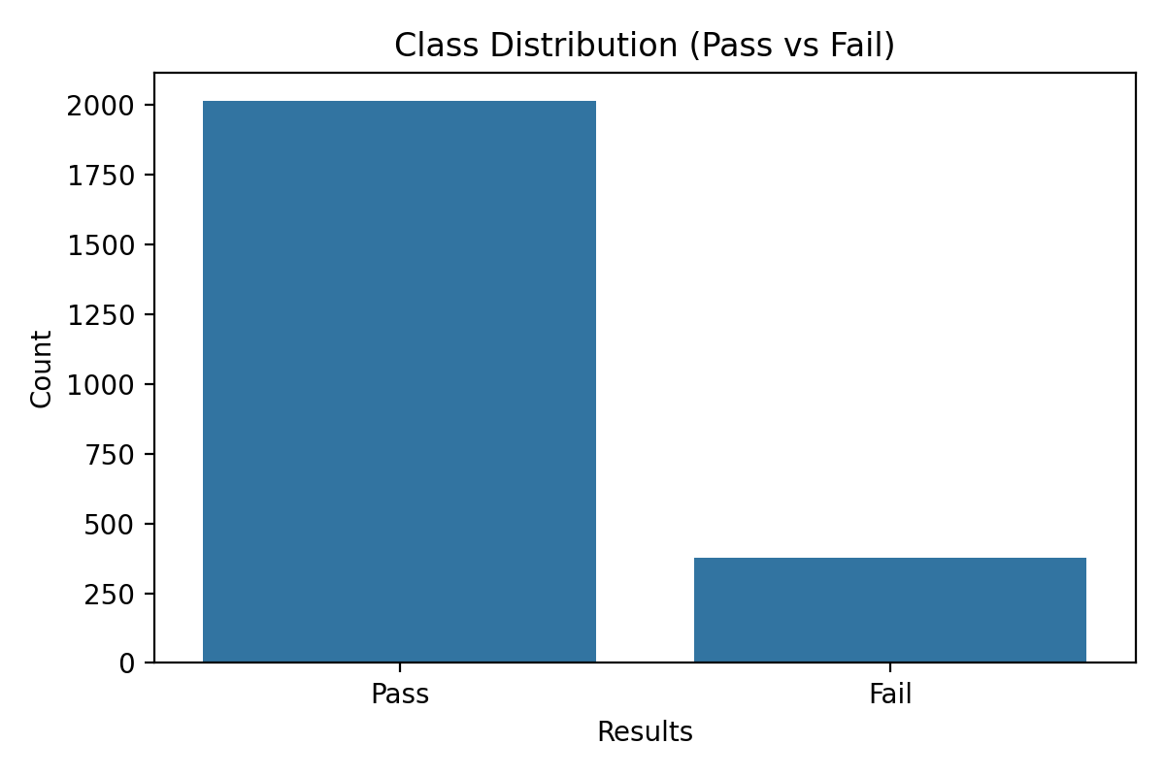
If you want the image to have the correct font/size report, you can change the figsize and dpi when exporting.

2.2 Pretreatment
- Duplicate: Make sure each student appears once
- Column Name Standardization: Uniform Formatting
- Rounding: GPA and StudyTimeWeekly rounding 2 decimal places
- Categorical Encoding: Label Encoding for Gender, Ethnicity, ParentalEducation
- Scaling numerical: StandardScaler for Age, StudyTimeWeekly, Absences, GPA
- Data Leakage Removal: Remove StudentID and GradeClass from features

2.2.1 Basic Cleaning
# Rounding variables to reduce noise
df["GPA"] = df["GPA"].round(2)
df["StudyTimeWeekly"] = df["StudyTimeWeekly"].round(2)

2.2.2 Encoding categorical
Notebooks use LabelEncoder for a number of classification variables.
from sklearn.preprocessing import LabelEncoder

cat_columns = ["Gender", "Ethnicity", "ParentalEducation"]
le = LabelEncoder()
for col in cat_columns:
df[col] = le.fit_transform(df[col])

2.2.3 Scaling numeric
from sklearn.preprocessing import StandardScaler

numeric_features = ["Age", "StudyTimeWeekly", "Absences", "GPA"]
scaler = StandardScaler()
df[numeric_features] = scaler.fit_transform(df[numeric_features])

2.2.4 Avoid data leakage
X = df.drop(columns=["Results", "StudentID", "GradeClass"])
y = df["Results"]
Reason:
- StudentID is an identifier only (not predictive).
- GradeClass is used to create Results, so if used as a feature, it will create a loop (leakage) and make a good "virtual" model.

2.3 Random Forest & Hyperparameter Tuning
Grid Search with 5-Fold Cross-Validation:
- n_estimators: [50, 100, 150]
- max_depth: [5, 10, 15]
- max_features: ['sqrt', 'log2']
Optimal Parameters:
- n_estimators: 50
- max_depth: 5
- max_features: 'sqrt'

2.3.1 Train/Test split
The notebook is using random_state=42, test_size=0.2. (Notebooks don't have stratify enabled, so the Pass/Fail ratio in the test set may be slightly different.)
from sklearn.model_selection import train_test_split
from sklearn.preprocessing import LabelEncoder

y_enc = LabelEncoder().fit_transform(y) # Fail=0, Pass=1

X_train, X_test, y_train, y_test = train_test_split(
X, y_enc, test_size=0.2, random_state=42
)

print(len(X_train), len(X_test))
Actual results:
- Test size: 479 samples
- Support in classification report: Fail=71, Pass=408

2.3.2 GridSearchCV
from sklearn.ensemble import RandomForestClassifier
from sklearn.model_selection import GridSearchCV

param_grid = {
"n_estimators": [50, 100, 150],
"max_depth": [5, 10, 15],
"max_features": ["sqrt", "log2"],
}

rf = RandomForestClassifier(random_state=42)
grid_search = GridSearchCV(rf, param_grid, cv=5, scoring="accuracy")
grid_search.fit(X_train, y_train)

best_model = grid_search.best_estimator_
print(grid_search.best_params_)
Actual results:
{'max_depth': 5, 'max_features': 'sqrt', 'n_estimators': 50}

2.4 Train-Test Split
- Training set: 80% (1,913 students)
- Test set: 20% (479 students)
- Random state: 42 (reproducibility)

2.5 Data Survey (EDA) and Visualization
The EDA section in the notebook focuses on 2 simple but useful perspectives:
- GPA distribution (post-normalization)
- The relationship between self-study time and GPA

2.5.1 GPA distribution
import matplotlib.pyplot as plt
Import Seaborn as SNS

plt.figure(figsize=(10, 6))
sns.histplot(df["GPA"], kde=True, bins=20)
plt.title("GPA Distribution")
plt.xlabel("GPA")
plt.ylabel("Frequency")
plt.show()
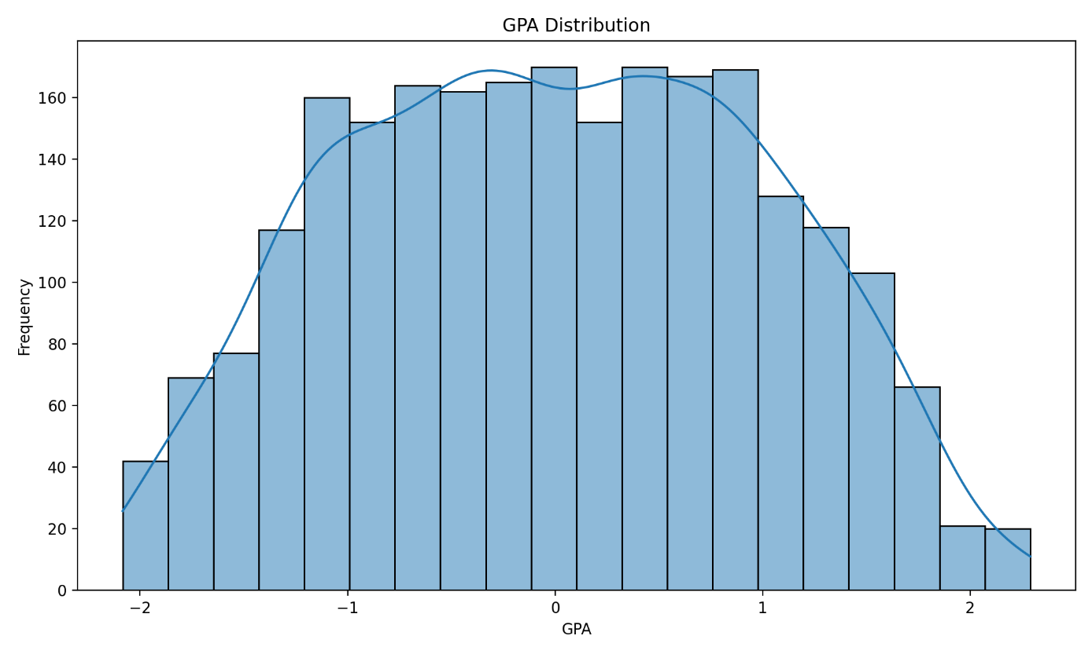
Interpretation:
- Because of the standardized data (StandardScaler), the GPA is around ~[-2.5, 2.5].
- The distribution is quite "smooth" and there is no outlier that is too extreme → suitable for the pattern learning pattern to be stable.

2.5.2 StudyTime vs GPA
plt.figure(figsize=(10, 6))
sns.scatterplot(data=df, x="StudyTimeWeekly", y="GPA")
plt.title("Study Time vs GPA")
plt.xlabel("Study Time Weekly")
plt.ylabel("GPA")
plt.show()
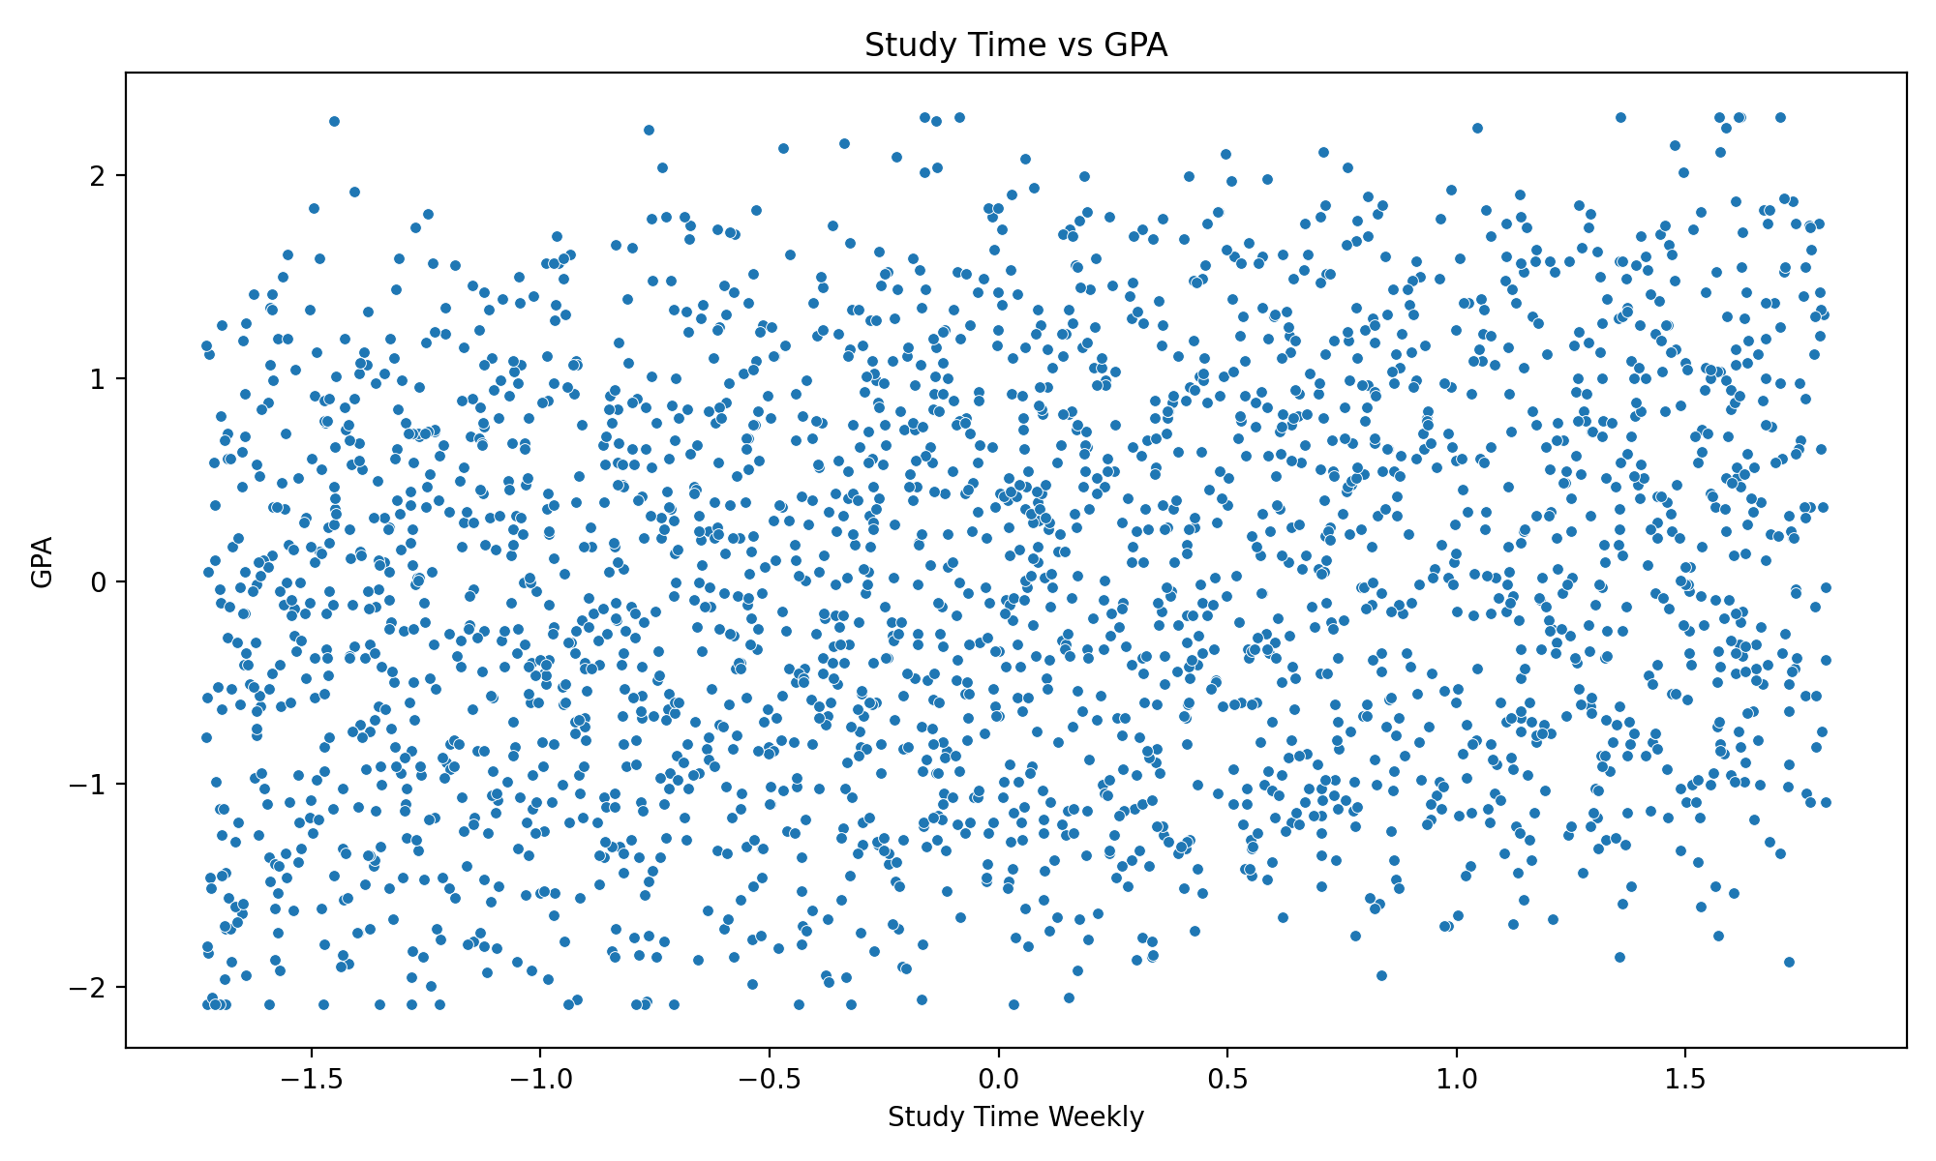
Interpretation:
- The Scatter plot shows a distinctly non-linear relationship; there is great interference.
- This explains why the tree-based model (Random Forest) is more suitable than the linear model.
- StudyTime is influential (feature importance ~4.6%) but does not "alone" determine" the results.

3. Evaluation

3.1 Model Performance
Overall Accuracy: 96.45% (462/479 correct predictions)
Classification Report:
Class | Precision | Recall | F1-Score | Support
Fail (0) | 0.91 | 0.83 | 0.87 | 71
Pass (1) | 0.97 | 0.99 | 0.98 | 408
Macro Avg | 0.94 | 0.91 | 0.92 | 479
Weighted Avg | 0.96 | 0.96 | 0.96 | 479
ROC-AUC Score: 0.912 (excellent discrimination)
In classification report code
from sklearn.metrics import classification_report

y_pred = best_model.predict(X_test)
print(classification_report(y_test, y_pred))
Quick Explanation:
- Fail (0) is the most important class because the system's goal is to detect students at risk of failing to intervene.
- Recall(Fail)=0.83 means catching 83% of students who actually fail the test.

3.2 Confusion Matrix
PREDICTION
Fail Pass
REALITY Fail 59 12
Pass 6 402
Analysis:
- 59 True Negatives: Correct Predictions Will Fail → Intervention
- 12 False Positives: False Predictions (Failing but Actually Passing) → 16.9% of Students Receiving Unnecessary Warnings
- 6 False Negatives: Missing (passing but actually failing) → 8.5% of students are not detected
- 402 True Positives: Correctly predict will pass
Trade-off: Accept 12 false alarms to catch 59 students who really need help. In education, the cost of missing a student at risk is much higher than a false alarm.

3.2.1 Confusion Matrix Imaging
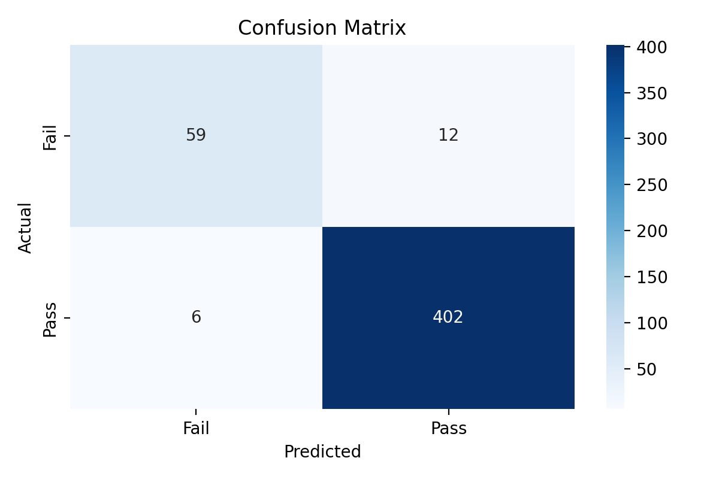

3.2.2 Confusion matrix + heatmap
from sklearn.metrics import confusion_matrix

cm = confusion_matrix(y_test, y_pred)
print(cm)
Import Seaborn as SNS
import matplotlib.pyplot as plt

plt.figure(figsize=(6, 4))
sns.heatmap(cm, annot=True, fmt='d', cmap='Blues',
xticklabels=['Fail', 'Pass'],
yticklabels=['Fail', 'Pass'])
plt.title("Confusion Matrix")
plt.xlabel("Predicted")
plt.ylabel("Actual")
plt.show()
- If the goal of the field is "not to miss" (decrease FN=6), it is possible:
  - lower the decision threshold (increase recall fail, decrease precision), or
  - use class_weight='balanced', or
  - optimal scoring = 'recall' or 'f1' for the Fail class.

3.3 Feature Importance
The model identifies the factors that affect learning outcomes in order:
Rank | Feature | Importance | Type | Intervention Potential
1 | GPA | 63.58% | Fixed | Cannot be changed short-term
2 | Absences | 25.21% | Modifiable | OK Can intervene
3 | StudyTimeWeekly | 4.60% | Modifiable | OK Can intervene
4 | ParentalSupport | 2.20% | Fixed | NOT
5 | Tutoring | 1.04% | Modifiable | OK
6 | ParentalEducation | 0.87% | Fixed | NOT
7 | Ethnicity | 0.47% | Fixed | NOT
8 | Gender | 0.40% | Fixed | NOT
9 | Sports | 0.39% | Modifiable | OK
10 | Music | 0.39% | Modifiable | OK
11 | Age | 0.38% | Fixed | NOT
12 | Extracurricular | 0.33% | Modifiable | OK
13 | Volunteering | 0.14% | Modifiable | OK
Key Insights:
Top 3 factors (93.39% of total importance):
- GPA (63.58%): Academic history is the strongest factor. Students with low GPAs need early academic support.
- Absences (25.21%): Multiple absences = high risk. It is necessary to supervise attendance and handle barriers (traffic, work, family).
- StudyTimeWeekly (4.60%): Self-study time correlates with results. Encourage ≥10 hours/week.
Factors that can intervene (accounting for 32.06% of importance):
- Absences (25.21%): Attendance policy, traffic support
- StudyTimeWeekly (4.60%): Workshop on study skills, time management
- Tutoring (1.04%): Providing free tutoring to at-risk students
- Extracurricular activities (1.25%): Encourage participation to increase engagement
Demographic factors (1.25% combined): Gender, Ethnicity, Age are not determinants → a relatively fair educational environment.
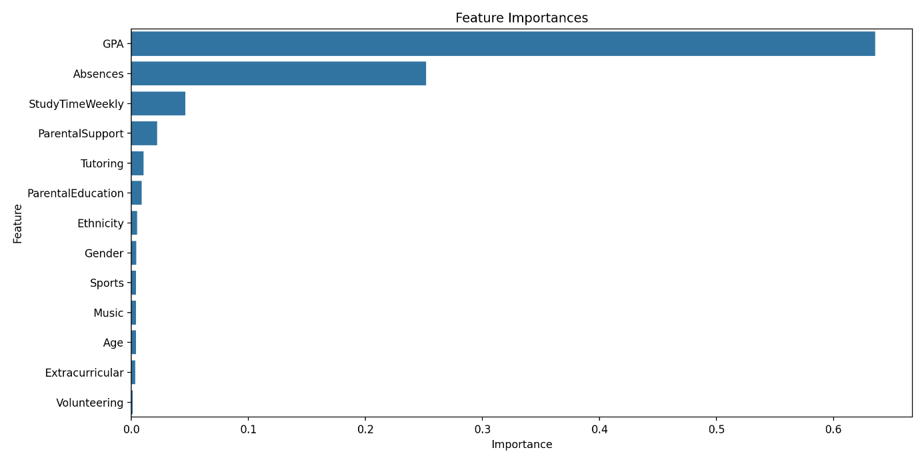
Feature importances code
import pandas as pd

importances = best_model.feature_importances_
features = X.columns

importance_df = pd. DataFrame({
'Feature': features,
'Importance': importances
}).sort_values(by='Importance', ascending=False)

print(importance_df)
Actual results (top):
- GPA: 0.635786
- Absences: 0.252053
- StudyTimeWeekly: 0.046013

3.4 Summary of indicators and implementation significance
To bring the model to the real environment, it is recommended to read the indicators from an "operational" perspective:
- High accuracy (96.45%) is a good signal, but not enough.
- The important point is that the Fail class:
  - Precision(Fail)=0.91: out of 100 students who were warned of "at risk of failing", ~91 were actually at risk (limiting excessive disturbance).
  - Recall(Fail)=0.83: out of 100 students who were actually at risk of failing, the model caught ~83 students.
- FN=6 in the test set: there are still students who fail → need a "human-in-the-loop" process.
Recommendations:
- Use the model as a screening tool, not to "stamp" students.
- Focus the intervention on variable variables: Absences, StudyTimeWeekly, Tutoring.

4. Application

4.1 Early Warning System
Traditional Scenario:
- Weeks 1-4: Students are struggling but not clear
- Week 10: Mid-term - late detection, far behind
- Week 16: Final grades – some students fail
Data-driven scenarios:
- Week 2: Admission Data Processing System, Attendance, GPA, → Risk Prediction
- Week 3: Counselor receives warning: "15 high-risk students, 37 medium-risk students"
- Weeks 3-4: Proactive Intervention
- High-risk students: Meet with counselor 1-on-1, individualized support plan
- Medium-risk students: Check-in every 2 weeks, group study
- Week 6: Integrate First Assessment Results → Predictive Updates
- Week 16: Significant increase in pass rate thanks to early intervention
Benefits: 12-week intervention window instead of 4 weeks. Research shows that early intervention is many times more effective than late intervention.

4.2 Risk stratification
High Risk (P(Pass) < 30%):
- Action: Dedicated counselor, tutor 3 hours/week, daily attendance supervision
- Example: Student A - GPA 1.8, absent 8 sessions, study 3 hours/week → P(Pass) = 18%
Medium Risk (30% ≤ P(Pass) ≤ 70%):
- Action: Check-in every 2 weeks, peer study group, tutor on request
- Example: Student B - GPA 2.5, absent 3 sessions, study 6 hours/week → P(Pass) = 55%
Low Risk (P(Pass) > 70%):
- Action: Standard support, advanced documentation, periodic monitoring
- Example: Student C - GPA 3.5, absent 0 sessions, study 12 hours/week → P(Pass) = 92%

4.3 Benefits for stakeholders
Teachers:
- Bright dashboard showing 4 high-risk students, 11 averaging in a class of 35
- Focus 1-1 time on students who need it most
- Understand why students are struggling (study time vs attendance vs support)
Counselor:
- Managed 250 students: 25 high-touch, 60 moderate-touch, 165 light-touch
- Reasonable allocation of effort instead of thin spreads
Administrator:
- Evidence-based budget allocation: "87 high-risk students (18% enrollment) → need 1.5 additional FTE counselors"
- Evaluate the effectiveness of the program: "Peer tutoring improves pass rate by 15%, costs 1/5 of professional tutoring"

4.4 Calculating Probability and Risk Stratification
In real-world implementations, risk stratification based on predicted probability helps prioritize resources.

4.4.1 Obtain Pass Probability
# P(Pass) = predict_proba[:, 1]
pass_proba = best_model.predict_proba(X_test)[:, 1]

4.4.2 Assigning Risk Tier Labels by Threshold
Thresholds can be adjusted by resource. This report uses an example:
- High risk: P(Pass) < 0.30
- Medium risk: 0.30 ≤ P(Pass) ≤ 0.70
- Low risk: P(Pass) > 0.70
import numpy as np

def risk_tier(p_pass: float) -> str:
if p_pass < 0.30:
return "High"
if p_pass <= 0.70:
return "Medium"
return "Low"

risk_labels = np.array([risk_tier(p) for p in pass_proba])

4.4.3 Creating an Intervention Priority Table
import pandas as pd

priority_df = X_test.copy()
priority_df["P(Pass)"] = pass_proba
priority_df["RiskTier"] = risk_labels
priority_df["Predicted"] = best_model.predict(X_test)

# Sort: High risk first, then Medium, then Low; in each group, P(Pass) increases gradually
priority_df["RiskTierOrder"] = priority_df["RiskTier"].map({"High": 0, "Medium": 1, "Low": 2})
priority_df = priority_df.sort_values(["RiskTierOrder", "P(Pass)"])

print(priority_df[["P(Pass)", "RiskTier"]].head(10))
Suggestions for presenting the report:
- Create a list of Top-N High risk students for academic advisors.
- For each student, display 2–3 salient factors (e.g., High Absences, Low StudyTimeWeekly).
NOTE: There is currently no SHAP/LIME in the notebook, so the definition of "individual student" will be based primarily on the overall feature importance and individual feature values.

4.5 Recommendations for intervention according to risk factors
This section translates the model's insights into action. The goal is to prioritize the changeable factor.

4.5.1 If Absences are High
- Set up weekly absence alerts (e.g., ≥2 sessions/week)
- Barrier checks: overtime schedule, transportation, health
- "Mild" but early intervention: reminders + support before absences become a habit

4.5.2 If StudyTimeWeekly is low
- Workshop on learning skills (pomodoro, active recall, spaced repetition)
- Sample weekly schedule (minimum 6–10 hours/week depending on the subject)
- Peer study groups to increase commitment

4.5.3 If the GPA is low (background factor)
- Tutoring by weak subjects (preferably foundation subjects)
- "Learning plan" 4–6 weeks: small goals + progress measurement
- Continuous monitoring: update predictions every 2 weeks

5. Limitations & Development Directions

5.1 Current Limitations
Missing data:
- Psychological factors: Motivation, confidence, mental health
- Social factors: Friendships, bullying, belonging
- Learning Strategies: Learning Techniques, Seeking Help
- Trend: The current model is snapshot, not trajectory
Binary Classification: Oversimplified Pass/Fail. Regardless of whether students need help less vs more.
Generalization: The training model on 1 school may not work well in other schools (different assessment standards, population, resources).
Interpretability gap: Knowing important features but not clearly explaining the decision path of each individual.
Correlation ≠ Causation: The model knows that low study time predicts slippage, does not prove that increasing study time will cause improvement.

5.1.1 Impact of imbalanced classes
Dataset has 84.3% Pass and 15.7% Fail. This can cause the model to predict Pass if left unchecked.
In the current results:
- The model still catches Fail quite well (Recall(Fail)=0.83)
- However, the Fail support in the test is only 71 → so it should be further evaluated by cross-validation according to the Fail class or the confusion matrix according to each split.

5.1.2 Risks from scaling data in tree-based models
Random Forest doesn't require scaling, but the notebook is standardizing to uniformize the pipeline.
Points to note:
- Scaling does not degrade the quality of the tree-based model, but it can be misleading if the reader thinks the GPA is the original value.
- So the report clearly states: the EDA charts are showing the value after normalization.

5.2 Moral risk
Self-fulfilling prophecy: If teachers know students are predicted to fail, they may unconsciously lower expectations → students perceive and act on prophecy.
Bias amplification: If historical data reflects discrimination, the model may perpetuate bias. Fair monitoring is needed for each demographic group.
Privacy: Heavy data collection = high invasion of privacy. It is necessary to balance benefits (early detection) and costs (monitoring, data breach risk).
5.2.1 Safe Implementation Guidelines (Recommended)
- Positive message: "join the academic support program" instead of "predicted to fail".
- Access restrictions: teachers only view students in their class; counselors view by shift.
- Audit log: who sees the data, when.
- Data minimization: collect only the data necessary for the intervention.
- Human-in-the-loop: prediction is just a signal; the decision to intervene is made by a human.

5.3 Development direction
Advanced ML:
- LSTM/RNN: Time series analysis (scores, weekly attendance)
- Causal ML: Predict Which Interventions Work for Which Students
- Ensemble stacking: Combining Random Forest + XGBoost + Neural Network
Richer data:
- LMS analytics: Login frequency, time on task, submission patterns
- NLP: Analyzing writing quality, sentiment in forums
- Wearables (with consent): Sleep quality, stress level
Longitudinal research:
- Multi-Year Student Follow-up: How Does 9th Grade Intervention Affect Graduation Rates?
- Multi-institutional: Federated learning to train across multiple schools without sharing raw data
Personalized intervention engine:
- Recommender system: "Students like you succeed by: 1) Peer tutoring, 2) Time management workshop"
- Reinforcement learning: Learning optimal intervention sequences through trial-reward
Ethical AI:
- Participatory design: Students, parents, teachers participate in the definition of fairness
- Bias audits: Quarterly disaggregate metrics by demographic
- Transparency: Explainable AI (SHAP, LIME) to interpret individual predictions

5.4 Implementation roadmap (phased suggestions)
Phase 1 — Proof-of-Concept (2–4 weeks)
- Run notebooks on historical data
- Export metrics reports (accuracy, recall Fail, confusion matrix)
- Uniform minimum intervention process (tutoring/attendance)
Phase 2 — Pilot (4–8 weeks)
- Applicable for 1–2 classes/subject
- Weekly Review: High Risk List and Teacher Feedback
- Recording the impact: the number of absences decreased? Rising points?
Phase 3 — Scale (1 semester)
- Integration into the learning management system
- Standardize dashboards
- Set up a semester-by-semester retraining mechanism

6. Conclusion
The study proved that Random Forest could predict learning outcomes with an accuracy of 96.45% and a ROC-AUC of 0.912. Model Identification:
GPA (63.58%) and Absences (25.21%) are the 2 most important factors, in which Absences can intervene immediately.
Paradigm Conversion:
- Old: Waiting for a bad grade → Intervening late (often too late)
- New: Early Risk Prediction → Proactive Intervention → Surveillance → Slip Prevention
Practical Benefits:
Create a 12-week intervention window instead of 4 weeks. Rational allocation of resources (high-risk students receive centralized support). Scale Personalization: Systematically Assess Every Student, Not Rely on Self-Reporting
Responsibilities:
- Predicting no intervention is futile. If a student is identified at risk, the school must provide quality support.
- Equity is the ultimate measure: Success = narrowing the achievement gap between the advantaged and disadvantaged groups.
- Humans are irreplaceable: Data supports teachers, not replacements. The adult-student caring relationship is still the strongest intervention.
Call to action:
- Educators: Use predictions as early warnings, combined with a deep understanding of each student
- Administrators: Data infrastructure investment + human intervention + training
- Researchers: Development of causal methods, explainability, fairness tools
- Policymakers: Fund infrastructure, protect privacy, mandate fairness audits
- Students/Families: Asking questions, understanding rights, feedback on support quality
Machine learning in education is not about replacing humans with algorithms. It's about equipping educators with powerful tools to identify the system of students who need help early, when there's still time to make a difference.
Summary
- Dataset: 2,392 students; Pass 84.3%, Fail 15.7%
- Best RF params: n_estimators=50, max_depth=5, max_features=sqrt
- Accuracy: 96.45%; ROC-AUC: 0.912
- Confusion matrix: TN=59, FP=12, FN=6, TP=402 (on test=479)
- Feature importance: GPA (63.6%), Absences (25.2%), StudyTimeWeekly (4.6%)
- The model is very good on the current dataset, but needs to be verified when applied to other contexts.
- Predictive results must not be used to label negatively or limit opportunities.
- Priority should be given to Absences/StudyTime/Tutoring interventions as they are subject to change.

Experimental results from 2,392 students show that early prediction systems are feasible, accurate, and capable of transforming education from reactive to proactive – if implemented responsibly with a focus on equity, privacy and human dignity.

APPENDIX A — Code
import pandas as pd
import numpy as np
Import Seaborn as SNS
import matplotlib.pyplot as plt

from sklearn.preprocessing import LabelEncoder, StandardScaler
from sklearn.model_selection import train_test_split, GridSearchCV
from sklearn.ensemble import RandomForestClassifier
from sklearn.metrics import classification_report, confusion_matrix, roc_auc_score

df = pd.read_csv("content/Student_performance_data _.csv")
df.drop_duplicates(inplace=True)

df["GPA"] = df["GPA"].round(2)
df["StudyTimeWeekly"] = df["StudyTimeWeekly"].round(2)

df["Results"] = np.where(df["GradeClass"] <= 1.5, "Fail", "Pass")

cat_columns = ["Gender", "Ethnicity", "ParentalEducation"]
le = LabelEncoder()
for col in cat_columns:
df[col] = le.fit_transform(df[col])

numeric_features = ["Age", "StudyTimeWeekly", "Absences", "GPA"]
scaler = StandardScaler()
df[numeric_features] = scaler.fit_transform(df[numeric_features])

X = df.drop(columns=["Results", "StudentID", "GradeClass"])
y = LabelEncoder().fit_transform(df["Results"]) # Fail=0 Pass=1

X_train, X_test, y_train, y_test = train_test_split(X, y, test_size=0.2, random_state=42)

param_grid = {
'n_estimators': [50, 100, 150],
'max_depth': [5, 10, 15],
'max_features': ['sqrt', 'log2']
}

rf = RandomForestClassifier(random_state=42)
grid_search = GridSearchCV(rf, param_grid, cv=5, scoring='accuracy')
grid_search.fit(X_train, y_train)

best_model = grid_search.best_estimator_
y_pred = best_model.predict(X_test)

print("Best params:", grid_search.best_params_)
print("\nClassification Report:\n", classification_report(y_test, y_pred))

cm = confusion_matrix(y_test, y_pred)
print("Confusion Matrix:\n", cm)

print("ROC AUC:", roc_auc_score(y_test, best_model.predict_proba(X_test)[:, 1]))

importances = best_model.feature_importances_
importance_df = pd. DataFrame({'Feature': X.columns, 'Importance': importances}).sort_values('Importance', ascending=False)
print("\nFeature Importances:\n", importance_df)

APPENDIX B — Experimental output (copy/paste into report if necessary)
C1. Best parameters
{'max_depth': 5, 'max_features': 'sqrt', 'n_estimators': 50}
C2. Classification report (test set)
Precision Recall F1-Score Support

0 0.91 0.83 0.87 71
1 0.97 0.99 0.98 408

accuracy 0.96 479
Macro AVG 0.94 0.91 0.92 479
weighted avg 0.96 0.96 0.96 479
C3. Confusion matrix values
[[ 59 12]
[ 6 402]]
C4. ROC-AUC
0.9122825186412594

