**Problem 1:** The University needs a database to keep track of student activities. Data needs to be kept on each activity (activity name, type, etc.), and each student (student name, contact information, etc.).

* 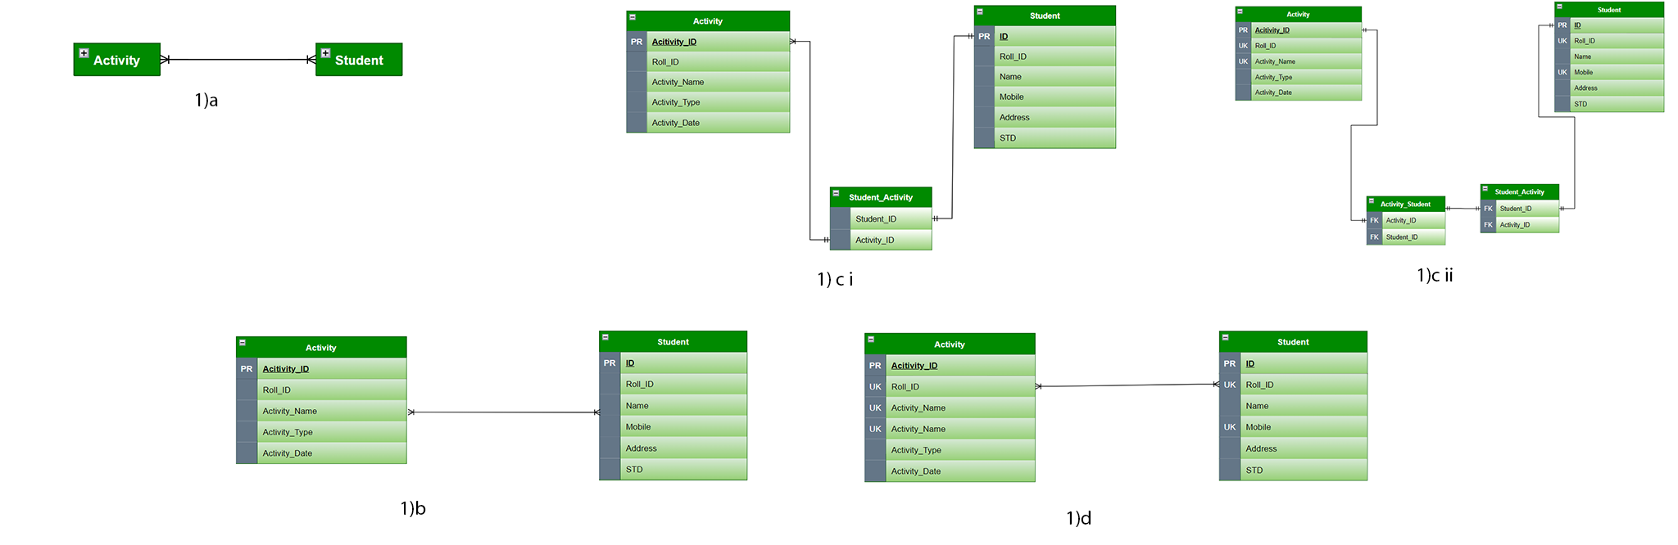A student can engage in one or more activities and an activity can involve one or more students.

**Problem 2:** A newly established pet rescue organization needs a database to keep track of pets and their owners. Data needs to be kept on the new owners (names, contact info, etc.), pets (names, breed, etc.), and services (service type, cost, etc.)

* An owner can have many pets, and a pet can have multiple owners.
* 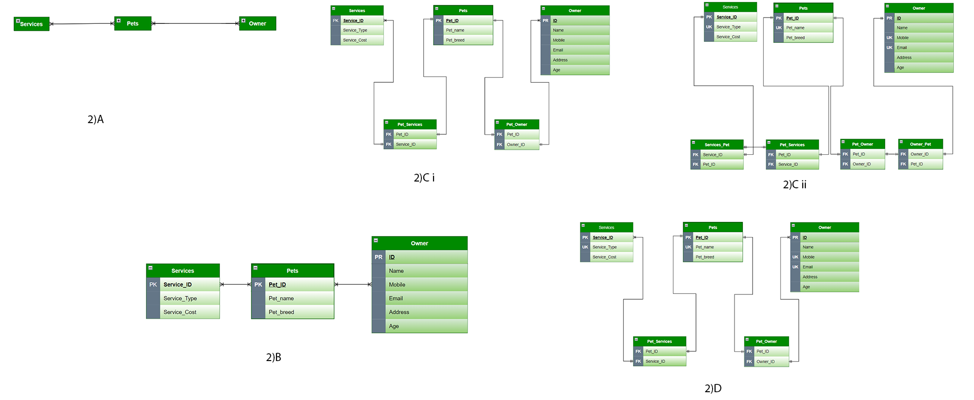A pet can have many services and services can be performed on many pets.