1. OLS ESTIMATOR
2. function [Sr,St,e,a] = ols(X,Y)
3. a = polyfit(X,Y,1)
4. Ym = a(2)+a(1)*X;
5. %ERROR
6. e = Y-Ym
7. Sr = sum(e.^2)
8. %St = Deviation of y wrt mean y
9. St = sum((Y-mean(Y)).^2)
10. end
11. Confidence Interval
12. function [CI_upp,CI_low]=confidence_interval(Y,alpha)
13. N=length(Y);
14. std_err=std(Y)/sqrt(N);
15. %[(100-alpha)/200 (alpha+(100-alpha/2))/100]
16. A=(100-alpha)/200;
17. B=(alpha+(100-alpha)/2)/100;
18. ts = tinv([A B],N-1); % T-Score
19. CI_upp= mean(Y) + ts*std_err;
20. CI_low= mean(Y) - ts*std_err;
21. end
22. Statistical Significance
23. function [h,p]=stat_significance(X,Y,a)
24. Ym = a(2)+a(1)*X;
25. [h,p] = ttest2(Y, Ym);
26. end
27. R Squared Error
28. function J = r_squared(Sr,St)
29. % Computes the R squared error
30. J = 1-(Sr/St);
31. end
32. Adjusted R Squared Error
33. function J= adjusted_r_squared(Sr,St,n,K):
34. J=1-((Sr/(n-K))/(St/(n-1)))
35. end
36. F statistics
37. function fs= f_Stat(Y,X)
38. [~,~,~,~,stats] = regress(Y,X);
39. Fs=stats(2)
40. end
41. Plot of the Linear Model on basis of theta
42. function plotter(X,Y,a)
43. % PLOT
44. X1=min(X)-5:max(X)+5;
45. Ym=a(2)+a(1)*X1;
46. plot(X,Y,'bo')
47. hold on,
48. plot(X1,Ym)
49. Legend('data','linear')
50. end

**Empirical Analysis**

1. %Model:
2. % y=a0+a1*x
4. %Least Square Method
6. %Sr= Σ e(i)^2 = Σ (y(i)-a0-a1*x(i))^2
8. %| n Σx(i) | |a0| = | Σy(i) |
9. %| Σx(i) Σx(i)^2 | |a1| |Σx(i)y(i)|
10. %Aa=B
11. % a1= (n Σ(xi*yi) - Σxi*Σyi)/(n Σ(xi*xi) - Σxi*Σxi)
12. % a0 = mean(y) - a1*mean(x)
14. X = [0,2,4,6,9,11,12,15,17,19];
15. Y = [5,6,7,6,9,8,8,10,12,12];
16. N = length(X);
17. %OLS (a)
18. [Sr,St,e,a] = ols(X,Y);
19. alpha=95; % 95% (b)
20. [CI_upp,CI_low]=confidence_interval(Y,alpha)
21. [h,p]=stat_significance(X,Y,a) (c)
22. slope=arctan(a(1));
23. % R squared (d)
24. R2 = r_squared(Sr,St);
25. K = 1;
26. % Adjusted R Squared
27. Adjusted_R2 = adjusted_r_squared(Sr,St,N,K)
28. fs= f_Stat(Y,X) (e)
30. %Plotting(f) (f)
31. Plotter(X,Y,a)

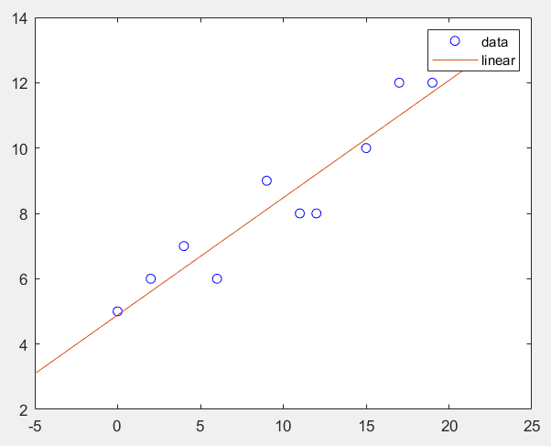

**ARIMA FORECAST**

%Reading the csv file to extract data

data = readtable(‘current.csv');

%Converted table type to array type, and then creating a row vector of the

investdata = current(:,127);

investdata=table2array(investdata);

Mdl = arima(2,0,1)

EstMdl = estimate(Mdl,investdata)