Steps:

1) NO BUG: https://github.com/xpleaf/Blog_mini/

1) BUGGY :

a) Go here: <https://github.com/xpleaf/Blog_mini>

b) Go to Commit Section by clicking 95 commits

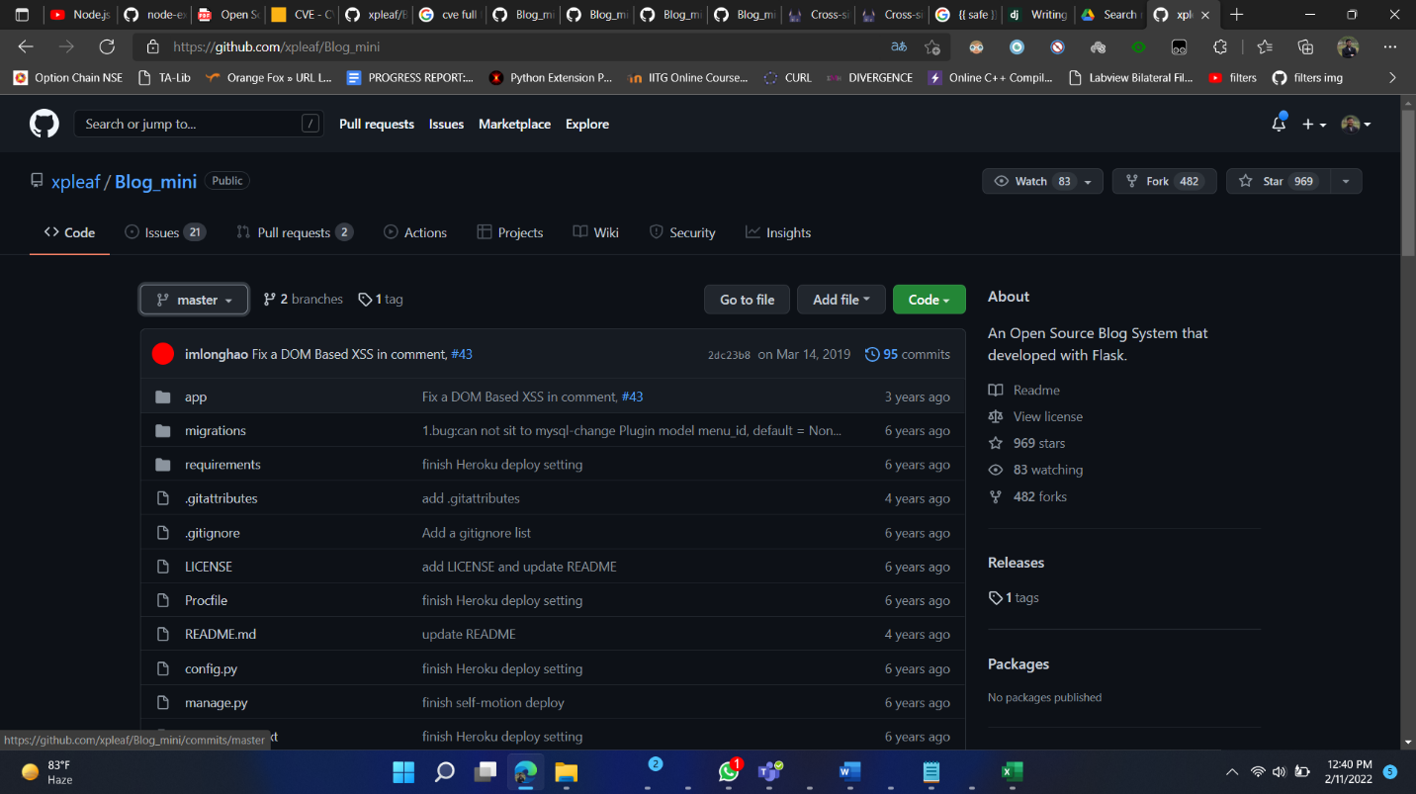

c) Click on 2dc23b8 link to see code changed, or **click <> button to go to BUGGY APP(BY CLICKING CODE YOU CAN DOWNLOAD)**

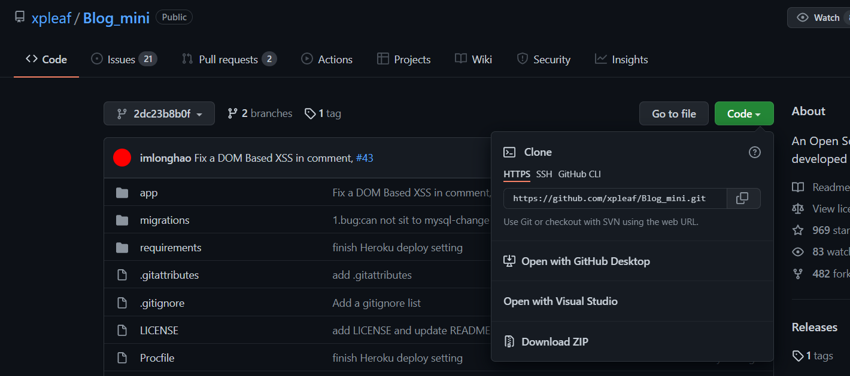

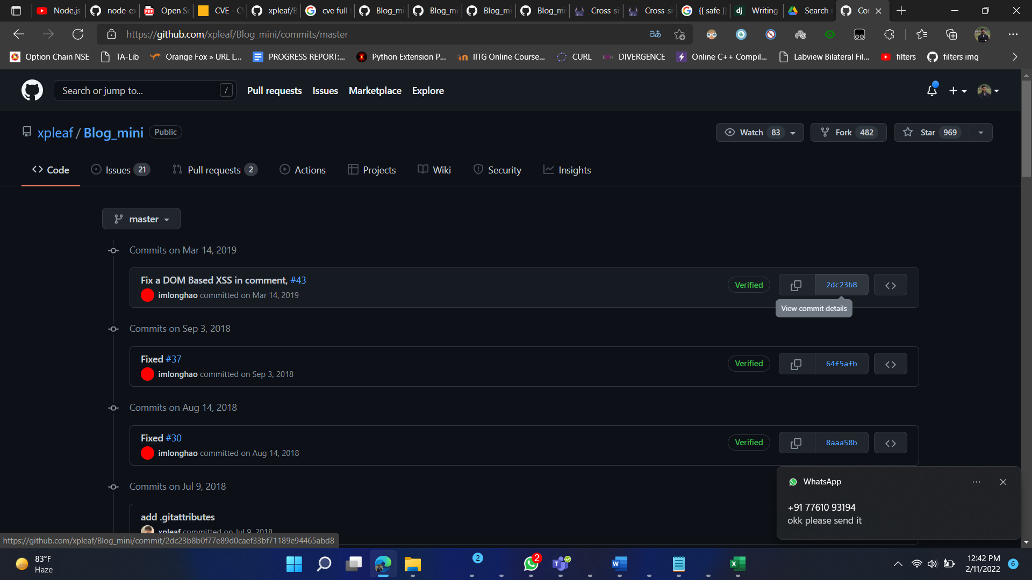

d) You get the comparision (LEFT BUGGY, RIGHT SOLVED)

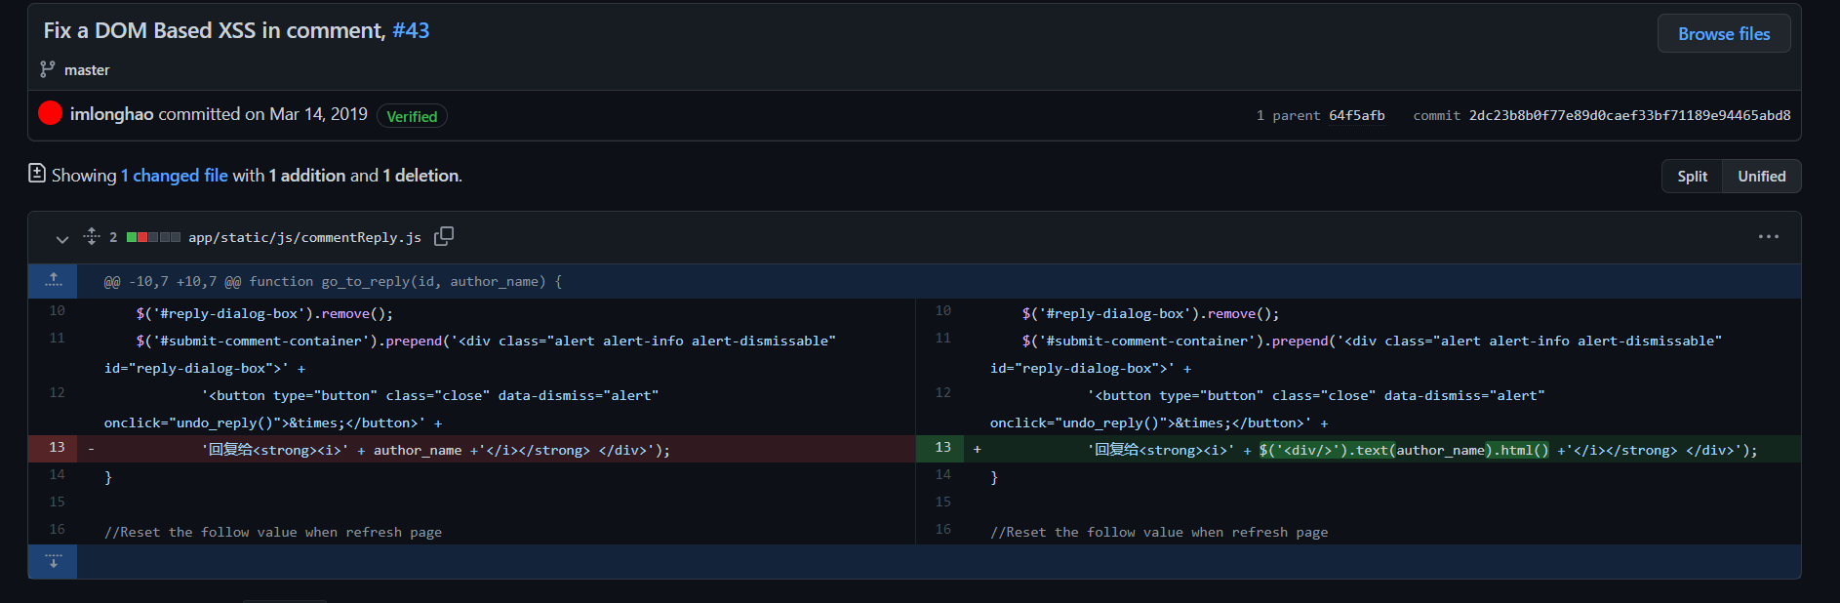

STEPS TO RUN:

Install Python3.9

Go inside the folder Blog folder

Run Commands

pip install virtualenv

virtualenv venv

source venv/bin/activate

pip install -r requirements/common.txt

copy DLL file and set path files

python manage.py db migrate

python manage.py db update

python manage.py runserver

open 127.0.0.1:5000