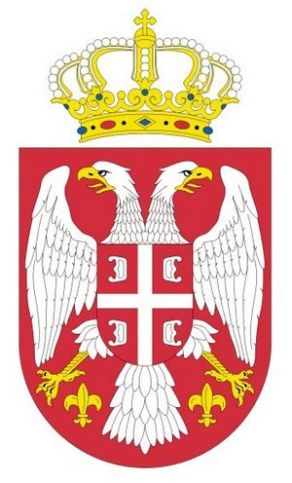 | A G E N D A  of the 3rd BALKAN MOUNTAIN RUNNING CHAMPIONSHIP 2011  Dimitrovgrad, Serbia  10. – 13. June 2011 | 

FRIDAY, 10th JUNE 2011
12,00 – 20,00 | ARRIVAL OF THE MISSIONS AND ACCREDITATION BY T.I.C. ( HOTEL“ BALKAN” DIMITROVGRAD)

SATURDAY, 11th JUNE 2011
10,00 – 12,00 | COURSE INSPECTION AND TRAINING
17,00 – 18,00 | TECHNICAL MEETING
18,30 – 19,30 | OPENING CEREMONY (PARADE)
20,00 – 22,00 | RECEPTION OF CHIEF OF MISSIONS GIVEN BY THE MAYOR OF DIMITROVGRAD

SUNDAY, 12th JUNE 2011
08.30 – 9.30 | OPEN RACE 4 km
10,00 – 10,30 | JUNIOR WOMEN RACE 4 km
10,45 – 11,30 | JUNIOR MEN 8 km
11,45 – 12,30 | SENIOR WOMEN 8 km
12,45 – 13,45 | SENIOR MEN 12 km
18,00 – 19,00 | FLOWER CEREMONY FOR INDIVIDUAL AND TEAM WINNERS
19,00– 20,00 | CLOSING CEREMONY
20,30 – 24,00 | FINAL PARTY

MONDAY, 13th JUNE 2011
08,00 – 20,00 | DEPARTURE OF MISSIONS

