Install Virtual Machines

- Download CDH

Download from http://www.cloudera.com/content/cloudera/en/downloads/quickstart_vms/cdh-4-7-x.html your favourite hypervisor version (VMware, VirtualBox or KVM)

In this tutorial we will use KVM for a Debian 7 wheezy:

# wget https://downloads.cloudera.com/demo_vm/kvm/cloudera-quickstart-vm-4.7.0-0-kvm.7z
# 7z e cloudera-quickstart-vm-4.7.0-0-kvm.7z

- Create 4 copies

Based on training Cloudera courses we will use 4 machines: elephant, tiger, monkey and horse.

$ mv cloudera-quickstart-vm-4.7.0-0-kvm.qcow2 elephant-vm-4.7.0-0-kvm.qcow2
$ cp elephant-vm-4.7.0-0-kvm.qcow2 tiger-vm-4.7.0-0-kvm.qcow2
$ cp elephant-vm-4.7.0-0-kvm.qcow2 monkey-vm-4.7.0-0-kvm.qcow2
$ cp elephant-vm-4.7.0-0-kvm.qcow2 horse-vm-4.7.0-0-kvm.qcow2

- Install Kvm

https://wiki.debian.org/KVM

# aptitude install qemu-kvm libvirt-bin virt-manager
# adduser <youruser> kvm
# adduser <youruser> libvirt
# virsh --connect qemu:///system list –all

Important! Reboot the hosted machine
# reboot

- Configure Machine

From pannel go to System Tools -> Virtual Machine Manager

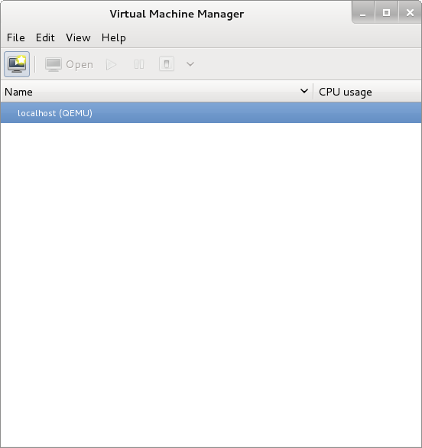

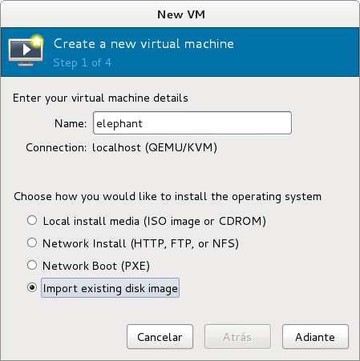

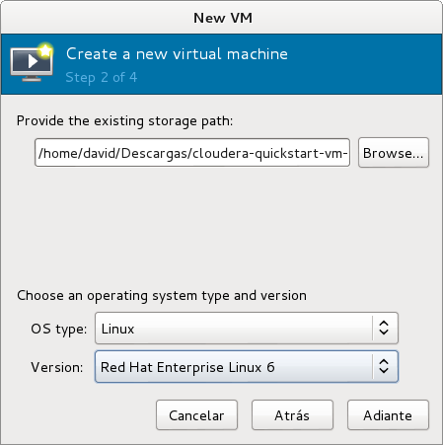
For a 8Gb RAM machique we will use 1,5Gb per VM and left 2Gb for the machine.

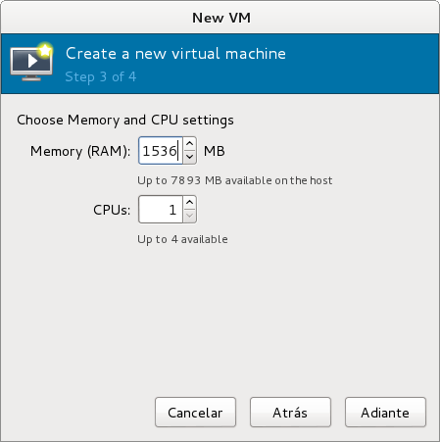
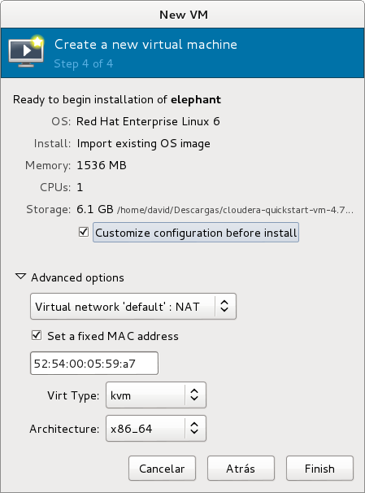

Important mark “Custimize configuration before install” box.

On configuration vm, disk 1 -> Advanced options -> Storage format, select qcow2

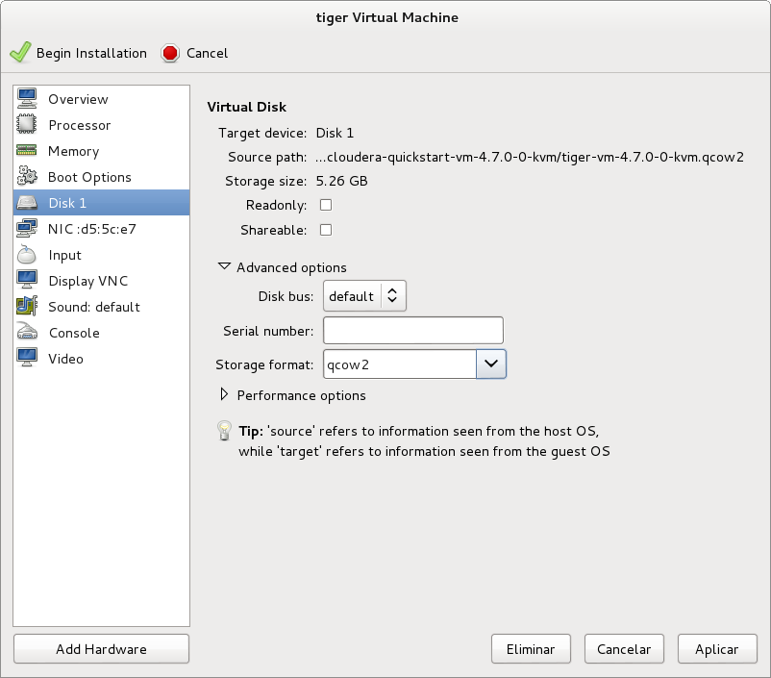
Clic on “Begin Instalation”

Also it is possible configure virtual machines from terminal using virt-sh:

- $ virt-install -n elephant -r 1536 --os-type=linux --os-variant=rhel6 --disk path=elephant-vm-4.7.0-0-kvm.qcow2,device=disk,bus=virtio,format=qcow2 --vcpus=2 --vnc --noautoconsole –import
- $ virsh --connect qemu:///session list –all
- $ virsh --connect qemu:///session connect elephant

- Shut down elephant
- Clone elpehant with clone disk option

