Install Virtual Machines

- Download CDH

Download from http://www.cloudera.com/content/cloudera/en/downloads/quickstart_vms/cdh-4-7-x.html your favourite hypervisor version (VMware, VirtualBox or KVM)

In this tutorial we will use KVM for a Debian 7 wheezy:

# wget https://downloads.cloudera.com/demo_vm/virtualbox/cloudera-quickstart-vm-4.7.0-0-virtualbox.7z
# 7z e cloudera-quickstart-vm-4.7.0-0-virtualbox.7z

- Rename vm

Based on training Cloudera courses we will use 4 machines: elephant, tiger, monkey and horse.

$ cd cloudera-quickstart-vm-4.7.0-0-virtualbox
$ mv cloudera-quickstart-vm-4.7.0-0-virtualbox.ovf elephant-vm-4.7.0-0-virtualbox.ovf
$ mv cloudera-quickstart-vm-4.7.0-0-virtualbox-disk1.vmdk elephant-vm-4.7.0-0-virtualbox-disk1.vmdk

- Install virtualbox

$ sudo apt-get install virtualbox

- Configure Machine

From pannel go to Accessories -> VirtualBox

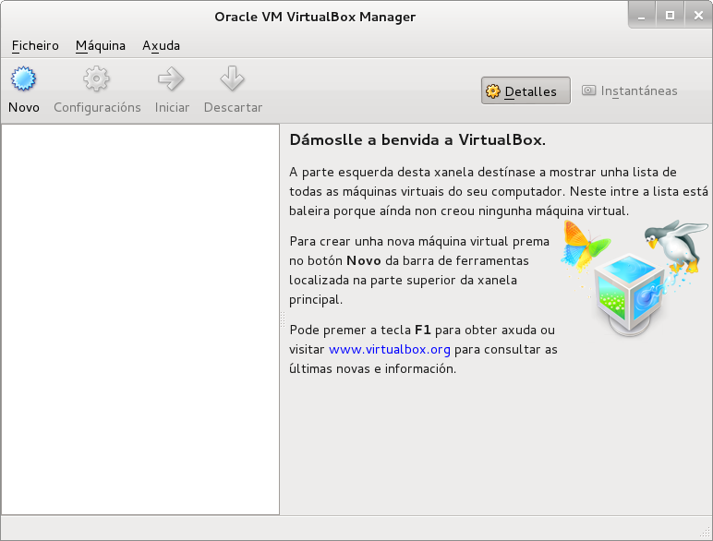

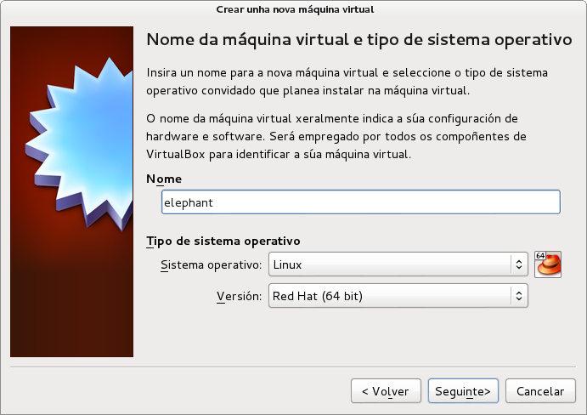
- 8Gb RAM: 1536MB
- 4Gb RAM: 1280MB
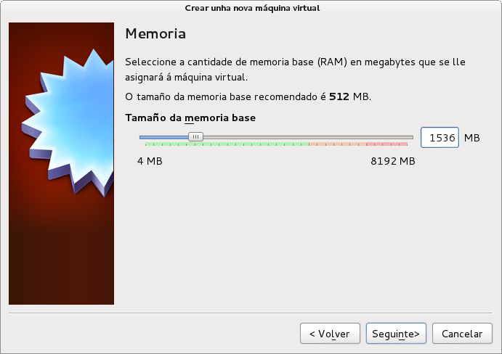
Select .vmdk file from virtual disk:

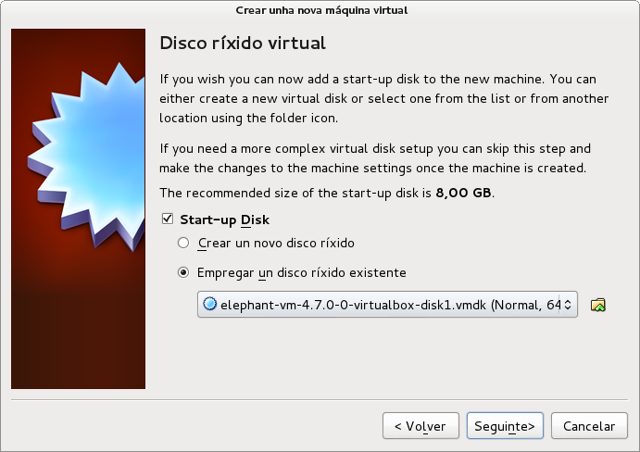
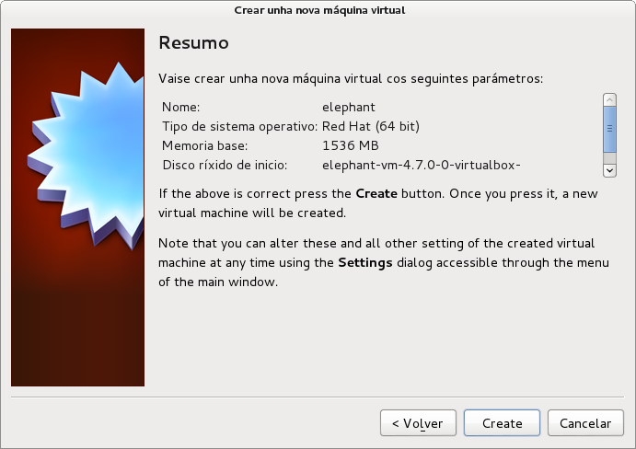
Select elephant VM and click on Configurations:
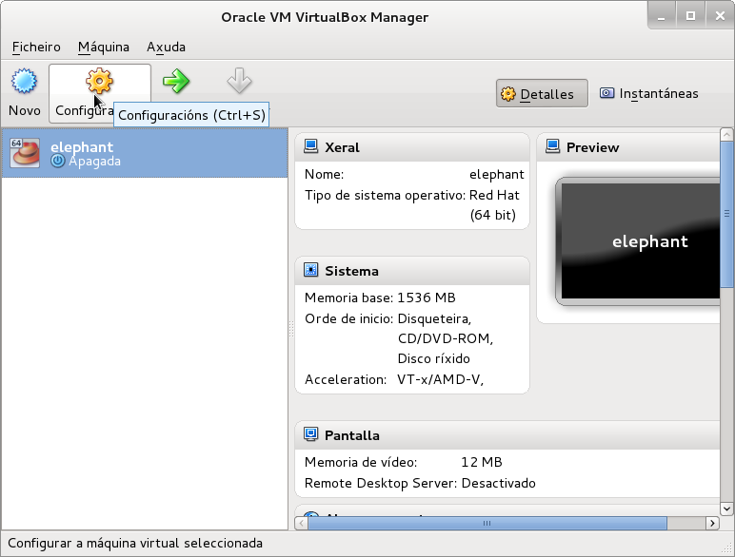
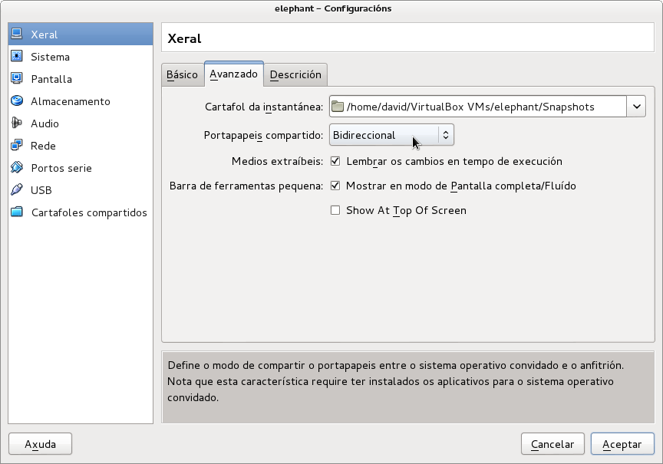
Create second network adapter as a “internal network”:

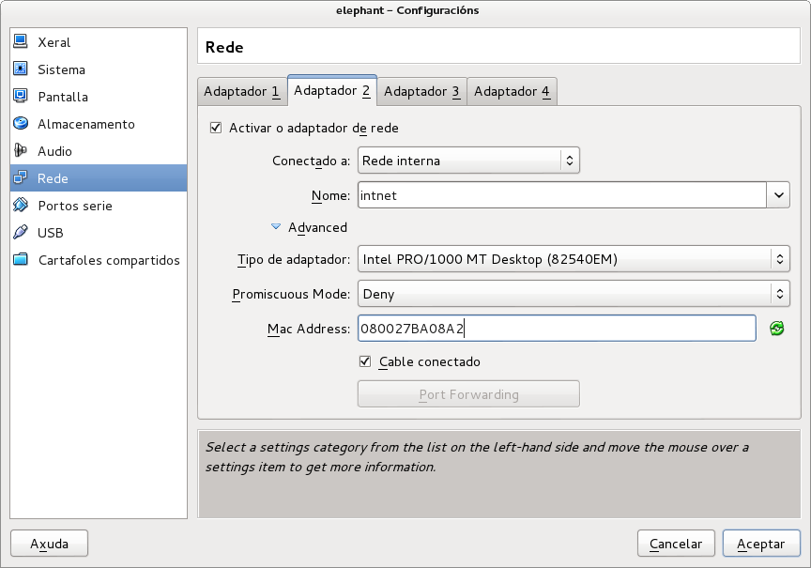
Check “Solid-state drive” if your guest has a SSD disk.

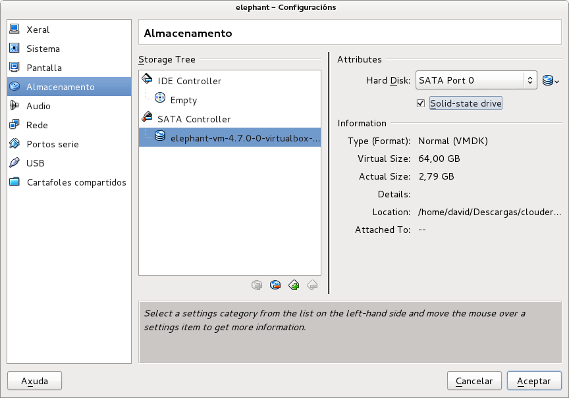
Unmark following options:
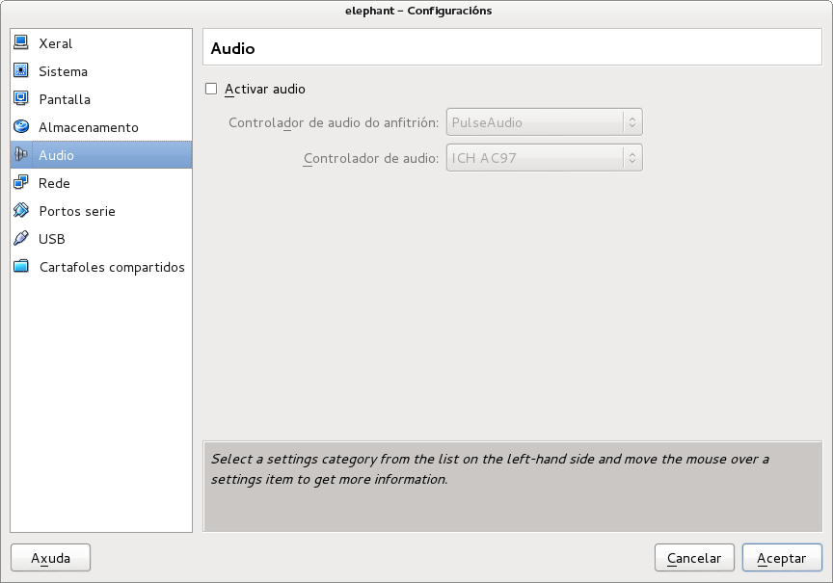
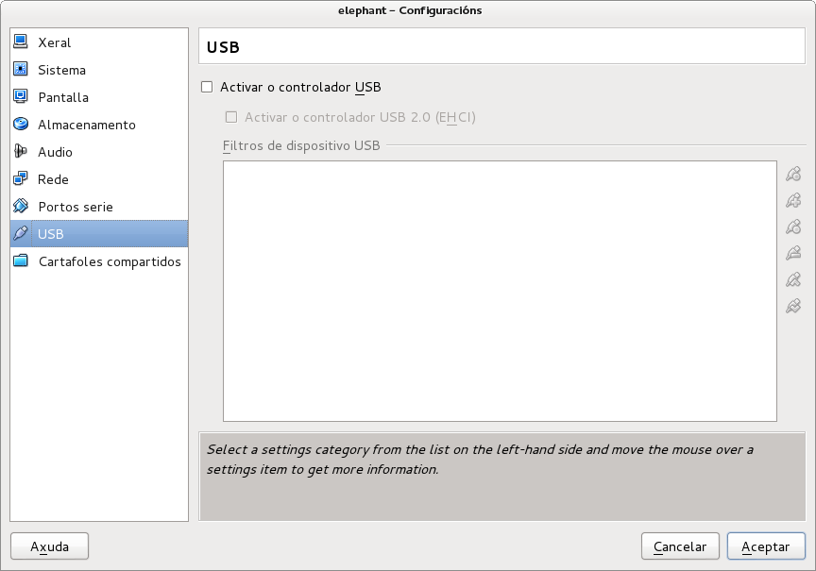

Enable intel vt-x or amd-v set intructions from guest processor:

