Install Virtual Machines

We will use 4 VM with differentes packages:

- elephant: NameNode, DataNode, TaskTracker.
- tiger: SecundaryNamenode, DataNode and TaskTracker.
- horse: JobTracker, DataNode and TaskTracker.
- monkey: DataNode and TaskTracker.

First, we configure one VM with basic components and network configurations. Later, we copy for 3 others VMs.

- Configure keyboard
System -> Keyboard. Go to Layouts -> Add... -> Country -> Spain

See: https://access.redhat.com/documentation/en-US/Red_Hat_Enterprise_Linux/3/html/System_Administration_Guide/ch-keyboardconfig.html

Select Spain as default and remove US keyboard.

- Set Clock settings

Sudoer user password by default is “cloudera”.

- Update packages

$ yum update -y

If you want a vim editor

$ yum install vim -y

- Stop Cloudera Manager

- Go to file:///home/cloudera/Documents/quick-hadoop/cloudera-manager.html
- Click on Actions -> Stop
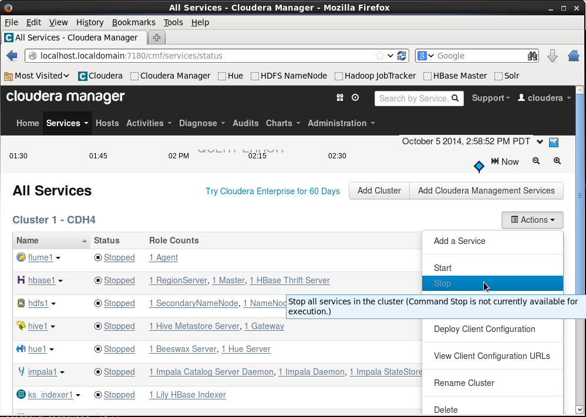
- Stop Clouder Services:
one-step-one
  - for s in `cd /etc/init.d/; ls cloudera*`; do sudo service $s stop; done
or serveral-steps
  - $ sudo service cloudera-scm-server stop
  - $ sudo service cloudera-scm-server-db stop
  - $ sudo service cloudera-scm-agent hard_stop
- Remove from start on boot
  - $ sudo chkconfig --list|grep cloudera
  - $ for s in `cd /etc/init.d/; ls cloudera*`; do sudo chkconfig $s on; done

- Remove pseudodistributed configuration
- $ sudo yum remove -y hadoop-0.20-conf-pseudo

- Reinstall basic packages
- $ sudo yum -y reinstall hadoop-hdfs-namenode hadoop-hdfs-datanode hadoop-0.20-mapreduce-tasktracker hadoop-hdfs-secondarynamenode hadoop-0.20-mapreduce-jobtracker
- $ for s in `cd /etc/init.d/; ls hadoop*`; do sudo chkconfig $s on; done

- Configure network

- Configure dhcp with Network-Manager for eth1 (we will use NAT config with guests OS):

$ sudo vim /etc/sysconfig/network-scripts/ifcfg-eth1
DEVICE="eth1"
TYPE=Ethernet
BOOTPROTO="dhcp"
NM_CONTROLLED="yes"
DEFROUTE=yes
IPV4_FAILURE_FATAL=yes
IPV6INIT=no
NAME="eth1"
ONBOOT=yes

- Configure static IP on eth2 (Internal Network device)
$ sudo nano /etc/sysconfig/network-scripts/ifcfg-eth2
DEVICE="eth2"
TYPE=Ethernet
BOOTPROTO="static"
NM_CONTROLLED="no"
IPADDR=192.168.1.1
PREFIX=24
DEFROUTE=yes
IPV4_FAILURE_FATAL=yes
IPV6INIT=no
NAME="eth2"
ONBOOT=yes

- Configure hostname
$ sudo nano /etc/sysconfig/network
NETWORKING=yes
HOSTNAME=elephant

- Configure hosts
  - 4 VMs
$ sudo nano /etc/hosts
192.168.1.1 elephant
192.168.1.2 tiger
192.168.1.3 horse
192.168.1.4 monkey

- Restart network
$ sudo service network restart

- Verify hostname
$ hostname

- Create Hadoop Configuration files

- Move old Cloudera Manager config files
  - $ sudo mv /etc/hadoop/conf /etc/hadoop/conf.alternatives
- Create basic Hadoop config files
  - $ sudo mv /etc/hadoop/conf.empty /etc/hadoop/conf
- Create enviroment vars file
  - $ touch /etc/hadoop/conf/hadoop-env.sh

- Clone elephant VM

- Shut down elephant on System -> Shut down
- Select elephant on Virtual Box manager and go to menu Machine -> Clone
- Select new names: tiger, horse and monkey.
- Mark reinitialize the MAC address...
- Select Full clone.

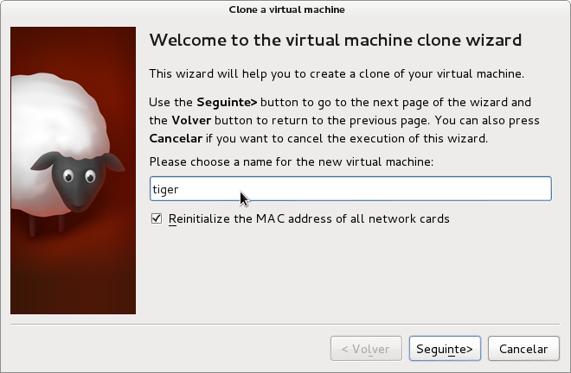
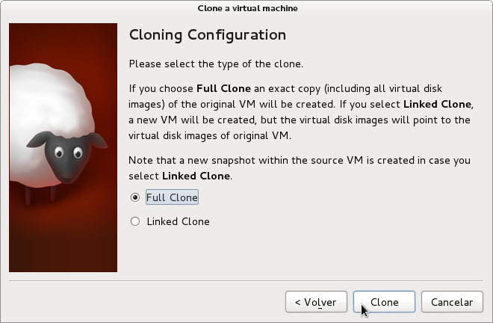

- Start new VM tiger

- Reconfigure interfaces name
By default, VirtualBox creates new internal interfaces. We can change the names using these commands:

- $ sudo nano /etc/udev/rules.d/70-persistent-net.rules
- Comment with # eth0, eth1 and eth2
- Rename eth3 -> eth1 and eth4 -> eth2
# PCI device 0x8086:0x100e (e1000
SUBSYSTEM=="net", ACTION=="add", DRIVERS=="?*", ATTR{address}=="08:00:27:6a:1b:86", ATTR{type}=="1", KERNEL=="eth*", NAME="eth1"

# PCI device 0x8086:0x100e (e1000)
SUBSYSTEM=="net", ACTION=="add", DRIVERS=="?*", ATTR{address}=="08:00:27:75:b5:92", ATTR{type}=="1", KERNEL=="eth*", NAME="eth2"

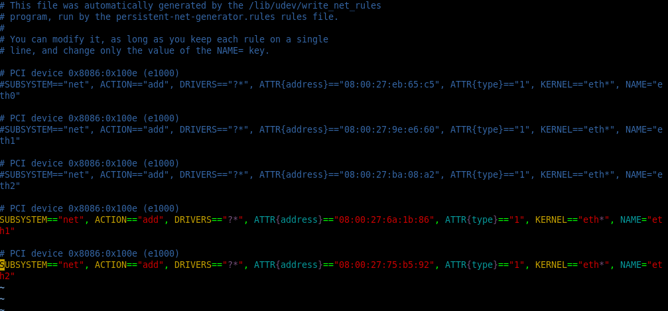

- Configure tiger Network

- Configure IP
$ sudo nano /etc/sysconfig/network-scripts/ifcfg-eth2
...
IPADDR=192.168.1.2
...

- Configure hostname
$ sudo nano /etc/sysconfig/network
NETWORKING=yes
HOSTNAME=tiger.gpul.org

- We need reboot VM after change ethX names
$ sudo reboot

- Copy and configure horse same as tiger in steps 10 to 14
- Copy and configure monkey same as tiger in steps 10 to 14

Test ping to elephant, tiger, horse and monkey:
$ ping elephant
$ ping tiger
$ ping horse
$ ping monkey

There should be the cluster prepared like in this picture:

