Configure HDFS

 | NameNode | SecundaryNamenode | DataNode | JobTracker | TaskTracker
elephant | x |  | x |  | x
tiger |  | x | x |  | x
horse |  |  | x | x | x
monkey |  |  | x |  | x

- Uninstall packages from elephant

- $ sudo yum remove -y hadoop-hdfs-secondarynamenode hadoop-0.20-mapreduce-jobtracker

- Uninstall packages from tiger
$ sudo yum remove -y hadoop-hdfs-namenode hadoop-0.20-mapreduce-jobtracker

- Uninstall packages from horse
$ sudo yum remove -y hadoop-hdfs-namenode hadoop-hdfs-secondarynamenode

- Uninstall packages from monkey
$ sudo yum remove -y hadoop-hdfs-datanode hadoop-hdfs-secondarynamenode hadoop-0.20-mapreduce-jobtracker

- Stop process on all nodes

$ for s in `cd /etc/init.d/; ls hadoop-hdfs*`; do sudo service $s stop; done

- Create OS path for Hadoop HDFS and MapReduce

$ sudo mkdir -p /disk1/dfs/nn
$ sudo mkdir -p /disk2/dfs/nn
$ sudo mkdir -p /disk1/dfs/dn
$ sudo mkdir -p /disk2/dfs/dn
$ sudo mkdir -p /disk1/mapred/local
$ sudo mkdir -p /disk2/mapred/local
- Change properties

$ sudo chown -R hdfs:hadoop /disk1/dfs/nn
$ sudo chown -R hdfs:hadoop /disk2/dfs/nn
$ sudo chown -R hdfs:hadoop /disk1/dfs/dn
$ sudo chown -R hdfs:hadoop /disk2/dfs/dn
$ sudo chown -R mapred:hadoop /disk1/mapred/local
$ sudo chown -R mapred:hadoop /disk2/mapred/local

- Configure HDFS on elephant

- $ sudo nano /etc/hadoop/conf/core-site.xml
<configuration>
<property>
<name>fs.default.name</name>
<value>hdfs://elephant:8020</value>
</property>
</configuration>

- $ sudo nano /etc/hadoop/conf/hdfs-site.xml
<configuration>
<property>
<name>dfs.name.dir</name>
<value>/disk1/dfs/nn,/disk2/dfs/nn</value>
</property>
<property>
<name>dfs.data.dir</name>
<value>/disk1/dfs/dn,/disk2/dfs/dn</value>
</property>
<property>
<name>dfs.http.address</name>
<value>elephant:50070</value>
</property>
</configuration>

- Configure enviroment vars for Java memory usage

- $ sudo nano /etc/hadoop/conf/hadoop-env.sh
export HADOOP_NAMENODE_OPTS="-Xmx64m"
export HADOOP_SECONDARYNAMENODE_OPTS="-Xmx64m"
export HADOOP_DATANODE_OPTS="-Xmx64m"
export HADOOP_JOBTRACKER_OPTS="-Xmx64m"
export HADOOP_TASKTRACKER_OPTS="-Xmx64m"

- $ sudo chmod +x /etc/hadoop/conf/hadoop-env.sh

- Copy configuration to all nodes

- $ sudo yum install -y sshpass
- $ nano ~/copy_config.sh
#!/bin/bash
sshpass -p 'cloudera' scp /etc/hadoop/conf/core-site.xml root@tiger:/etc/hadoop/conf/
sshpass -p 'cloudera' scp /etc/hadoop/conf/core-site.xml root@horse:/etc/hadoop/conf/
sshpass -p 'cloudera' scp /etc/hadoop/conf/core-site.xml root@monkey:/etc/hadoop/conf/
sshpass -p 'cloudera' scp /etc/hadoop/conf/hdfs-site.xml root@tiger:/etc/hadoop/conf/
sshpass -p 'cloudera' scp /etc/hadoop/conf/hdfs-site.xml root@horse:/etc/hadoop/conf/
sshpass -p 'cloudera' scp /etc/hadoop/conf/hdfs-site.xml root@monkey:/etc/hadoop/conf/
sshpass -p 'cloudera' scp /etc/hadoop/conf/mapred-site.xml root@tiger:/etc/hadoop/conf/
sshpass -p 'cloudera' scp /etc/hadoop/conf/mapred-site.xml root@horse:/etc/hadoop/conf/
sshpass -p 'cloudera' scp /etc/hadoop/conf/mapred-site.xml root@monkey:/etc/hadoop/conf/
sshpass -p 'cloudera' scp /etc/hadoop/conf/hadoop-env.sh root@tiger:/etc/hadoop/conf/
sshpass -p 'cloudera' scp /etc/hadoop/conf/hadoop-env.sh root@horse:/etc/hadoop/conf/
sshpass -p 'cloudera' scp /etc/hadoop/conf/hadoop-env.sh root@monkey:/etc/hadoop/conf/
echo done

- $ chmod +x copy_config.sh
- Exec first time ssh againts consoles (to storage RSA key fingerprint)
  - $ ssh tiger (write yes and cancel later with Control+C)
  - $ ssh horse (write yes and cancel later with Control+C)
  - $ ssh monkey (write yes and cancel later with Control+C)
- ./copy_config.sh

- Format HDFS and start NameNode

- $ sudo service hadoop-hdfs-namenode stop
Wait until NaneNode kill Java Process
- $ sudo jps |grep NameNode
- $ sudo -u hdfs hdfs namenode -format
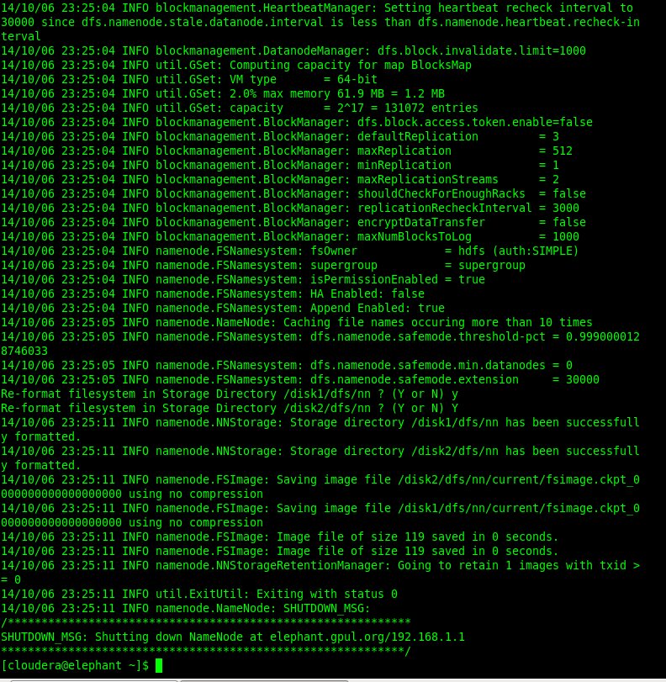
- $ sudo service hadoop-hdfs-namenode start

- Check Java processes with parameters

- sudo jps

- Start Secundary NameNode on tiger

- $ sudo service hadoop-hdfs-secondarynamenode start
- Start DataNode on all nodes

- $ sudo service hadoop-hdfs-datanode start
- Verify daemons on Java process
$ sudo jps

- If there are some problems check log files
$ tail -n 99 /var/log/hadoop-hdfs/hadoop-hdfs-datanode-elephant.log
$ tail -n 99 /var/log/hadoop-hdfs/hadoop-hdfs-datanode-tiger.log
$ tail -n 99 /var/log/hadoop-hdfs/hadoop-hdfs-datanode-horse.log
$ tail -n 99 /var/log/hadoop-hdfs/hadoop-hdfs-datanode-monkey.log
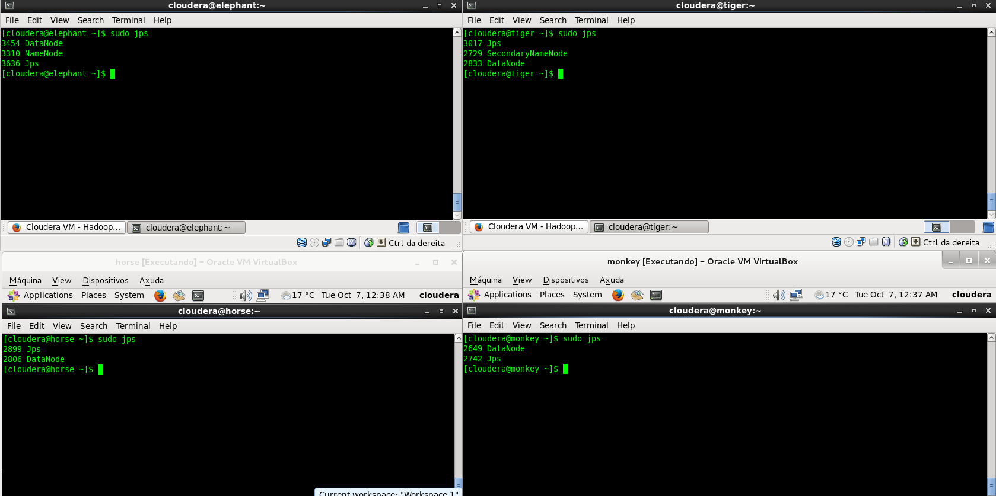
- Create path on HDFS for user
- $ sudo -u hdfs hadoop fs -mkdir /user/cloudera
- $ sudo -u hdfs hadoop fs -chown cloudera /user/cloudera

