HDFS Exersices

- Verify HDFS access

- Help
  - $ hadoop fs -help

- As hdfs user
  - $ sudo -u hdfs hadoop fs -ls -R /
- As local user
  - $ hadoop fs -ls -R -d
  - $ hadoop fs -mkdir wordcount
  - $ hadoop fs -ls -R

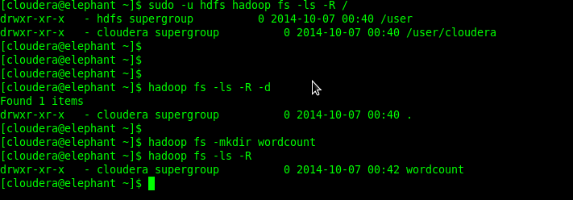

- Create input path
$ hadoop fs -mkdir /user/cloudera/wordcount/input

- Download a file example:

$ wget http://www.gnu.org/licenses/gpl.txt
$ wget http://www.apache.org/licenses/LICENSE-2.0.txt

- Put on Hadoop HDFS
$ hadoop fs -put gpl.txt LICENSE-2.0.txt wordcount/input

- Test output files on HDFS

$ hadoop fs -tail wordcount/input/gpl.txt
$ hadoop fs -tail wordcount/input/LICENSE-2.0.txt

- Verify on web service http://elephant:50070/dfshealth.jsp

- Click on Browse the filesystem -> /user/cloudera/wordcount/input -> gpl.txt

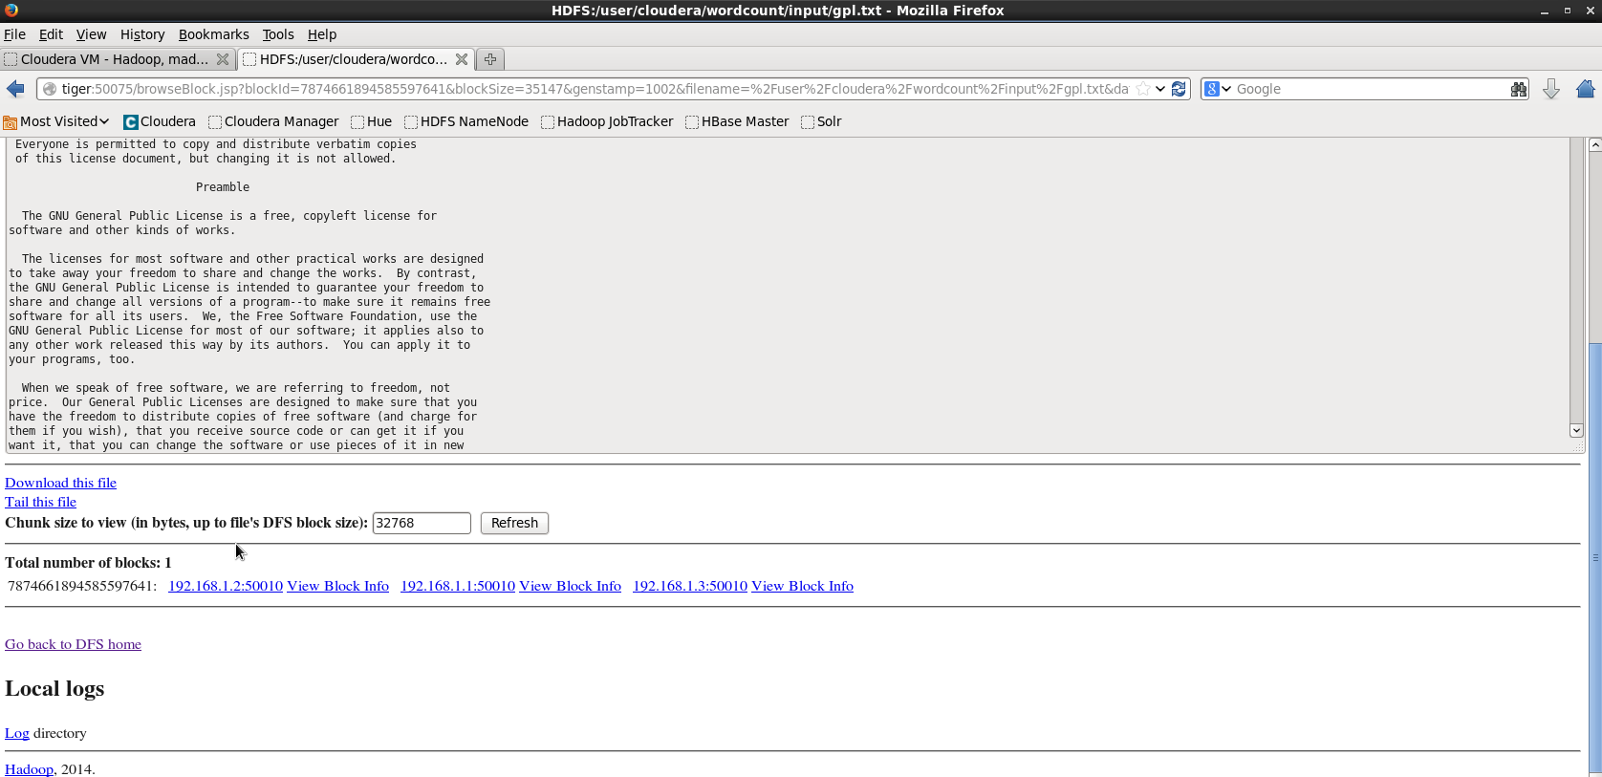

- Check DataNodes where are the blocks
- Click on View Block Info from DataNode 192.168.1.1:50010 (elephant)
- Search value from parameter “block_name” and copy number
example: blk_7874661894585597641

- Login as root

$ sudo su -

- Search file in /disk1 or /disk2

# find /disk1/dfs/dn/current/ -name blk_7874661894585597641
/disk1/dfs/dn/current/BP-936788720-192.168.1.1-1412634379960/current/finalized/blk_7874661894585597641

- Go to path from file

# cd /disk1/dfs/dn/current/BP-936788720-192.168.1.1-1412634379960/current/finalized/blk_7874661894585597641

# ls -l
total 40
-rw-r--r-- 1 hdfs hdfs 35147 Oct 7 01:10 blk_7874661894585597641
-rw-r--r-- 1 hdfs hdfs 283 Oct 7 01:10 blk_7874661894585597641_1002.meta

- View file blk_[id]

# tail blk_7874661894585597641

- Modify file
# cat >> blk_7874661894585597641
new line
[Control + D]

- Exit as root and read from Hadoop HDFS

$ hadoop fs -tail wordcount/input/gpl.txt

- What happened?

- Return to http://elephant:50070/dfshealth.jsp and click on Browse the filesystem -> /user/cloudera/wordcount/input -> gpl.txt

- Check the health of HDFS

Hadoop includes the dfsadmin command line tool for HDFS administration functionality. This tool allows the user to view the status of the HDFS cluster

$ sudo -u hdfs hadoop dfsadmin -report

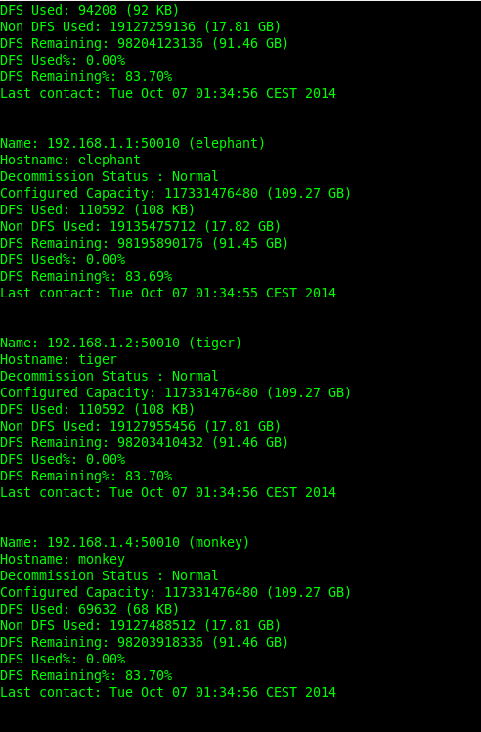

- Go to http://elephant:50070/dfsnodelist.jsp and click on Live Nodes

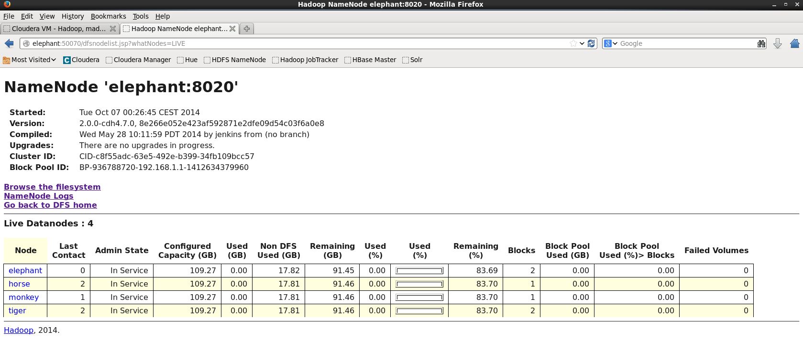

- Check size from terminal, 109Gb or 55Gb?

$ df -h

We configured tow paths (/disk1 and /disk2) as DN and NN devices for Hadoop. But the device has only 55Gb size.

