Exercises MapReduce

- Check files
$ hadoop fs -ls wordcount/input

- Launch Job WordCount MapReduce

$ hadoop jar /usr/lib/hadoop-0.20-mapreduce/hadoop-examples.jar wordcount wordcount/input wordcount/output

Note: wordcount/input cannot exists or the job will fail.

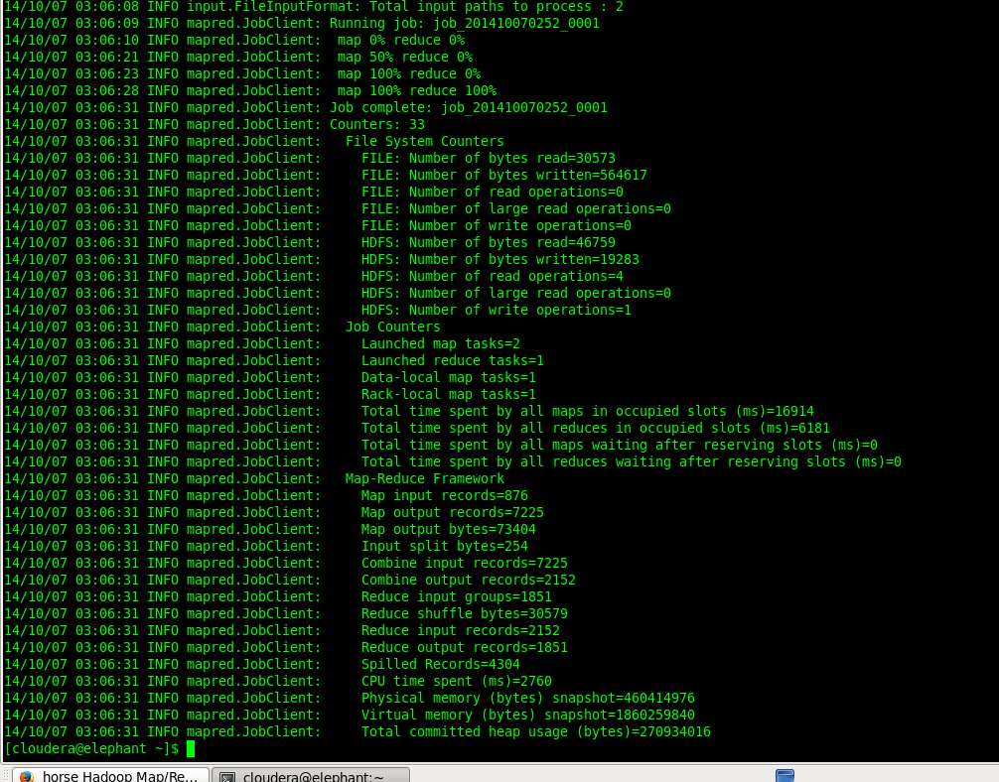

- Go to JobTracker web

http://horse:50030/jobtracker.jsp

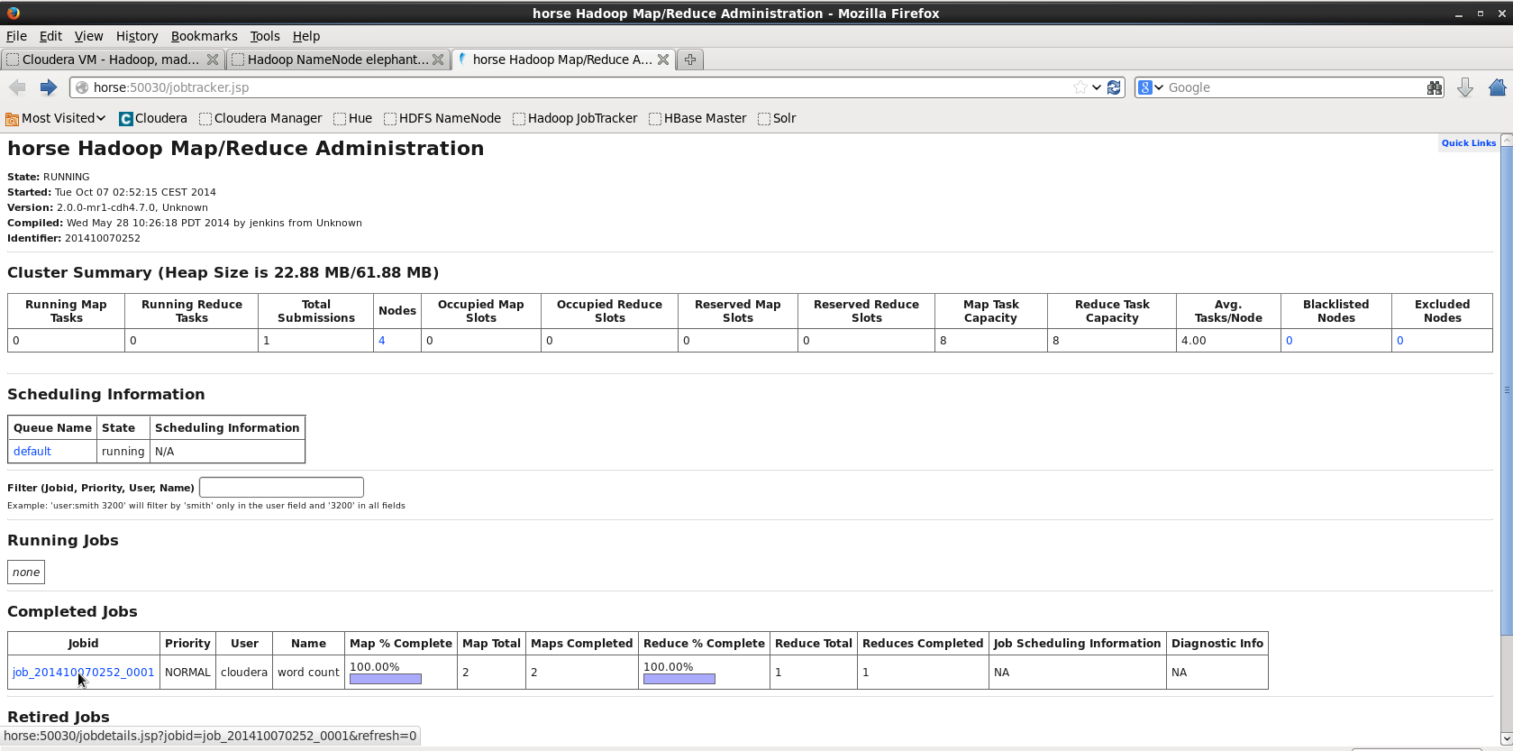

- View job on “Completed Jobs” or “Running Jobs”

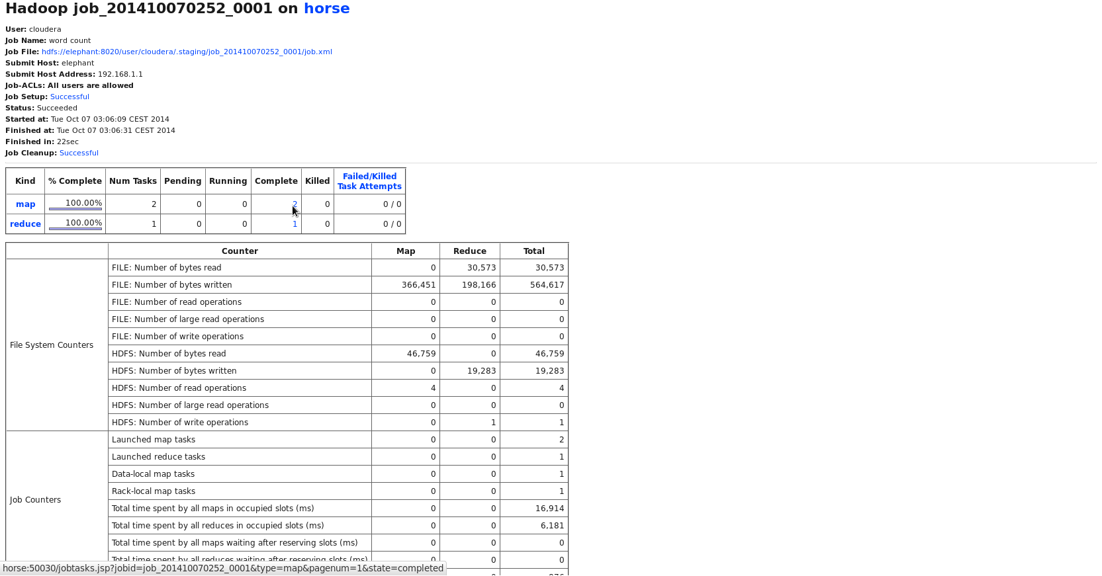

- On Job File you can view metadata configuration for the job

- Click on map link

- Click on one from two tasks

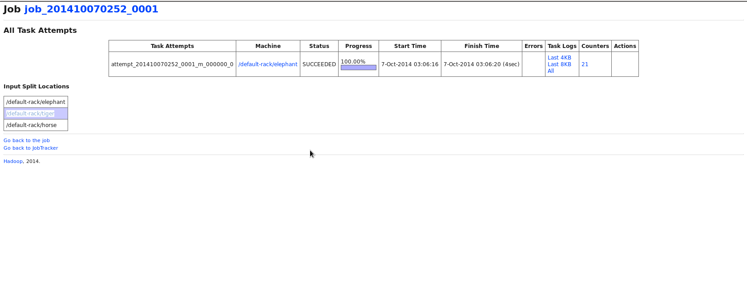
Which datanode read the block?

