Pig

- Install Pig
- $ sudo yum install -y pig

- Run grunt shell
- $ pig
grunt>

- Load data from musicbrainz paths
grunt> tracks = LOAD 'musicbrainz_tracks' AS (trackid:int, releaseid:int, trackname:chararray, position:int);

grunt> releases = LOAD '/user/cloudera/musicbrainz_releases' AS (id:int, album:chararray, artist:chararray);

- Join bags releases and tracks
- grunt> jnd = JOIN tracks BY releaseid, releases BY id;

- Filter by position 1 on list
- grunt> filtro = FILTER jnd BY position == 1;

- Store result filtro on HDFS
- grunt> STORE filtro INTO 'music_position_1';

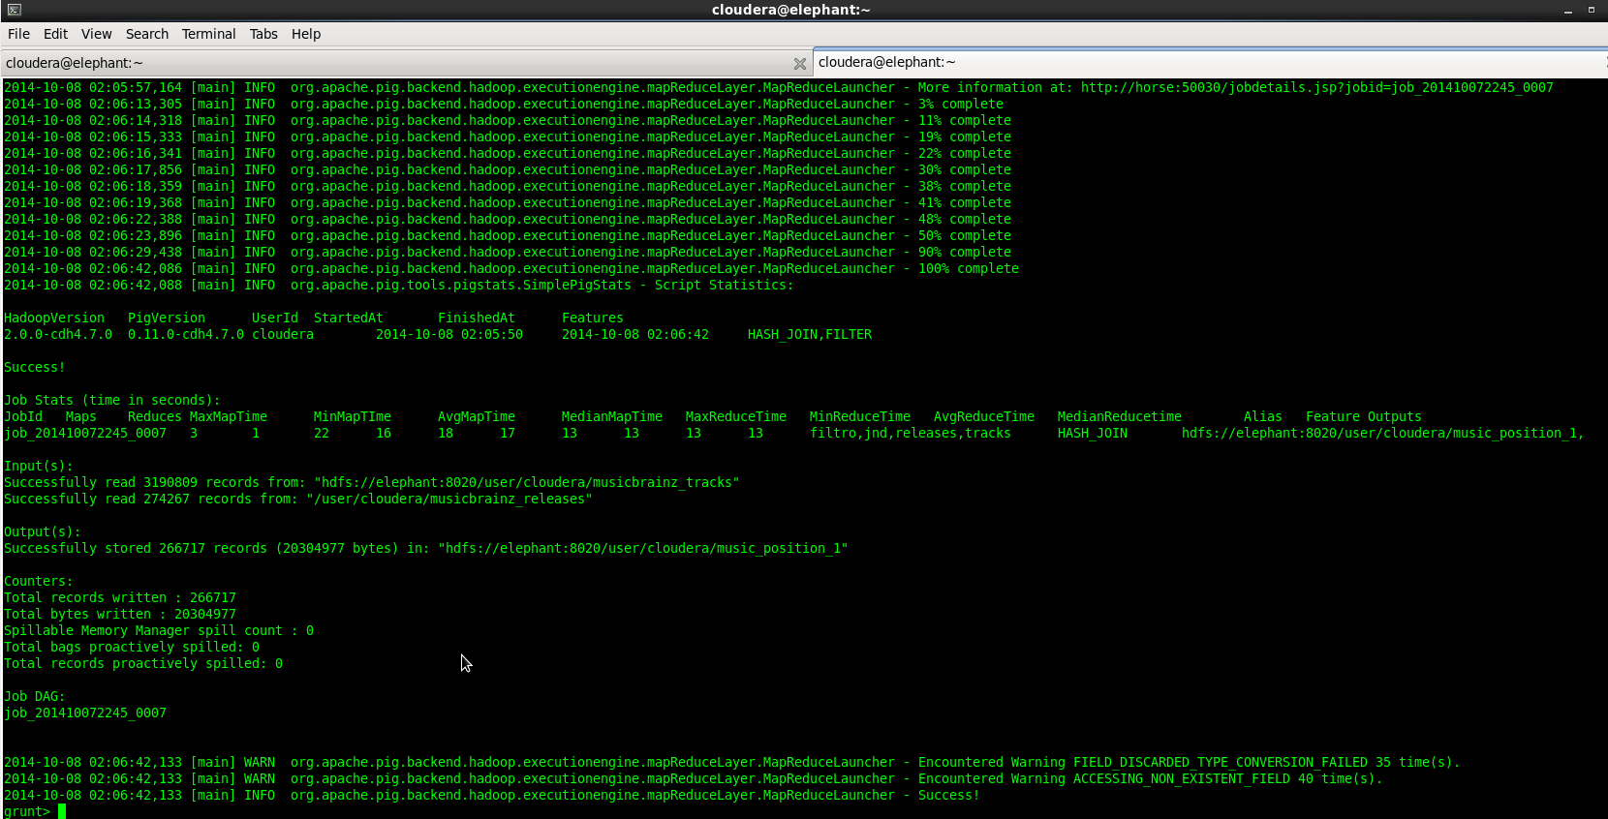

- Check results in file
- grunt> quit
- $ hadoop fs -tail music_position_1/part-r-00000

