Jesse Osiecki
HW4 Comp 530H
Fall 2014
SmithFD
User Round Robin Scheduling:
In this assignment we implement a User-controlled round robin scheduler via a psuedo systemcall implemented via a linux kernel module for the 2.6.32 kernel (using debugfs).
Running 10 processes with weights ranging from 1 to 10 (where the time alloted in a processes quantum was equal to 10ms * weight), the following graph was created from the data:
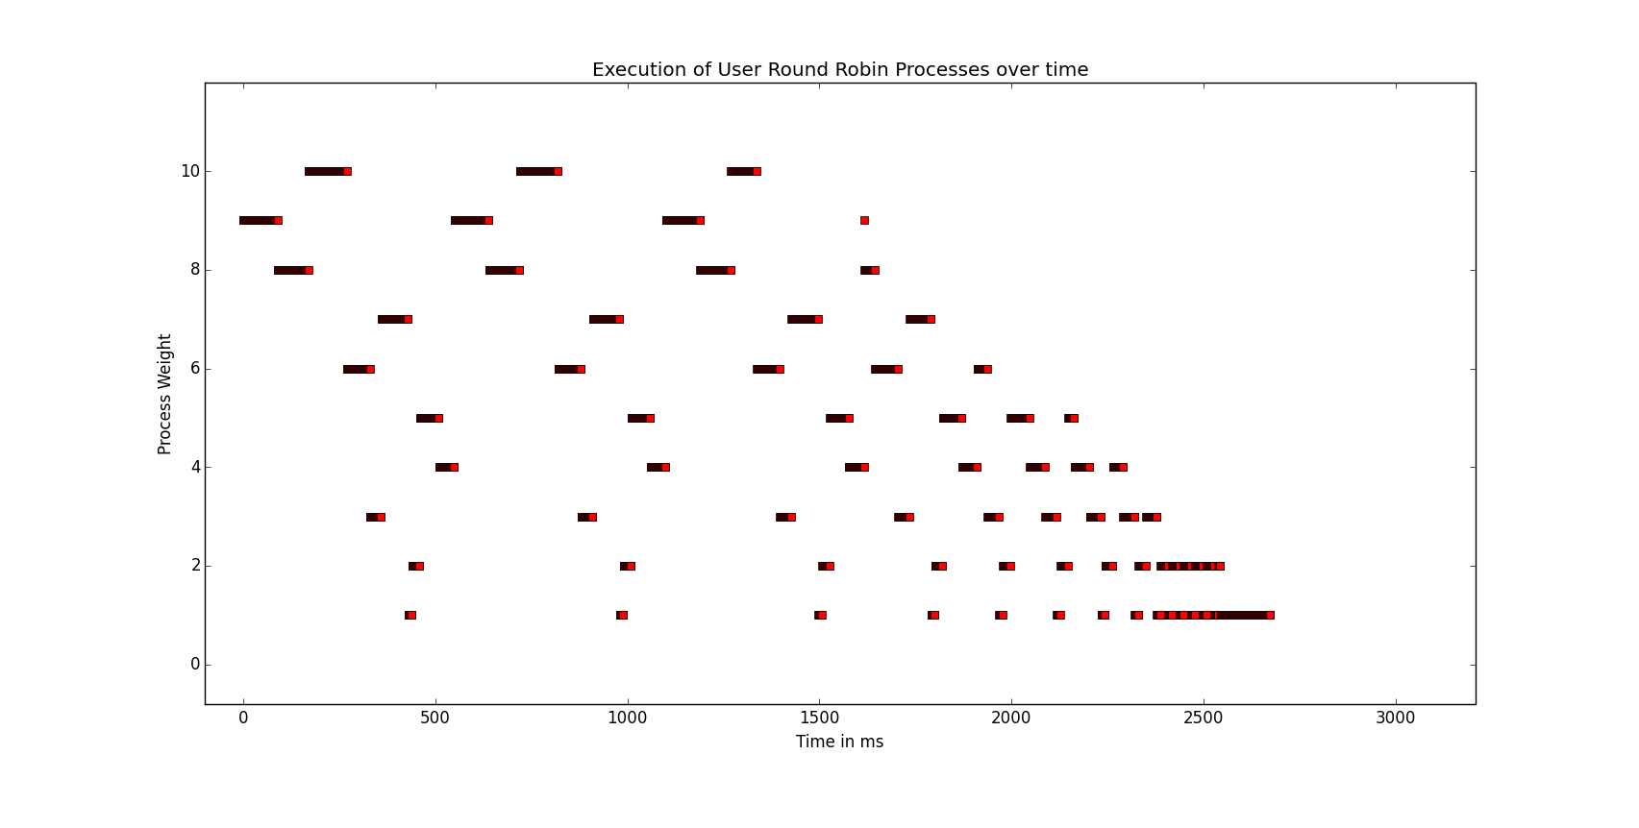
The following chart is a collection of each PID's final entry in the kernel log, and the relevant data associated with it.

As shown, Each tick count roughly was equal. Worth noting is the timeslice: as the timeslice is decremented each tick, and then reset to a predefined value before our module modify's that value, we can see where in the quantum each of these processes finished execution.

Here we can see the initial values for comparison (after the realtime class decremented the timeslice).

