**机器学习第二次作业**

**1、BP公式推导**

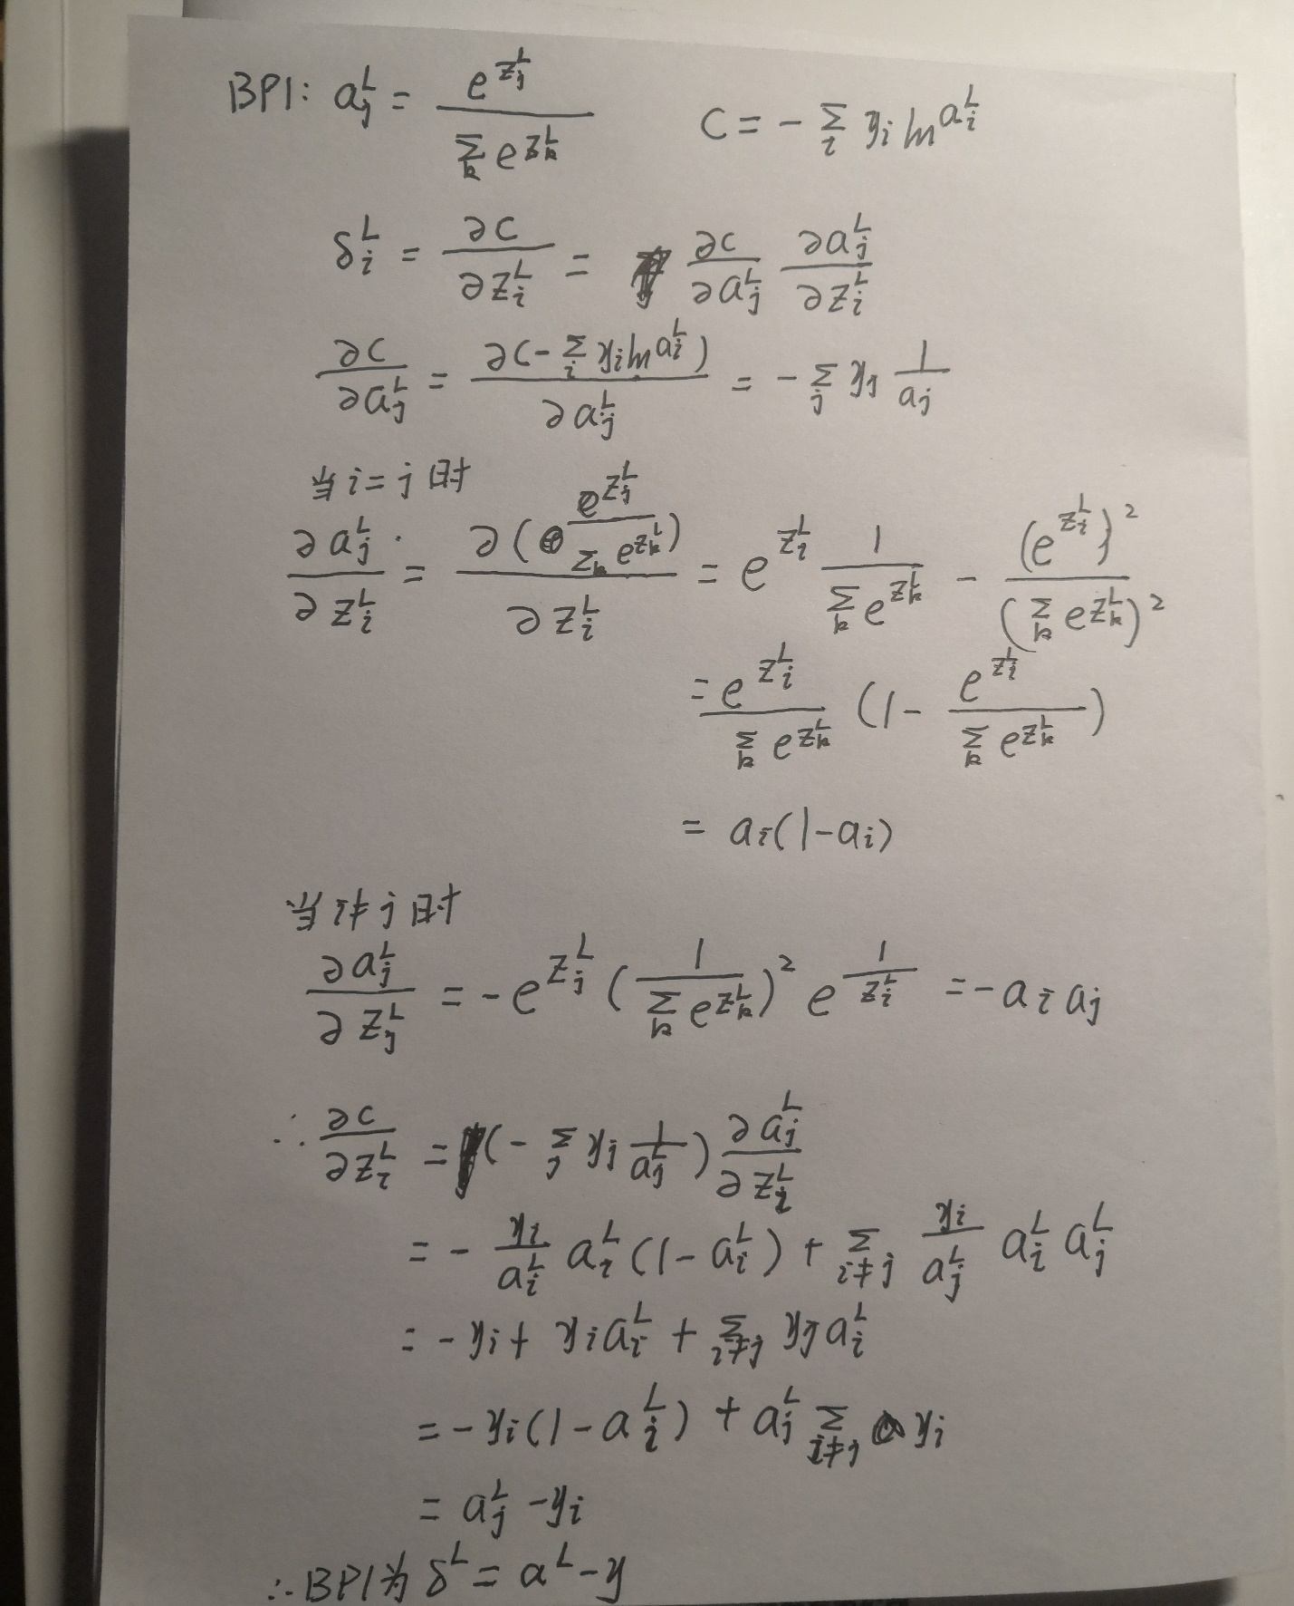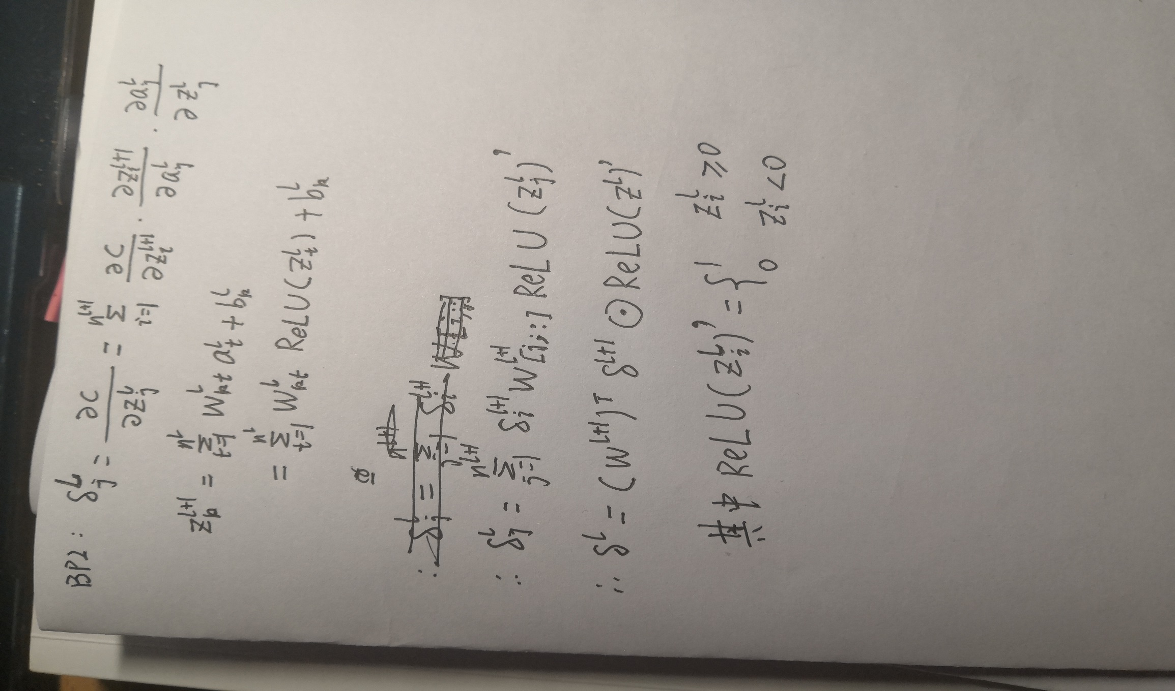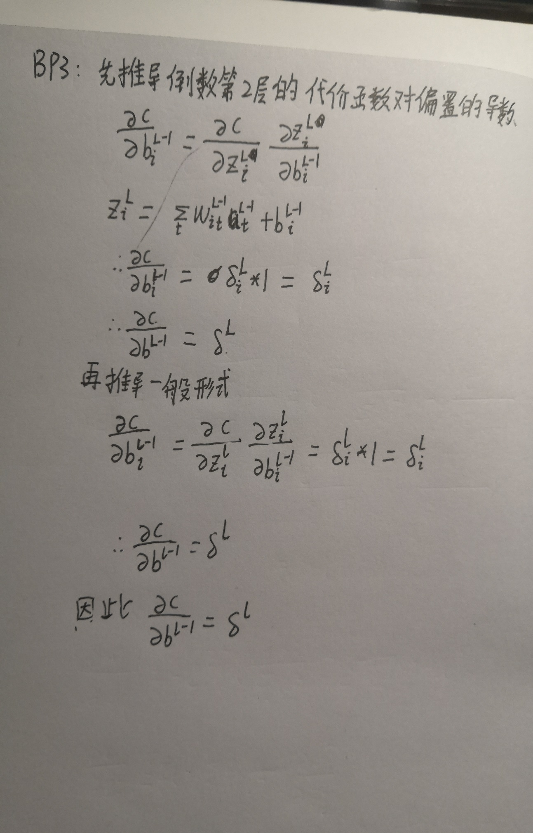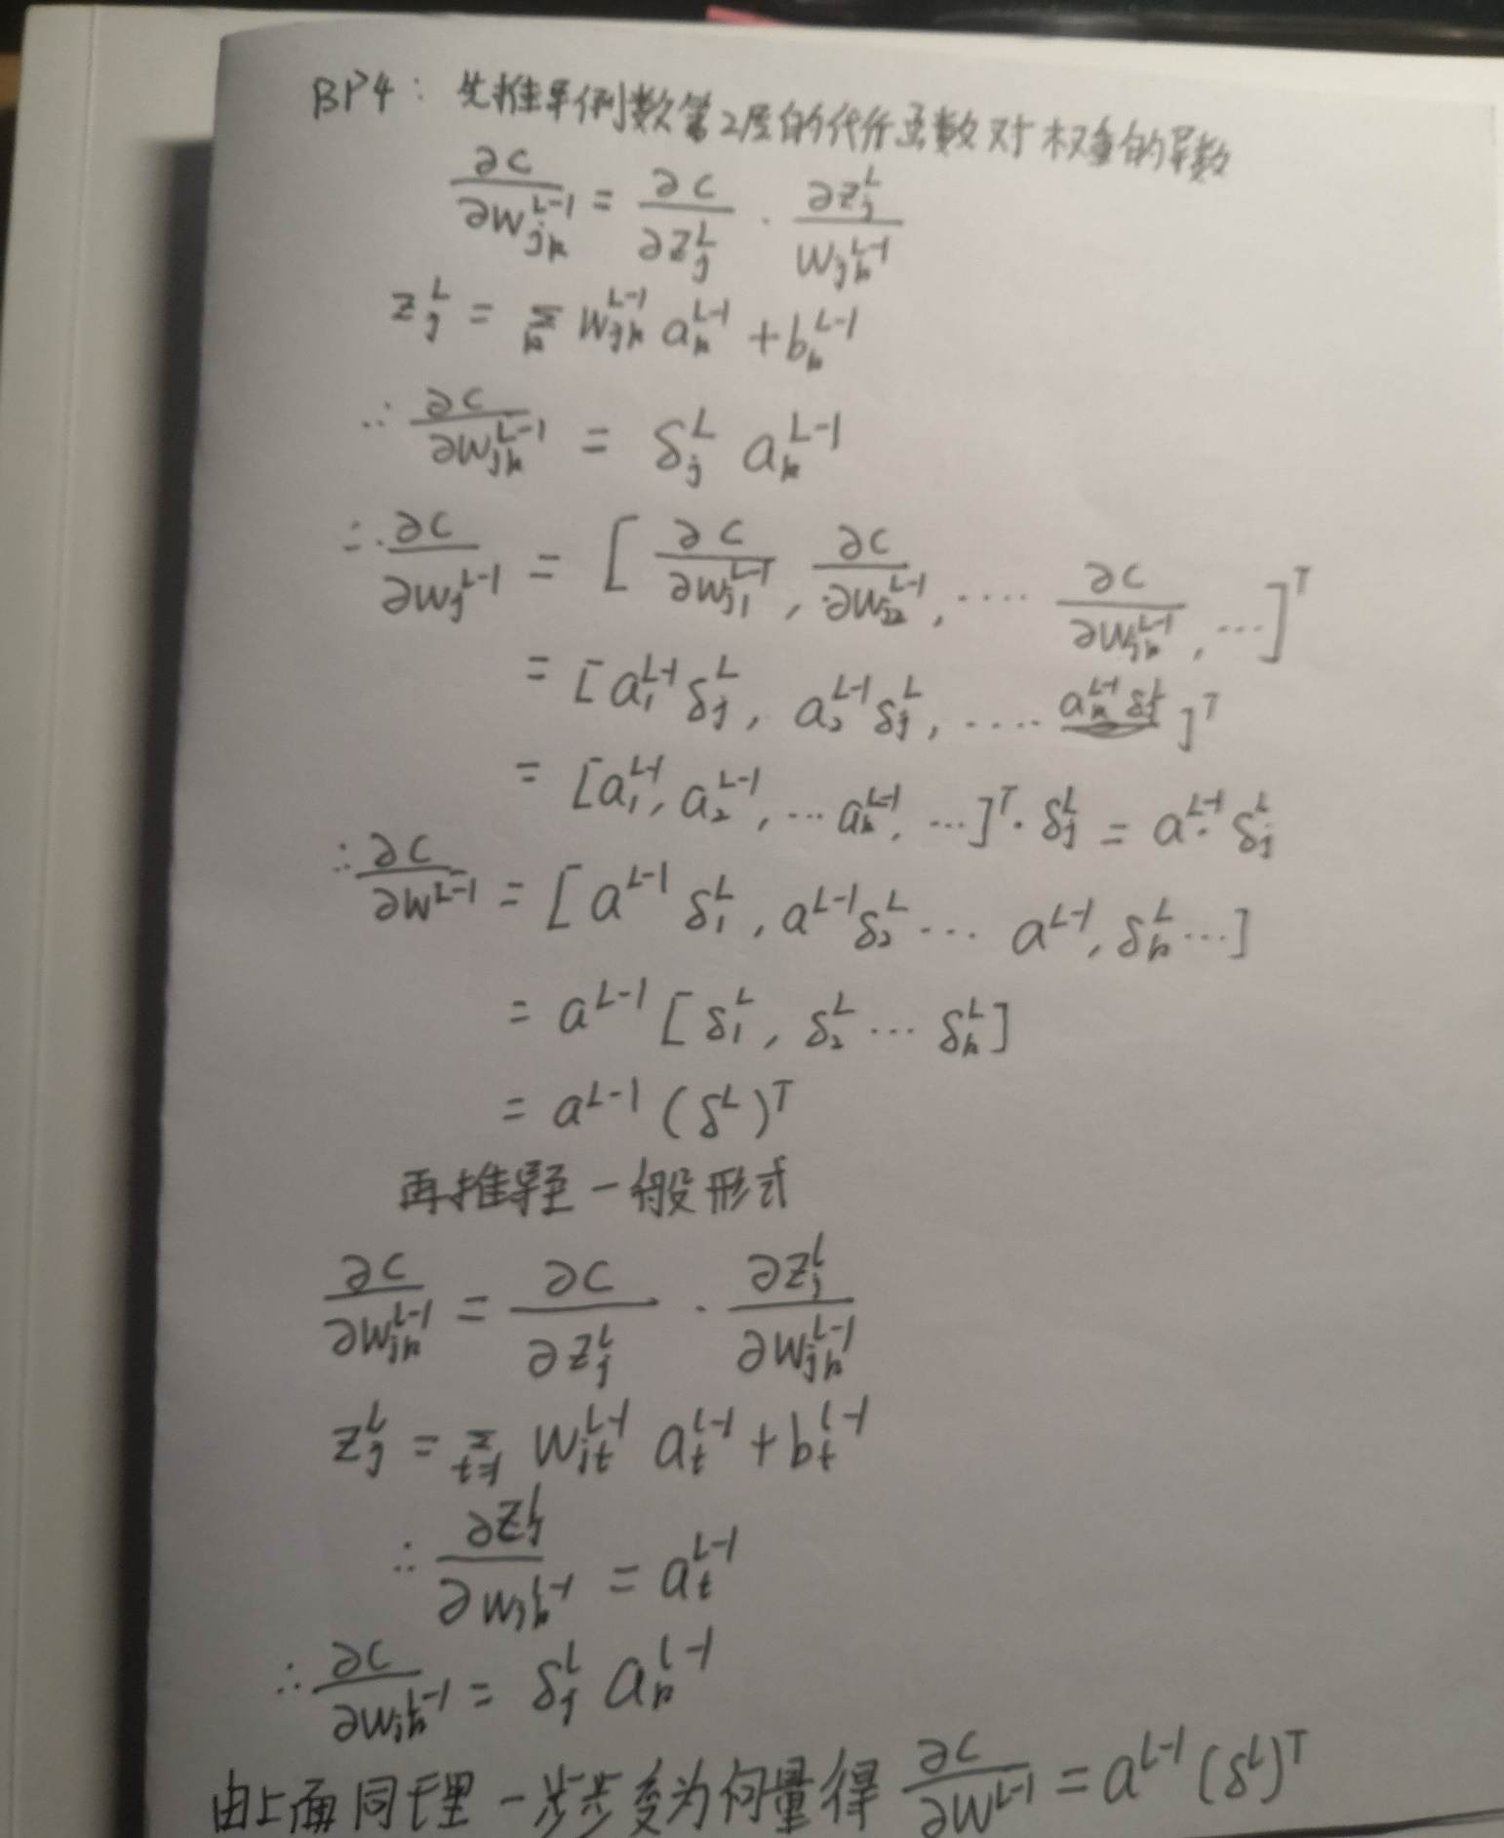

**2、编程题**

（1）将sigmoid函数改为ReLU函数

def ReLU(z):  
 *"""ReLU函数"""* return np.where(z < 0, 0, z)  
  
  
def ReLU_prime(z):  
 *"""ReLU函数的导数"""* return np.where(z < 0, 0, 1)

（2）通过网格搜索找到超参数的大致值

x_scatter = np.arange(5, 16, 1)  
y_scatter = np.linspace(0.08, 0.18, 11)  
results = {}  
  
for x in x_scatter:  
 for y in y_scatter:  
 training_data, validation_data, test_data = load_data.load_data_wrapper()  
 training_data = training_data[0:5000]  
 test_data = test_data[0:1000]  
 net = network.Network([784, 15, 10], cost=network.CrossEntropyCost)  
 res = net.SGD(training_data, 20, x, y,  
 evaluation_data=test_data,  
 monitor_training_accuracy=True,  
 monitor_evaluation_accuracy=True)  
 accuracy = max([i / 1000 for i in res[1]])  
 results[(x, y)] = accuracy  
marker_size = 100 *# default: 20*best_point = max(results, key=results.get)  
best_acc = max(results.values())  
worst_acc = min(results.values())  
colors = [results[x] for x in results.keys()]  
colors = 1-((best_acc - colors)/(best_acc - worst_acc))  
[Y, X] = np.meshgrid(y_scatter, x_scatter)  
  
X = X.reshape(len(X.reshape(-1, 1)))  
Y = Y.reshape(len(Y.reshape(-1, 1)))  
plt.figure()  
plt.scatter(X, Y, marker_size, c=colors, cmap=plt.cm.coolwarm)  
plt.annotate(**'(%.2f,%.2f,%.2f%%)'** % (best_point[0], best_point[1], best_acc),  
 xy=best_point, xytext=(-30, 30), textcoords=**'offset pixels'**,  
 bbox=dict(boxstyle=**'round,pad=0.5'**, fc=**'yellow'**, alpha=0.5),  
 arrowprops=dict(arrowstyle=**'->'**, connectionstyle=**'arc3,rad=0'**))  
plt.colorbar()  
plt.xlabel(**'mini_batch_size'**)  
plt.ylabel(**'eta'**)  
plt.title(**'search best parameter'**)  
plt.show()

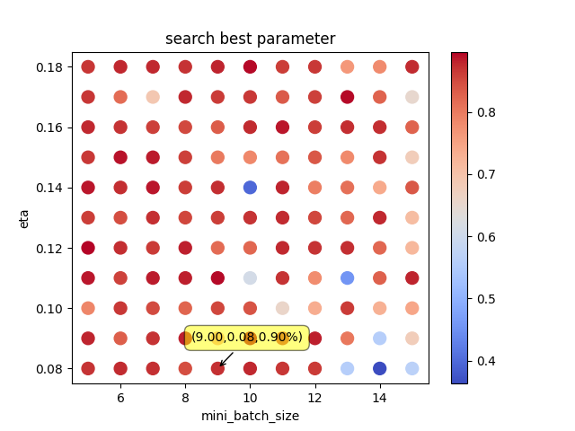

（3）缩小超参数范围，继续搜索更好的值

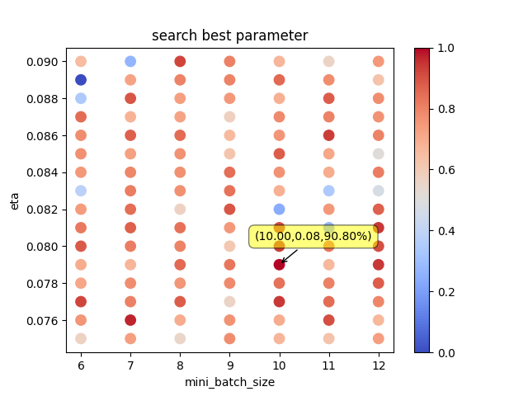

（4）采用隐含层有15个神经元的网络，得出初步结果

training_data, validation_data, test_data = load_data.load_data_wrapper()  
net = network.Network([784, 15, 10], cost=network.CrossEntropyCost)  
y = net.SGD(training_data, 30, 9, 0.08,  
 evaluation_data=test_data,  
 monitor_training_accuracy=True,  
 monitor_evaluation_accuracy=True)  
x = np.arange(30)  
y1 = [i/10000 for i in y[1]]  
y2 = [i/50000 for i in y[3]]  
plt.axis([0, 30, 0.89, 0.98])  
plt.plot(x, y1, **'g'**, label=**'evaluation_accuracy'**)  
plt.plot(x, y2, **'b'**, label=**'training_data'**)  
plt.legend()  
plt.show()

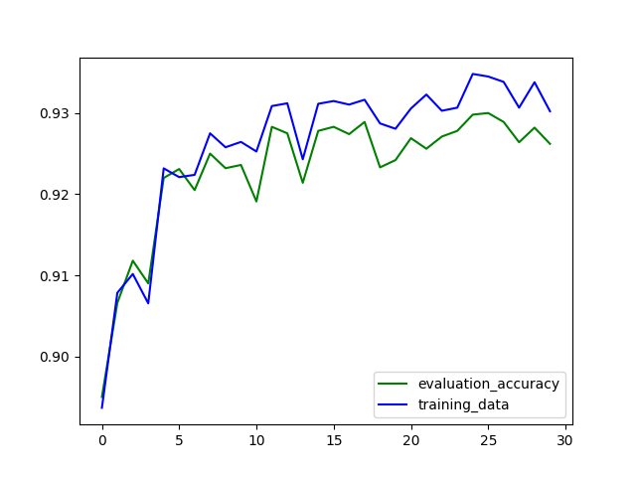

可以看出最后的查准率在93%左右，图像有轻微的过拟合现象

（5）增加正则化项，减少过拟合

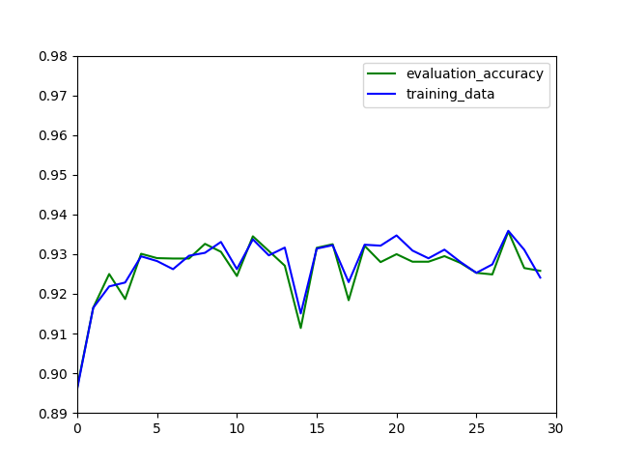

有图可以看出，过拟合现象减轻，查准率在93%左右

（6）将隐含层改为30个神经元

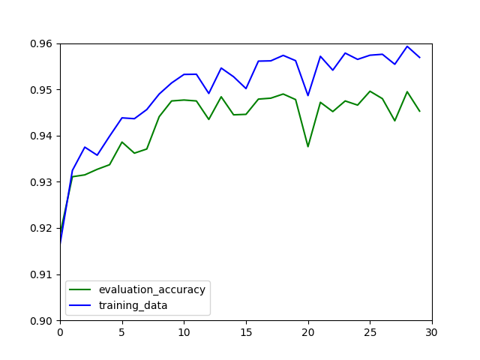

可以看出过拟合现象更严重，但是查准率上升到95%左右

（7）对三十个隐含神经元的网络增加正则化项

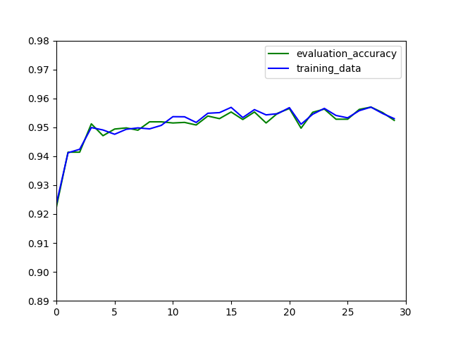

完美的解决了过拟合的现象，在验证集上表现不错，查准率提升到95%以上。