https://www.bilibili.com/video/BV1YY41117Fy/?spm_id_from=333.337.search-card.all.click&vd_source=f7392813cd5dee7276f90054e05e062b
https://www.bilibili.com/video/BV1u71LY2EBk?spm_id_from=333.788.recommend_more_video.0&vd_source=f7392813cd5dee7276f90054e05e062b
ESP32之使用TFT_eSPI操控彩色LCD屏 ESP32驱动TFT彩屏教程（st7789，st7735）
http://www.lcdwiki.com/zh/3.5inch_ESP32-32E_Display
https://item.taobao.com/item.htm?abbucket=13&detail_redpacket_pop=true&id=862321126654
ESP32液晶屏开发板 WiFi蓝牙 HMI智能TFT触摸屏显示模块 LVGL GUI
https://message.bilibili.com/#/whisper/mid515504477
消息
https://item.taobao.com/item.htm?abbucket=12&detail_redpacket_pop=true&id=864674621940&skuId=5855304830163
BIGTREETECH Rodent CNC主板FluidNC固件激光雕刻机控制板RS485
http://wiki.fluidnc.com/en/hardware/existing_hardware
BigTreeTech Rodent

https://oshwhub.com/wdmomo/esp32-grbl-4axis
https://www.wdmomo.fun:81/flasher/index.html
https://www.wdmomo.fun:81/flasher/ESP32_4AXIS/index.html
https://www.bilibili.com/video/BV1aD421W78e/?spm_id_from=333.337.search-card.all.click&vd_source=f7392813cd5dee7276f90054e05e062b
立创开源ESP32-GRBL-4AXIS

https://item.taobao.com/item.htm?id=922359258010&spm=a21m98.27004841
手轮mks
https://installer.fluidnc.com/
固件烧录
https://www.bilibili.com/video/BV1aD421W78e/?spm_id_from=333.337.search-card.all.click&vd_source=f7392813cd5dee7276f90054e05e062b
下一代GBRL-FluidNC
https://www.bilibili.com/video/BV1AaLwzPEnQ/?spm_id_from=333.337.search-card.all.click&vd_source=f7392813cd5dee7276f90054e05e062b
fluidnc脱机手轮
https://item.taobao.com/item.htm?abbucket=12&detail_redpacket_pop=true&id=699699511883&skuId=5674950518040
ESP32开发2.8寸IPS高清电容触摸
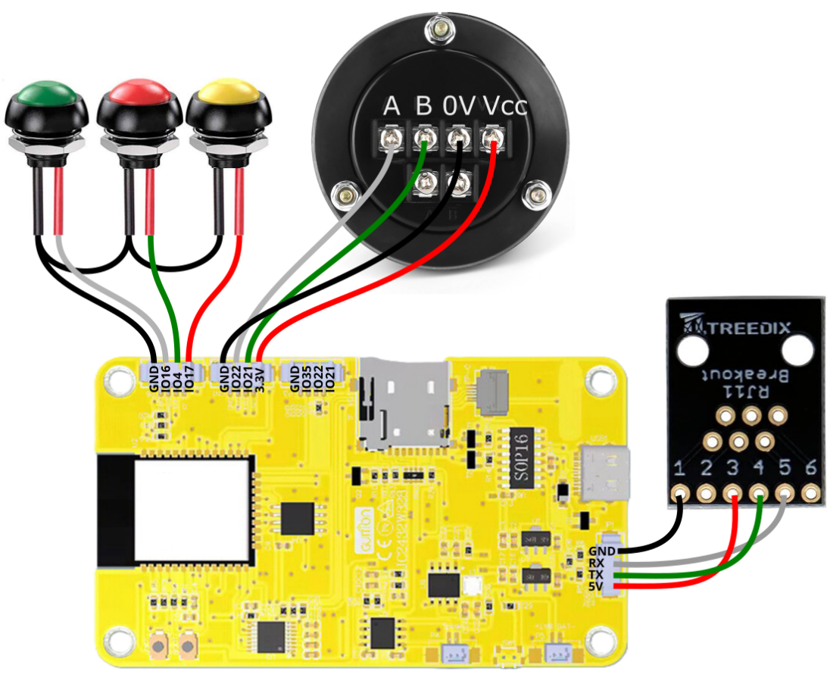
控制板和手轮连接后，控制板发出的数据
[09:12:07.366]收←◆?陫 苯嵀?龉禊?偤聜?,len:13232
load:0x40080400,len:3028
entry 0x400805e4

[09:12:07.408]收←◆\0
[09:12:07.449]收←◆ets Jul 29 2019 12:21:46
rst:0x1 (POWERON_RESET),boot:0x13 (SPI_FAST_FLASH_BOOT)
[09:12:07.707]收←◆T7789 panel OK
E (10) ledc: ledc_channel_config(608): gpio_num argument is invalid

[09:12:07.939]收←◆display.init

[09:12:07.960]收←◆choose_board
?error:1
[MSG:ERR: Expected GCodecommand letter]
ok
error:2
[MSG:ERR: Bad GCode number format]
ok
error:2
[MSG:ERR: Bad GCode number format]
ok
error:2
[MSG:ERR: Bad GCode number format]
ok

[09:12:10.307]收←◆error:2
[MSG:ERR: Bad GCode number format]
ok
error:2
[MSG:ERR: Bad GCode number format]
ok
error:2
[MSG:ERR: Bad GCode number format]
ok
error:2
[MSG:ERR: Bad GCode number format]
ok

[09:12:10.761]收←◆error:2
[MSG:ERR: Bad GCode number format]
o
[09:12:12.157]收←◆k
error:2
[MSG:ERR: Bad GCode number format]
ok
error:2
[MSG:ERR: Bad GCode number format]
ok
[09:12:13.175]收←◆<Idle|MPos:10.000,15.000,0.000|FS:0,0>

[09:12:16.436]收←◆[GC:G0 G54 G17 G21 G90 G94 M5 M9 T0 F0 S0]
ok
[GC:G0 G54 G17 G21 G90 G94 M5 M9 T0 F0 S0]
ok

[09:12:16.894]收←◆[MSG:INFO: uart_channel0 auto report interval set to 200 ms]
ok
<Idle|MPos:10.000,15.000,0.000|FS:0,0|WCO:33.191,18.936,0.000>
[GC:G0 G54 G17 G21 G90 G94 M5 M9 T0 F0 S0]
[JSON:{"files":[],"path":"/sd","error":"No volume"}]
ok

[09:12:17.361]收←◆$/axes/x/homing/cycle=2
ok

[09:12:17.810]收←◆$/axes/x/homing/allow_single_axis=true
ok

[09:12:18.262]收←◆$/axes/y/homing/cycle=2
ok

[09:12:18.712]收←◆$/axes/y/homing/allow_single_axis=true
ok

[09:12:19.162]收←◆error:3
[MSG:ERR: Invalid $ statement]

[09:12:19.614]收←◆error:3
[MSG:ERR: Invalid $ statement]
//正常后触摸屏每4秒钟发一次问询数据 ？
[09:12:24.498]收←◆<Idle|MPos:10.000,15.000,0.000|FS:0,0|Ov:100,100,100>
[09:12:28.508]收←◆<Idle|MPos:10.000,15.000,0.000|FS:0,0>
[09:12:32.516]收←◆<Idle|MPos:10.000,15.000,0.000|FS:0,0>
[09:12:36.524]收←◆<Idle|MPos:10.000,15.000,0.000|FS:0,0>
//正常后触摸屏每4秒钟发一次问询数据 ？
[09:16:00.962]收←◆?
[09:16:04.970]收←◆?
[09:16:08.979]收←◆?
[09:16:12.987]收←◆?

//触摸屏上电发出的数据

[09:17:33.809]收←◆init_hardware init_fnc_uart
init_hardware OK
init_system OK
回复[MSG:ERR: Bad GCode number format]
[09:17:36.116]收←◆button position 0,240
button position 80,240
button position 160,240
FluidNC Pendant v0.0.x (noGit)
?
[09:17:36.577]收←◆button position 0,240
button position 80,240
button position 160,240
?
[09:17:37.973]收←◆
[09:17:38.992]收←◆
[09:17:42.251]收←◆$G
$G
[09:17:42.711]收←◆$RI=200
回复[MSG:INFO: uart_channel0 auto report interval set to 200 ms]
ok
[GC:G0 G54 G17 G21 G90 G94 M5 M9 T0 F0 S1200]

[09:17:42.740]收←◆$Files/ListGCode=/sd
[09:17:43.175]收←◆?/axes/x/homing/cycle
回复< error:1
[MSG:ERR: Expected GCodecommand letter]

[09:17:43.624]收←◆$/axes/x/homing/allow_single_axis
[09:17:44.077]收←◆$/axes/y/homing/cycle
[09:17:44.526]收←◆$/axes/y/homing/allow_single_axis
[09:17:44.979]收←◆$/axes/z/homing/cycle
[09:17:45.428]收←◆$/axes/z/homing/allow_single_axis

[09:17:50.312]收←◆?
[09:17:54.322]收←◆?
[09:17:58.330]收←◆?
[09:18:02.338]收←◆?
[09:18:06.347]收←◆?
$RI=200
[MSG:INFO: uart_channel0 auto report interval set to 200 ms]
ok
[GC:G0 G54 G17 G21 G90 G94 M5 M9 T0 F0 S1200]
$FILES/LISTGCODE=/SD
[JSON:{"files":[],"path":"/SD","error":"No volume"}]
ok
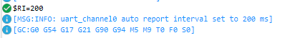

https://github.com/bdring/FluidDial
A CNC Pendant for FluidNC Firmware.手轮脱机屏
http://wiki.fluidnc.com/en/hardware/official/CYD_Dial_Pendant
http://wiki.fluidnc.com/en/hardware/official/M5Dial_Pendant
https://github.com/bdring/FluidDial/issues
https://github.com/bdring/FluidDial/issues/17

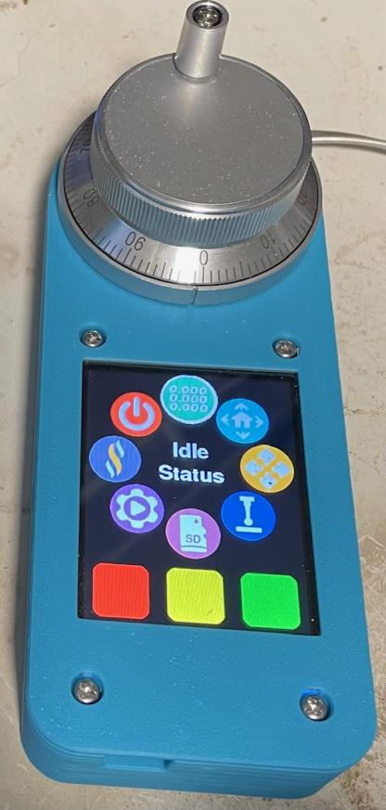
https://www.bilibili.com/video/BV1MzdyYnEGA/?spm_id_from=333.337.search-card.all.click&vd_source=f7392813cd5dee7276f90054e05e062b
https://www.bilibili.com/video/BV1BddhYwEPH?spm_id_from=333.788.recommend_more_video.7&vd_source=f7392813cd5dee7276f90054e05e062b
fluidnc脱机屏 【完美DIY】
https://www.bilibili.com/video/BV1rT411Y7Es?spm_id_from=333.788.recommend_more_video.7&vd_source=f7392813cd5dee7276f90054e05e062b
【淘宝】链接打不开【淘宝】https://m.tb.cn/h.ULZIrXL?tk=3FdvdRa6gTB CZ0001 「脱机4轴GRBL雕刻机主板激光机写字机控制板」
https://www.bilibili.com/video/BV1AaLwzPEnQ?spm_id_from=333.788.recommend_more_video.-1&vd_source=f7392813cd5dee7276f90054e05e062b
https://github.com/bdring/FluidDial
grbl脱机屏 grbl_controller_esp32 mks 3.5
https://item.taobao.com/item.htm?abbucket=12&detail_redpacket_pop=true&id=660133023604
MKS DLC32
https://www.bilibili.com/video/BV1Jy4y1N7Ym?spm_id_from=333.788.recommend_more_video.0&vd_source=f7392813cd5dee7276f90054e05e062b
199元的CNC触摸屏脱机控制器 优惠价136元
https://www.bilibili.com/video/BV12A41167cx/?spm_id_from=333.337.search-card.all.click&vd_source=f7392813cd5dee7276f90054e05e062b
GRBL4轴移植到32位ARM芯片添加脱机控制
https://www.bilibili.com/video/BV1ijKMedEZN/?spm_id_from=333.337.search-card.all.click&vd_source=f7392813cd5dee7276f90054e05e062b
ESP32s3_1.69寸触摸屏lvgl开发（arduino ide

https://item.taobao.com/item.htm?id=873307555978
ESP32开发板WiFi蓝牙模块3.5寸ST7796U驱动 【创客风暴】电话：13066992300
https://item.taobao.com/item.htm?id=873862657208
ESP32开发板WiFi蓝牙模块3.5寸ST7796U驱动 XPT2046(触摸)
https://item.taobao.com/item.htm?abbucket=13&detail_redpacket_pop=true&id=891138616651
MKS TS35-R 3.5寸触摸屏 激光/CNC雕刻机脱机控制屏 ¥77.99
https://item.taobao.com/item.htm?id=563037493558
3.2寸触摸屏 TFT液晶屏彩屏模块 芯片ILI9340(LCD控制)、XPT2046(触摸)
https://item.taobao.com/item.htm?abbucket=13&detail_redpacket_pop=true&id=874158280277
ESP32开发板WiFi蓝牙模块ILI9341驱动2.8寸智能TFT
https://item.taobao.com/item.htm?id=873490926279
ESP32开发板WiFi蓝牙模块ILI9341驱动2.8寸智能TFT

https://shop337979560.taobao.com/search.htm?search=y&keyword=3.5%B4%E7&lowPrice=&highPrice=
3.5寸 显示屏
一家店

https://www.waveshare.net/wiki/3.2inch_TFT_Touch_Shield
https://www.waveshare.net/wiki/3.2inch_320x240_Touch_LCD_(C)
3.2寸Arudino电阻屏 带LCD控制器 TFT 芯片ILI9340(LCD控制)、XPT2046(触摸)
https://github.com/witnessmenow/ESP32-Cheap-Yellow-Display
基于 ESP32 的低成本黄色显示屏项目，可用作 GRBL 控制器，支持脱机操作
https://github.com/cguerrero1205/LCD_GRBL/tree/master
an offline controller for a CNC machine with GRBL V1.1.
https://gitcode.com/open-source-toolkit/9da9b
STM32F103RC系列的GRBL脱机控制代码，带屏幕控制
https://gitcode.com/angcyo/LaserGRBL
LaserGRBL 是一款面向 Windows 的 GRBL 图形界面。
https://gitee.com/crash32/esp32_handwheel
esp32 grbl电子手轮接入插件 该程序可以将市面上的常见5v电子手轮接入到esp32 grbl控制板上
https://www.bilibili.com/video/BV1MzdyYnEGA?spm_id_from=333.788.recommend_more_video.-1&vd_source=f7392813cd5dee7276f90054e05e062b
grbl脱机屏，grbl脱机控制器，2.8寸触屏，带摇杆，该项目来自github。
https://github.com/mstrens/grbl_controller_esp32/tree/master
https://gitee.com/ad2000/grbl_controller_esp32
https://gitee.com/uncommon_ljl_admin/grbl_controller_esp32
a display module combining 3 components:
a touch screen 320 X 240 a ILI9341(display controller),
a XPT2046 (control the touch panel) and
a SD card support.
It should also be possible to use a separate SD card support.
Note: this configuration uses the ILI9341 with 4 wires (CLK, MOSI, MISO and CD).
Currently, this project works only with a TFT having a ILI9341 chip, a resolution of 320X240 and XPT2046 chip for the touch screen.

https://blog.csdn.net/lianyinghhh/article/details/139971338
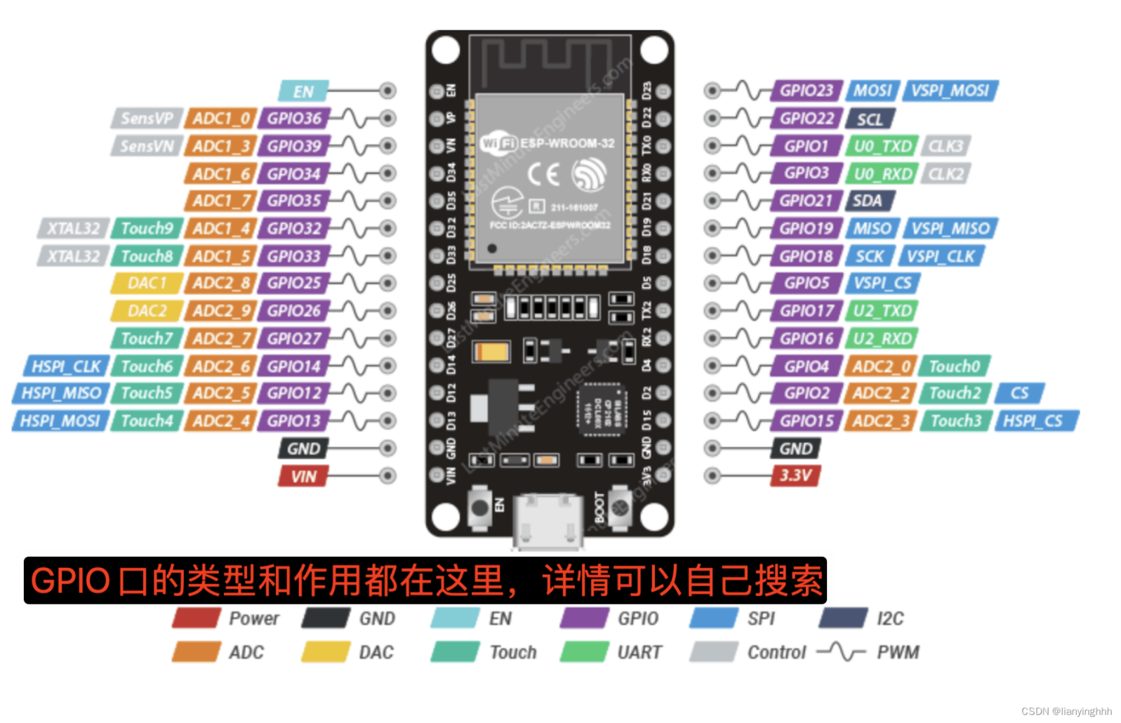
https://www.bilibili.com/video/BV1kT411G7c8/?spm_id_from=333.337.search-card.all.click&vd_source=f7392813cd5dee7276f90054e05e062b
ESP32 驱动树莓派专用微雪3.5寸LCD电阻触控屏 TFT_eSPI
https://www.mydigit.cn/forum.php?mod=viewthread&tid=77220
grbl_controller_esp32
https://v.qq.com/x/page/c3010357mg8.html?ptag=2_7.6.0.20170_copy
a touch screen 320 X 240 a ILI9341(display controller),
a XPT2046 (control the touch panel) and
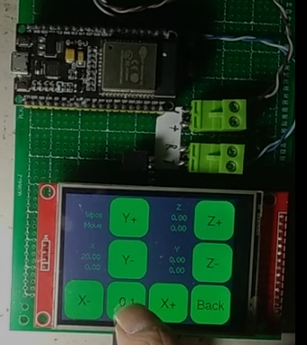
https://www.bilibili.com/video/BV1wbPJe8E86/?spm_id_from=333.337.search-card.all.click&vd_source=f7392813cd5dee7276f90054e05e062b
基于ESP32 S2开发的一个WiFi小屏幕，提供HTTP接口、Websocket接口，以及Mqtt客户端三种方式控制屏幕显示内容。支持的屏幕型号：ST7735S、ST7789/ST7789V、ST7796。图文教程地址:
https://zhuanlan.zhihu.com/p/25850834018
源代码地址:
https://github.com/planet0104/esp32-wifi-screen
https://www.bilibili.com/video/BV1xL4y1z7G7/?spm_id_from=333.337.search-card.all.click&vd_source=f7392813cd5dee7276f90054e05e062b
ESP32打印机Marlin主板；链接：
https://pan.baidu.com/s/1UxnRj7JPDibPGLzaCbZBrw
提取码：j27x

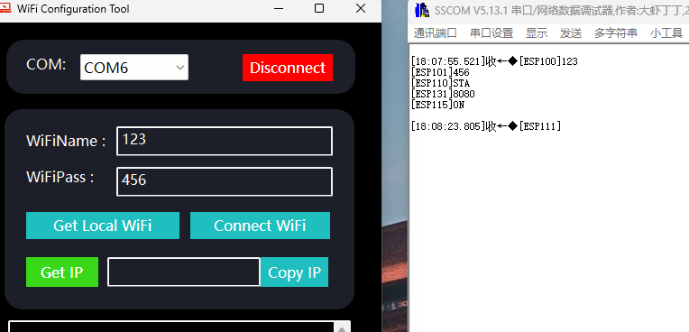
https://item.taobao.com/item.htm?abbucket=9&detail_redpacket_pop=true&id=715723043953&skuId=4999549308786
1.28寸圆形彩色TFT显示屏 ¥15
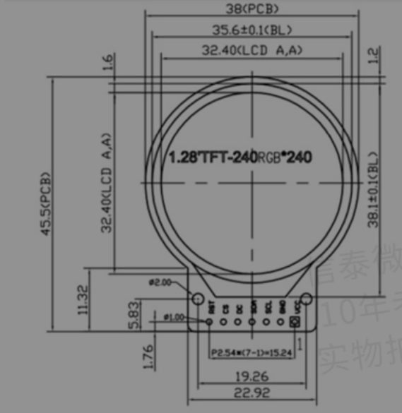
https://item.taobao.com/item.htm?id=674578608304
25¥
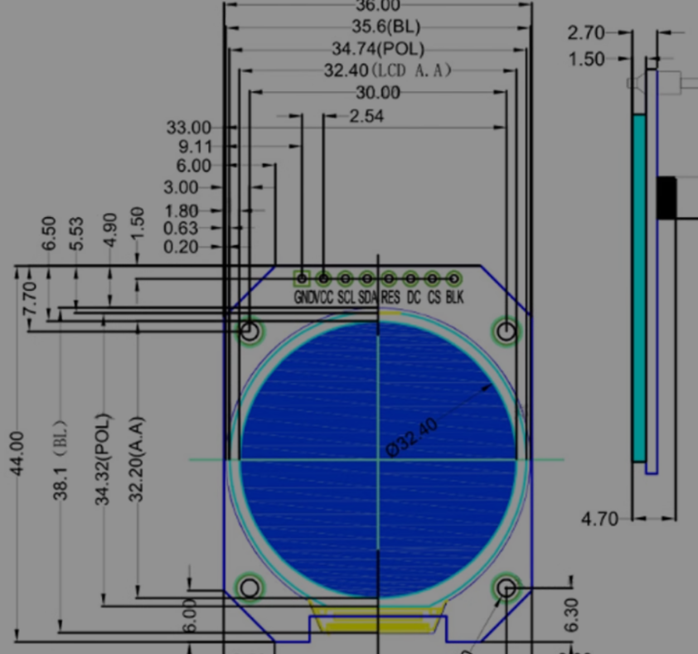 https://item.taobao.com/item.htm?id=637486887926&skuId=4945627792600
微雪 1.28寸圆形显示屏 ¥ 67.62
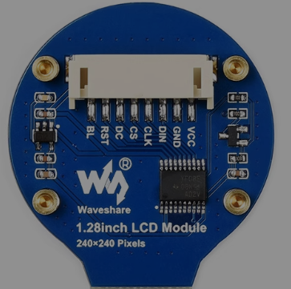

https://www.waveshare.net/
https://www.bilibili.com/video/BV1SnREYCE8U/?spm_id_from=333.337.search-card.all.click&vd_source=f7392813cd5dee7276f90054e05e062b
https://item.taobao.com/item.htm?abbucket=9&detail_redpacket_pop=true&id=715723043953&skuId=4999549308787
1.28inch LCD 驱动GC9A01

https://item.taobao.com/item.htm?abbucket=13&detail_redpacket_pop=true&id=836529194325&skuId=5595504341612
1.44寸：ST7735驱动
https://item.taobao.com/item.htm?abbucket=13&detail_redpacket_pop=true&id=583173435654
彩屏0.96寸资料网盘下载：ST7735驱动https://pan.baidu.com/s/1Qw6FYtRole8ENg7iPVweGg 提取码: zn2b
1.14寸资料网盘下载：

http://www.lcdwiki.com/zh/1.14inch_IPS_Module

1.3寸资料网盘下载：ST7789驱动

https://pan.baidu.com/s/1JmQQYl0-odRt7iiwHKaDLA 提取码: y5tp

1.44寸资料：ST7735驱动
https://pan.baidu.com/s/1CEunLuGUqLABR6I0UZG-Sg
提取码: fjzc

1.8寸资料：ST7735驱动

https://pan.baidu.com/s/1hnFQgBu2nn8TnmFnThajow 提取码: 5wyq

1.54寸资料网盘下载：分辨率240*240 ST7789驱动

https://pan.baidu.com/s/1G1iEfwjTZZsURUKI6GdOqA?pwd=8889 提取码: 8889
2.0 寸资料网盘下载：分辨率240*320 ST7789驱动链接: https://pan.baidu.com/s/1RBHxjwpamw8Q9a0mPRuuFw 提取码: 8889

https://www.waveshare.net/list.html?cat=3&pno=2

https://www.waveshare.net/wiki/0.85inch_LCD_Module
0.85寸IPS彩色LCD屏 GC9107驱动芯片 SPI接口

https://www.waveshare.net/wiki/ESP32-S3-LCD-2
ESP32-S3 2寸高清显示 彩色LCD屏开发板
https://www.waveshare.net/wiki/1.28inch_LCD_Module
LCD_Module_code.zip
https://www.waveshare.net/shop/1.28inch-LCD-Module.htm
https://item.taobao.com/item.htm?id=637486887926
1.28inch LCD 驱动GC9A01接口： SPI；STM32、arduino例程
https://www.bilibili.com/opus/689440133330501721
GC9A01配置
https://item.taobao.com/item.htm?abbucket=19&detail_redpacket_pop=true&id=774569841389

https://item.taobao.com/item.htm?id=696762473179
https://item.taobao.com/item.htm?id=641025993034
1.28寸++开发板

1.28寸tft圆形显示屏 GC9A01驱动
https://blog.csdn.net/weixin_43599390/article/details/131547751
圆形GC9A01_LCD模块
https://item.taobao.com/item.htm?id=674568208964
1.8英寸TFT液晶屏显示器模块 SPI串行总线ST7735S
https://item.taobao.com/item.htm?id=675762958735&skuId=5701285859790
1.44寸液晶屏

http://www.lcdwiki.com/zh/1.28inch_IPS_Module
STM32开发板+1.44寸TFT液晶屏
https://pan.baidu.com/s/14-rd5Bn5JHwFYnW6pzpnZQ
提取码: 9888
https://item.taobao.com/item.htm?abbucket=19&detail_redpacket_pop=true&id=675762958735&skuId=5028006234452
STM32开发板+1.44寸TFT液晶屏
https://item.taobao.com/item.htm?abbucket=19&detail_redpacket_pop=true&id=760069509568
RCT6开发板OLED资料：
链接：https://pan.baidu.com/s/1XR70vM7GOGf32HOgtLc1kQ
提取码：8ocf

GC9A01
https://www.waveshare.net/shop/ESP32-S3-Touch-LCD-1.28.htm
ESP32-S3-LCD-1.28屏幕，GC9A01()：GC9A01构造函数
https://www.waveshare.net/shop/1.28inch-LCD-Module.htm
https://www.waveshare.net/wiki/ESP32-S3-LCD-1.85
技术资料

https://blog.csdn.net/weixin_42880082/article/details/135745843
ESP32 USB CDC功能使用介绍
https://espressif-docs.readthedocs-hosted.com/projects/espressif-esp-iot-solution/zh-cn/latest/usb/usb_overview.html
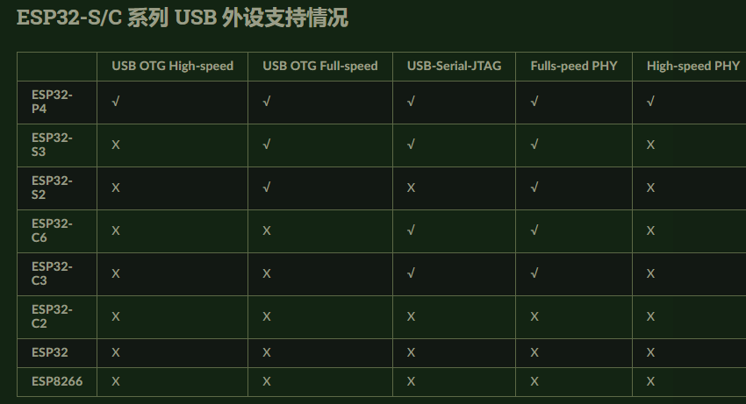
STM32F103VET6开发版资料链接:
https://pan.baidu.com/s/1CsqKzeO8aW1KlQf9fGly3g?pwd=xw72
提取码:xw72

20个ESP32项目！供大家参考学习
相关链接：
20.https://github.com/makermoekoe/Reflow-Controller
19.https://github.com/0015/ThatProject/tree/master/ESP32_LVGL/LVGL8_SquareLine/03_Let's_build_a_GPS_Speedometer
18. https://www.instructables.com/DIY-Wireless-Water-Level-Controller/
17. https://www.youtube.com/watch?v=vn4FT4M9Qqg
16. https://www.instructables.com/DIY-Wireless-Water-Level-Controller/
15. https://community.element14.com/challenges-projects/element14-presents/project-videos/w/documents/28328/stey-by-step-guide-to-creating-your-own-speaking-animatronic-hat----episode-620?CMP=SOM-YOUTUBE-PRG-E14PRESENTS-e14Presents-620
14. https://github.com/seemoo-lab/openhaystack
13. https://techiesms.graphy.com/
12. https://how2electronics.com/iot-smart-exhaust-fan-esp32-based-monitoring-control/
11. https://github.com/makermoekoe
10. https://www.instructables.com/DIY-Weather-Station-With-ESP32/
9. https://hackaday.io/project/185994-diy-retro-audio-player
8. https://github.com/Minergabe/TTGO-ESP32-T-display-smart-watch
7. https://circuitdigest.com/microcontroller-projects/esp32-cam-surveillance-car
6. https://github.com/SnippetsOfAkshay/DIY-Keyhole-Light
5. https://github.com/ProfBoots/3D-Printed-RC-DumpTruck-2.0
4. https://community.element14.com/challenges-projects/project14?CMP=SOM-YOUTUBE-PRG-E14P-PROJECT14
3. https://www.instructables.com/Retro-Internet-Radio-Using-ESP32/
2. https://github.com/VolosR/OEBlink
1. https://github.com/VolosR/Messenger/tree/main

