https://item.taobao.com/item.htm?abbucket=9&detail_redpacket_pop=true&id=773934844371
https://item.taobao.com/item.htm?abbucket=9&detail_redpacket_pop=true&id=24034676341
https://item.taobao.com/item.htm?abbucket=9&detail_redpacket_pop=true&id=739916969483
宏发继电器

https://item.taobao.com/item.htm?abbucket=17&detail_redpacket_pop=true&id=529281320016&skuId=3739322329903
https://item.taobao.com/item.htm?abbucket=17&detail_redpacket_pop=true&id=728382915818&skuId=5047573884736
宏发继电器JQC/HF3FF
https://item.szlcsc.com/3385097.html
宏发继电器

https://cloud.tencent.com.cn/developer/article/1967280
安全继电器工作原理、接线图、使用方法图解

G7SA-4A2B DC24
https://item.szlcsc.com/1056749.html
https://item.taobao.com/item.htm?abbucket=9&detail_redpacket_pop=true&id=665390635504
G7SA-3A1B 48VDC 日本欧姆龙继电器AC250V 6A 10脚
https://item.taobao.com/item.htm?abbucket=9&detail_redpacket_pop=true&id=805957098869
HFA4-12 24VDC-2H2DTGF 3H1DTGF 10脚 6A250V 宏发安全继电器

https://item.taobao.com/item.htm?abbucket=9&detail_redpacket_pop=true&id=723480573584
HF171F-5 12 24VDC-HT ZT Z3 一组常开4脚6A250VAC

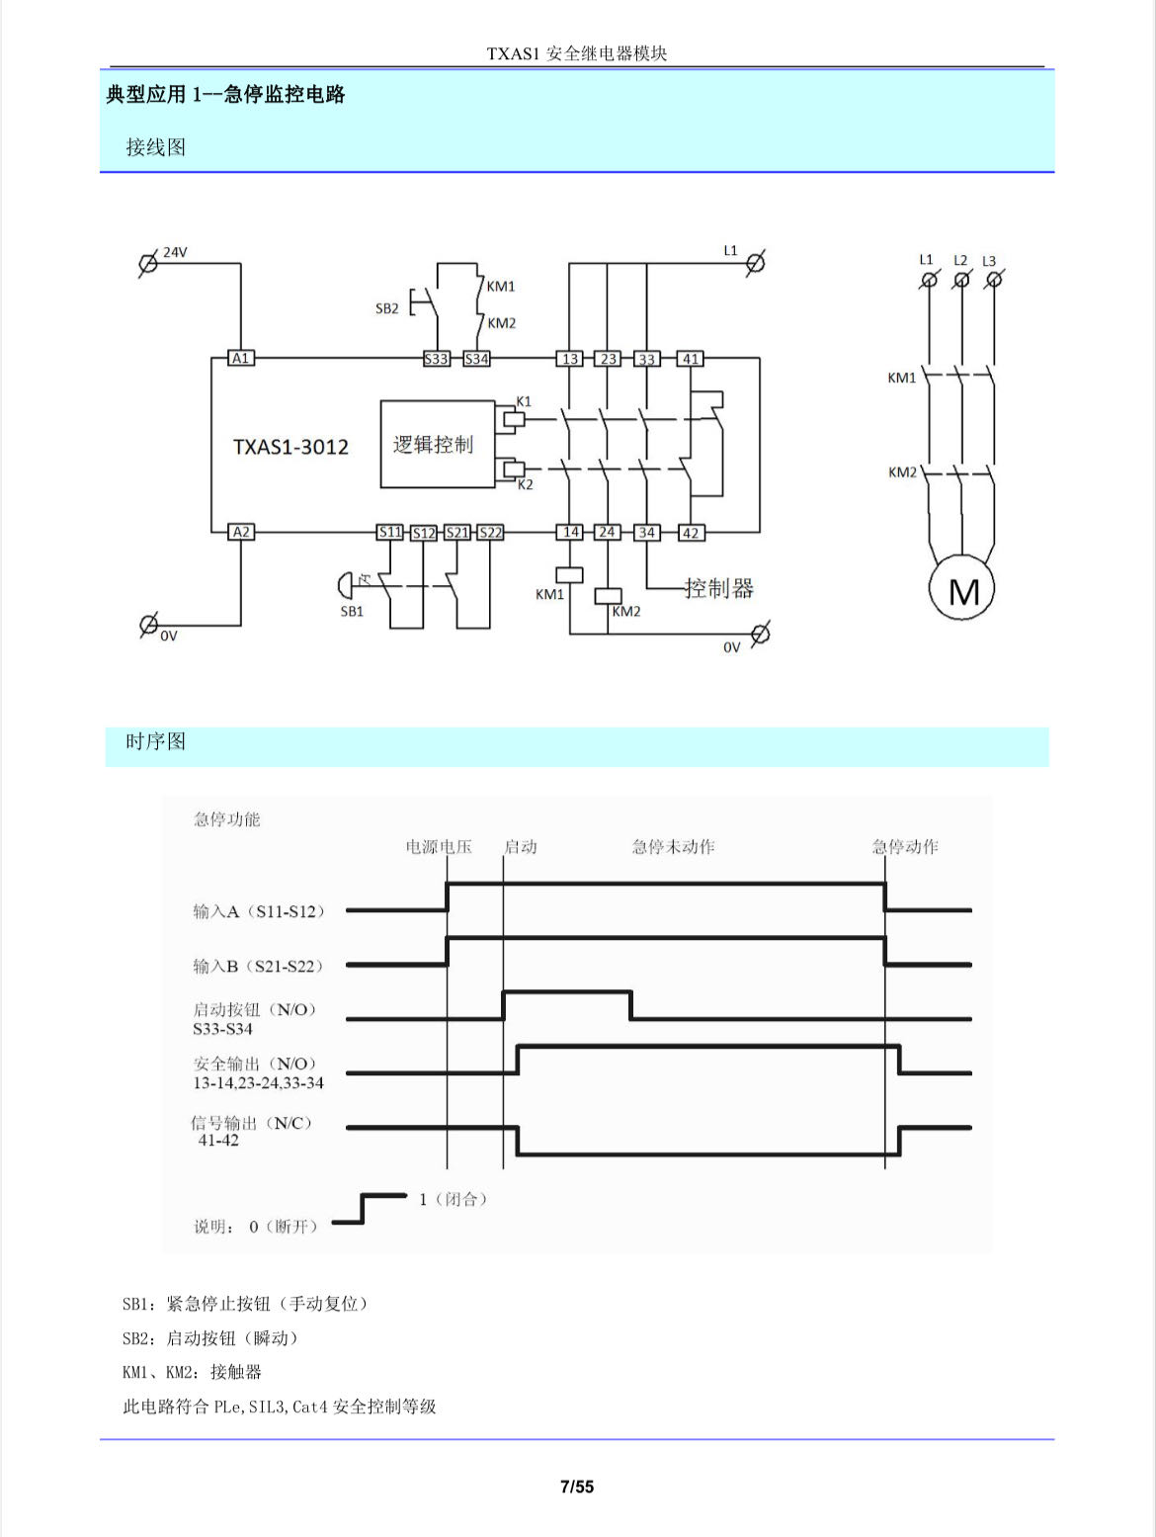

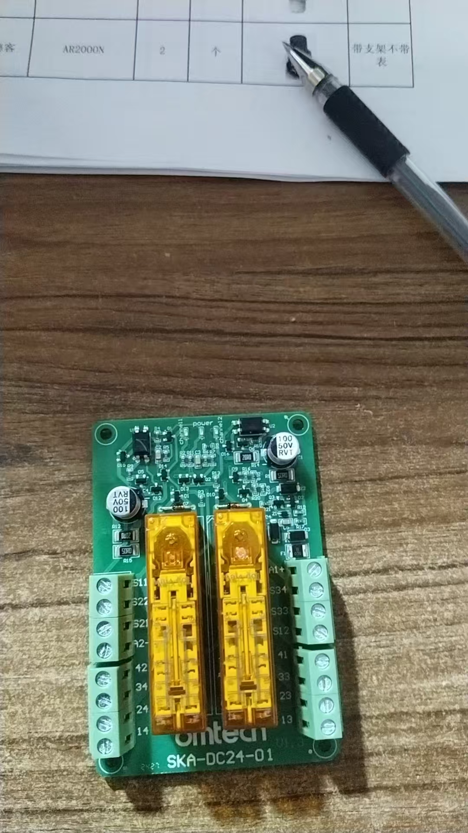
https://item.taobao.com/item.htm?abbucket=9&detail_redpacket_pop=true&id=809721051148
保险丝
https://item.taobao.com/item.htm?abbucket=9&detail_redpacket_pop=true&id=839254239100
二极管 sot-23

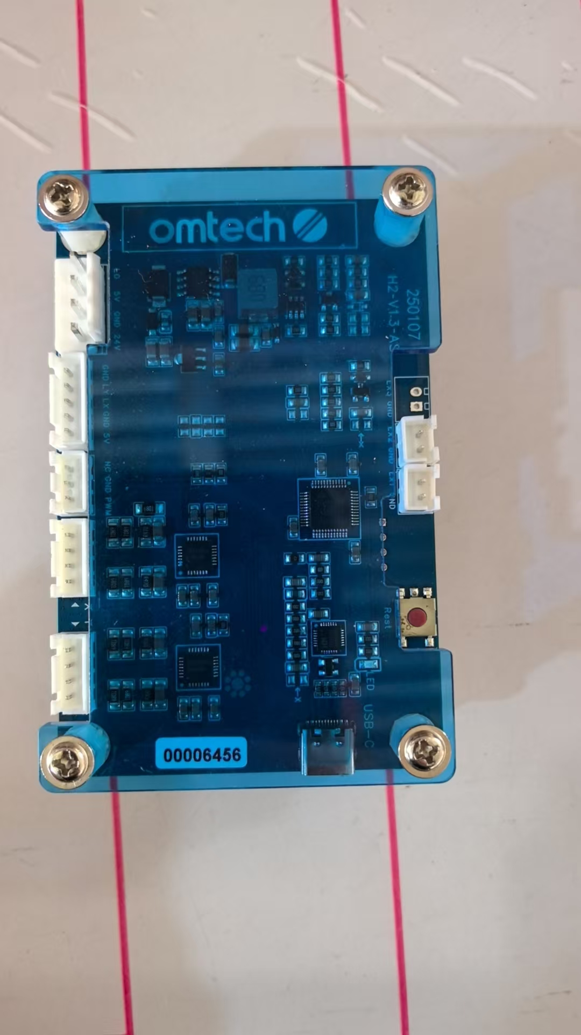

https://www.bilibili.com/video/BV1qz4y1477C/?spm_id_from=333.337.search-card.all.click&vd_source=f7392813cd5dee7276f90054e05e062b
stm32f103c8t6驱动任意尺寸spi tft彩屏

