We draw N discs on a plane. The discs are numbered from 0 to N − 1. A zero-indexed array A of N non-negative integers, specifying the radiuses of the discs, is given. The J-th disc is drawn with its center at (J, 0) and radius A[J].

We say that the J-th disc and K-th disc intersect if J ≠ K and the J-th and K-th discs have at least one common point (assuming that the discs contain their borders).

The figure below shows discs drawn for N = 6 and A as follows:

A[0] = 1

A[1] = 5

A[2] = 2

A[3] = 1

A[4] = 4

A[5] = 0

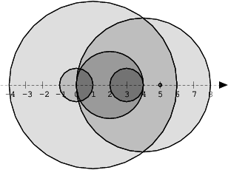

There are eleven (unordered) pairs of discs that intersect, namely:

* discs 1 and 4 intersect, and both intersect with all the other discs;
* disc 2 also intersects with discs 0 and 3.

Write a function:

int solution(int A[], int N);

that, given an array A describing N discs as explained above, returns the number of (unordered) pairs of intersecting discs. The function should return −1 if the number of intersecting pairs exceeds 10,000,000.

Given array A shown above, the function should return 11, as explained above.

Assume that:

* N is an integer within the range [0..100,000];
* each element of array A is an integer within the range [0..2,147,483,647].

Complexity:

* expected worst-case time complexity is O(N\*log(N));
* expected worst-case space complexity is O(N), beyond input storage (not counting the storage required for input arguments).

Elements of input arrays can be modified.