DATA ANALYSIS PROJECT REPORT
IPL Ball-by-Ball Data Analysis
Using Pandas, NumPy, and Matplotlib
Project Title | IPL Ball by Ball Data Analysis
Student Name | 1.Md.Golam Rabbani Sajib  2.Mahdiat Rahman  3.Rabeta Tanjum Arni
Student ID | 24-60374-3  24-59007-3  24-59142-3
Course / Section | Programming In Python[B]
Instructor | Md.Tanzeem Rahat
Date of Submission | 3 May 2026

1. Executive Summary
This project presents a comprehensive ball by ball analysis of IPL cricket data using Python's core data science libraries: Pandas,NumPy and Matplotlib.The dataset contains over 260,000 delivery records spanning multiple IPL seasons,covering batting teams,bowlers,run types,extras,dismissals and match phases.After thorough data cleaning including handling missing values, removing super-over deliveries,standardising team names and eliminating duplicates feature engineering was applied to enrich the dataset with over-phase classification,boundary flags,dot ball indicators and run categories.Key findings reveal that Mumbai Indians and Chennai Super Kings have consistently accumulated the most runs in IPL history that the Death overs (16–20) produce the highest scoring rate per ball and that the top 10 run-scorers account for a disproportionate share of total runs.NumPy based z-score outlier detection identified rare high-impact deliveries while Matplotlib visualisations confirmed patterns across teams and batting phases.

2. Introduction and Project Objectives
IPL is one of the most data-rich cricket competitions in the world,producing detailed ballbyball records for every match.Analysing this data provides insight into team strategies,player performance patterns and the dynamics of T20 cricket.This project uses IPL ball by ball data to explore scoring patterns,identify top performers and understand how match phases affect run rates and wicket distributions.

Item | Content
Dataset Name | IPL Ball by Ball Dataset (Dataset.csv)
Dataset Source | Kaggle
Main Project Goal | Analyse IPL ball by ball data to uncover team performance trends,phase-wise scoring patterns and individual player contributions using Pandas,NumPy and Matplotlib.
Research Question 1 | Which teams have scored the most total runs in IPL history and how are boundaries distributed across teams?
Research Question 2 | How do scoring rates differ across the three match phases (Powerplay,Middle,Death)?
Research Question 3 | Who are the top run-scorers in IPL history and which bowling teams apply the most pressure via dot balls?

3. Dataset Description
The dataset is a ball by ball record of IPL matches.Each row represents a single delivery bowled in a match,capturing information about the batting team,bowling team,batter,bowler,over number,runs scored off the bat,extras,wicket information and dismissal details.The dataset spans multiple IPL seasons and includes all regular innings(super overs were excluded during cleaning).

3.1 Basic Dataset Information
Property | Value
Number of rows (original) | 260,920
Number of columns | 18 columns+4 engineered features
Data types present | Numerical (runs,overs),Categorical (team names,player names,dismissal kind)
Target/Key variables | total_runs,batsman_runs,is_wicket,extras_type,player_dismissed
Potential issues observed | Missing values in extras_type,player_dismissed,dismissal_kind,fielder;outdated team names;super-over rows;duplicate records

3.2 Initial Observations
The dataset arrived with missing values in four columns- extras_type,player_dismissed,dismissal_kind and fielder which was structurally expected since these fields are only populated when extras or wickets occur.Several franchise names were outdated (e.g., ‘Delhi Daredevils’ instead of ‘Delhi Capitals’) which would have caused grouping inconsistencies without correction.Super-over rows were present and needed filtering to restrict analysis to regular play.A small number of duplicate rows were also identified.After cleaning,the dataset contained zero missing values across all 21 columns confirming a fully complete and analysis-ready state.

4. Data Cleaning and Preparation
The following cleaning steps were performed to ensure the dataset was accurate, consistent, and ready for analysis:
Issue Found | Action Taken | Reason / Justification | Code Reference
Missing values in extras_type | Filled nulls with none | Nulls indicate no extra was bowled;none is a meaningful, non-distorting label | Pandas notebook,Cell 8
Missing values in player_dismissed,dismissal_kind, fielder | Filled with 'not_out' and 'no_fielder' | Nulls occur when no wicket fell descriptive labels preserve logical meaning | Pandas notebook, Cell 10
Super-over rows present (innings > 2) | Filtered to keep only innings 1 and 2 | Super overs are tiebreakers not regular play including them distorts run and wicket analysis | Pandas notebook, Cell 12–13
Outdated franchise names | Replaced via dictionary mapping (e.g.,Delhi Daredevils → Delhi Capitals,Kings XI Punjab→Punjab Kings) | Ensures consistency in groupby operations and accurate team-level comparisons across seasons | Pandas notebook, Cell 14–15
Duplicate rows | Removed with drop_duplicates() and index reset | Duplicates artificially inflate run and ball counts,skewing all aggregate statistics | Pandas notebook, Cell 17–20
Numeric type inconsistencies | Cast over,total_runs, is_wicket to int | Ensures correct arithmetic operations and prevents silent float comparisons in NumPy | NumPy notebook, Cell 4

5. Feature Engineering
Four new columns were created to enrich the dataset and enable phase-based and event-based analysis:

New Feature | How It Was Created | Why It Is Useful
over_phase | Applied a function:overs 1–6='Powerplay',7–15 = 'Middle',16–20='Death' using df['over'].apply(get_phase) | Allows phase-by-phase comparison of scoring rates and wicket patterns is a core analytical dimension in T20 cricket
is_boundary | Lambda:1 if batsman_runs in [4,6] else 0 | Enables counting and comparing boundary frequency across teams and phases without filtering the full dataframe repeatedly
is_dot_ball | 1 if batsman_runs==0 AND extras_type=='none',else 0 | Dot balls represent bowling pressure;this feature lets us compute dot ball percentage per bowling team accurately
run_category | Custom function mapping 0→'Dot',1→'Single', 2→'Double',3→'Triple', 4→'Four',6→'Six' | Provides a categorical view of scoring patterns useful for distribution analysis and visualisation

6. Analysis Methodology
The analysis followed a structured pipeline across three notebooks,each dedicated to one library:
- Pandas:Used for data loading,exploration(shape,dtypes,value counts),cleaning (fillna,drop_duplicates,filtering),feature engineering(apply,lambda) and grouped aggregations(groupby,agg,sort_values).Summary tables for team totals,phase averages, top batters,boundaries and dot ball percentages were all produced using Pandas.
- NumPy:Used for numerical analysis beyond Pandas defaults.Key operations included np.unique() for run distribution frequencies,np.corrcoef() for runs-vs-wickets correlation,np.mean() / np.std() for statistical summaries, and z-score computation for outlier detection.NumPy arrays were also used for run rate per 100 balls.
- Matplotlib :Used to create four visualisations directly linked to the research questions a bar chart for total team runs,a bar chart for top 10 batters,a pie chart for dot ball percentages by bowling team and a histogram for boundary distribution across teams.

7. Analysis and Visualisations

7.1 Research Question 1—Team Run Totals and Boundary Distribution
Which teams have scored the most total runs in IPL history, and how are boundaries distributed across teams?

Total runs were aggregated per batting team using groupby on 'batting_team' and summed over 'total_runs' then sorted in descending order.Boundary counts were separately computed by filtering is_boundary==1 and grouping by batting team.

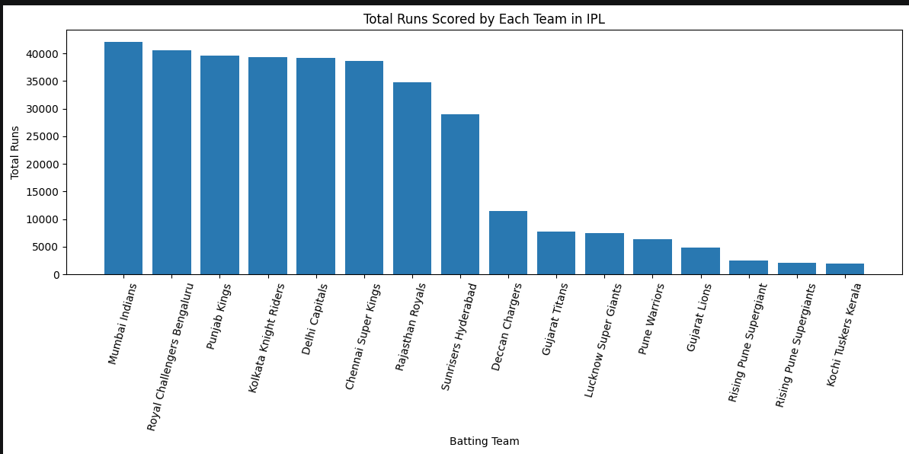
Mumbai Indians and Chennai Super Kings lead all franchises in total runs scored,reflecting their consistent participation and strong batting line-ups across multiple seasons. Teams that joined the IPL later or were discontinued appear at the lower end which is largely explained by fewer matches played rather than weaker batting.The boundary distribution chart further confirms that higher-scoring teams also hit proportionally more boundaries,suggesting boundary-hitting is a reliable proxy for overall batting dominance in T20 format.

7.2 Research Question 2—Phase-Wise Scoring Rates
How do scoring rates differ across the three match phases (Powerplay, Middle, Death)?
The results show a clear and consistent pattern across all three phases:
- Powerplay (overs 1–6):1.237 average runs per ball across 95,182 deliveries,producing 117,770 total runs.Field restrictions allow batters to find gaps freely but the pressure of early wickets keeps scoring somewhat conservative.
- Middle overs (7–15):1.297 average runs per ball across 118,939 deliveries,producing 154,288 total runs.Bowling teams introduce specialist spinners and set defensive fields though batters in strong positions begin accelerating toward the end of this phase.
- Death overs (16–20):1.619 average runs per ball across 46,566 deliveries,producing 75,412 total runs.This is the highest-scoring phase by a clear margin 31% higher than the Powerplay and 25% higher than the Middle overs as batters play aggressively to maximise the final score regardless of risk.
Despite covering the fewest deliveries(46,566 compared to 118,939 in the Middle overs) the Death phase still contributes 75,412 total runs purely due to its exceptional scoring rate.This confirms that bowling teams face their greatest pressure in the final five overs of any IPL innings.

7.3 Research Question 3—Top Run-Scorers and Dot Ball Pressure
Who are the top run-scorers in IPL history and which bowling teams apply the most pressure via dot balls?
Top 10 batters were identified by grouping on 'batter' and summing batsman_runs then taking the top 10.Dot ball percentage was computed per bowling team using a grouped aggregation with total ball count and dot ball count,producing a Dot_Ball_Percent column.

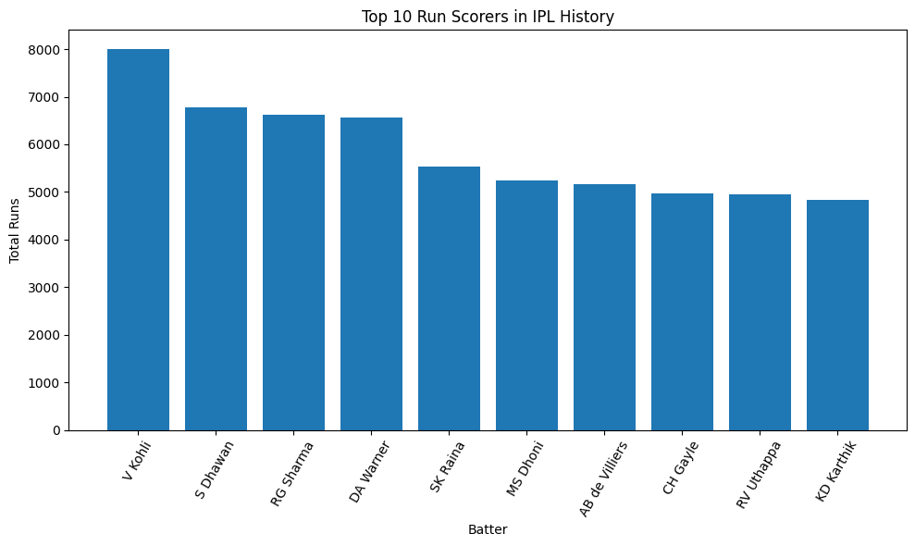

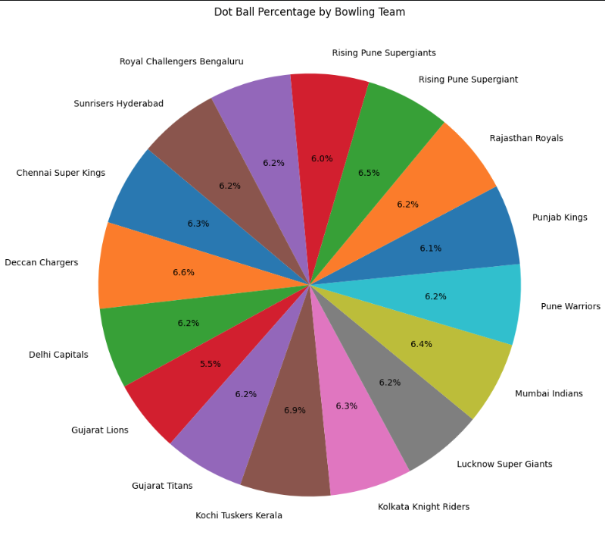

Virat Kohli and Shikhar Dhawan appear among the leading IPL run-scorers due to their long careers and consistent presence at the top of the order. The dot ball analysis reveals that bowling teams with historically strong bowling attacks maintain a higher dot ball percentage,reflecting better containment under pressure.A dot ball percentage above 35–38% is generally regarded as strong in T20 cricket indicating that the best bowling sides succeed in restricting batters on roughly one in three deliveries.

8. NumPy-Based Custom Computation
The NumPy notebook included a meaningful outlier detection analysis using z-scores applied to the runs array derived from the dataset:
Component | Description
Computation Used | Z-score outlier detection using np.mean(),np.std() and np.abs()
Purpose | To identify deliveries where an unusually large number of runs were scored highlighting rare high-impact balls
Formula/Logic | z=(x - mean) / std; outliers flagged where |z| > 3.Applied to the runs array extracted from total_runs column.
Result/Takeaway | A small number of deliveries were flagged as outliers.These likely correspond to rare events such as 6-run wides,5-run overthrows or penalty extras.Their removal or isolation ensures aggregate statistics such as mean and standard deviation are not distorted.

9. Key Findings

- Mumbai Indians and Chennai Super Kings are the highest run-scoring teams in IPL history reflecting their sustained batting depth and the greater number of seasons they have competed in compared to newer or discontinued franchises.
- The Death overs (16–20) produce the highest average runs per ball across all three match phases,confirming that T20 finishes are the most aggressive batting periods and that bowlers face the greatest pressure in the final five overs.
- The Middle overs (7–15) have the lowest scoring rate,suggesting that bowling teams successfully apply containment strategies during this phase often through spin bowlers and defensive field placements.
- The top 10 run-scorers account for a large portion of all batsman runs in IPL history with Virat Kohli consistently featuring among the leaders.This concentration of run-scoring suggests that a small number of elite batters significantly influence team totals.
- Dot ball percentage varies meaningfully across bowling teams.Teams with reputations for strong bowling attacks tend to maintain higher dot ball rates indicating that bowling unit quality directly translates into measurable on-field pressure.
- Z-score outlier detection revealed a small but non-trivial number of deliveries with exceptionally high run values likely due to extras-heavy events.These anomalous deliveries, though rare can affect aggregate run totals if not identified and handled appropriately.

10. Limitations
- Dataset completeness: The dataset is limited to ball by ball delivery records and does not include match-level context such as pitch conditions,weather,toss result or venue. These factors can substantially influence run rates and outcomes,meaning our analysis reflects statistical patterns rather than causal explanations.
- Season coverage uncertainty: The exact number of IPL seasons covered by the dataset was not confirmed during analysis.If more recent seasons are missing,the run totals and player rankings may not reflect the current state of IPL records.
- Team name standardisation: While three franchise name changes were corrected (Delhi Daredevils,Kings XI Punjab,Royal Challengers Bangalore) other rebranding events or mid-season changes may not have been captured,potentially causing minor inconsistencies in team-level groupings.
- Correlation does not imply causation: The phase-wise scoring analysis shows that Death overs have higher run rates but this does not mean that overs 16–20 inherently produce more runs.Selection bias is present teams in strong batting positions are more likely to play out all 20 overs aggressively.
- Outlier handling: Outlier deliveries identified via z-scores were flagged but not removed from the main dataset.Their continued presence may slightly inflate mean run values and standard deviations in aggregate statistics.
- No predictive modelling: This project is descriptive and exploratory.No predictive models were built so findings cannot be used to forecast future match outcomes or player performance.

11. Conclusion
This project successfully applied Pandas,NumPy and Matplotlib to conduct a thorough ball-by-ball analysis of IPL cricket data. Beginning with raw delivery records,the work proceeded through systematic data cleaning,meaningful feature engineering and structured analysis organised around three research questions.The analysis confirmed several well-established IPL patterns: dominant franchises like Mumbai Indians and Chennai Super Kings lead in total runs; the Death overs are the most productive batting phase and a small group of elite batters contribute disproportionately to overall run tallies.The dot ball analysis provided an evidence-based view of bowling team effectiveness while the NumPy-powered outlier detection demonstrated how statistical techniques can surface rare but impactful events in large datasets.

12. References / Dataset Source
- IPL Ball-by-Ball Dataset - https://www.kaggle.com/datasets/patrickb1912/ipl-complete-dataset-20082020

Final Submission Checklist
- I included my GitHub repository link or Google Colab notebook link in the Google Sheet provided by the instructor.
- I attached the project report as a separate file.
- My report includes dataset source, project objective, cleaning steps, feature engineering, analysis, visualizations, findings, limitations, and conclusion.
- My code uses Pandas, NumPy, and Matplotlib meaningfully.
- All bracketed placeholder text and helper notes were replaced or deleted before submission

