Task 3
1. Generate Erdos-Renyi G(n=150,p=0.08).
2. Analyze:
- number and size of connected components
- histograms for: degree value, closeness, and betweenness centralities
- normalize degree histogram and plot Poisson PMS over it (scipy.stats.poisson)
- compare for different bin numbers. Q Is the bin size important?
3. Export the network as GraphML file and attributes (centralities, degree) as csv file
4. Check what happens when different 'p' (no need to hand in)

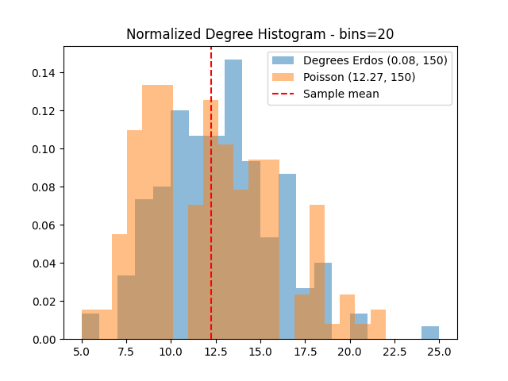
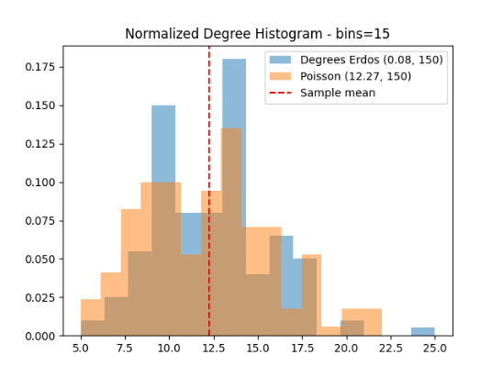
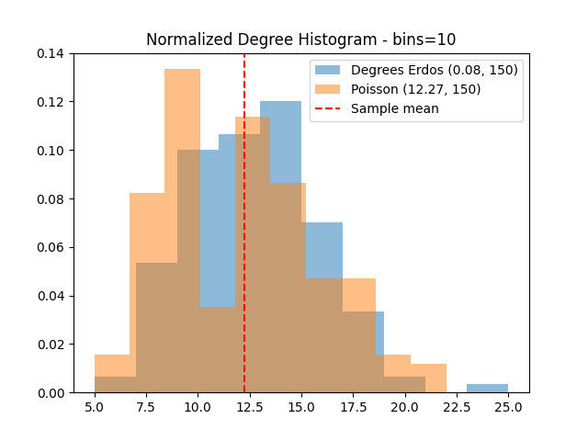
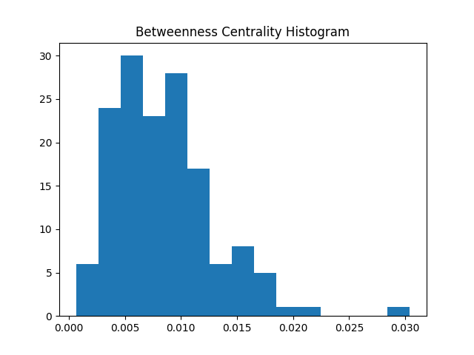
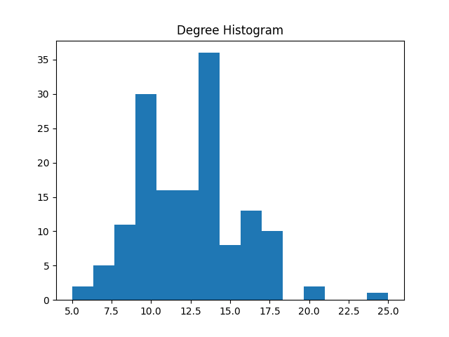
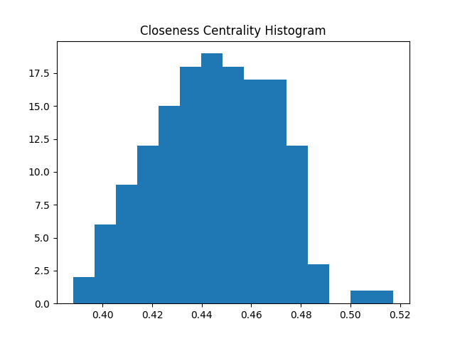

Task 1

Relation if euclidian distance is greater than 11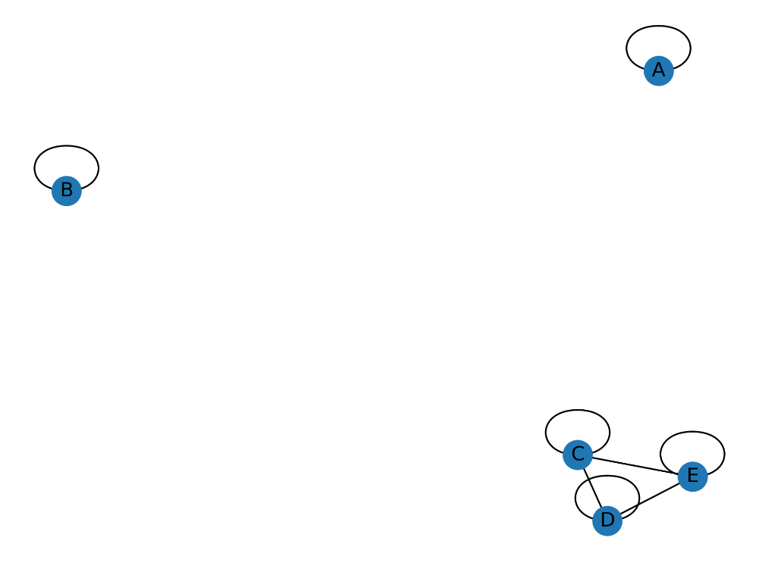

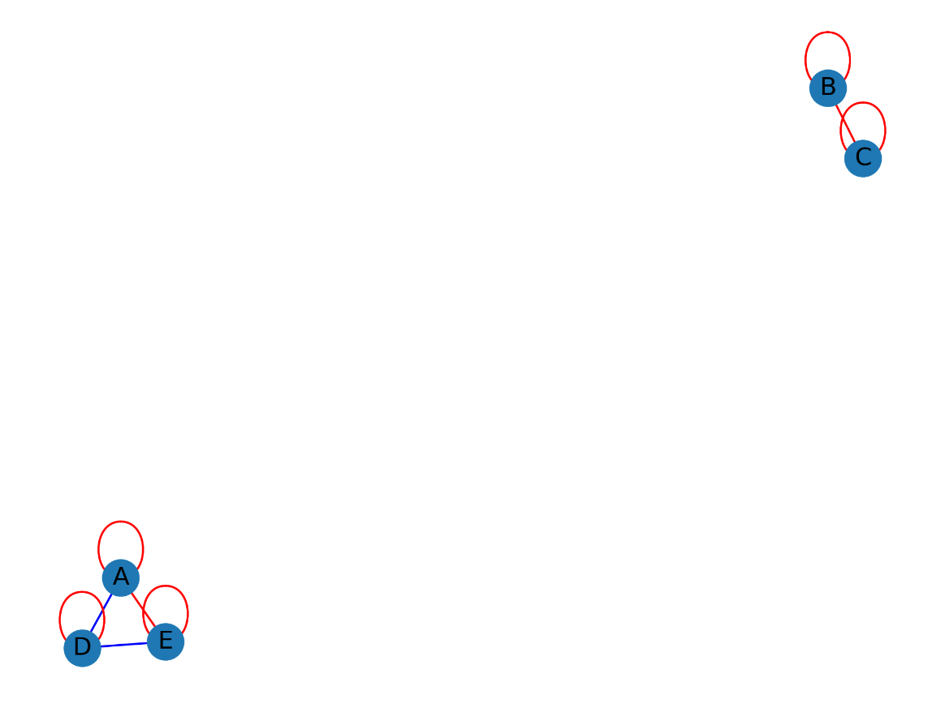
Relation if correlation coefficient is greater than 0.75 (in absolute value). Colored red if positive correlation

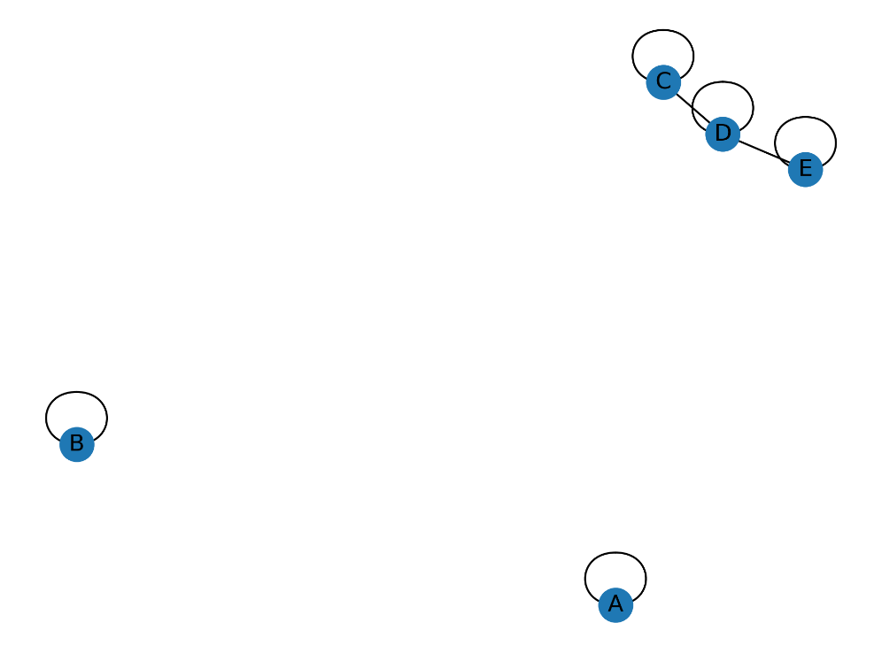
Relation if L1 form is smaller than 20

Relation if Mutual Information is greater than 0.65
