**Daily Scrum or Standup Meeting**

Team name: __Hell’s Kittens____________

Scrum Master: __Jack Miranda__________

Date:____10/21/2019_________________

|  |  |  |  |
| --- | --- | --- | --- |
| **Team Member** | **What did you do since the last scrum?** | **What do you plan to do before the next scrum?** | **What obstacles do you have?** |
| Jack Miranda | Finished Burndown graph | HTML pages assigned | Interfacing with back end |
| Laryssa Revelli | Finished Timer | Finish HTML tasks | time |
| Gavin Reid | Rapid Protoype | Redo rapid prototype | Errors in Django |
| Griffin |  |  |  |
|  |  |  |  |

# Burndown

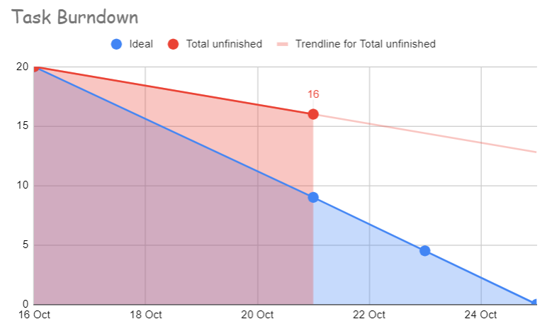

# Screenshot of you project board

