**Daily Scrum or Standup Meeting**

Team name: __Hell’s Kittens_______________________

Scrum Master: __Griffin Hackley_____________________

Date:__11/4/2019_____________________________

|  |  |  |  |
| --- | --- | --- | --- |
| **Team Member** | **What did you do since the last scrum?** | **What do you plan to do before the next scrum?** | **What obstacles do you have?** |
| Griffin Hackley | Save user registration into database? | Get pictures | time |
| Jack Miranda | Registration redirect | Fix Django | Django screwy |
| Gavin Reid | Worked on tests | Do tests | Project still broken |
| Laryssa Revelli | Learned about tests, handled exceptions in html | User view auction? Admin completed page | Time, other work |
|  |  |  |  |

# Burndown

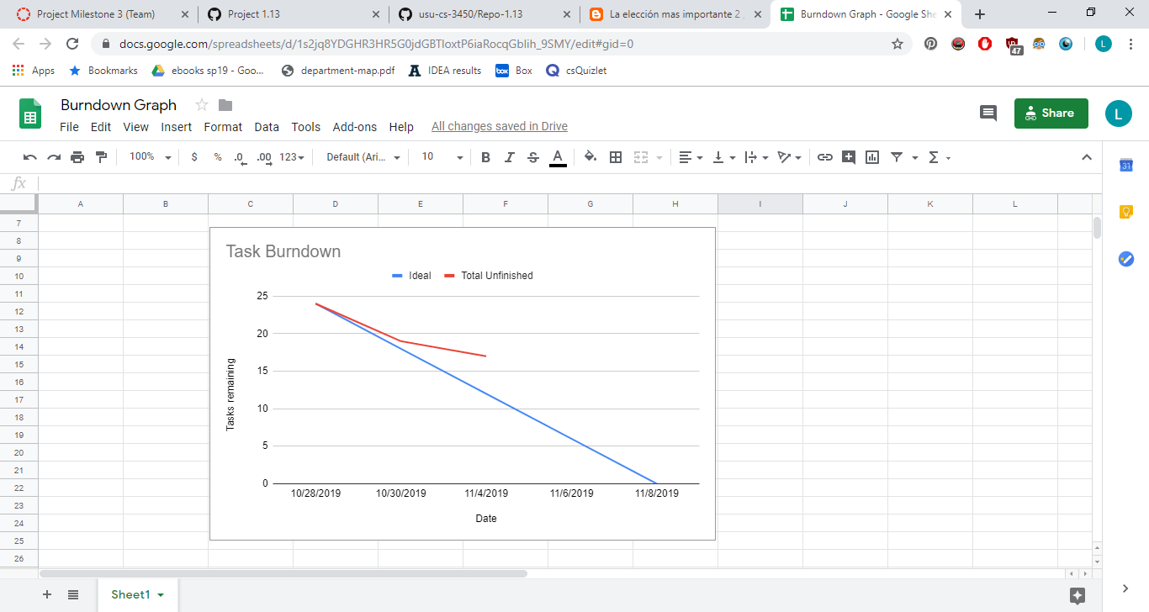

# Screenshot of you project board

