1,000 Nodes (200 as root)
Left/Right Branch Balance
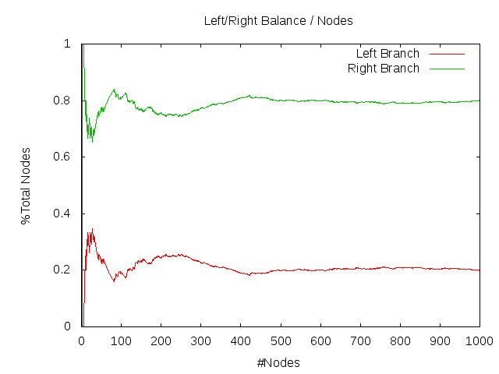

1,000 Nodes (200 as root)
Min, Max, and Difference in Depths

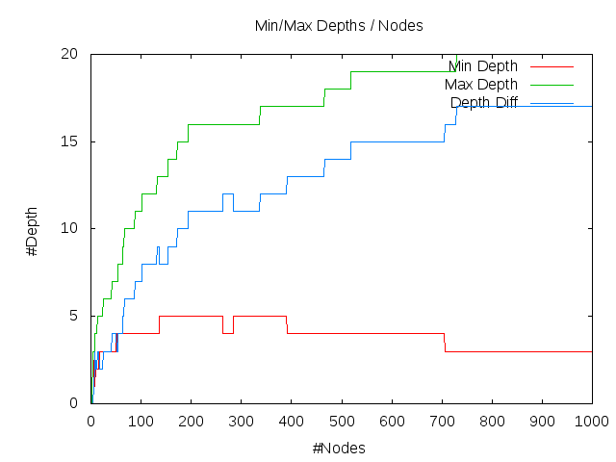

1,000 Nodes (200 as root)
Number of Leaves

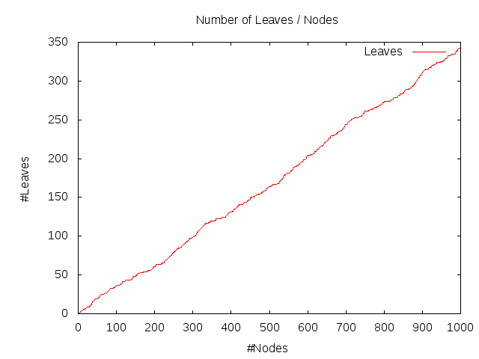

1,000 Nodes (500 as root)
Left/Right Branch Balance

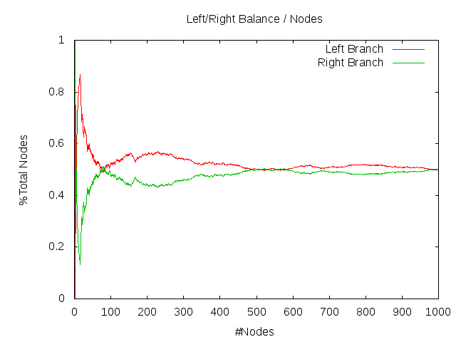

1,000 Nodes (500 as root)
Min, Max, and Difference in Depths

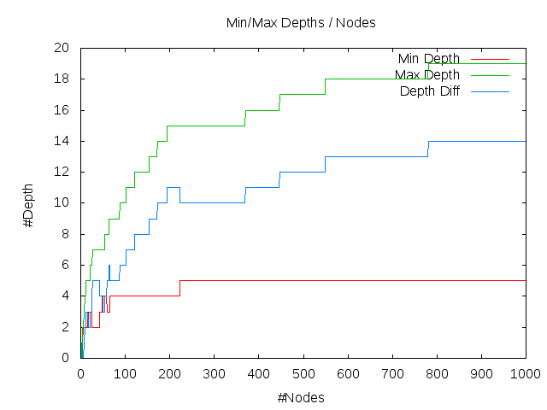

1,000 Nodes (500 as root)
Number of Leaves

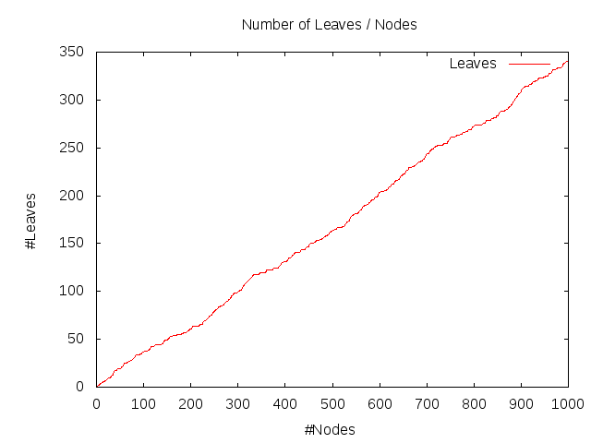

1,000 Nodes (800 as root)
Left/Right Branch Balance

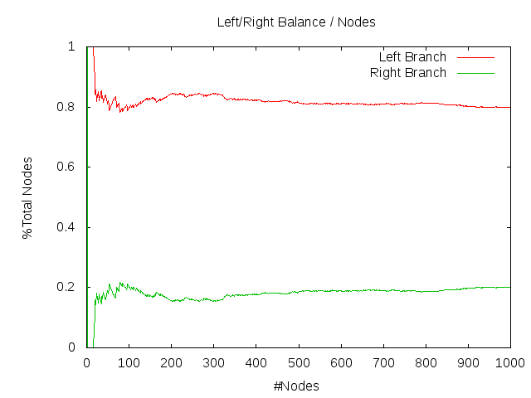

1,000 Nodes (800 as root)
Min, Max, and Difference in Depths

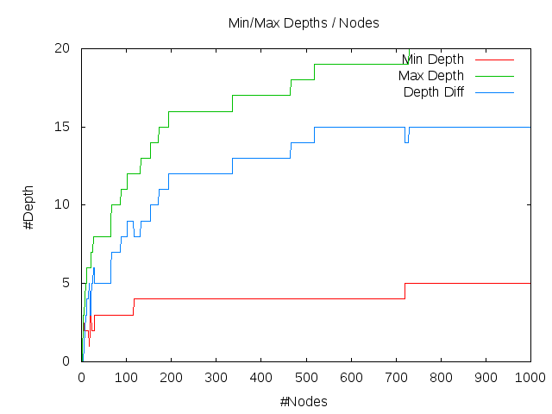

1,000 Nodes (800 as root)
Number of Leaves

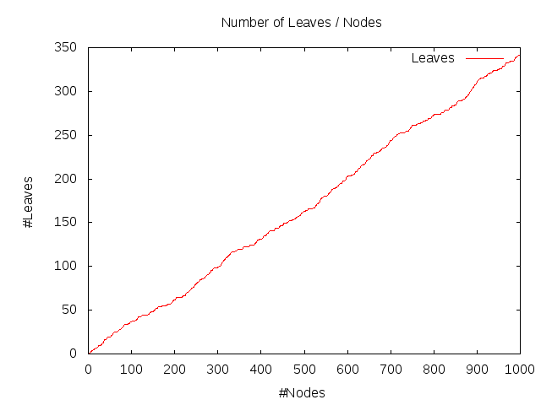

10,000 Nodes (2,000 as root)
Left/Right Branch Balance

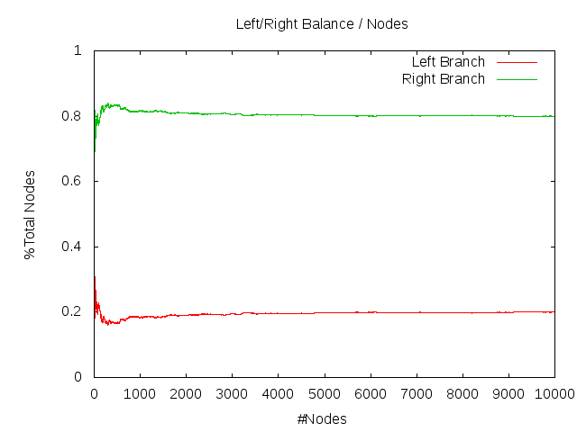

10,000 Nodes (2,000 as root)
Min, Max, and Difference in Depths

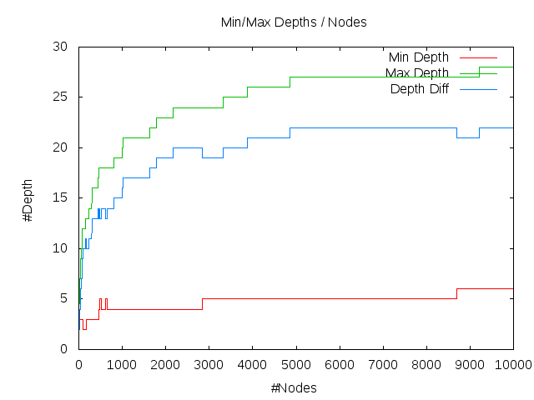

10,000 Nodes (2,000 as root)
Number of Leaves

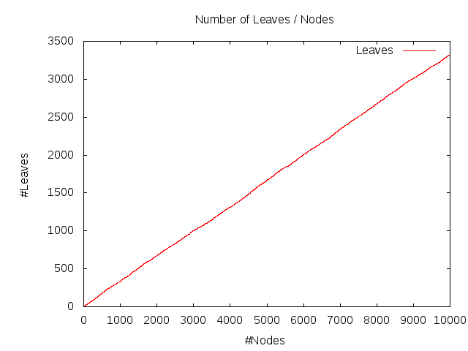

10,000 Nodes (5,000 as root)
Left/Right Branch Balance

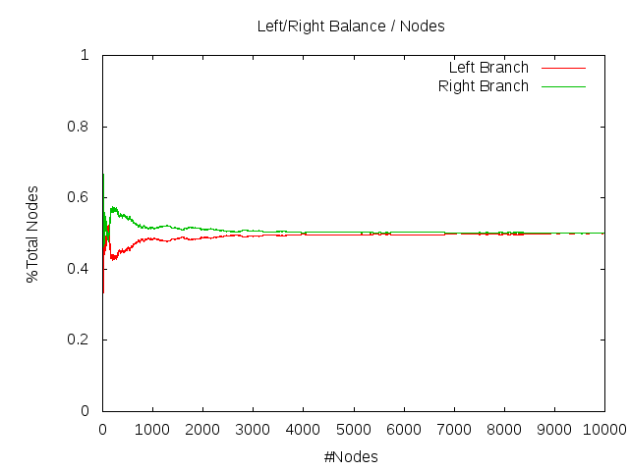

10,000 Nodes (5,000 as root)
Min, Max, and Difference in Depths

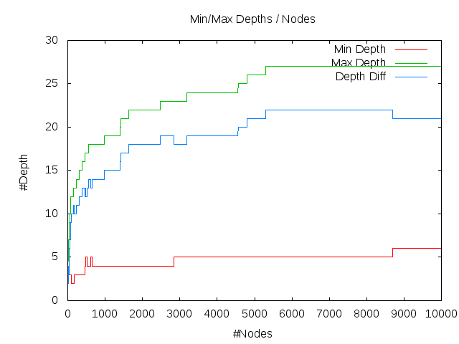

10,000 Nodes (5,000 as root)
Number of Leaves

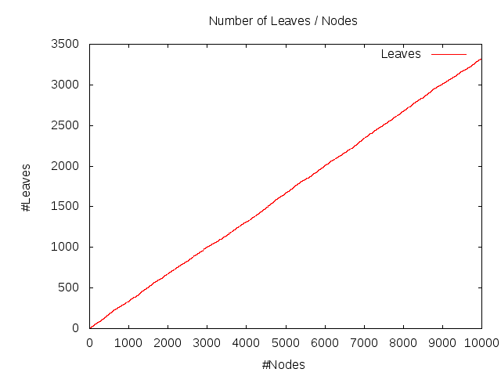

10,000 Nodes (8,000 as root)
Left/Right Branch Balance

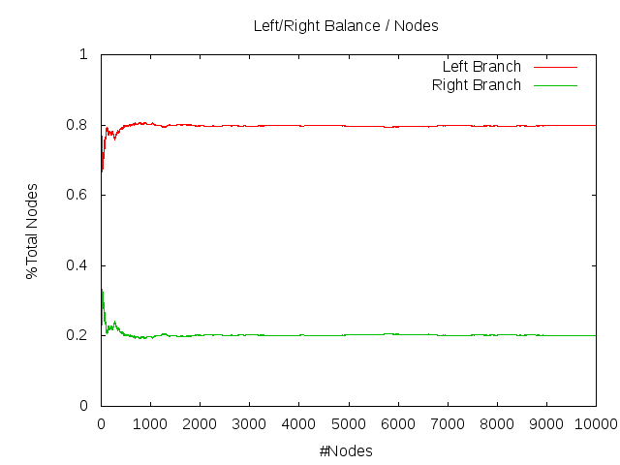

10,000 Nodes (8,000 as root)
Min, Max, and Difference in Depths

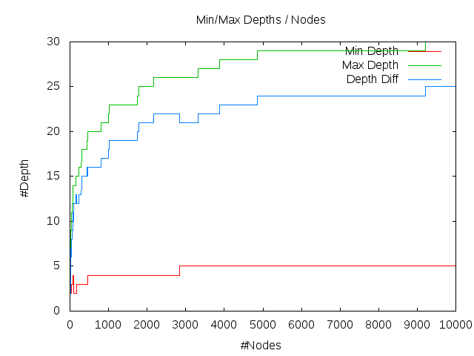

10,000 Nodes (8,000 as root)
Number of Leaves

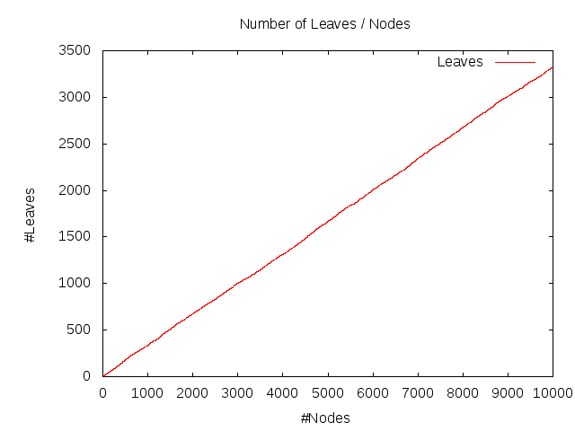

100,000 Nodes (20,000 as root)
Left/Right Branch Balance

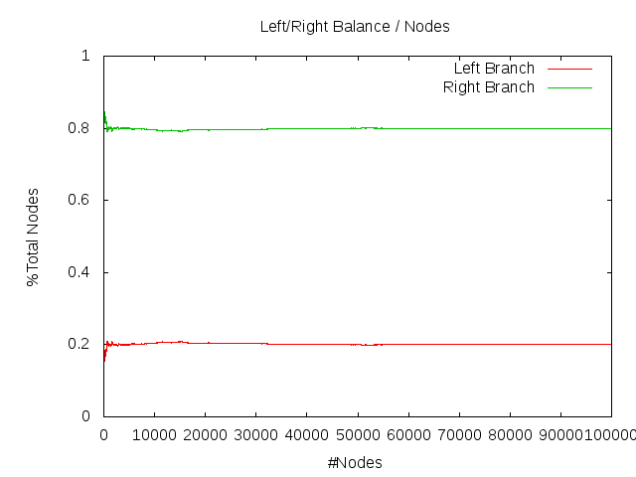

100,000 Nodes (20,000 as root)
Min, Max, and Difference in Depths

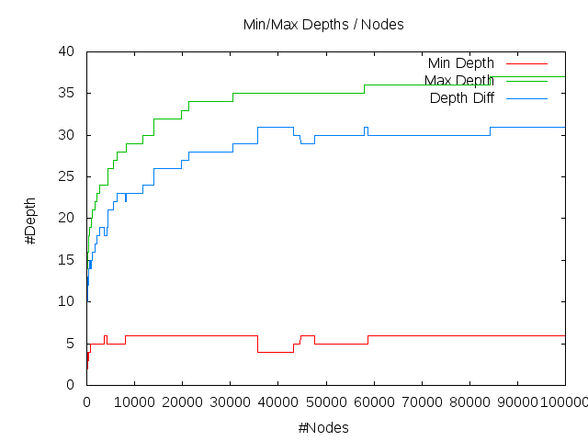

100,000 Nodes (20,000 as root)
Number of Leaves

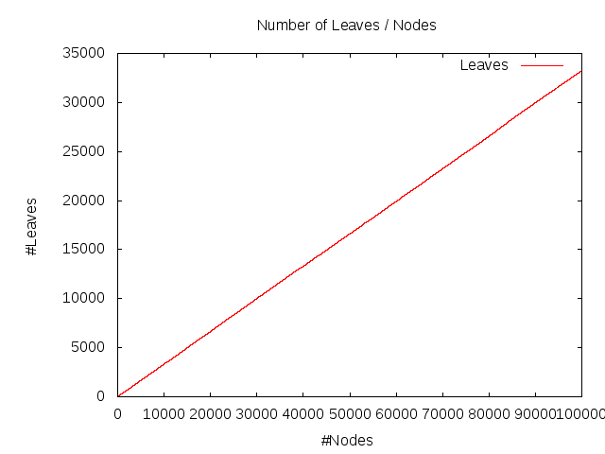

100,000 Nodes (50,000 as root)
Left/Right Branch Balance

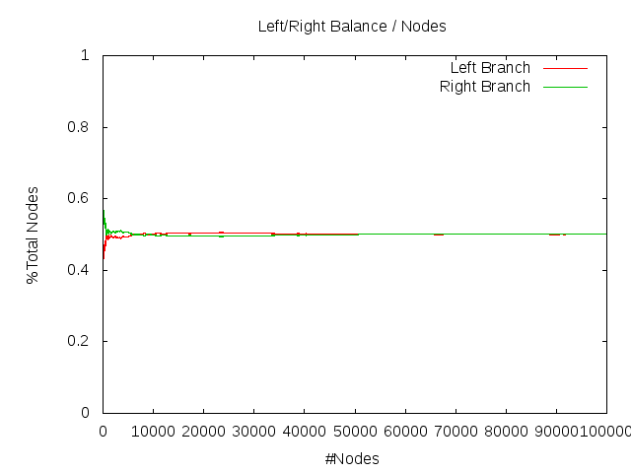

100,000 Nodes (50,000 as root)
Min, Max, and Difference in Depths

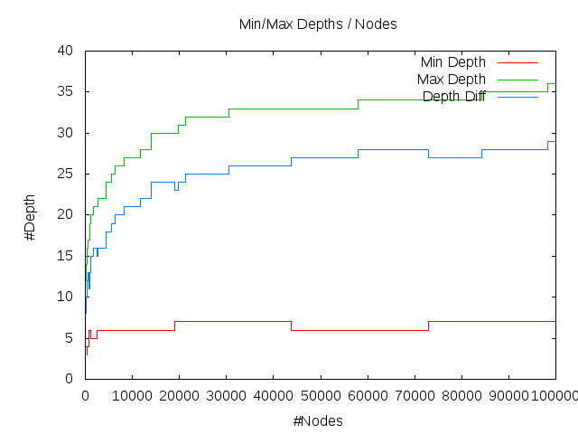

100,000 Nodes (50,000 as root)
Number of Leaves

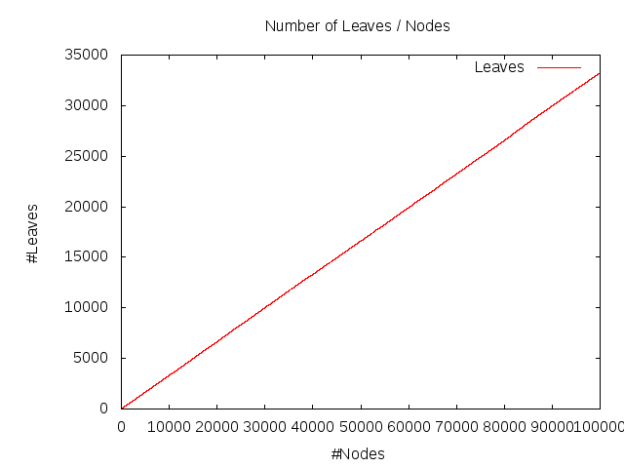

100,000 Nodes (80,000 as root)
Left/Right Branch Balance

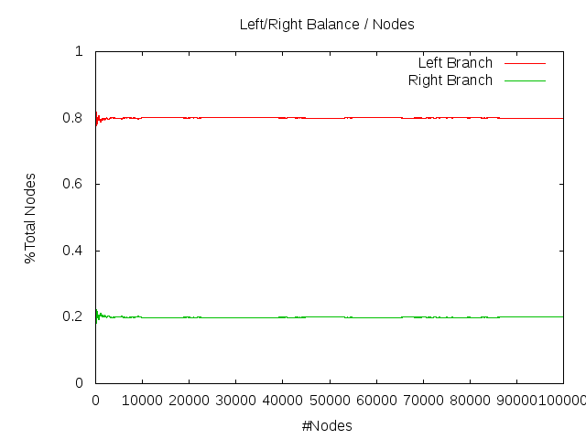

100,000 Nodes (80,000 as root)
Min, Max, and Difference in Depths

100,000 Nodes (80,000 as root)
Number of Leaves

