HOMEWORK 1 – CS 211 Spring 2010
Due: April 12, 2010
(25 pts)
Name: _______________________________________________________________
Names of students you worked with on this assignment (if any): ____________________

Each student must turn in an assignment and do her/his own work. Turn in these pages with your answers written in the spaces provided. Please write clearly and large enough for me to read. Print each page on a separate piece of paper. Each problem is worth 5 points. Word processed homework assignments can receive 5 points extra credit, but only if all symbols, expressions and sentences are correctly represented.

- Prove: the product of two odd integers is odd.

Given a,b,c ∈ ℤ,
Assume x and y are odd integers ⇒
x = 2∙a + 1
y = 2∙b + 1
Start with the product of two odd integers
x ∙ y
Substitute values with definitions
(2∙a + 1) ∙ (2∙b + 1)
Expand the equation by multiply through
4∙a∙b + 2∙a + 2∙b + 1
Extract the common divisor of 2
2 ∙ (2∙a∙b + a + b) + 1
And we find the definitive form of an arbitrary odd integer.

∴ True, the product of two odd integers is odd.

- Prove: If 3n is even, then n is even.

I’ll prove the contrapositive: If n is odd, then 3∙n is odd.

Given a ∈ ℤ,
Assume n are odd integers ⇒
n = 2∙a + 1
Start with any arbitrary odd integer
n
Multiply by 3
3∙n
Substitute the values with their definitions
3∙(2∙a + 1)
Expand by multiplying 3 through the quantity
6∙a + 3
Substitute (+ 2 + 1) for (+ 3)
6∙a + 2 + 1
Extract the common divisor 2 from 6∙a + 2
2∙(3∙a + 1) + 1
To find that 3∙n follows the definitive form of an arbitrary odd integer.

∴ True, if n is odd, then 3n is odd.

- Write down the converse of the following statement about integers:

If x and y are odd then x-y is even.

Converse:
If x - y is even, then x and y are odd.

  - Is the statement that you wrote down true or false? Prove your answer.

- The claim was made in lecture that a conditional and its contrapositive always had the same truth value. Recalling that “P implies Q” means the same thing as “not P or Q”, verify this result by completing the following truth table.

P | Q | not P | not Q | not (not Q) | not P or Q | not (not Q) or not P
T | T | F | F | T | T | T
T | F | F | T | F | F | F
F | T | T | F | T | T | T
F | F | T | T | F | T | T

- What is wrong with the following proof that 1 = 2?

Assume that 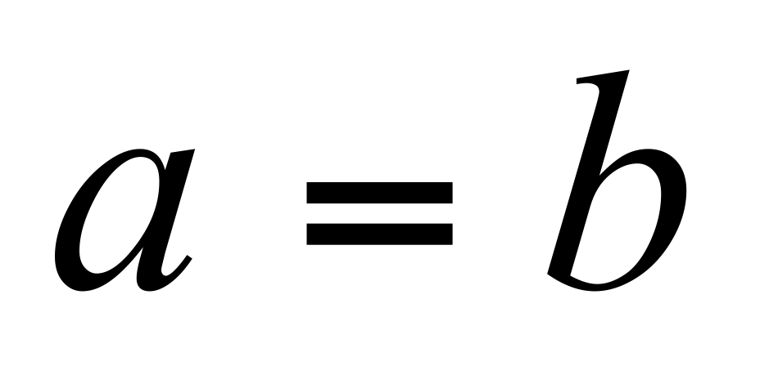and so
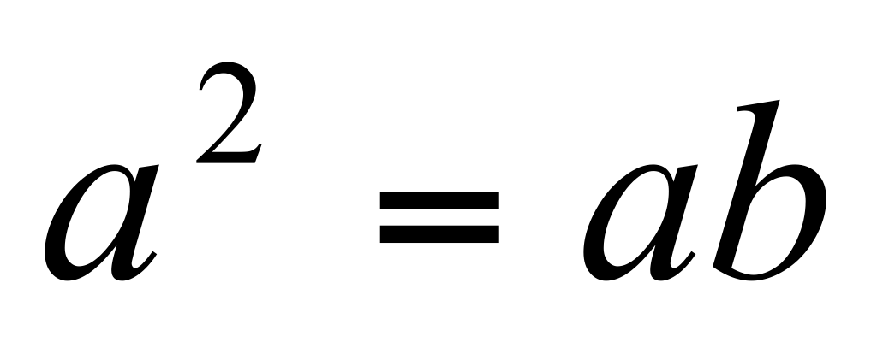
Adding 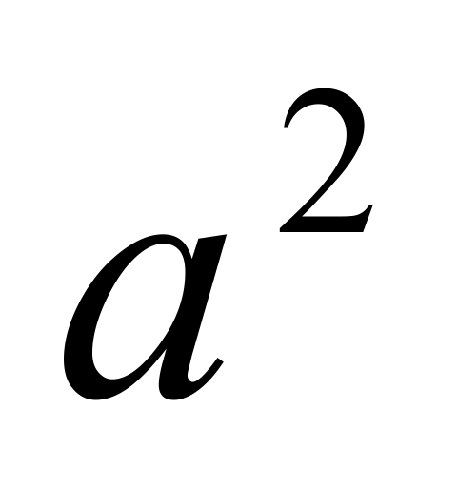to both sides gives
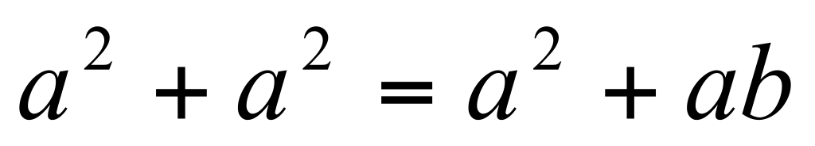
Collecting terms on the LHS yields
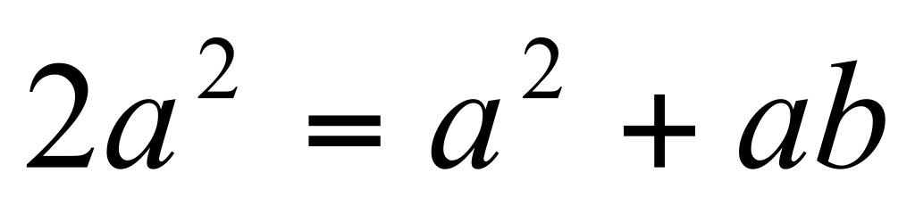
Subtracting 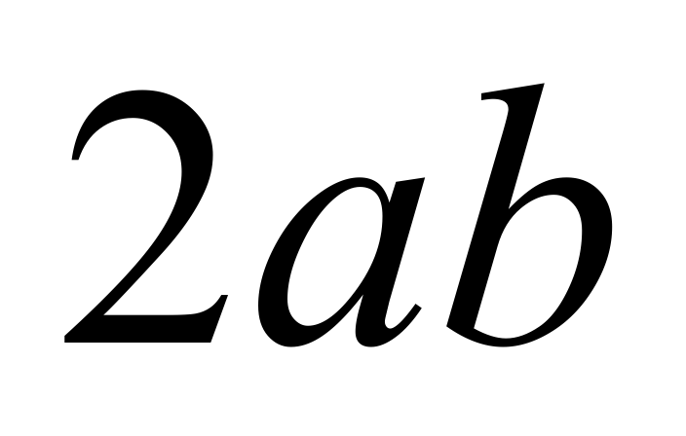from both sides results in
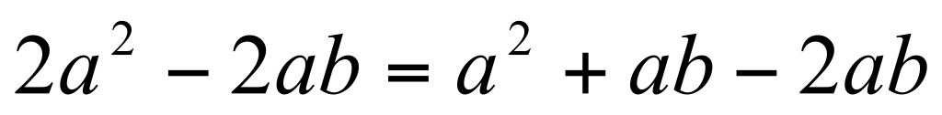
This is equal to
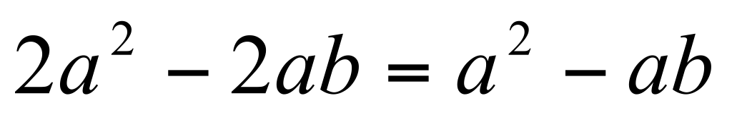
Which, in turn can be expressed as
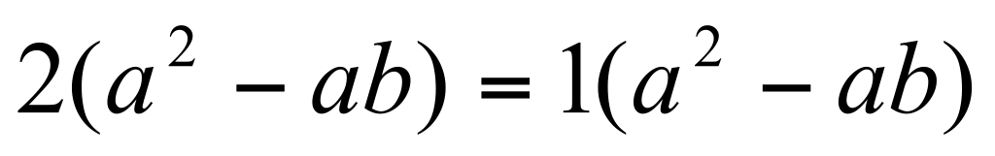
Dividing the equation through by 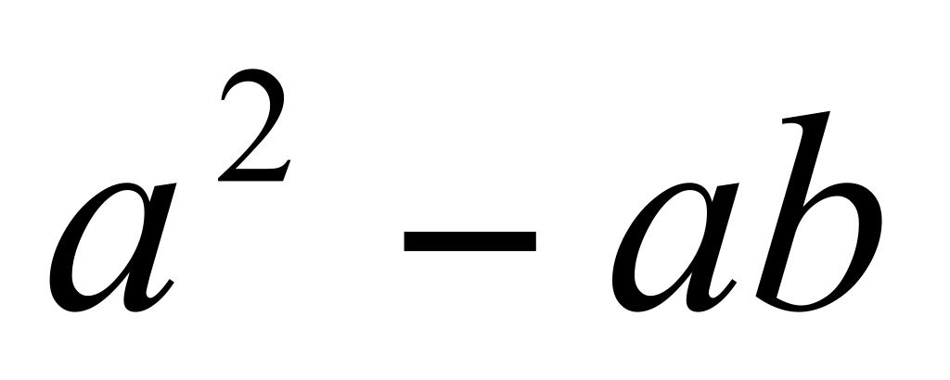gives the desired result that
1 = 2
QED.

We started with
a^2 = ab
Using this equality
(a^2 - ab) = (a^2 - a^2) = 0
And you cannot divide by zero.

