Exporter plugin :
For instance oFusion plugin is used to export the .osm and .mesh files.

Requirements :
Scene must respect the standard meter unit (scale)
(0, 0, 1) is 1 meter vector on the UP-axis (Z in 3DSMax)

In 3DS Max, (Xmax, Ymax, Zmax) with UP axis = Z axis
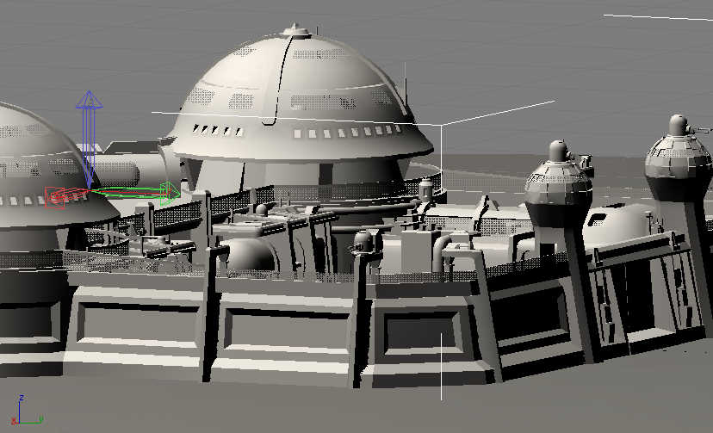

In Solipsis (Ogre engine), (X, Y, Z) = (Xmax, Zmax, -Ymax) with UP axis = Y axis
