Solipsis

Installation Guide

System configuration

Minimal system configuration
- 1Gb of physical memory
- 250 Mb of free disk space
- Windows® XP or Vista
- DirectX® 9.0 or OpenGL® 2 compatible graphic card with 128Mb memory
- Internet connection

Recommended system configuration
- 2Gb of physical memory
- 250 Mb of free disk space
- Windows® XP or Vista
- DirectX® 9.0 or OpenGL® 2 compatible graphic card with 512Mb memory
- Internet connection

Installation

CD/DVD installation : Insert the disk
Network installation : Open the Windows® explorer and reach the installation directory

Run the Setup program Solipsis-x.y.z-win32.exe and follow instructions

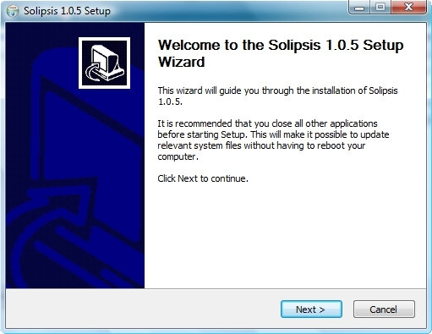
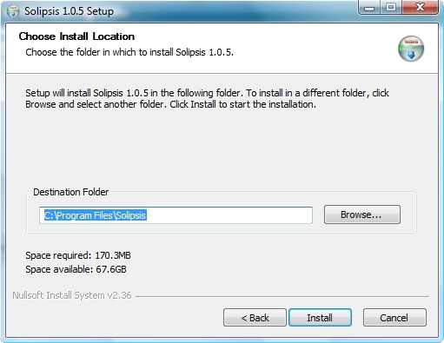

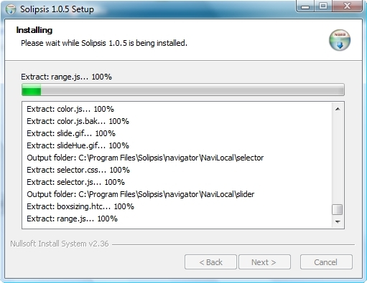

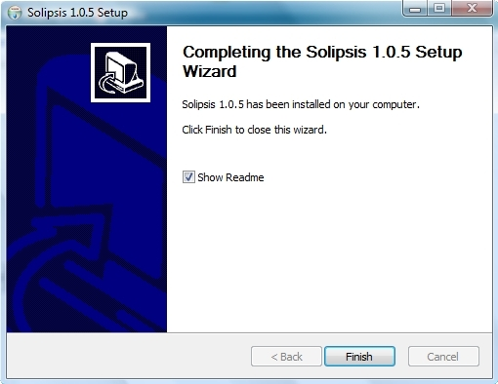
After installation you will be prompted to install required third-parties components : Ms Visual C++ redistributable, Python, DirectX and Ageia PhysX packages. Install them if they are not yet present on your computer.

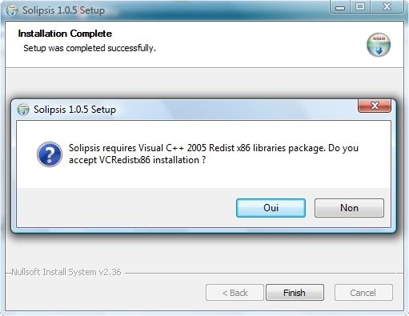

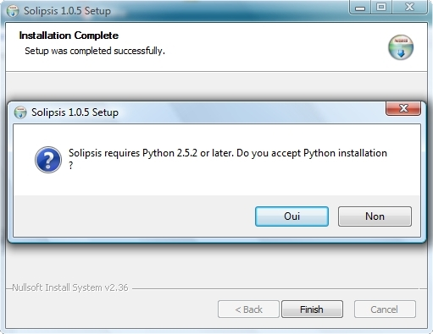

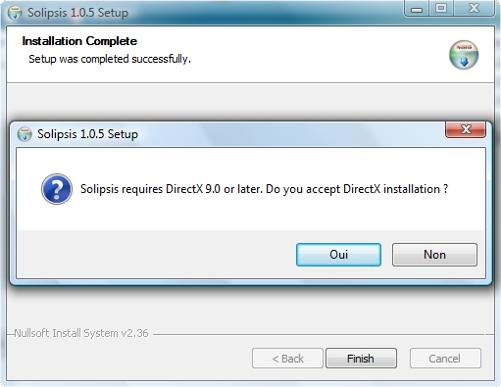

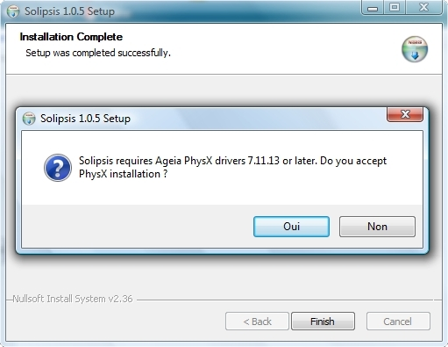

Applications launch

Start menu and Desktop icons
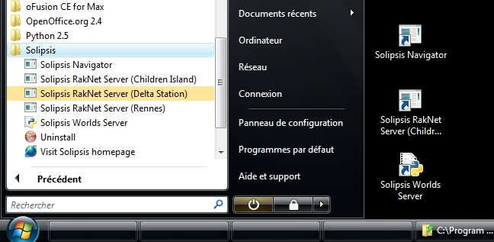

Navigator is the front-end, you will use it to navigate into Solipsis worlds.

RakNet Servers are, for instance, main site nodes describing different worlds. By default, 3 worlds are available : the Children Island, the Delta Station and the city of Rennes.

The Worlds Server is an helper server registering known Solipsis worlds managed by their respective RakNet Servers.

First, launch the Worlds Server
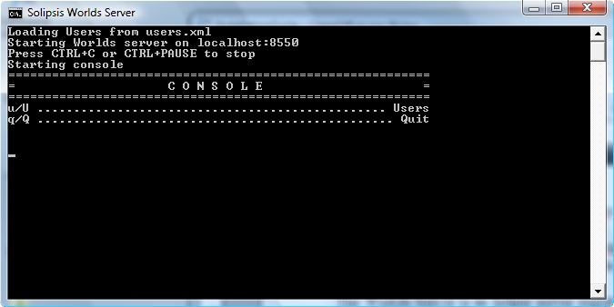
Then, launch RakNet servers of worlds you will visit, for example the Children Island
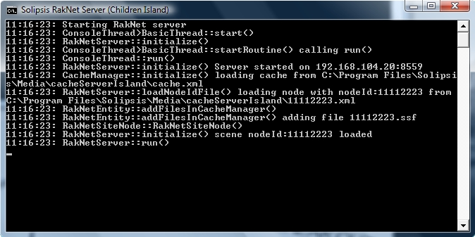

Finally, run the Navigator, on first launch you will have to choose your rendering configuration
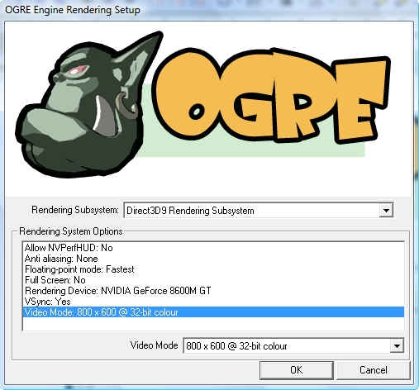
On login panel, click on the World button,

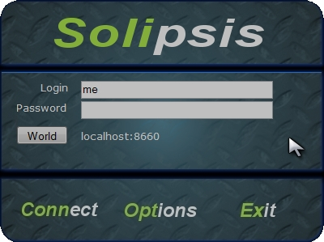
select the world, you will return to the login panel,
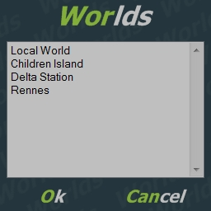
go to the Options panel to choose the autentication type, by default the Worlds Server will give you 1 unique identifier according to your login, press Ok and return to the login panel,

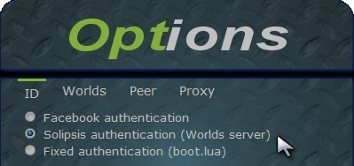
Nota : you can choose to use your Facebook account, then you will be redirected on the Facebook authentication page on your external web browser to log on the Solipsis external application.
Enter your login/password (choose a password if you are a new user) and press Connect, after the authentication process you should return to the login panel, press Connect again to enter into the world.

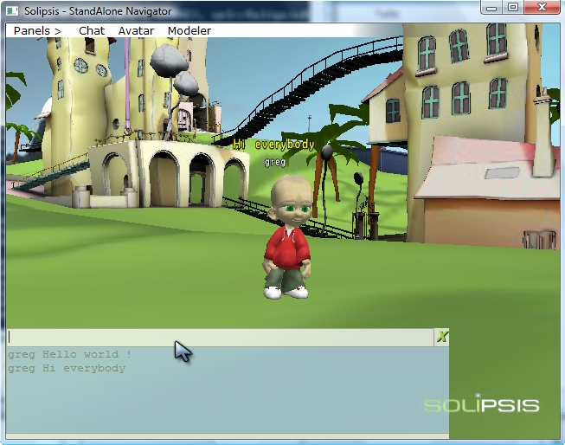

Solipsis - Installation Guide - v1.0

