Exporter plugin :
For instance lexiExporter is exporting correctly avatars, oFusion has some troubles with bounding box computed/exported into the .mesh file.

Requirements :
Avatar must respect the standard unit (scale)

Avatar is facing the X axis ie. Eye vector=(1, 0, 0)

All animations are embedded into the same .max file, each animation will be described into the exporter plugin dialogs.
Animations are : Idle, Walk, Run, Fly, Swim

Pivot on mesh should be on center and just below feet like this
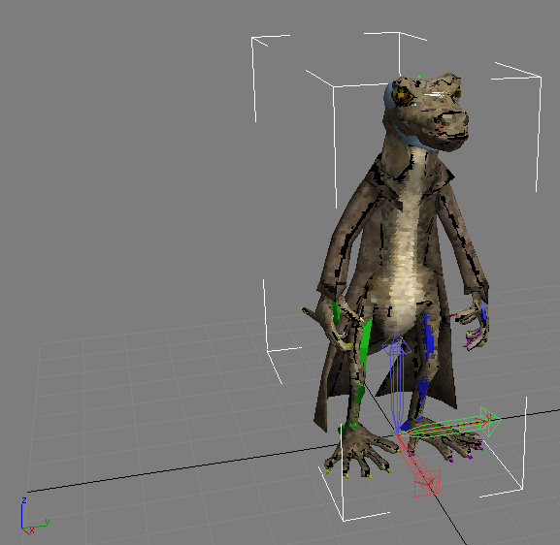

Pivot on skeleton should be on center on the hip joint like this
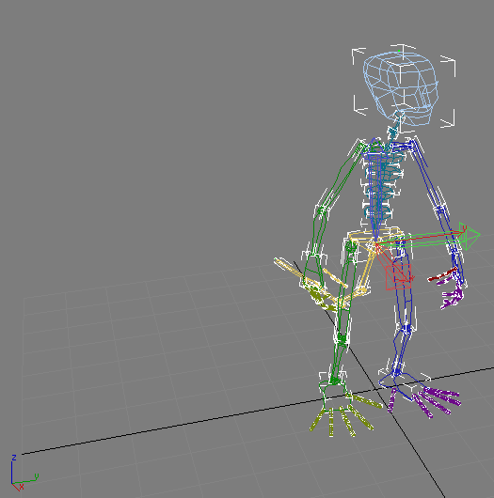

Take care about initial pose of skinned mesh according to the rigged skin because oFusion take this pose into account on bounding box computation
