SOLIPSIS beta-version

Scene requirements
and
Import

Exporter plugin
For instance oFusion plugin for 3DS Max 7/8/9 is used to export the .osm and .mesh files.
You can download the plugin on http://www.ofusiontechnologies.com.

Requirements
Scene must respect the standard meter unit (scale)
(0, 0, 1) is 1 meter vector on the UP-axis (Z in 3DSMax)

In 3DS Max, (Xmax, Ymax, Zmax) with UP axis = Z axis
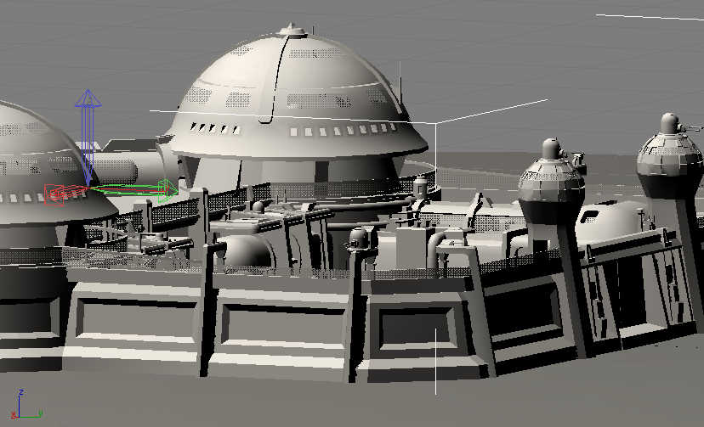

In Solipsis (Ogre engine), (X, Y, Z) = (Xmax, Zmax, -Ymax) with UP axis = Y axis
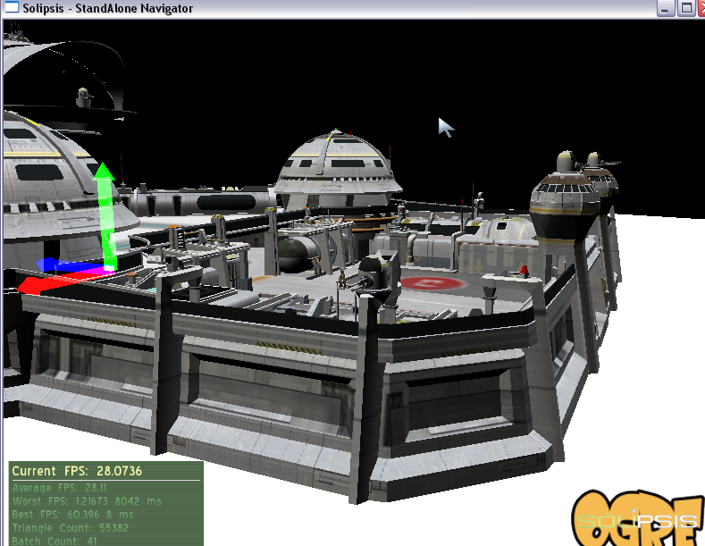

Step 1 : Create your scene in 3DS Max

meshs, materials, textures ...

Step 2 : Create the collision mesh of the scene

floor, walls, stairs, ...
Keep it as simple as possible, avoid too much tesselation
Give it a specific name (COLLISION_mesh for example)
Choose the position where new incoming avatars will be dropped (the entry gate)

Step 3 : Export your Max scene with the oFusion plugin

You will have a .OSM file with all associated files (meshs, materials, textures)

Step 4 : Build your Solipsis Scene File (SSF)

The SSF file is a simple ZIP file renamed in SSF and contains all exported files :
- .OSM : the oFusion scene file
- .mesh : OGRE mesh files
- .material : OGRE material files
- .bmp, .jpg, ... : textures files

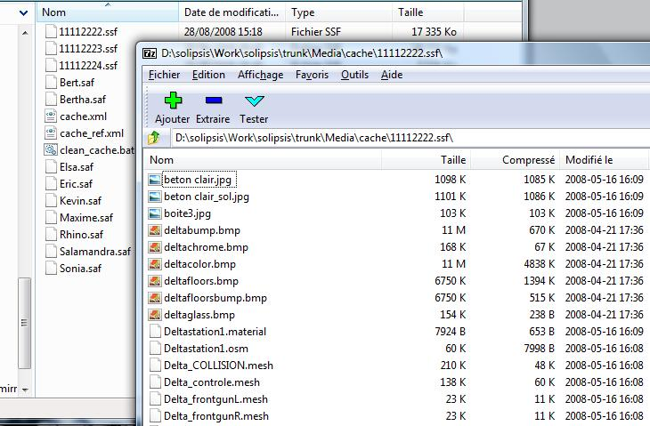

Step 5 : Create the XML scene description file

The final step is the creation of the XML file describing your scene.
In this example the XML file 00001111.xml looks like :

<node>
<entity uid="11112222" owner="00000001" type="1" name="Deltastation1" version="00000000">
<position x="18" y="-58" z="133" />
<orientation x="0" y="0" z="0" w="1" />
<aabb>
<min x="0" y="0" z="0" />
<max x="0" y="0" z="0" />
</aabb>
<content>
<sceneContent>
<entryGate gravity="true">
<position x="17" y="-50" z="115" />
</entryGate>
</sceneContent>
<lod level="0">
<sceneLodContent mainFilename="Deltastation1.osm" collision="Delta_COLLISION" />
<files>
<file name="11112222.ssf" version="00000000" />
</files>
</lod>
</content>
</entity>
</node>

00001111 is the unique node identifier (nodeId) and 11112222 is the unique entity identifier (entityUID).
Owner is the node identifier of the creator avatar.
Adjust if necessary position and orientation of the scene.
Define the entryGate attribute : position of new incoming avatars and the flag indicating if the gravity is activated.
Define the mainFilename attribute with the OSM file present in the SSF archive.
Define the collision attribute with the name of the collision mesh present in the SSF archive.
Finally define the SSF archive file into the files tag.

Server administrator tasks

The server administrator can now integrate the scene into the dedicated RakNet server. He will just have to copy the SSF file and the <nodeId>.xml file into the server Media/cache directory.
To simplify clean up of cache, copy the <nodeId>.xml file into <nodeId>_ref.xml file and update the clean_cache.bat.
Finally launch the RakNet server with argument -s <nodeId>.

