**2-1 Assignment: CRUD in MongoDB**

Grace Fletcher

Southern New Hampshire University

CS 340: Client/Server Development

Prof. Judy Mason

September 8th, 2025

**Verifying Load**

**Inserting a Document** *(I messed up “date” the first time, so I had to delete my first entry to correct my mistakes)*

**Answer the following questions using MongoDB queries:**

1. What is the distinct list of inspection “sector” in the current inspections collection? How many are in the list? Do not county by hand.

*There are 87 distinct sector entries in the list.*

1. What is the difference in the date data type for the business named “AUSTIN 2012” versus your business document insertion of “Acme Explosives”?

*The date data type for the business named “AUSTIN 2012” is a string type while the date data type for “Acme Explosives” is a data object.*

1. How many businesses have a “Violation Issued”?

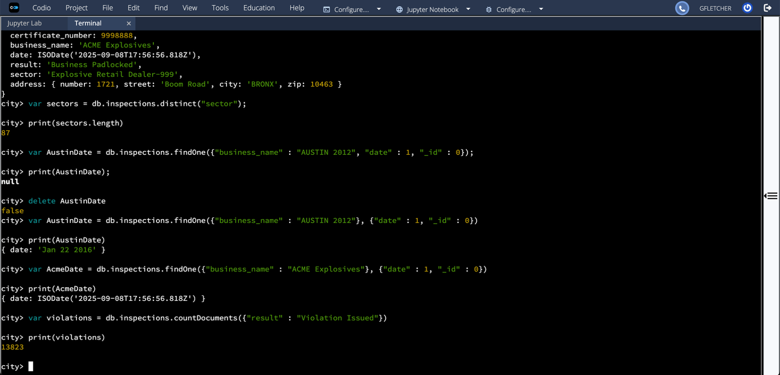

*13,823 businesses have a “Violation Issued”.*

**Updating the Document**

**Updating All Documents**

**Removing the First Document**

