**Module One Assignment**

Grace Fletcher

Southern New Hampshire University

CS 340: Client/Server Development

Prof. Judy Mason

September 3rd, 2025

***Verifying Access to the Environment***

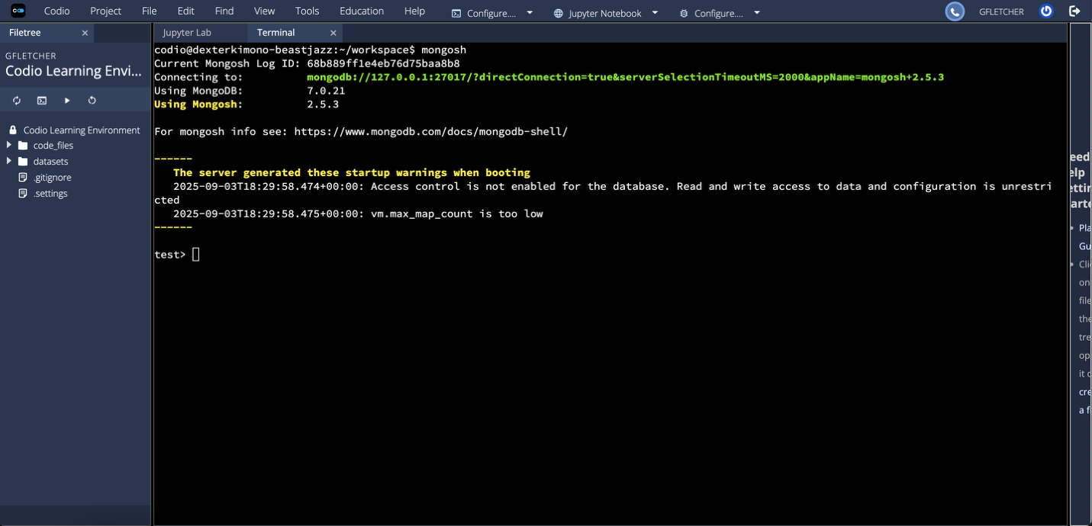

***Retrieving a Document from the Collection***

***Finding the Size of One Document***

***Finding the Size of a Collection of Documents***

