Thoughts and Notes on Chapter Twenty-two
Bible Chapter Titles
Ezekiel
22. The Sins of Jerusalem
23. Oholah & Oholibah
24. The Boiling Pot
25. Ammon, Moab, Edom, Philistia
26-28. Tyre & Sidon
29-32. Egypt (Six Visions)
33. The Watchman
34. The Shepherds
35. Doom of Edom Confirmed
36. New Covenant Confirmed
37. The Valley of Dry Bones
38-39. Gog & Magog
40-43. The Millennial Temple
44-46. The Millennial Worship
47-48. The Millennial Land
Daily Scripture Reading:
Sunday: Ezek. 22-24
Monday: Ezek. 25-27
Tuesday: Ezek. 28-30
Wednesday: Ezek. 31-33
Thursday: Ezek. 34-36
Friday: Ezek. 37-39
Saturday: Ezek. 40-42
- The Lord asks Ezekiel to judge the bloody city (Ezek. 22:1-16).
  - It is a two-count indictment: blood-shedding & idolatry.
  - Judah’s lack of positive witness produced a negative witness, and made them the object of reproach & mocking.
  - The rulers are named as defendants in this judgment (Ezek. 22:6-8).
  - Particular slanderers are also addressed (Ezek. 22:9-12).
- The Lord tries His servants through the fire of testing which removes their dross (Ezek. 22:17-22; Isa. 1:25,26; Zech. 13:9; Mal. 3:2-4; 1st Pet. 1:6,7).
- The Lord exposes Jerusalem’s conspiracy of priests, prophets, princes & people, and laments a lack of even one man to stand in the gap (Ezek. 22:23-31).
- Even one man can make a difference (Jms. 5:16b-18; Gen. 18:23-32; Jn. 9:31)!
Thoughts & Notes on Chapter Twenty-three
- Chapter 23 is a parable of two wicked sisters—Oholah & Oholibah (Ezek. 23:4a).
- The sisters were symbolic of Samaria & Jerusalem (Ezek. 23:4b).
- The parable teaches the unfaithfulness of Israel towards their covenant husband (Ezek. 23:5ff.; 16:8,20; Jer. 3:6-11).
- The premarital harlotry of these two sisters prompted their adultery (Ezek. 23:2,3,5-8).
- Although the example of Oholah should have promted Oholibah’s repentance, her evil was even worse (Ezek. 23:11-21).
- Ezekiel is asked to judge the two sisters, and three additional summaries of their harlotry are then described (Ezek. 23:36-44).
  - Their harlotry came at the expense of the children they sacrificed (vv.37-39).
  - Their harlotry extended to more and more lovers, of less and less distinguished stature (vv.40-42).
  - Their harlotry continues even long after her body is destroyed by her harlotries (vv.43,44).
- Graphic evil at times needs graphic messages (Jn. 16:25; Prov. 26:4,5; Eccl. 3:7).
- Sin patterns from our past must be recognized, and guarded against in present time (Prov. 26:11; 2nd Pet. 2:21,22).
Thoughts & Notes on Chapter Twenty-four
- On the first day of the siege of Jerusalem, the Lord directs Ezekiel to mark the day and deliver another parable (Ezek. 24:1-3a).
  - The day is also mentioned in 2nd Kings (25:1).
  - Jeremiah also records this exact day (Jer. 39:1).
- Ezekiel’s parable consists of a recipe—cooking instructions for the exiles (Ezek. 24:3b-5). This parable is a reminder of Jerusalem’s evil message (Ezek. 11:3ff.).
- The meal is ruined because the pot itself is rusty (Ezek. 24:6).
- Ezekiel’s next work assignment is to silently endure the loss of his beloved wife, without any mourning (Ezek. 24:16-24).
- The chapter closes with the Lord’s promise to release Ezekiel’s mouth on the day that word of Jerusalem’s destruction arrives in Babylon (Ezek. 24:25-27).
- Summary thoughts on the chapter:
  - The plan of God is precise, determining the perfect days for His perfect will (Ps. 139:16; Dan. 12:11,12; 9:24-27 cp. Matt. 21:2,3; 26:18; Acts 1:7).
  - Believers are admonished to keep their vessels pure (2nd Tim. 2:21).
  - Personal tragedies have a purpose—to teach us, and others the grace of God (Gen. 50:20; Rom. 8:28; Heb. 5:8).
  - The Old Testament prophets endured a tremendous amount of testing and suffering, for purposes that were left incomplete until this present age of grace (Heb. 11:32-40).
Thoughts & Notes on Chapter Twenty-five
- Chapter 25 begins an 8 chapter section of prophecies directed against the gentile nations.
- Ammon is rebuked for the pleasure they took in the fall of Jerusalem (Ezek. 25:3,6).
  - God takes no pleasure in the death of the wicked (Ezek. 18:32; 33:11).
  - Ezekiel was also to clap and stamp his foot (Ezek. 6:11), but with God’s mental attitude, and not with the scorn of his soul (Ezek. 25:6).
  - Ammon’s Divine discipline will result in their knowledge of the Lord (Ezek. 25:5,7).
- Moab is rebuked for their insult of the Lord (Ezek. 25:8-11).
  - Moab & Seir claimed that Judah is “like” all the nations (Ezek. 25:8).
  - The Lord states that there is no nation on earth like His chosen people (Ex. 34:10; Num. 23:9; Deut. 26:18,19; 28:1; but see 1st Sam. 8:5,20).
  - Moab’s Divine discipline will result in their knowledge of the Lord (Ezek. 25:11).
- Edom is rebuked for acting upon their mental-attitude of celebration & scorn by exacting vengeance upon Judah (Ezek. 25:12-14).
  - They took vengeance of vengeance, µq;n: µqonÒBi.
  - They are guilty of guilt, µwvoa; Wmv]a]Y<w.
  - Edom’s Divine discipline will result in their knowledge of the vengeance of the Lord (Ezek. 25:14).
- Philistia’s rebuke is like Edom’s as a result of their own vengeance upon Judah (Ezek. 25:15-17). Their Divine discipline also results in a knowledge of the Lord (v.17).
Thoughts & Notes on Chapter Twenty-six
- Chapter 26 begins a three chapter discourse on Tyre. Four oracles are thus directed:
  - A message against Tyre for their intended actions against fallen Israel (Ezek. 26).
  - A poetic message describing the sinking of the “ship” of Tyre (Ezek. 27).
  - A message against the Prince of Tyre (Ezek. 28:1-10).
  - A lament for the King of Tyre (Ezek. 28:11-19).
- Tyre said “Aha” like Ammon did (Ezek. 26:2 cf. 25:3), and was eager to control land-based caravan trade through the region (Ezek. 26:2b).
- The Lord speaks to Tyre in language of the sea so they clearly understand the coming judgment (Ezek. 26:3-6).
- The fall of Tyre at the hands of Babylonians, Persians, & Greeks illustrates the faithfulness of God in fulfilling not only His prophecies through Ezekiel, but also the Gentile dominion as prophesied by Daniel (Ezek. 26:3-14; Dan. 2:36-43; 7:1-8).
- The fall of Tyre foreshadows the fall of a future world commercial power (Ezek. 26:15-18; Rev. 18).
- The fall of Tyre recalls the fall of two past world commercial powers (Ezek. 26:19-21).
  - The antediluvian world (Gen. 4:17-24; 6:1-4).
  - The angelic world (Isa. 14:15-21; Ezek. 28:18,19).
Thoughts & Notes on Chapter Twenty-seven
- Chapter 27 sings the song of the Ship of Tyre.
- The song is a lament based upon the sadness of Tyre’s own words (Ezek. 27:3).
- The beautiful ship is described (Ezek. 27:4-11).
- Her customers are detailed (Ezek. 27:12-25).
- The ship is sunk (Ezek. 27:26-36).
- Every nation weeps and laments. They ask “who is like Tyre” (v.32), when they should be asking “who is like the Lord?” (Ex. 15:11). This, too, is a foreshadowing of future pride to come (Rev. 13:4).
Thoughts & Notes on Chapter Twenty-eight
- The addressee for this message cannot be confused with the following message.
  - The addressee here is identified as n^{e}giyd tsor rxo dygInÒli (Ezek. 28:2).
  - The addressee in the following message is identified as melek tsowr rwxo Jl,m, (Ezek. 28:12).
- The Prince of Tyre (n^{e}giyd tsor) is the human ruler of Tyre (Ethbaal III), but the King of Tyre (melek tsowr) is the true ruler (Satan) (Jn. 12:31; 14:30; 16:11; 1st Jn. 5:19; Dan. 10:13,20,21; 12:1).
- The human ruler of Tyre had lifted up his heart and made his heart like the heart of God (Ezek. 28:2,6).
- The human ruler of Tyre believed that he was a god, controlling events in the world around him. His view of himself was as an antediluvian god-king ruling in the “heart of the seas.”
- In the following message, the true power behind the human power is unveiled, and the rebuke of Satan is expressed.
  - Like Isaiah 14, the prophet looks beyond the human realm and sees the reality of the angelic realm in the details of Satan’s fall.
  - The recipient of this lament cannot be a human being because:
    - Adam & Eve were the only human beings to be in the Adamic Garden of Eden (Ezek. 28:13a).
    - Human beings are not covered in jewels (Ezek. 28:13b).
    - Human beings are born, not created (Ezek. 28:13c).
    - He is called a cherub angel (Ezek. 28:14).
    - He went from a blameless condition to an unrighteous condition (Ezek. 28:15). In the history of the human race, only Adam & Eve experienced a fall from blamelessness to unrighteousness. Every other human being from Cain onward began their lives totally depraved.
  - Like the human ruler he influenced, Satan’s heart was lifted up, and he viewed himself as being a god (Ezek. 28:16-19).
- The Tyre section concludes with a message to her sister city Sidon (Ezek. 28:20-24).
- Tyre & Sidon’s discipline results in knowledge of the Lord (Ezek. 26:6; 28:22-24).
Thoughts & Notes on Chapter Twenty-nine
- Chapter 29 contains the first two of seven messages directed against Egypt.
- Like chapter 28, there is an earthly ruler (Pharaoh) and the dragon who empowers him (Ezek. 29:3).
  - l/dG:h' µyNIT'h' hattanniym haggadowl. ÷yNIT' tanniyn ^{#8577}: dragon, serpent, sea monster. (Job 7:12; Ps. 74:13*; Isa. 27:1*; 51:9**; Jer. 51:34; Ezek. 29:3; 32:2).
* || ÷t;y:wÒli livyathan ^{#3882} ** || bh'r' rahab ^{#7294}
  - The dragon claims Creator status (v.3).
  - God intends to spear this dragon, and leave his dead physical body for the beasts and the birds to eat (vv.4,5; Ps. 74:13,14; Job 41:1,2).
  - See the Week 05 Study Guide for Job 41, the Week 26 Study Guide for Isaiah 27, and the Week 27 Study Guide for Isaiah 51.
- The message to Egypt highlights a 40 year captivity & a return (Ezek. 29:9b-16).
- Egypt’s Divine discipline results in their knowledge of the Lord (Ezek. 29:6,9,16).
- The plunder of Egypt was God’s reward to Nebuchadnezzar for doing His work at Tyre (Ezek. 29:17-21).
Thoughts & Notes on Chapter Thirty
- A four-part message of destruction details the imminent Day of the Lord (Ezek. 30:2,3).
- Four individual messages each begin with “Thus says the Lord God” (Ezek. 30:2,6,10,13).
- Egypt will be destroyed, and her idolatry will be destroyed city by city (Ezek. 30:2-19).
- Even as the Lord breaks Egypt’s arms, He is strengthening Babylon’s arm (Ezek. 30:20-26).
  - Historically, the conflict of Nebuchadnezzar’s Babylon with Egypt is well documented.
  - Prophetic Babylon (Rev. 17:5) led by Antichrist will clash with Egypt and her helpers (Dan. 11:40-43).
Thoughts & Notes on Chapter Thirty-one
- Chapter 31 is a descriptive allegory of Egypt & Assyria.
- The Satanic glory of Assyria is described (Ezek. 31:2-17).
  - Assyria rose to become the world’s only great superpower (Ezek. 31:3-5).
  - Fallen angels infested Assyria’s upper branches, and oversaw the daily human activity (Ezek. 31:6 cf. Dan. 4:12,21; Matt. 13:32; Eph. 2:2).
  - Edenic trees were jealous of Assyria’s glory (Ezek. 31:8,9).
  - God judges Assyria because of their pride (Ezek. 31:10-14; Nahum; Jonah).
  - Assyria was welcomed into Sheol by other trees, who were “comforted” by Assyria’s downfall (Ezek. 31:15-17 cf. Isa. 14:15-17).
- Pharaoh is reminded that his glory and greatness doesn’t rise to Assyria’s level, and that he will share Assyria’s fate (Ezek. 31:18).
Thoughts & Notes on Chapter Thirty-two
- Pharaoh, the Dragon of Egypt, is lamented once again (Ezek. 32:1-16).
  - The Lord destroys this dragon (Ezek. 32:3-10 cp. 29:3-7).
  - The fall of the dragon will leave other kings horrified (Ezek. 32:9,10; Rev. 6:12-17).
- Sheol itself is described and lamented (Ezek. 32:17-32).
  - Ezekiel is commanded to wail (Ezek. 32:18).
  - The eternal destruction of the Lord’s enemies is a cause for lamentation.
- The one “perfect in beauty” (Ezek. 28:12) is asked whom he surpasses in beauty (Ezek. 32:19).
- “The death of the uncircumcised” is a human death apart from the blessings of God’s covenant; i.e. the death of an unbeliever.
- The Chiefs of the Mighty Ones will tell the story of the fall of Egypt (Ezek. 32:21).
  - “Him and his helpers” is in reference to Egypt & the supporting nations under him (Ezek. 30:5-8; Nah. 3:9).
  - There is also a poetic allusion to Rahab and her helpers (Job 9:13; Isa. 30:7).
  - The Chiefs of the Mighty ones are the Nephilim offspring of the fallen angels (Gen. 6:4) who sing the “praises” of those very same fallen angels.
- The arrangement of Sheol is outlined (Ezek. 32:22-32).
  - Assyria occupies the remotest part of the pit, having been slain by the sword (vv.22,23).
  - Elam also occupies the pit, having been slain by the sword (vv.24,25).
  - Meshech, & Tubal occupy the pit, having been slain by the sword (v.26).
  - The Nephilim Mighty Ones are there with their swords (v.27; Gen. 6:4).
  - You (Pharaoh/Satan) will be in the midst of these people (v.28).
  - Edom, having been slain by the sword (v.29).
  - The chiefs of the north, and Sidonians, having been slain by the sword (v.30).
  - Egypt, having been slain by the sword (vv.31,32).
- Angelic Conflict principles gleaned from Ezekiel & other passages:
  - Satan rules this world (Jn. 12:31; 14:30; 16:11).
  - Satan obtained this sovereignty over the kosmos when Adam abdicated his authority to him (1st Jn. 5:19; Matt. 4:8,9).
  - Satan’s forces are organized into layers of agents (Eph. 6:12; Dan. 10:20,21; 11:1; 12:1).
  - Satan’s activity is under God the Father’s stated limitations (Job 1:12; 2:6), and God the Holy Spirit’s world-wide restraint through the indwelt Church (2nd Th. 2:6,7).
  - Satan’s goal is to establish an alternative plan and program to God the Father’s plan and program (Isa. 14:13,14; Rev. 13).
  - Satan is already judged, and his parole will soon be revoked (Jn. 16:11; Gen. 3:15; Lk. 10:18-20; 1st Jn. 3:8; Col. 2:15; Heb. 2:14,15; Isa. 49:24-26; Rom. 16:20; Rev. 12:7-12; 20:2,3,10).
  - God is in total control of human history, and He will fulfill His plan and program regardless of what human or Satanic opposition attempts to stop it (Job 42:2; Prov. 19:21; Eccl. 3:14; Isa. 14:24-27; 46:10; Dan. 4:35).
Thoughts & Notes on Chapter Thirty-three
- Following the destruction of Jerusalem, Ezekiel is re-commissioned to the prophetic ministry (Ezek. 33:7 cf. 3:17).
- “The sons of your people” indicates that Ezekiel’s message of encouragement is targeted to a coming generation (Ezek. 33:2).
- The illustration of an earthly watchman (Ezek. 33:2-6) establishes the principle for a spiritual watchman (Ezek. 33:7-9).
- Ezekiel’s message of encouragement tells a people without hope that they can indeed have hope (Ezek. 33:10-20).
- The Lord opened Ezekiel’s mouth the night before the human messenger arrives with news of Jerusalem’s destruction (Ezek. 33:22 cf. 24:27).
- Ezekiel is reminded once more what sort of audience he has (Ezek. 33:23-33).
Thoughts & Notes on Chapter Thirty-four
- Chapter 34 is a scathing rebuke upon the shepherds (princes, prophets, priests) of Israel for their dereliction of duty.
- The shepherds have been taking care of themselves and not caring for the flock (Ezek. 34:2b,3).
- Their negligence is recorded in five areas (Ezek. 34:4a).
  - The sickly need strength.
  - The diseased need to be healed.
  - The broken need to be bound up.
  - The scattered need to be brought back.
  - The lost need to be sought.
- The shepherds’ activity is called a “domination” and is characterized by “force” and “severity” (Ezek. 34:4b).
- The Lord’s solution to His flock’s lack of a shepherd is to step in and be their Good Shepherd (Ezek. 34:7-24).
  - He will relieve the negligent shepherds of duty (Ezek. 34:7-10).
  - He will faithfully feed the faithful flock, and destroy the false shepherds & false sheep (Ezek. 34:11-22).
  - He will lift up David to be their Millennial shepherd (Ezek. 34:23,24; Jer. 30:9; Ezek. 37:24,25; Hos. 3:5).
- The Millennial conditions for this flock are described (Ezek. 34:25-31).
Thoughts & Notes on Chapter Thirty-five
- Chapter 35 is another prophetic message against Edom (Ezek. 35:1-15 cp. 25:12-14).
- The Good Shepherd protects His flock from the preying wolves (Ezek. 34:5,8,28), Edom most of all.
- Historically, Edom celebrated Israel’s fall to Babylon. Prophetically, Edom will do likewise (Ezek. 35:5-9).
Thoughts & Notes on Chapter Thirty-six
- Ezekiel receives a message that describes the glory of the coming kingdom.
- The mountains are addressed (Ezek. 36:1) and promised abundant blessings (vv.8-15).
- The millennial blessings of Israel will produce amazing birthrates (Ezek. 36:10,11) and the erasure of the infant-mortality rate (v.12).
- The Lord explains to Ezekiel why the restoration of Israel has been promised, and then delivers three messages concerning this promised restoration (Ezek. 36:16-38).
  - Ezekiel’s explanation of the promised restoration is that the Lord is acting for the sake of His own name (Ezek. 36:16-21).
  - Message #1 highlights the unmerited nature of Israel’s millennial blessings, and spotlights the ministry of the Holy Spirit in that day (Ezek. 36:22-32).
  - Message #2 indicates the miraculous nature of the rebuilding of the earth after the Tribulation, and the glory that God will receive for restoring Eden on the earth (Ezek. 36:33-36).
  - Message #3 describes the blessings of Israel to be multiplied numerically and be blessed spiritually throughout their millennial prosperity (Ezek. 36:37,38).
Thoughts & Notes on Chapter Thirty-seven
- Ezekiel is taken on another spiritual journey (Ezek. 37:1).
- The dry bones prophecy describes the national resurrection of Israel and forms the clearest Biblical description of the bodily resurrection of individual believers (Ezek. 37:7-14).
- Ezekiel performs another skit to teach Bible class. Two sticks are joined into one stick in order to teach the unified millennial kingdom of Israel (Ezek. 37:15-23).
- The restored Throne of David is seen, with the resurrected David in view (Ezek. 37:24-28).
Thoughts & Notes on Chapters Thirty-eight and Thirty-nine
- Chapters 38 & 39 describe an invasion of Israel by Gog, from the land of Magog (Ezek. 38:2).
  - Magog (land of Gog) was the 2nd son of Japheth, & grandson of Noah (Gen. 10:2).
  - Chief prince (n^{e}siy’ ro’sh) of Meshech & Tubal. The alternate reading: prince of Rosh, Meshech, & Tubal is preferred by those who find etymological affinity between Rosh and Russia. That affinity is uncertain, and unattested elsewhere in Scripture.
- Gog heads a coalition of nations unified in the necessity to invade Israel (Ezek. 38:4-7).
  - Persia (modern Iran). A blend of Japhetic peoples.
  - Cush (Ethiopia/Sudan). 1st son of Ham (Gen. 10:6,7).
  - Put (modern Libya). 3rd son of Ham (Gen. 10:6).
  - Gomer (historical Cimmerians, through intermarriage disappeared from history in the 6th century BC; modern Turks could claim such descent). 1st son of Japheth (Gen. 10:2,3).
  - Beth-Togarmah (modern Armenians). 3rd son of Gomer, grandson of Japheth (Gen. 10:3).
- The Gog federation will be summoned to attack a disarmed Israel (Ezek. 38:8-16).
  - Gog will have hooks in his jaws, and be summoned (Ezek. 38:4,8).
  - Israel has returned from “many nations” (not all nations) (Ezek. 38:8,12).
  - Israel has unwalled cities (Ezek. 38:8,11,14; 39:26).
  - The purpose for this invasion will be for the instruction of the nations (Ezek. 38:16).
- The Lord promises to personally destroy Gog and his armies (Ezek. 38:17-23).
- The Lord repeats His promise to Gog and indicates how Israel & the nations will respond to Gog’s destruction (Ezek. 39:1-8).
- The cleanup for this invasion will take seven years (Ezek. 39:9-16).
  - The inability to fit a seven year cleanup within the Tribulation has led many scholars to place this event within the Millennium.
  - Another possibility places the event within the Tribulation, and places the cleanup within the Millennium.
  - A third possibility places the event and the cleanup before the Tribulation.
    - After the Church Age, but before the Dan. 9:27 covenant with Antichrist.
    - A time-gap between the Rapture and the Dan. 9:27 covenant is entirely likely. Dan. 9:26 encompasses 40 years.
- The destruction of Gog is a witness to the nations (Ezek. 39:21-24).
- The restoration to the land is once again promised (Ezek. 39:25-29).
Thoughts & Notes on Chapter Forty
- Chapter 40 begins the last portion of the Book of Ezekiel—a guided tour of the Millennial Temple and the surrounding land of Israel (Ezek. 40-48).
- Ezekiel is once again transported through time and space “in the visions of God” (Ezek. 40:2).
- Ezekiel is instructed to relate the Millennial temple information to Israel (Ezek. 40:3,4).
  - The description does not match any historical temple.
  - It is therefore a future temple.
  - The dimensions of the temple, and the surrounding land do not match present-day geography.
- Tour Stop #1 is the outer wall, and the eastern gate (Ezek. 40:5-16).
- Tour Stop #2 is the outer court, and the northern & southern gates (Ezek. 40:17-27).
- Tour Stop #3 is the inner court, and the three inner gates (Ezek. 40:28-47).
Thoughts & Notes on Chapter Forty-one
- Tour Stop #4: the temple proper, from the porch (Ezek. 40:48,49), to the Holy Place (Ezek. 41:1,2), to the Holy of Holies (Ezek. 41:3,4).
- Tour Stop #5: the side chambers (Ezek. 41:5-11).
- Tour Stop #6: the mysterious western building (Ezek. 41:12).
  - No purpose for this building is given.
  - No activity within this building is described.
  - No entrance to this building is mentioned.
- Tour Stop #7: an overall measurement of the house, and a more detailed examination of the engravings (Ezek. 41:16-26).
Thoughts & Notes on Chapter Forty-two
- Tour Stop #8: the holy chambers (Ezek. 42:1-14).
- Tour Stop #9: an overall measurement of the entire temple complex (Ezek. 42:15-20).
Summary of Thoughts
on the Millennial Temple
- The prophetic vision of a future temple must be taken as literally and perfectly as the prophetic visions of the destruction of Jerusalem.
- Israel is an earthly nation among earthly nations, and their Millennial land inheritance will be guaranteed by the Lord Jesus Christ Himself.
- The Millennial temple will feature extensive symbolic ritual.
- That ritual will include animal sacrifices.
- That ritual will include a human, earthly priesthood.
  - A restoration of the Aaronic/Levitical Priesthood.
  - Modified to establish the Zadokite Priesthood. All non-Zadokite Aaronites will be considered as Levites.
- The Millennial reign of Jesus Christ will feature a return of the environment to pre-flood conditions, and a return of national governments to post-flood instructions.
Note: A thorough development of this entire portion of Ezekiel is available from Austin Bible Church.
Ezekiel: A chapter-by-chapter study guide, as taught by Pastor Robert L. Bolender, at Austin Bible Church, 2000-2001.
Note:
This material is provided on a grace basis, free of charge. It may not be sold in any form or for any reason. Neither Austin Bible Church, nor Pastor Bob are profiting from these study guides. They are intended strictly as an assistance to the verse-by-verse isogogical, categorical, and exegetical Bible teaching ministry of Austin Bible Church.
Sources:
The Bible reading schedule is from a long-forgotten, and uncertain source.
Chapter Titles are from The Categorical Notebook, Vol. 3 / Ralph G. Braun—Brookings, OR: Berean Fundamental Church, 1974.
Book Charts are from Talk thru the Bible [computer file] / Bruce Wilkinson and Kenneth Boa.—electronic ed.—Nashville : Thomas Nelson, 1997, c1983.
Scripture Citations come from the New American Standard Bible : 1995 update [computer file] / The Lockman Foundation.—LaHabra, CA : The Lockman Foundation, c 1995.
Hebrew and Greek vocabulary words, and Strongs Exhaustive Concordance numbers are from the Logos Library System 2.1 / Logos Research Systems.

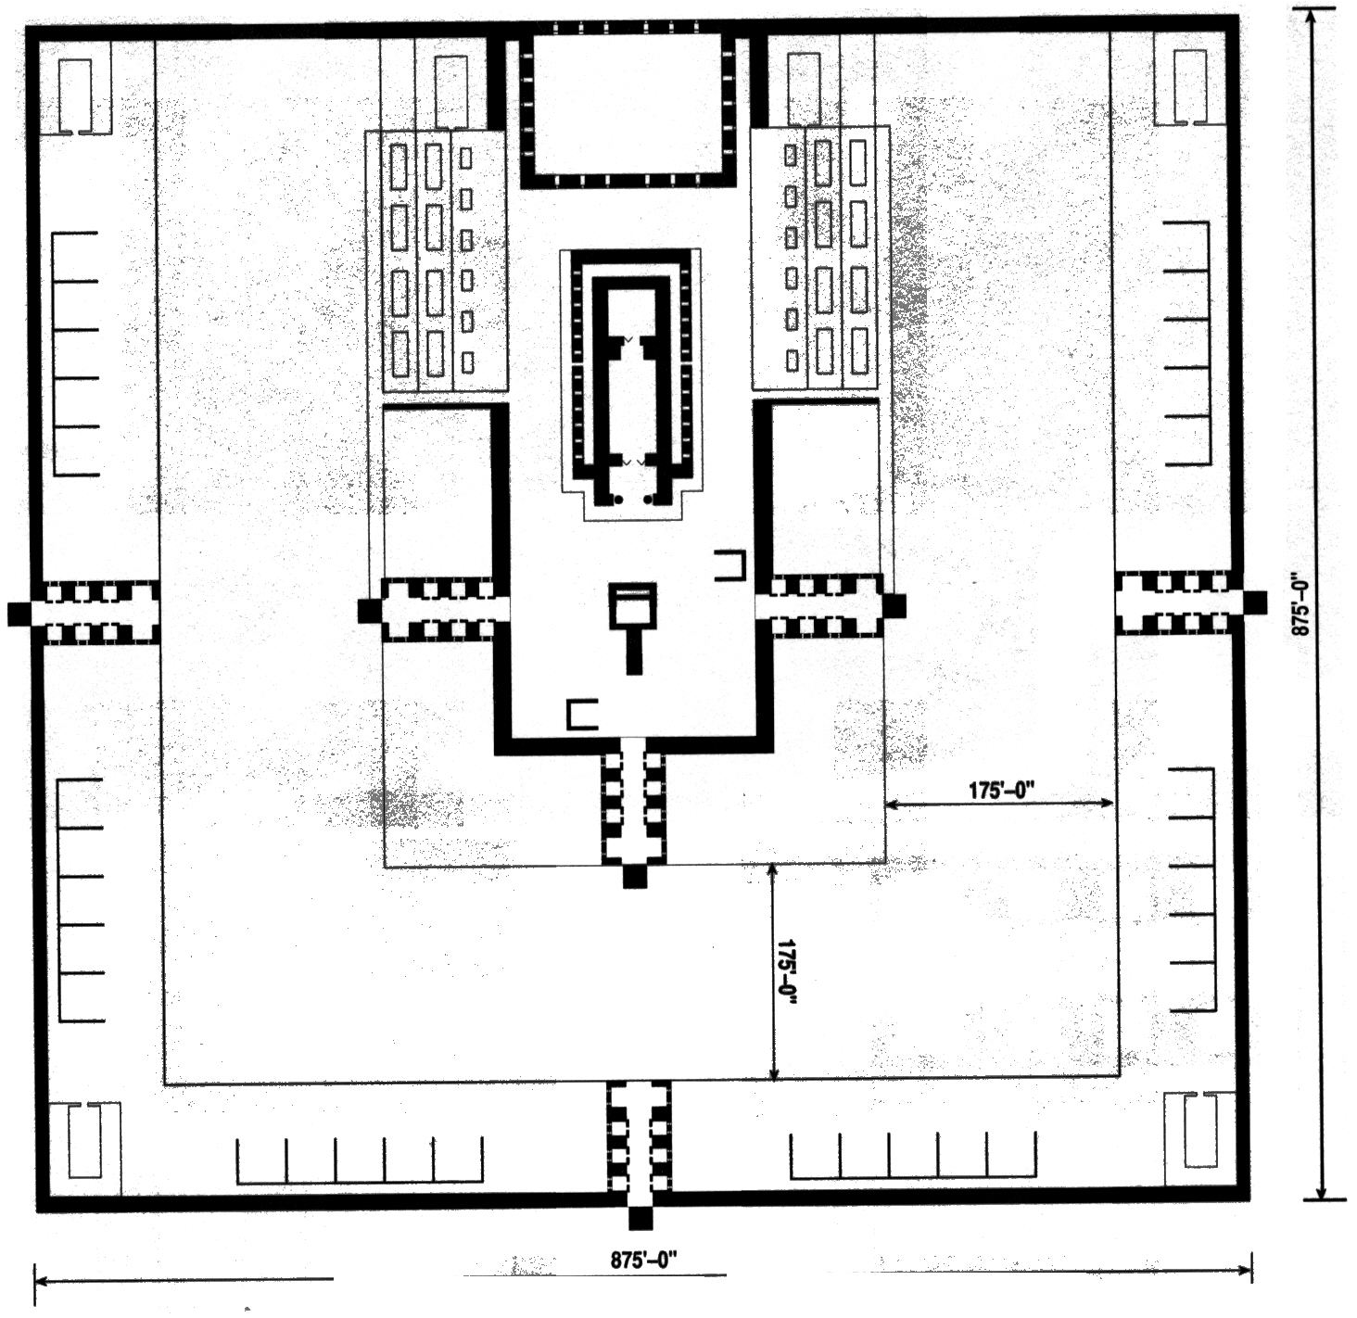
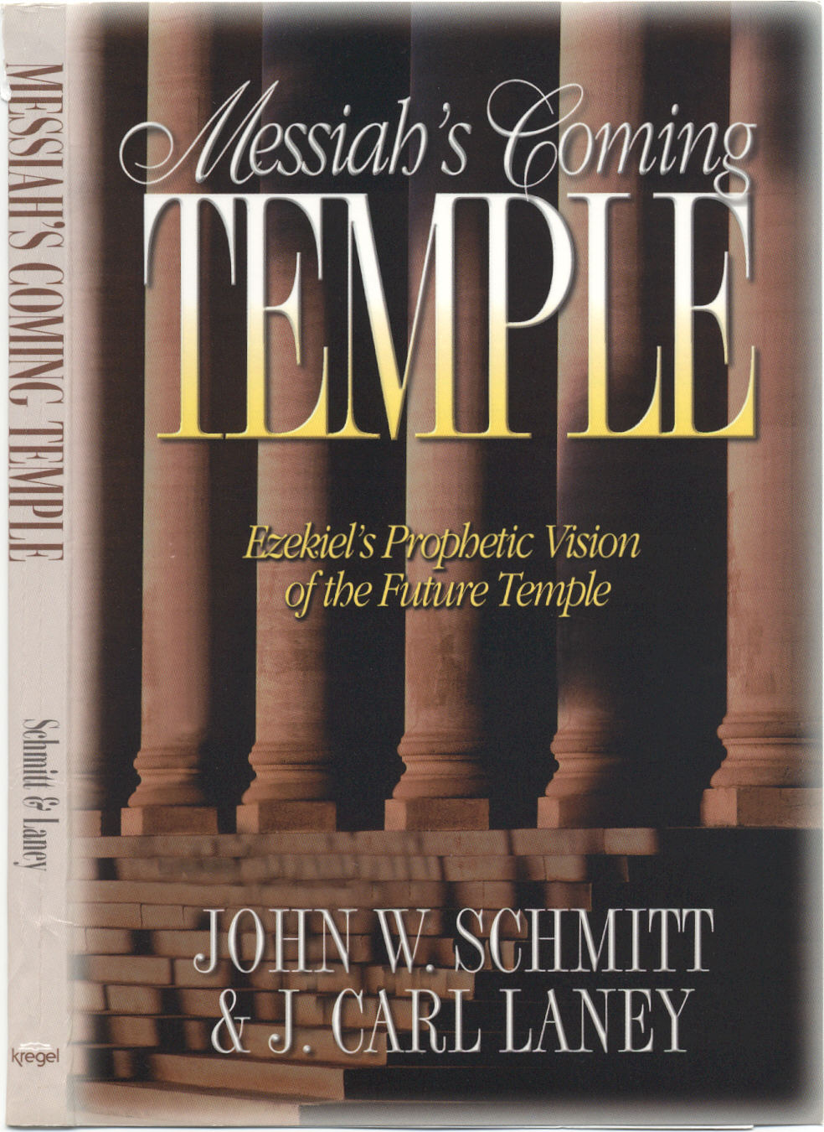
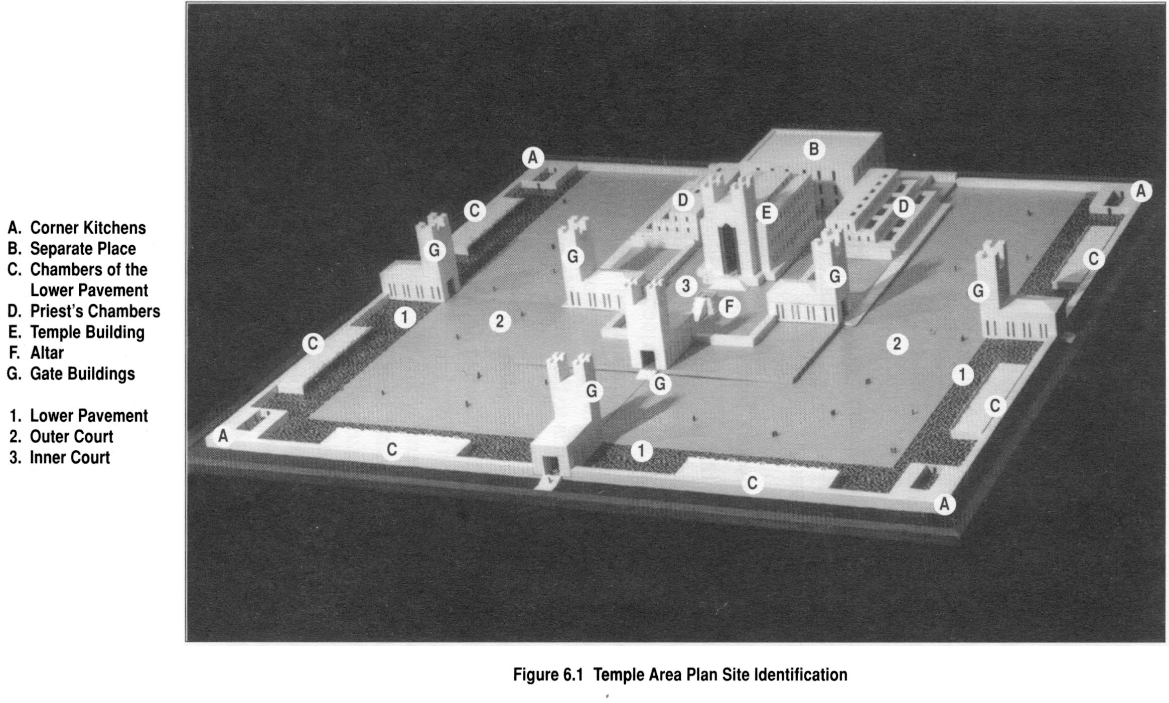
For good reference on Ezekiel 40-48, Pastor Bolender recommends “Messiah’s Coming Temple” by John W. Schmidt & J. Carl Laney.

