**Neuroimaging Paradigms**

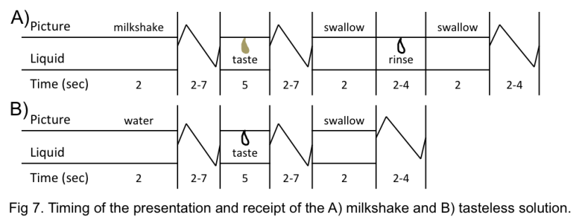fMRI food receipt/anticipated receipt paradigm. We will use an adapted version of our milkshake paradigm, which assesses activation in response to receipt and anticipated receipt of milkshakes that vary in fat and sugar content. Each milkshake will include the same low-fat chocolate ice cream base. Fat content of the milkshakes will be varied by the type of milk used (whipping cream vs non-fat milk); sweetness will be increased by adding sweetened condensed milk. We will use a high-fat, high-sugar milkshake (5.1g fat, 3.4g sugar/fl oz), a high-fat, low-sugar milkshake (5.1g fat, from nilearn.decoding import SpaceNetClassifier

# Fit model on train data and predict on test data

decoder = SpaceNetClassifier(memory_level=2, n_jobs=4,

mask=mask_img, standardize=True,

memory="nilearn_cache", penalty='graph-net')

decoder.fit(X_train, y_train)

y_pred = decoder.predict(X_test)

accuracy = (y_pred == y_test).mean() * 100.

print("Graph-net classification accuracy : %g%%" % accuracy)1.7g sugar/fl oz), a low-fat, high-sugar milkshake (.5g fat, 4g sugar/fl oz), and a low-fat, low-sugar milkshake (.5g fat, 2.4g sugar/fl oz). Pilot testing showed these differences in fat and sugar content are detectable without varying flavor. We will use a tasteless, odorless solution containing the main ionic components of saliva (25 mM KCl, 2.5 mM NaHCO3 in distilledwater) as a control contrast. Subjects will receive the 5 fluids through individual beverage tubes, which will be anchored to the headcoil and deliver the tastes in the same area in the mouth (see Resources for details regarding the gustometer). We have used this delivery system previously (Stice et al., 2008c,d, 2010b). Participants are cued with a picture (glass of milkshake or water) and written description of the forthcoming stimuli (e.g., ‘high-fat high-sugar milkshake’) before receipt of tastes. Information on the fat/sugar content of the taste will be presented to maximize to the sensitivity of the stimuli. Fig 7 depicts the timing and ordering of presentation of pictures and drinks in a run. During milkshake delivery, the cue is presented, followed by a jitter were a fixation cross is presented. The milkshake (0.7cc) delivery then occurs, followed by a jitter. A swallow cue is then presented followed by another jitter. The subjects then receive a rinse of the tasteless solution followed by a second swallow cue followed by a jitter. Tasteless solution delivery follows the same pattern without a rinse. In total, there will be 20 repeats of each of the experimental events of interest (4 milkshake types and tasteless solution) presented in a counter balanced fashion. 4 runs (M 10 min, 20 secs) will be performed in a randomized order. Total paradigm duration = 41 mins, 36 secs. We will contrast fMRI blood oxygen level dependent (BOLD) response during milkshake receipt vs tasteless receipt, during milkshake cue vs tasteless cue, and during receipt and cues for receipt of milkshakes varying in fat and sugar content.

fMRI food picture paradigm. We will use a paradigm designed to examine activation in response to food images (Stice et al., 2010a). Before the scan session, participants rate how appetizing they find foods from a set of 100 pictures. During the paradigm, participants are exposed to the 20 pictures rated as the most appetizing and the 20 pictures rated as the least appetizing, as well as 20 pictures of glasses of water. Stimuli are presented in 2 runs. Each picture is presented for 5 secs and the participant will be asked to imagine tasting and consuming the food/beverage. A 2-4 secs jitter occurs between each picture during which a blank screen with a cross-hair at the center for fixation. Run time = 10 min; total paradigm duration = 20 min. We will contrast BOLD response during pictures of appetizing vs unappetizing foods and vs water glasses.

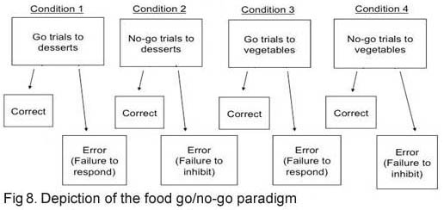fMRI food go/no-go paradigm. We will use a food go/no-go paradigm that assesses inhibitory control in response to palatable food images, adapted from Batterink et al (2010). This task requires subjects to respond to “go” signals and occasionally inhibit responses to “no-go” signals (Fig 8). It measures the ability to inhibit a pre-potent tendency to respond. Participants are presented with images of desserts or vegetables; the dessert images are highly appetizing and the vegetable images unappetizing by design. In one condition, subjects are asked to press the button when they see a vegetable, but to inhibit the button press when they see a dessert. Instructions are reversed in the other condition. Each trial ends with a 2-4 sec jitter during which a fixation cross appears (stimuli presented in random order). We will include a speeded response component, present 144 trials of each of the 2 conditions, and no-go cues will be randomly preceded by 3, 5 or 7 go cues to increase the error rate to no-go trials. Run time = 8 mins, 30 secs; total paradigm time = 17 mins. We will contrast BOLD response during no-go dessert trials vs go dessert trials. The number of responses to no-go stimuli (commission errors) will be used to provide a behavioral measure of inhibition failure.