|  |  |
| --- | --- |
| **Ex. No. 10** | **NodeJS Forms** |
| Date of Exercise: | 31/10/2022 |

**Aim:** To Create a 2022 Christmas Megaplay registration form on the first page and webscrap the posted form data to display in the values using NodeJS.

# Description:

* Node.js allows you to run JavaScript outside the web browser.
* Used to create both client and server-side applications (Full Stack Web Application Development).
* Node JS is single threaded application environment.
* A single response for all the requests.
* NodeJS best suitable for creating websites and web applications which contain less CPU-intensive tasks.

# HTML Code

<!DOCTYPE *html*>

<html *lang*="en">

<head>

<meta *charset*="UTF-8">

<meta *http-equiv*="X-UA-Compatible" *content*="IE=edge">

<meta *name*="viewport" *content*="width=device-width, initial-scale=1.0">

<link *href*="https://cdn.jsdelivr.net/npm/bootstrap@5.2.2/dist/css/bootstrap.m in.css" *rel*="stylesheet" *integrity*="sha384-

Zenh87qX5JnK2Jl0vWa8Ck2rdkQ2Bzep5IDxbcnCeuOxjzrPF/et3URy9Bv1WTRi" *crossorigin*="anonymous">

<script *src*="https://cdn.jsdelivr.net/npm/bootstrap@5.2.2/dist/js/bootstrap.bun dle.min.js" *integrity*="sha384-

OERcA2EqjJCMA+/3y+gxIOqMEjwtxJY7qPCqsdltbNJuaOe923+mo//f6V8Qbsw3" *crossorigin*="anonymous"></script>

<title>Megaplay Registration</title>

|  |
| --- |
| </head>  <body>  <div *class*="container">  <div *class*="row m-5 p-3 bg-warning">  <h1>Megaplay 2023 Registration Form!</h1><br><br><br>  <form *action*="/form" *method*="post" *class*="form-horizontal">  <div *class*="form-group">  <div *class*="col-sm-10">  <label *class*="control-label col-sm-2" *for*="name">Name:  </label>  <input *type*="text" *class*="form-control " *name*="name"  *id*="name">  </div>  </div><br>  <div *class*="form-group">  <div *class*="col-sm-10">  <label *class*="control-label col-sm-2" *for*="reg">RegNo:  </label>  <input *type*="text" *class*="form-control " *name*="reg"  *id*="reg">  </div>  </div><br>  <div *class*="form-group">  <div *class*="col-sm-10">  <label *class*="control-label col-sm-2" *for*="year">Year of  Study: </label>  <input *type*="text" *class*="form-control " *name*="year"  *id*="year">  </div>  </div><br>  <div *class*="form-group">  <div *class*="col-sm-10">  <label *class*="control-label col-sm-2" *for*="dept">Department:  </label>  <select *name*="dept" *class*="form-control ">  <option *value*="CSE">CSE</option>  <option *value*="ECE">ECE</option>  <option *value*="EEE">EEE</option>  <option *value*="Media">Media</option> |
| <option *value*="Mechanical">Mechanical</option>  <option *value*="Agriculture">Agriculture</option> </select>  </div>  </div><br>  <div *class*="form-group">  <div *class*="col-sm-10">  <label *class*="control-label col-sm-2" *for*="school">School:  </label>  <select *name*="school" *class*="form-control ">  <option *value*="School of Engineering">School of Engineering</option>  <option *value*="School of Agriculture and  Biosciences">School of Agriculture and Biosciences</option>  <option *value*="School of Management Studies">School of Management Studies</option>  </select>  </div>  </div><br>  <div *class*="form-group">  <div *class*="col-sm-10">  <label *class*="control-label col-sm-2" *for*="event">Type of  Event: </label>  <input *type*="checkbox" *name*="event" *value*="Musician">  Musician  <input *type*="checkbox" *name*="event" *value*="Singing"> Singing  <input *type*="checkbox" *name*="event" *value*="Choreography">  Choreography  <input *type*="checkbox" *name*="event" *value*="Backstage">  Backstage  <input *type*="checkbox" *name*="event" *value*="Finance"> Finance  <input *type*="checkbox" *name*="event" *value*="Purchase">  Purchase  <input *type*="checkbox" *name*="event" *value*="Volunteer">  Volunteer  </div>  </div><br>  <div *class*="form-group">  <div *class*="col-sm-10"> |
| <button *class*="btn btn-primary"  *type*="submit">Submit</button>  </div>  </div><br>  </form>  </div>  </div>  <br><br>  </body>  </html> |

# NodeJS Code

|  |
| --- |
| **var http = require('http'); const fs = require('fs');**  **const server = http.createServer(function (req, res) { if(req.url==='/'){ res.writeHead(200,{"Content-**  **Type": "text/html"}); fs.createReadStream('./index.html').pipe(res);**  **} else if(req.url ==='/form' && req.method == 'POST'){ var rawData = '';**  **req.on('data',function(data){ rawData += data;**  **}) req.on('end',function(){** |

|  |
| --- |
| **var inputdata = new URLSearchParams(rawData); res.writeHead(200,{"Content-Type": "text/html"}); res.write('Name: ' +inputdata.get('name') + '<br><br>'); res.write('RegNo: ' +inputdata.get('reg') + '<br><br>'); res.write('Year of Study: ' +inputdata.get('year') + '<br><br>') res.write('Department: ' +inputdata.get('dept') + '<br><br>'); res.write('School: ' +inputdata.get('school') + '<br><br>');**  **res.write('Type of event: ' +inputdata.get('event') +**  **'<br><br>');**  **res.end();**  **});**  **} }); server.listen(3013,function(){ console.log('listening at 3013')**  **});** |

**;**

# Output:

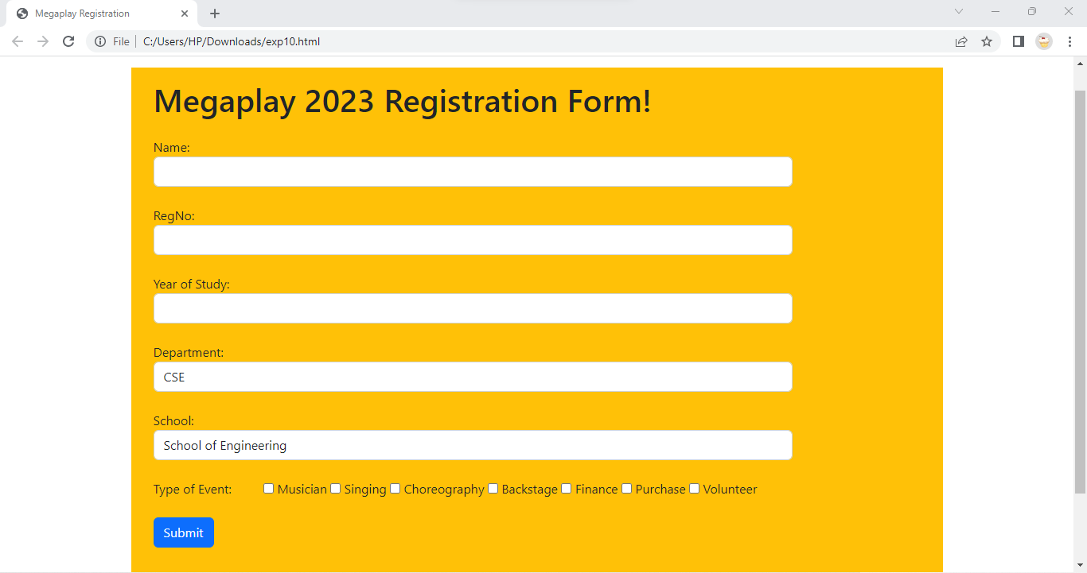

**Result:** The form was successfully created and its data was web-scrap to display using NodeJS.

.